TENDER DOCUMENT

TCA 3/7/1123 East Prawle RRS Tender Documentation
  - East Prawle RRS
Client: | Maritime & Coastguard Agency
Reference: | PB6209-RHD-ZZ-XX-RP-Z-0001
Status: | Draft/P01.01
Date: | 05 August 2019

 | HaskoningDHV UK Ltd.
74/2 Commercial Quay
Commercial Street
Leith
Edinburgh
EH6 6LX
Maritime & Aviation
VAT registration number: 792428892
+44 131 5550506  info.edinburgh@uk.rhdhv.com  royalhaskoningdhv.com | T  E  W

Document title: | TCA 3/7/1123 East Prawle RRS Tender Documentation
Document short title: | East Prawle
Reference: | PB6209-RHD-ZZ-XX-RP-Z-0001
Status: | P01.01/Draft
Date: | 05 August 2019
Project name: | East Prawle RRS Mast Replacement
Project number: | PB6209
Author(s): | Ross Mackay
Drafted by: | John Freer
Checked by: | Ross Mackay
Date / initials: | 06/08/2019, RM
Approved by: | John Freer
Date / initials: | 06/08/2019, JF
Classification
Project related

Disclaimer
No part of these specifications/printed matter may be reproduced and/or published by print, photocopy, microfilm or by any other means, without the prior written permission of HaskoningDHV UK Ltd.; nor may they be used, without such permission, for any purposes other than that for which they were produced. HaskoningDHV UK Ltd. accepts no responsibility or liability for these specifications/printed matter to any party other than the persons by whom it was commissioned and as concluded under that Appointment. The integrated QHSE management system of HaskoningDHV UK Ltd. has been certified in accordance with ISO 9001:2015, ISO 14001:2015 and OHSAS 18001:2007.

Table of Contents
1 NEC 3 Engineering & Construction Short Contract 5
2 General and Preliminary Items 19
3 Specification 1
3.1 General 1
3.2 Introduction 1
3.3 Design and Build Contract 1
3.4 Legislation, Regulations & Design Standards 1
3.5 Working at Height Requirements 2
3.6 Construction (Design & Management) Regulations 2015 2
3.7 Tender Drawing List 3
3.8 Scope of Works 4
3.8.1 Design Requirements 4
3.8.2 The scope of work descripted herein. 4
3.9 Work Excluded 5
3.10 Design Life 5
3.11 Defects Correction Period 5
3.12 Materials and Equipment Storage 5
3.13 Site Visits and Access 6
3.14 Reports and Documents to be submitted by Contractor following award of Contract 6
3.15 Principal Contractor Drawings and Calculations 6
4 Service Information 7
4.1 Overhead Services 7
4.2 Underground Services 7
5 Structural Engineering – lattice steel tower 7
5.1 General 7
5.2 Wind and Ice Loading 8
5.2.1 Site Reference Wind Speed 8
5.2.2 Ice Loading 8
5.2.3 Wind Loads on Antenna 8
5.3 Antenna Loading 9
5.4 Deflection Constraints 10
5.5 Analysis 10
5.5.1 Load Combination 10
5.5.2 Method of Analysis 10
5.6 Steelwork 11
5.6.1 General 11
5.6.2 Submittal for Information 11
5.6.3 Contractor’s drawings 11
5.6.4 Quality Assurance and Standards 12
5.6.5 Test Certificates 12
5.6.6 Bolts, Nuts and Washers 12
5.6.7 Connections 12
5.6.8 Structural Steels 13
5.7 Steelwork Fabrication 13
5.7.1 Technical Delivery Conditions 13
5.7.2 Surface Condition 13
5.7.3 Flame Cutting and Shearing Procedures 14
5.7.4 Dimensional Control 14
5.8 Corrosion Protection 14
5.8.1 Surface Preparation and Galvanising 14
5.8.2 Hot-Dip Galvanising 14
5.9 Access Ladders 15
5.10 Rest Platforms 15
5.11 Cable Management System 15
5.12 Fall Protection System 15
5.13 Anti-Climb Device 16
6 Handling, Transport and Erection 16
6.1 Handling of Structural Steelwork 16
6.2 Loading of Structural Steelwork 16
6.3 Erection Plant and Equipment 17
6.4 Safety of Pedestrian and Vehicular Traffic 17
6.5 Marking for Erection 17
6.6 Trial Erection 17
7 Groundworks 17
7.1 General 17
7.2 Ground Conditions 17
7.3 Site layout 18
7.4 Topsoil 18
7.4.1 Stripping Topsoil 18
7.4.2 Handling Topsoil 18
7.4.3 Foundations Generally 18
7.4.4 Preparation of Foundation Base 18
7.5 Unstable Ground 19
7.6 Unrecorded Features 19
7.7 Disposal of materials/spoil 19
7.8 Water 19
7.9 Ground Water Level 19
7.10 Filling - Hazardous or Unstable Materials 19
7.11 Frost Susceptibility 20
7.12 Placing Fill 20
7.13 Hardcore Filling 20
7.14 Blinding 21
8 Structural Concrete 21
8.1 Concrete Design 21
8.1.1 General 21
8.1.2 Bearing Capacity 22
8.1.3 Sliding 22
8.1.4 Uplift 22
8.1.5 Overturning 22
8.1.6 Raft Foundations – Application of Factors of Safety 22
8.1.7 Individual Blocks – Application of Factors of Safety 22
8.1.8 Specific Requirements for Pad and Chimney Foundations 22
8.2 Materials, Batching and Mixing 22
8.3 Concrete Testing 23
8.4 Placing and Compaction 23
8.4.1 Premature Water Loss 23
8.4.2 Surfaces to Receive Concrete 23
8.4.3 Placing 24
8.4.4 Compacting 24
8.4.5 Curing 24
8.4.6 Covering for Curing 24
8.4.7 Curing Periods and Protection 25
8.5 Formwork for In Situ Concrete 25
8.5.1 Loadings 25
8.5.2 Accuracy 25
8.5.3 Striking Formwork 25
8.5.4 Finish 25
8.6 Reinforcement for In Situ Concrete 26
8.6.1 Quality Assurance of Reinforcement 26
8.6.2 Plain Bar Reinforcement 26
8.6.3 Ribbed Bar Reinforcement 26
8.6.4 Standard Fabric Reinforcement 26
8.6.5 Cutting and Bending Reinforcement 26
8.6.6 Protection of Reinforcement 26
8.6.7 Laps Not Detailed on Drawings 26
8.6.8 Fixing Reinforcement 27
9 Lightning Protection System 27
9.1 General 27
10 Demolition 28
10.1 General 28
10.2 Desk Study/ Survey 28
10.3 Extent of Demolition 28
10.4 Services Affected by Deconstruction/ Demolition 29
10.5 Deconstruction / Demolition Work 29
10.6 Partly Demolished Structures 29
10.7 Materials Arising 29
11 Topsoil and Landscaping 29
11.1 General 29
11.2 Seeded and Turfed Areas 30
11.3 Topsoil Products 30
11.3.1 Preparation Materials Generally 30
11.3.2 Grading Subsoil 30
11.3.3 Subsoil Surface Preparation 30
11.3.4 Surplus Topsoil to be Retained 30
11.3.5 Surplus Materials to be Removed 30
11.3.6 Watering 31
11.3.7 Seeding 31
11.3.8 Quality of Seed 31
12 Price Schedule 32
12.1 Preamble to Price Schedule 32
13 Collection Page 35

Appendices
Appendix A Tender Drawings
Appendix B As-built Information

INSTRUCTIONS FOR TENDERING

- You are invited to submit a Tender to supply the following:

TCA 3/7/1123 East Prawle RRS– Provision of New Radio Tower

Works to be undertaken in accordance with NEC3 Engineering and Construction Short Contract April 2013.

This contract has been advertised on the Contracts Finder portal, and all communications with tenderers during the process will, as far as possible, take place via that portal. Tender documents, including the specification and documents for return with your tender, can be found in the ‘Attachments’ section of the Contracts Finder advertisement.

- Tenderers, before entering upon any non-public land or premises being the Site of any of the works comprised in this Contract to inspect the same, shall make prior arrangements to do so through:
Mr Ross Mackay
Royal HaskoningDHV
74/2 Commercial Quay
Commercial Street
Leith, EDINBURGH
EH6 6LX
E-mail: ross.mackay@rhdhv.com
Tel: 0131 555 0506

- The Employer (The Maritime and Coastguard Agency) have delegated powers of authority to ‘Royal HaskoningDHV’ as the ‘Project Manager’, to administer and manage the contract. The Maritime and Coastguard Agency retains powers associated with financial matters, programme and final sign-off.

- Tenderers shall treat the details of the tender document as private and confidential.

- Period of Validity: Your tender will remain open for acceptance for a period of 90 days from the submission date of the tender unless withdrawn in writing.

- Prior to the date for the submission of Tenders the Employer may issue Addenda or Corrigenda to clarify, modify or add to the Tender Documents. A copy of each Addendum or Corrigendum will be published on the Contracts Finder website and shall become part of the Tender Documents. No addition or alteration shall be made to the Tender Documents unless it is the subject of an Addendum or Corrigendum

- Tenderers are welcome to ask questions about any aspect of the procurement process. Such queries should be addressed to Mr Ross Mackay at the following email address: ross.mackay@rhdhv.com , and should contain the reference number or title of the contract. The deadline for submission of queries is 5pm on 23rd September 2019.

- In the interest of fairness, all answers will be published on the Contracts Finder website as a further attachment to the advertisement, unless clearly only relevant to one supplier. Answers to questions will not be individually emailed to tenderers, so you are strongly advised to keep up to date with any additional documents posted to the site.

- The Tender Documents shall be returned by email to ross.mackay@rhdhv.com by 1200hrs on Monday 30th September 2019.

The subject line must state | (1) the project: “TCA 3/7/1123 East Prawle RRS – Provision of New Radio Tower”,
and | (2) the Words “Not to be opened before “Monday 30th September 2019”

Tenders submitted after the latest time for return may be disqualified unless there is clear evidence that the completed tender had been sent within a sufficient margin of time to pre-suppose its due arrival.

- The Contractor’s fully priced offer should appear in this tender document with submission and completion of the following sections:

- Completed Form of Tender – NEC3 Engineering and Construction Short
Contract April 2013 (Conditions of Contract not included)
- General and Preliminary Items (Section 2.0)
- Price Schedule (Section 4.0)
- Insurance details to meet the requirements of Clause 82 of the Conditions of Contract
- Tender stage method statements
- A tender programme showing the phasing of construction of all Temporary and Permanent Works, separately detailed, and correlated to a programme of labour and plant requirements. Please be aware that your tender programme may be incorporated as the accepted programme if this is selected by the Client at tender stage.

Tender submissions without these documents will be deemed incomplete and will not be considered further.

- If "Included" is entered by the Tenderer against any item the Tenderer shall state in which items the price has been included and how much has been allowed.

- Tenders must be submitted strictly in accordance with the tender document, i.e. without qualifications. Any point of doubt or difficulty requires discussion with the Project Manager as early as possible in the tender period.

- Unit rates and prices must be quoted in pounds and decimal fractions of a pound. Such fractions need not be restricted to any specific number of decimal places, but the product of multiplying the rate by the quantity should be expressed in pounds and whole new pence (i.e. to two decimal places).

- The Employer does not bind himself to accept the lowest or any tender.

- The Employer will not be responsible for any cost incurred in the preparation of any tender.

- Tenderers are deemed to have satisfied themselves on all matters affecting their Tender. Any questions relating to the tender should be addressed to Mr Ross Mackay at the following email address: ross.mackay@rhdhv.com no later than 1 week prior to tender return date. Answers together with the questions asked will be published to all tenderers.

- Tenderers shall furnish the names and addresses of any sub-contractors whom they propose to employ on the site and the names and addresses of suppliers of materials.

- Unless otherwise agreed by both parties, the completion date marked on the successful contractors agreed programme will become the completion date currently marked “TBC” in the Contract Data section.

- Access to site is to be co-ordinated by the Project Manager.

- The Project Manager reserves the right to adjust arithmetical or other errors in any Tender in the way he considers suitable. If the Project Manager discovers major errors or omissions in any tender he may require the Tenderer to adjust the same. The Tenderer will be invited to stand by his price, revise it, or withdraw entirely.

- The Employer is required to be satisfied under the CDM Regulations that only competent companies are appointed as Principal Contractor and that sufficient resources will be allocated to safety. The Contractor shall submit sufficient information for the Project Manager to assess the Contractor’s Health and Safety resources. The assessment shall be made in accordance with the recommendations set out in “Managing health and safety in construction” Approved Code of Practice.

- Tender Evaluation

The Contract, if awarded, shall be awarded based on the criteria set out below to the Tenderer who has submitted a Tender in compliance with these Instructions to Tenderers, and whose Tender is adjudged to be the most economically advantageous to the Employer. The criteria which will be used to establish which tender is the most economically advantageous are marked and weighted under the following headings and sub headings:

- Quality Scoring – [Weighting 60%]

- Degree of understanding, interpretation of the requirement and compliance with the specification requirements. Weighting 30%
- Suitability of proposed tender stage method statements. Weighting 20%
- Project team’s relevant ability and experience including provision of working at height documentation. Weighting 20%
- The tenderer’s programme of works. Weighting 20%
- Project management including Health and Safety management on site. Weighting 10%
The best score is then given a rating of 100, and all other scores are adjusted accordingly i.e. they are baselined to 100. The baselined scores are then multiplied by the weighting percentage (i.e. 60%).

- Price Scoring – [Weighting 40%]

The ‘lowest price’ tender is given 100 points. All the other higher priced tenders are then baselined against the best priced tender. The baselined scores are then multiplied by the weighting percentage (i.e. 40%).

NEC 3 Engineering & Construction Short Contract

NEC3 Engineering and Construction

Short Contract

A contract between: The Maritime and Coastguard Agency

And:

For: Tower Build works associated with the
Construction of a new 16.5m high slimline triangular lattice steel tower at East Prawle RRS.

Contract Data

 | The Employer is
Name | Maritime and Coastguard Agency
Address | ICT  Bay 3/1,  Spring Place  Southampton  SO15 1EG
Telephone | +44 (0) 23 80329 190
E-mail address | Thomas.Ogg@mcga.gov.uk
The works are | The works comprises the design and construction of a new reinforced concrete tower foundation, provision of a 16.5m high slimline tower (to match the configuration given in the planning drawing), the delivery and installation of this tower, antenna and rigging works and the demolition of an existing telescopic steel lattice mast (incl. foundation)
The site is | East Prawle Remote Radio Site, Coastguard Station, Town Road, East Prawle, TQ7 2DF
The starting date is | To be confirmed upon receipt of Contractor’s programme
The completion date is | To be confirmed upon receipt of Contractor’s programme
The period for reply is | One week
The defects date is | Fifty two weeks after completion
The defects correction period is: | Four weeks after notification
The delay damages are | £75.00 per day
The assessment day is the | 25th of each month
The retention is | 5.0%
Does the United Kingdom Housing Grants, Construction and Regeneration Act (1996) apply? | Yes / No (delete as appropriate)
The Adjudicator is | To be nominated by the president of the  Institute of Civil Engineers
Contract Data

The interest on late payment is | 0.5% per complete week of delay
The Contractor is not liable to the Employer for loss of or damage to the Employer’s property in excess of | £1,000,000.00 for any one event
The Employer provides this insurance | None
The minimum amount of cover for the third insurance stated in the Insurance Table is | £1,000,000.00 for any one event
The minimum amount of cover for the fourth insurance stated in the Insurance Table is | £5,000,000.00 for any one event
The Adjudicator nominating body is | The Institution of Civil Engineers Arbitration Procedure (1997)
The tribunal is | Arbitration
If the tribunal is arbitration, the arbitration procedure is | The Institution of Civil Engineers Arbitration Procedure (1997)
The conditions of contract are the NEC3 Engineering and Construction Short Contract (April 2013) and the following additional conditions;
Contractors Design: Undertake and accept full responsibility for the design of the Works | Design liability: Warrant that the parts of the Works are designed with reasonable skill and care of an appropriate professional designer competent to take on this type of work
 | Drawings and supporting documentation: Submit with tender

The Contractor’s Offer

The Contractor is

Name

Address

Telephone

Email

The percentage for overheads and profit added to the Contractor’s Cost for people

is ……….%

The percentage for overheads and profit added to other Contractor’s Cost

is………….. %

The Contractor offers to provide the Works in accordance with the conditions of contract for an amount to be determined in accordance with the conditions of contract

The offered total of the Prices is

…………………………………………………………………

Signed on behalf of the Contractor

Name …………………………………………………………..

Position …………………………………………………………..

Signature ……………………….. Date ……………………

The Employer’s Acceptance

The Employer accepts the Contractor’s Offer to provide the Works

Signed on behalf of the Employer

Name …………………………………………………………..

Position …………………………………………………………..

Signature ……………………….. Date ……………………

Price List

Balances from Section 2 & 4 to be carried to this page

 | GENERAL SUMMARY
Section 2 | Preliminaries/ General Conditions | £
Section 12 | Price Schedule | £
 | TENDER TOTAL | £

NOTE

All prices are done in accordance with the rules as set out in the Civil Engineering Standard Method of Measurement, 4th Edition, as published by the Institution of Civil Engineers.

Works Information

Description of the Works

The works comprise the design, delivery to site and erection of a triangular slimline lattice steel tower, the construction of a suitable concrete foundation, tower and antenna rigging works and demolition works associated with an existing guyed lattice steel mast.

See Specification in Section 3.0 of this document for further Works information details.

Drawings

DRAWING NUMBER | TITLE
PB6209-P-002. P3 | PLANNING DRAWING
PB6695/EPR/1 | EXISTING MAST

Specifications

Title Date or Revision Tick publicly if available

……………………….. ………………………… …………………………..

……………………….. ………………………… …………………………..

……………………….. ………………………… …………………………..

……………………….. ………………………… …………………………..

……………………….. ………………………… …………………………..

See specification in Section 3.0 for details.

.

Works Information

Constraints on how the Contractor Provides the Works

The Principal Contractor shall ensure that he protects the Employers property during all planned site works etc.

The principal dimensions, layout and configuration of the new towers steelwork must conform to the detail presented in tender drawing PB6209-P-002.P3.

The Principal Contractor must ensure that all construction materials required in connection with the development shall be kept/stored within the application site boundary as detailed in the Site Information.

The Principal Contractor must be trained and competent to work at Height in accordance with the Work at Height (Amendment) Regulations 2007

The Contractor is responsible for working in accordance with the CDM Regulations 2015.

Works Information

Requirements for the programme

The tender programme is to be submitted in the form of a Gantt chart with a clear start and finish date. It is to be updated and resubmitted should a change of the completion date be anticipated. It is important to note that the start and finish dates on the final agreed programme will have contractual importance.

Services and other items provided by the Employer

ITEM | LOCATION AND/OR DATE BY WHICH IT WILL BE SUPPLIED
Tender Stage Drawings | Included in Appendix A
Pre-construction Information | Included as part of the tender document
Site Photographs | Included as part of the tender document
Location Details | Included as part of the tender document

Site Information

Site Location Maps – East Prawle RRS

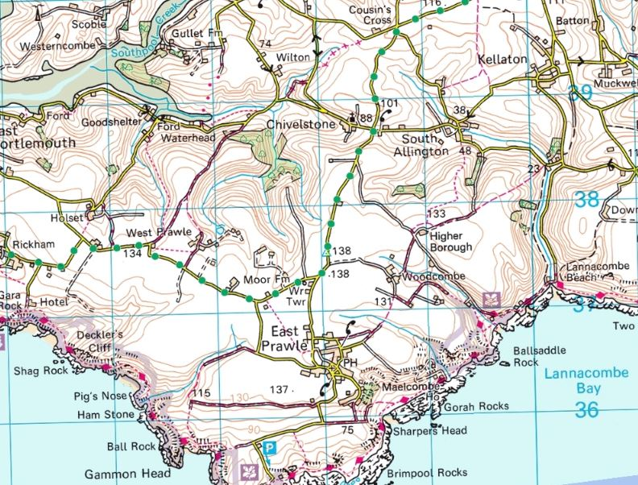
East Prawle RRS
REPRODUCED FROM ORDNANCE SURVEY MAPS WITH PERMISSION FROM THE CONTROLLER OF
HM STATIONERY OFFICE. CROWN COPYRIGHT RESERVED. LICENCE No. 100023422 2007.
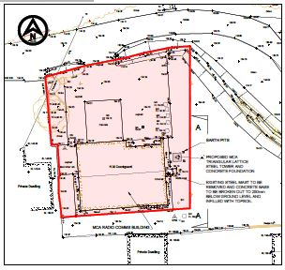
MCA Freehold
(in red)
Location of New Tower
.
Site Photographs

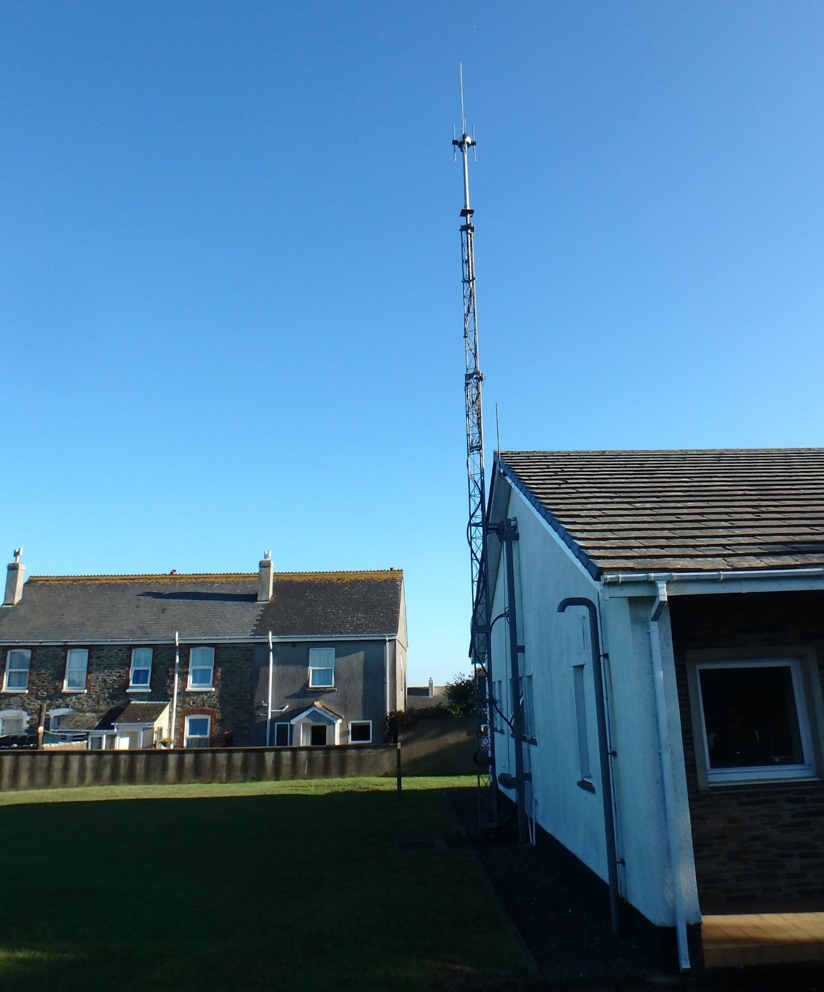

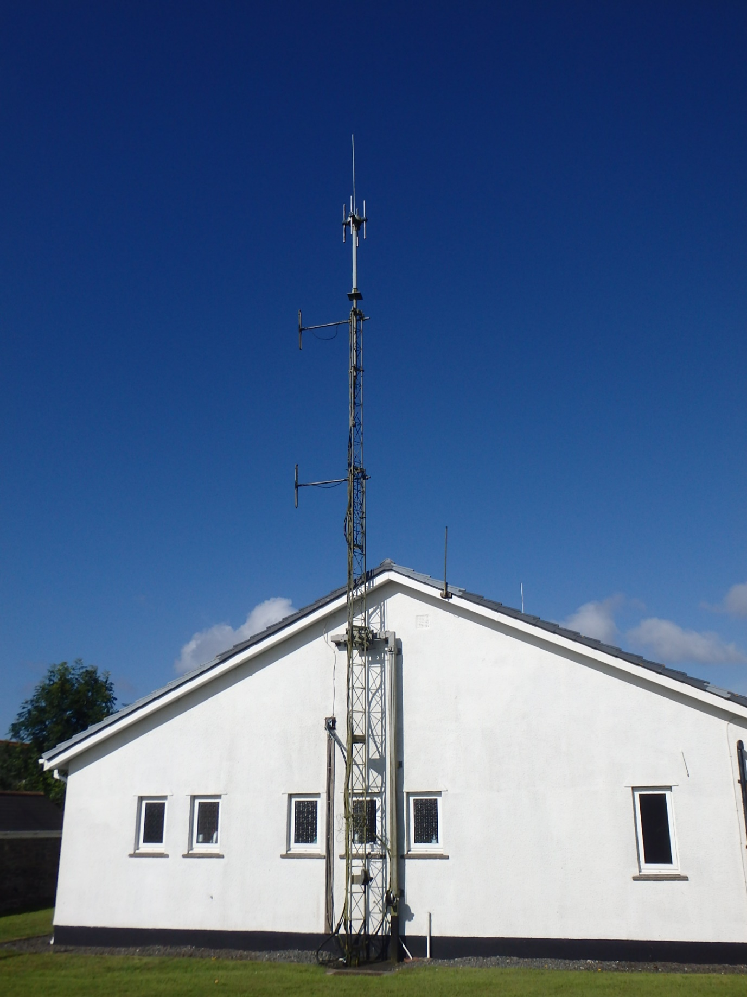
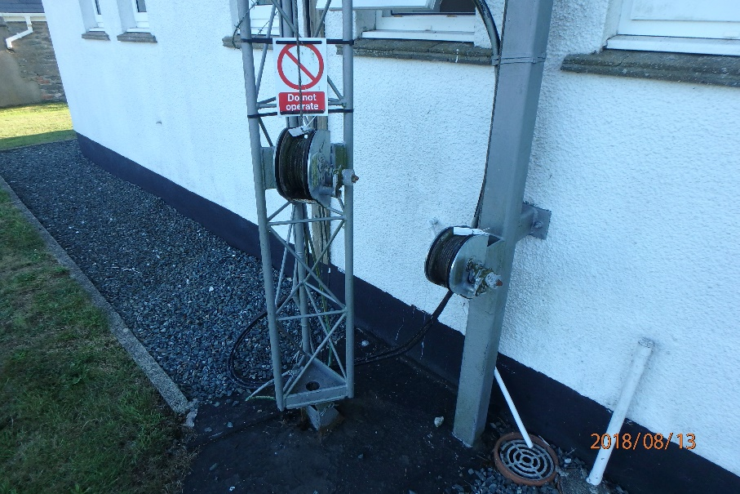
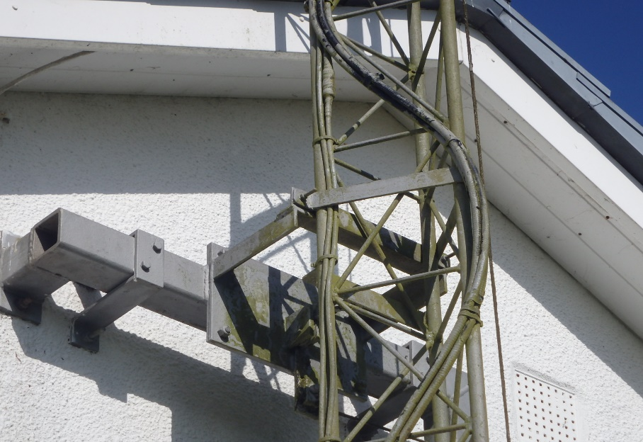
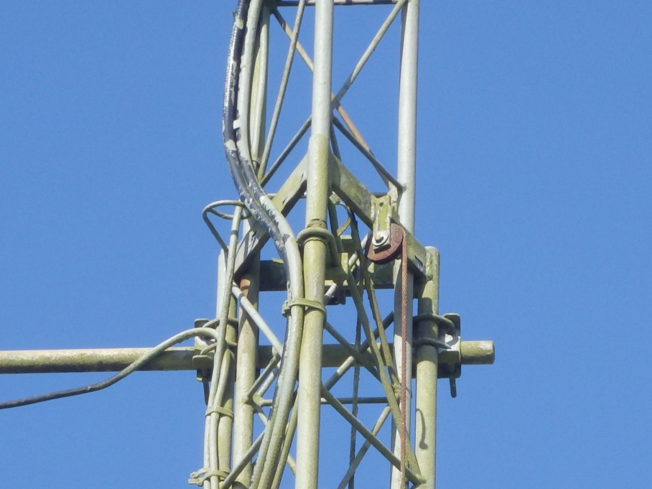

General and Preliminary Items

Item No. | Description | Unit | Quantity | Rate | Price (£)
2.00 | Preamble to General & Preliminary Items
 | The successful Contractor will be appointed as the Principal Contractor for the works in accordance with Part 3 of the CDM Regulations 2015.
 | The Contractor is responsible for providing the site establishment and general attendance (i.e. labour, plant, materials or other facilities as deemed necessary by the Contractor for the works)
 | The following items are only provided to give guidance to help the Contractor price the G&P items. It is the Contractors responsibility to assess the client’s requirements.
2.01 | Employer (Client)
Maritime and Coastguard Agency
Bay 3/1,
Spring Place,
Southampton
SO15 1EG
2.02 | Principal Contractor
 | To be confirmed
2.03 | Employers Representative/ Project Manager
Royal HaskoningDHV
74/2 Commercial Quay
Commercial Street
Leith, Edinburgh
EH6 6LX
2.04 | Principal Designer
Royal HaskoningDHV
74/2 Commercial Quay
Commercial Street
Leith, Edinburgh
EH6 6LX
2.05 | Tender Documents
 | The Tender Documents are, General and Preliminaries, Specification, Price Schedule, Tender Drawings
 | Page Total Carried to Collection
Item No. | Description | Unit | Quantity | Rate | Price (£)
2.06 | Pre-construction Information
 | Preconstruction information is described and included as part this tender document.
2.07 | The Site
 | The area identified for development is located at H.M Coastguard, Town road East Prawle. The site is located within the confines of the MCA Freehold Boundary.
2.08 | Existing Buildings on/ Adjacent to the Site
Buildings within Freehold Boundary:
- Unmanned radio building
- Steel lattice mast (for demolition as part of the Works)

Buildings outwith Freehold Boundary:
- Privately owned properties and gardens on Town Road
2.09 | Existing Utilities and Services
 | Included in Pre-construction Information document
2.10 | Soils and Ground Water
 | Included in Pre-construction Information document
2.11 | Site Investigation
 | Included in Pre-construction Information document
2.12 | Health and Safety File
 | There is no Health and Safety file available for East Prawle RRS
2.13 | Access to the Site
 | Site access is to be agreed with the Project Manager. The Contractor is required to discuss access requirements with the PM at least 5 days prior to any site activities.
 | Page Total Carried to Collection
Item No. | Description | Unit | Quantity | Rate | Price (£)
2.14 | Parking and Traffic Movement
There is a parking area just within the entrance to the Freehold. Parking areas and a site compound area to be agreed between the Principal Contractor, the Project Manager and the Clients representative at the pre-start meeting. Visitor parking must be made available for persons accessing the site during the Works to maintain continuous operation in the building as required.

The Principal Contractor is responsible for the control of his and any sub-contractor vehicles to and from the site, ensuring minimal disruption for the MCA and local road users. The Principal Contractor must ensure the access road to and from the Site is not blocked.
2.15 | Health and Safety Hazards
The nature and condition of the site cannot be fully and certainly ascertained before it is opened up. However the following hazards are or may be present:

- Underground drains;
- Buried services including mains power and telecoms

The accuracy and sufficiency of this information is not guaranteed by the Employer or the Employer’s representative. Ascertain if any additional information is required to ensure the safety of all persons and the Works.
2.16 | Site Visit
 | The Contractor is required to visit site in order to familiarise himself with the nature of the site and any difficulties that may be apparent or perceived. No claim will be considered that may arise from alleged lack of knowledge of such criteria. Access to the existing MCA site is open
2.17 | The Works
 | The Works comprise the design, delivery to site and construction of a 16.5m high triangular lattice steel tower (FLI ATS 1250 or equivalent of matching ultimate dimensions), design and construction of a suitable tower concrete foundation, tower antenna and rigging works and demolition works associated with an existing lattice steel tower.
 | Page Total Carried to Collection
Item No. | Description | Unit | Quantity | Rate | Price (£)
2.17 | The Works
 | The Works comprise the design, delivery to site and construction of a 16.5m high triangular lattice steel tower , design and construction of a suitable tower concrete foundation, tower antenna and rigging works and demolition works associated with an existing lattice steel telescopic tower and its foundations.
2.18 | Completion Work by Others
 | None known at this stage. Should a requirement for works by others that will affect the Works Programme, an Early Warning Notice will be raised.
2.19 | Tender
 | Tenders must include for all work shown or described in the tender documents as a whole or clearly apparent as being necessary for the complete and proper execution of the Works.
2.20 | Period of Validity
 | Period: After submission or lodgement, keep tender open for consideration (unless previously withdrawn) for not less than 90 days.
2.21 | Priced Documents
 | Alterations: Do not alter or qualify the priced documents without written consent. Tenders containing unauthorised alterations or qualifications may be rejected.
 | Measurements: Where not stated, ascertain from the drawings.
 | Deemed included: Costs relating to items, which are not priced, will be deemed to have been included elsewhere in the tender. Submit with tender.
 | Page Total Carried to Collection
Item No. | Description | Unit | Quantity | Rate | Price (£)
2.22 | Tender Programme
 | Programme of work: Prepare a summary showing the sequence and timing of the principal parts of the Works and periods for planning and design. Itemise any work which is excluded. Submit with tender. Please note your tender stage programme may be incorporated as the accepted programme if selected by the Employer at tender stage.
2.23 | Tender Stage Method Statements
Method Statements: Prepare, describing how and when the works will be carried out. Submit with tender.

Method Statements to be revised as required after the pre-start meeting with the Project Manager.
2.24 | Design Documents
Include the following in the Contractor’s Proposal:

Design drawings: Present outline drawings’ confirming the design of the new lattice steel tower conforms to the layout and configuration presented in drawing PB6209-P-02.P3 in Appendix A. Submit with tender. See specification for additional design responsibilities.
2.25 | Substitute Products
If products of different manufacture to those specified are proposed, submit details with the tender giving reasons for each proposed substitution. Substitutions, which have not been notified at tender stage, may not be considered.

Compliance: Substitutions accepted will be subject to the verification requirements of clause 2.35.
2.26 | Named Sub-contractors
General: Comply with the Construction Industry Board of ‘Code of Practice for the selection of Sub-Contractors’.
List: Provide details of all Sub-Contractors and the work for which they will be responsible.
Submit: Within one week of being requested to do so.
 | Page Total Carried to Collection
Item No. | Description | Unit | Quantity | Rate | Price (£)
2.27 | Definitions and Interpretation
 | Meaning: Terms, derived terms and synonyms used in the preliminaries/ general conditions and specification are as stated therein or in the appropriate British Standard or British Standard glossary.
2.28 | Communication
Definition: Includes advise, inform, submit, give notice, instruct, agree, confirm, seek or obtain information, consent or instructions, or make arrangements.
Format: In writing to the person named in clause 2.03 unless specified otherwise.

Response: Do not proceed until response has been received.
2.29 | Products
Definition: Materials, both manufactured and naturally occurring, and goods, including components, equipment and accessories, intended for the permanent incorporation in the Works.

Includes: Goods, plant, materials, site materials and things for incorporation into the Works.
2.30 | Site Equipment
Definition: All appliances or things of whatsoever nature required in or about the construction for completion of the Works but not materials or other things intended to form or forming part of the Permanent Works.

Includes: Construction appliances, vehicles, consumables, tools, temporary works, scaffolding, cabins and other site facilities.
2.31 | Contractors Design
 | Meaning: Design to be carried out or completed by the Contractor and supported by appropriate contractual arrangements, to correspond with specified requirements.
 | Page Total Carried to Collection
Item No. | Description | Unit | Quantity | Rate | Price (£)
2.32 | Submit Proposals
 | Meaning: Submit information in response to specified requirements.
2.33 | Manufacturer and Product Reference
Manufacturer: The firm under whose name the particular product is marketed.

Product reference: The proprietary brand name and/ or reference by which the particular product is identified.

Currency: References are to the Currency.

References are to the particular product as specified in the manufacturer’s technical literature current on the date of the invitation to tender.
2.34 | Substitution of Products
Products: If an alternative product to that specified is proposed, obtain approval from the Project Manager before ordering the product.

Reasons: Submit reasons for the proposed substitution.

Documentation: Submit relevant information.

Manufacturers’ guarantees: If substitution is accepted, submit before ordering products
2.35 | Reference Documents
 | Conflicts: Specification prevails over referenced documents.
2.36 | Equivalent Products
 | Inadvertent omission: Wherever products are specified by proprietary name the phrase 'or equivalent' is to be deemed included.
 | Page Total Carried to Collection
Item No. | Description | Unit | Quantity | Rate | Price (£)
 | Documents provided on behalf of Employer
2.37 | Dimensions
 | Scaled dimensions: Do not rely on
2.38 | The Specification
 | Coordination: All sections must be read in conjunction with Main Contract Preliminaries/ General conditions.
 | Documents provided by the Contractor/ Sub-contractor/ Supplier
2.39 | Contractors Design Information
Complete the design and detailing of the Works as specified.
Provide:
- Production information based on the drawings, specification and other information.
- Liaison to ensure coordination of the work with related construction elements and utility services.
- Master Programme: Make reasonable allowance for completing design/ production information, submission (including to the Principal Designer), comment, inspection, amendment, resubmission and re-inspection. Submit: Within two weeks of request.
Information required:
New tower/concrete foundation design calculations; tower fabrication drawings; tower foundation construction drawings;. –
- Format: PDF
- Number of copies: One
- Submit: Within three weeks of award of contract
2.40 | As Built drawings and information
Contractor designed work:
Provide drawings/ information for inclusion in the Health and Safety File.
- Submit: At least one week before completion date
 | Page Total Carried to Collection

Item No. | Description | Unit | Quantity | Rate | Price (£)
2.41 | Technical Literature
Information: Keep on site for reference by all supervisory personnel:
Manufacturers' current literature relating to all products to be used in the Works.
Relevant British, EN or ISO Standards.
2.42 | Maintenance Instructions and Guarantees
Components and equipment: Obtain or retain copies, register with manufacturer and hand over on or before completion of the Works.

Information location: In Building Manual.
 | Management of The Works
2.43 | Supervision
General: Accept responsibility for coordination, supervision and administration of the Works, including subcontracts.

Coordination: Arrange and monitor a programme with each subcontractor, supplier, local authority and statutory undertaker, and obtain and supply information as necessary for coordination of the work
2.44 | Insurance
 | Documentary evidence: Before starting work on site submit details, and/or policies and receipts for the insurances required by the Conditions of Contract.
2.45 | Insurance Claims
Notice: If any event occurs which may give rise to any claim or proceeding in respect of loss or damage to the Works or injury or damage to persons or property arising out of the Works, immediately give notice to the Employer, the person named in clause 2.01 and the Insurers.

Failure to notify: Indemnify the Employer against any loss, which may be caused by failure to give such notice
 | Page Total Carried to Collection
Item No. | Description | Unit | Quantity | Rate | Price (£)
2.46 | Programme/ Progress
Master programme: Immediately when requested and two weeks after award of contract submit in an approved form a master programme for the Works, which must include details of:
- Work stages or elements of the construction as appropriate for the Works.
Design and production information provided by the Contractor/Subcontractors/ Suppliers, including inspection and checking (see clause 2.40).
Planning and mobilisation by the Contractor
- Earliest and latest start and finish dates for each activity and identify all critical activities.
Running in, adjustment, commissioning and testing of all engineering services and installations.
Exclusions: Where and to the extent that the programme implications for work which is not so defined are impossible to assess the Contractor should exclude it and confirm this when submitting the programme. Submit one copy.
2.47 | Commencement of Work
 | Notice: Before the proposed date for commencement of work on site give minimum notice of two weeks
2.48 | Notification of Compensation Event
 | Notwithstanding the Contractor's obligations under the Contract written notice must also be given of all other causes which apply concurrently
2.49 | Site Meetings
General: Site meetings will be held to review progress and other matters arising from administration of the Contract.
Frequency: Pre-start, weekly visits during the site works and a final snagging inspection.

Attendees: Attend meetings and inform subcontractors and suppliers when their presence is required. Chairperson (who will also take and distribute minutes): Employer’s Representative.
 | Page Total Carried to Collection
Item No. | Description | Unit | Quantity | Rate | Price (£)
2.50 | Notice of Completion
Requirement: Give notice of the anticipated dates of completion of the whole or parts of the Works.

Associated works: Ensure necessary access, services and facilities are complete. Period of notice (minimum): Two weeks.
2.51 | Quotations for Proposed Instructions or Compensation Events
Include:
- A detailed breakdown of the cost, including any allowance for direct loss and expense.
- Details of any additional resources required.
- Details of any adjustments to be made to the programme for the Works.
- Any other information as is reasonably necessary to fully assess the implications of issuing such an instruction.

Inability to comply: Inform immediately if it is not possible to comply with any of the above requirements.

2.52 | Measurement
 | Covered work: Give notice covering work required to be measured.
 | Standards of Products and Executions
2.53 | Incomplete Documentation
General: Where and to the extent that products or work are not fully documented, they are to be:
- Of a kind and standard appropriate to the nature and character of that part of the Works where they will be used.
- Suitable for the purposes stated or reasonably to be inferred from the project documents. Contract documents: Omissions or errors in description and/ or quantity shall not vitiate the Contract nor release the Contractor from any obligations or liabilities under the Contract.
 | Page Total Carried to Collection
Item No. | Description | Unit | Quantity | Rate | Price (£)
2.54 | Workmanship Skills
Operatives: Appropriately skilled and experienced for the type and quality of work.
Riggers must also be trained and competent to Work at Height in accordance with the Work at Height (Amendment) Regulations 2007.

Evidence: Operatives must produce evidence of skills/ qualifications when requested.
2.55 | Quality of Products
Generally: New. (Proposals for recycled products may be considered).

Supply of each product: From the same source or manufacturer.

Whole quantity of each product required to complete the Works: Consistent kind, size, quality and overall appearance.

Tolerances: Where critical, measure a sufficient quantity to determine compliance.

Deterioration: Prevent. Order in suitable quantities to a programme and use in appropriate sequence.

2.56 | Quality of Execution
Generally: Fix, apply, install or lay products securely, accurately, plumb, neatly and in alignment.

Colour batching: Do not use different colour batches where they can be seen together.

Dimensions: Check on-site dimensions.

Finished work: Not defective, e.g. not damaged, disfigured, dirty, faulty, or out of tolerance.

 | Page Total Carried to Collection
Item No. | Description | Unit | Quantity | Rate | Price (£)
2.57 | Compliance
Compliance with proprietary specifications: Retain on site evidence that the proprietary product specified has been supplied.

Compliance with performance specifications: Submit evidence of compliance, including test reports indicating:

Properties tested.
- Pass/ fail criteria.
- Test methods and procedures.
- Test results.
- Identity of testing agency.
- Test dates and times.
- Identities of witnesses.
- Analysis of results.
2.58 | Inspections
Products and executions: Inspection or any other action must not be taken as approval unless confirmed in writing referring to:

- Date of inspection
- Part of the work inspected.
- Respects or characteristics which are approved.
- Extent and purpose of the approval.
- Any associated conditions.
2.59 | Related Work
Details: Provide all trades with necessary details of related types of work.

Before starting each new type or section of work ensure previous related work is:

- Appropriately complete
- In accordance with the project documents.
- To a suitable standard.
- In a suitable condition to receive the new work.

Preparatory work: Ensure all necessary preparatory work has been carried out.
 | Page Total Carried to Collection
Item No. | Description | Unit | Quantity | Rate | Price (£)
2.60 | Manufacturers Recommendations/ Instructions
General: Comply with manufacturer's printed recommendations and instructions current on the date of the Invitation to tender.

Changes to recommendations or instructions: Submit details.

Ancillary products and accessories: Use those supplied or recommended by main product manufacturer.

Agreed certified products: Comply with limitations, recommendations and requirements of relevant valid certificates.
2.61 | Approval of Products
 | Submissions, samples, inspections and tests: Undertake or arrange to suit the Works programme.
2.62 | Approval of Execution
Submissions, samples, inspections and tests: Undertake or arrange to suit the Works programme.

Approval: Relates to the stated characteristics of the sample. (If approval of the finished work as a whole is required this is specified separately). Do not conceal, or proceed with affected work until compliance with requirements is confirmed.

Complying sample: Retain in good, clean condition on site. Remove when no longer required.
2.63 | Setting Out
General: Submit details of methods and equipment to be used in setting out the Works.

Levels and dimensions: Check and record the results on a copy of drawings.

Notify discrepancies and obtain instructions before proceeding.

Inform: When complete and before commencing construction.
 | Page Total Carried to Collection

Item No. | Description | Unit | Quantity | Rate | Price (£)
2.64 | Appearance and Fit
Tolerances and dimensions: If likely to be critical to execution or difficult to achieve, as early as possible either:
- Submit proposals; or
- Arrange for inspection of appearance of relevant aspects of partially finished work.

General tolerances (maximum): To BS 5606: 1990, tables 1 and 2.
2.65 | Critical Dimensions
Critical dimensions: Set out and construct the Works to ensure compliance with the tolerances stated.

Location: Detailed on drawings PB1419-T-002.
2.66 | Service Regulations
 | New or existing services. Comply with the Byelaws or Regulations of the relevant Statutory Authority.
2.67 | Electrical Installation Certificate
Submit: When relevant electrical work is completed.

Original certificate: To be lodged in the Building Manual and Health and Safety File.
2.68 | Mechanical and Electrical Services
 | Final tests and commissioning: Carry out so that services are in full working order at completion of the Works.
2.69 | Supervision
General: In addition to the constant management and supervision of the Works provided by the Contractor's person in charge, all significant types of work must be under the close control of competent trade supervisors to ensure maintenance of satisfactory quality and progress.

Replacement: Give maximum possible notice before changing person in charge or site agent.
 | Page Total Carried to Collection

Item No. | Description | Unit | Quantity | Rate | Price (£)
2.70 | Proposals for Rectification of Defective Products/Executions
Proposals: Immediately any execution or product is known, or appears, to be not in accordance with the Contract, submit proposals for opening up, inspection, testing, making good, adjustment of the Contract Sum, or removal and re-execution.

Acceptability: Such proposals may be unacceptable and contrary instructions may be issued
2.71 | Work Before Completion
General: Make good all damage consequent upon the Works.

Temporary markings, coverings and protective wrappings: Remove unless otherwise instructed.

Cleaning: Clean the Works thoroughly inside and out, including all accessible ducts and voids. Remove all splashes, deposits, efflorescence, rubbish and surplus materials.

Cleaning materials and methods: As recommended by manufacturers of products being cleaned, and must not damage or disfigure other materials or construction.

COSHH dated data sheets: Obtain for all materials used for cleaning and ensure they are used only as recommended by their manufacturers.

New Galvanised Steelwork: Touch up any areas of abrasion or damage to the steelwork in accordance with the Galvanisers Association Handbook.

2.72 | Security at Completion
 | General: Leave the Works secure with, where appropriate, all accesses closed and locked.
 | Page Total Carried to Collection

Item No. | Description | Unit | Quantity | Rate | Price (£)
2.73 | Making Good Defects
Remedial work: Arrange access with the Client Representative and Employer.

Rectification: Give reasonable notice for access to the various parts of the Works.

Completion: Notify when remedial works have been completed.
2.74 | Security, Health & Safety
Preconstruction Information
Location: Integral with the project Preliminaries, including but not restricted to the following sections:
- Description of project
- Client’s consideration and management requirements
- Environmental restrictions and on-site risks
- Significant design and construction hazards
- The Health and Safety File
2.75 | Execution Hazards
Common hazards: Not listed. Control by good management and site practice.
Significant hazards: The design of the project includes the following:
- Climbing and working at height;
- Falls and accidents at height;
- Deep excavation works/collapse of trench;
- Electrical hazards/buried services;
- Radiation hazards;
- Falling objects;
2.76 | Product Hazards
Hazardous substances: Site personnel levels must not exceed occupational exposure standards and maximum exposure limits stated in the current version of HSE document EH40: Workplace Exposure Limits.

Common hazards: Not listed. Control by good management and site practice.

 | Page Total Carried to Collection

Item No. | Description | Unit | Quantity | Rate | Price (£)
2.77 | Construction Phase Health and Safety File
Submission: Present to the Employer/ Client no later than two weeks before commencement of work on site.

Confirmation: Do not start construction work until the Employer has confirmed in writing that the Construction Phase Health and Safety Plan includes the procedures and arrangements required by the CDM Regulations.

Content: Develop the plan from and draw on the Outline Construction Phase Health and Safety Plan and Preconstruction information.
2.78 | Security
Protection: Safeguard the site, the Works, products, materials, and any existing infrastructure affected by the Works from damage and theft. Provide temporary screening (e.g. Heras fencing).

Access: Take all reasonable precautions to prevent unauthorized access to the site, the Works and adjoining property.
2.79 | Stability
 | Responsibility: Maintain the stability and structural integrity of the Works and adjacent structures during the Contract.
2.80 | Employer’s Representatives Site Visits
Safety: Submit details in advance, to the Employer or the Employer’s Representative, of safety provisions and procedures (including those relating to materials, which may be deleterious), which will require their compliance when visiting the site.

Protective clothing and/ or equipment: Provide and maintain on site for the Employer and the person stated in clause 2.03 and other visitors to the site.
 | Page Total Carried to Collection

Item No. | Description | Unit | Quantity | Rate | Price (£)
2.81 | Working Restrictions
 | Storage of Construction Materials: All construction materials required in connection with the development shall be kept/stored within the application site boundary as detailed on tender drawing PB1419-T-001.
 | Protect Against the Following
2.82 | Pollution
Prevention: Protect the site, the Works and the general environment including the atmosphere, land, streams and waterways against pollution.

Contamination: If pollution occurs inform immediately, including to the appropriate Authorities and provide relevant information.
2.83 | Nuisance
Duty: Prevent nuisance from smoke, dust, rubbish, vermin and other causes.

Surface water: Prevent hazardous build-up on site, in excavations and to surrounding areas and access roads.
2.84 | Asbestos Containing Materials/Dangerous Substances
Duty: Report immediately any suspected materials discovered during execution of the Works.
- Do not disturb.
- Agree methods for safe removal or encapsulation
2.85 | Smoking on Site
 | Not permitted
2.86 | Burning on Site
 | Not permitted
 | Page Total Carried to Collection

Item No. | Description | Unit | Quantity | Rate | Price (£)
2.87 | Waste
Includes: Rubbish, debris, spoil, surplus material, containers and packaging.

General: Minimize production. Prevent accumulations. Keep the site and Works clean and tidy.

Handling: Collect and store in suitable containers. Remove frequently and dispose of site in a safe and competent manner:

Non-hazardous material: In a manner approved by the Waste Regulation Authority.

Hazardous material: As directed by the Waste Regulation Authority and in accordance with relevant regulations.
Recyclable material: Sort and dispose at a Materials Recycling Facility approved by the Waste Regulation Authority.
Voids and cavities in the construction: Remove rubbish, dirt and residues before closing in.

Waste transfer documentation: Retain on site.
 | Protect the Following
2.88 | Existing Services
Confirmation: Notify all service authorities, statutory undertakers and/ or adjacent owners of proposed works not less than four weeks before commencing site operations.

Identification: Before starting work, check and mark positions of mains/ services. Where positions are not shown on drawings obtain relevant details from service authorities, statutory undertakers or other owners.

Work adjacent to services:
- Comply with service authority's/ statutory undertaker's recommendations.
- Adequately protect, and prevent damage to services: Do not interfere with their operation without consent of service authorities/ statutory undertakers or other owners.

 | Page Total Carried to Collection
Item No. | Description | Unit | Quantity | Rate | Price (£)
Identifying services: Below ground: Use signboards, giving type and depth.

Damage to services: If any results from execution of the Works:
- Immediately give notice and notify appropriate service authority/ statutory undertaker.
- Make arrangements for the work to be made good without delay to the satisfaction of service authority/ statutory undertaker or other owner as appropriate.
- Any measures taken to deal with an emergency will not affect the extent of the Contractor's liability.

Marker tapes or protective covers: Replace, if disturbed during site operations, to service authority's/ statutory undertakers recommendations.
2.89 | Roads and Footpaths
Duty: Maintain roads, hard standing areas and footpaths within and adjacent to the site and keep clear of mud and debris.

Damage caused by site traffic or otherwise consequent upon the Works: Make good to the satisfaction of the Employer or other owner.
2.90 | Existing Topsoil and Subsoil
Duty: Prevent over compaction of existing topsoil and subsoil in those areas which may be damaged by construction traffic, parking of vehicles, temporary site accommodation or storage of materials and which will require reinstatement prior to completion of the Works.

Protection: Before starting work submit proposals for protective measures.
2.91 | Existing Features
 | Protection: Prevent damage to existing site fences, roads, paved areas and other site features, which are to remain in position during execution of the Works.
 | Page Total Carried to Collection

Item No. | Description | Unit | Quantity | Rate | Price (£)
2.92 | Existing Work
Protection: Prevent damage to existing work, structures or other property during the course of the work.

Removal: Minimum amount necessary.

Replacement work: To match existing
 | Specific Limitations on Method/Sequence/Timing
2.93 | Method/Sequence of Work
Specific limitations: Include the following in the programme:

MCA Engineering Support Contractor works
2.94 | Working Hours
Specific limitations: Monday - Friday 08:00 - 18:00

Approval from the PM will be required for Saturday and Sunday work and any work done outside normal working hours.
 | Facilities/Temporary Work/Services
2.95 | Spoil Heaps, Temporary Works/Services
Location: Give notice of intended siting.

Maintenance: Alter, adapt and move as necessary. Remove when no longer required and make good.
2.96 | Accommodation
 | There are no welfare facilities or accommodation provided by the Employer.
 | Page Total Carried to Collection
Item No. | Description | Unit | Quantity | Rate | Price (£)
 | Operation/Maintenance of the Finished Works
2.97 | The Health and Safety File
Responsibility: The Principal Contractor and Principal Designer.

Content: Obtain and provide comprehensive information for owners and users of the completed Works.

Include an overview of the main design principles and describe key components and systems within the finished Works, so affording a complete understanding of the Works, including the cabin systems to enable efficient and safe operation and maintenance.

Format: A4 size, plastics covered, loose leaf, four ring binders with hard covers, each indexed, divided and appropriately cover titled.
Number of copies: 2
Delivery to: Project Manager
 | Contractor’s General Cost Items
2.98 | Management and Staff
 | Cost significant items: Provide all disbursements arising from the employment of all staff
2.99 | Contractor’s General Cost Items: Site Accommodation
Site Accommodation
Details: Site accommodation not made available by the Employer: See section 2.96.

The Contractor will be responsible for the provision of site welfare facilities for their staff and sub-contractors.
3.00 | Services and Facilities
Details: Services or facilities required or made/ not made available by the Employer: See section 2.96 & 2.99.

Cost significant items: Provide all plant, tools and vehicles necessary for the execution of the works.
 | Page Total Carried to Collection

Item No. | Description | Unit | Quantity | Rate | Price (£)
3.01 | Mechanical Plant
 | Cost significant items: Allow for all mechanical plant not included for in the Schedule of Works e.g. cranes, hoists, personnel transport etc
3.02 | Temporary Works
Details: Temporary works made available by the Employer: None.

Cost significant items: Allow for all temporary works required for the proper execution of the works e.g. roads, footpaths, tracks, hard standing, fencing, gates, boards, scaffolding etc.
3.03 | Work by/on behalf of Employer
 | Antenna/Aerial Supply and Advice - MCA Engineering Support Contractor
 | Page Total Carried to Collection

Page Number | Amount |  | Page Number | Amount
1 | £ |  | 14 | £
2 | £ |  | 15 | £
3 | £ |  | 16 | £
4 | £ |  | 17 | £
5 | £ |  | 18 | £
6 | £ |  | 19 | £
7 | £ |  | 20 | £
8 | £ |  | 21 | £
9 | £ |  | 22 | £
10 | £ |  | 23 | £
11 | £ |  | 24 | £
12 | £
13 | £ |  | -
TOTAL CARRIED TO PRICE LIST |  |  |  | £

Specification

General
The Maritime and Coastguard Agency requires the construction of a new slimline steel lattice tower at East Prawle RRS.

Introduction
The tower shall be installed with full antenna compliment, anti-climb, access ladder, fall protection and a lightning protection system. A concrete pad foundation shall be constructed as part of the works.

The new steel lattice tower is to be installed on the North side of the existing tower.

An independent MCA Engineering support Contractor shall be responsible for supplying the proposed radio tower antenna compliment for the Contractor to fit on site. All feeder cables and building entries to be by the Contractor. Once the tower antenna and rigging works are completed and the site is fully operational, the Contractor will be permitted to demolish and remove the existing lattice steel tower.

A “Roxtec” gland (or equivalent) sized to meet the antenna requirements, needs to be incorporated in the wall of the existing building to allow the antenna feeder cables to connect to the existing building equipment.

Design and Build Contract
This performance specification sets out the requirements for the civil engineering, structural engineering and the electrical engineering aspects of the works, all as listed within the ‘Scope of Works’.

The Contract Documentation incorporates a conceptual design prepared by Royal HaskoningDHV for the layout and configuration of the new lattice steel tower. The concept design shall be developed to a detailed working design by the Contractor. The final detailed design for the new steel tower must conform to the tower outline shown in the tender drawings.

Legislation, Regulations & Design Standards
In addition to statutory compliance with relevant national standards, British Standards, British Standard Codes of Practice or Eurocodes referred to in the document, shall be held to be the latest edition published at the time of Tender.

It is envisaged that the Contractor and his personnel shall be fully conversant with the legislative/technical requirements derived from the following standards; codes and European Directives:

- BS EN 1990: Basis of Structural Design (or equivalent approved British Standard

- BS EN 1991-1-4:2005+A1:2010, Eurocode 1 : Actions on Structures. General actions. Wind actions (or equivalent approved British Standard)

- BS EN 1992-1-1:2004, Eurocode 2: Design of concrete structures (or equivalent approved British Standard

- BS EN 1993-1-1:2005, Eurocode 3: Design of steel structures – Part 1-1: General rules and rules for buildings (or equivalent approved British Standard)

- BS EN 1993-1-8:2005, Eurocode 3: Design of steel structures – Part 1-8: Design of Joints (or equivalent approved British Standard)

- BS EN 1993-3-1:2006 Eurocode 3: Design of Steel Structures-Part 3-1 Towers, masts and chimneys – Towers and masts (or equivalent approved British Standard)

- BS EN 1997-1:2004, Eurocode 7: Geotechnical design – General Rules (or equivalent approved British Standard

- BS EN 1997-2:2007, Eurocode 7: Geotechnical design – Ground Investigation and Testing (or equivalent approved British Standard

- The Building Regulations 2016

- Low Voltage Directive - 2014/35/EU.

- BS 7671:2008 - 2011 Requirements for Electrical installations. IEE 17th edition

- BS EN 62305 (4 Parts):2006 – 2011 – Code of Practice for Protection of Structures Against Lightning

- BS 7430:2011 – Code of Practice for Protective Earthing of Electrical Installations

Working at Height Requirements
The Contractor is required to provide evidence that demonstrates competence and qualification to climb structures in accordance with the requirements of the Work at Height Regulations 2007 and the Management of Health and Safety at Work Regulations. Contractors to provide appropriate documentation indicating the proposed operative’s qualifications including: -

- Climbing training certification
- Climbing log(s) and experience
- Medical and First Aid certification
- Rescue at height training certification
- Rigging qualifications

Construction (Design & Management) Regulations 2015
The CDM Regulations 2015 place duties on clients, designers and contractors to ensure that the health and safety aspects of the work are taken into account, and then co-ordinated and managed effectively throughout all stages of a construction project. This includes all stages of the works, from planning through to execution of works on site.

This project is not deemed to be “notifiable” under the Regulations.

We include the below as a list of items the Principal Contractor takes responsibility over.

- Plan, manage, monitor and coordinate the entire construction phase;
- Take account of the health and safety risks to everyone affected by the work (including members of the public), in planning and managing the measures needed to control them;
- Liaise with the client and principal designer for the duration of the project to ensure that all risks are effectively managed;
- Prepare a written construction phase plan before the construction phase begins, implement, and then regularly review and revise it to make sure it remains fit for purpose;
- Have ongoing arrangements in place for managing health and safety throughout the construction phase;
- Consult and engage with workers about their health, safety and welfare
- ensure suitable welfare facilities are provided from the start and maintained throughout the construction phase;
- Check that anyone they appoint has the skills, knowledge, experience and, where relevant, the organisational capability to carry out their work safely and without risk to health;
- Ensure all workers have site-specific inductions, and any further information and training they need;
- Take steps to prevent unauthorised access to the site;
- Liaise with the principal designer to share any information relevant to the planning, management, monitoring and coordination of the pre-construction phase.

A Principal Designer has been appointed by the Maritime and Coastguard Agency to advise on the health and safety aspects of the design phase during the project. Under these Regulations the Principal Designer will be responsible for preparing Pre-Construction Information and a Health and Safety File. This file shall be presented to the client on completion of the project.

Information which will need to be included in the Health and Safety File includes:

- Construction or As-built drawings;
- Designers - designers risk assessments;
- Structural design details
- Site investigation information;
- Maintenance procedures;
- Details and location of buried services;
- Certificates including electrical (if necessary), fall protection system etc.

The appointed Principal Designer for these works is:

Royal HaskoningDHV
74/2 Commercial Quay
Commercial Street,
Leith, EDINBURGH
EH6 6LX
Tel: 0131 555 0506
Email: ross.mackay@rhdhv.com

Tender Drawing List
The following is a list of drawings which should be read in conjunction with the tender documentation:

Royal HaskoningDHV drawings:

- PB6209 – P – 002 Proposed Site layout and Elevations

The drawings herein are intended to show the position and extent of the Works required and outline details of their typical construction, but neither they nor the specification are guaranteed to show or to describe every part or position of the Works.

It is the Contractors responsibility to ensure any dimensions on the tender drawings are correct and the Project Manager should be informed of any discrepancy. The Contractor is responsible for taking his own site dimensions.

The Contractor shall prepare his own drawings for works to be designed by him. No examination or approval by the Client of any drawing or other documents submitted by the Contractor shall relieve the Contractor of any of his responsibilities or liabilities under the Contract.

Scope of Works

Design Requirements
MCA require the Contractor to design and construct a new slimline steel lattice tower.

The equipment, materials and services shall satisfy the materials specification and workmanship requirements as set out in this specification. Important aspects to be considered when preparing the detailed design are the requirements for:

- The layout and configuration of the steelwork for the new lattice tower must be in accordance with outline, principal dimensions and layout shown in the tender drawings;
- The structure is to be of fully bolted construction and must not require any site welding;
- Antenna mounting steelwork/booms/brackets/connections etc shall be designed and supplied as part of this contract;
- The general layout of the proposed tower must be in accordance with the setting-out details and dimensions provided in the tender drawings;

The Contractor is responsible for the design and checking of all temporary works in accordance with BS 5975.

The scope of work descripted herein.
The structural, civil and electrical engineering aspects to be provided by the Contractor shall include (but not limited to) the following:

- Site Survey/Ground investigation works (Contractors Choice)
- The design of a 16.5m high slimline triangular lattice steel tower complete with full antenna compliment, access ladder(s); a fall protection system; rest platforms etc
- The design of a reinforced concrete foundation to support the 16.5m high slimline triangular lattice steel tower.
- The design of a suitable lightning protection system for the lattice steel tower.
- Excavation works associated with the construction of the reinforced concrete foundation for the new lattice steel tower.
- The construction of a new reinforced concrete foundation for the new lattice steel tower.
- The fabrication or selection of, and installation of the new 16.5m high slimline triangular lattice steel tower.
- The installation of a lightning protection system for the new lattice steel tower
- Provision of required feeder cables and antenna fixings
- Antenna rigging works
- Radio tower antenna installation and rigging works including breaking open and installing a new “Roxtec” gland to permit feeder entry into the building
- Demolition works associated with the existing lattice steel mast and foundation including repairs to existing building at existing fixing points and feeder openings
- The testing and certification of the lattice steel tower fall protection system.
- Liaison with Employer/Employers Representative.
- Liaison with Principal Designer.
- Liaison and works coordination with Employers Engineering Support Contractor.
- Liaison with Health and Safety Executive.
- Provision of Project Documentation for inclusion in the Health and Safety File.

All in accordance with drawings and performance specification listed in this document.

Work Excluded
The following items are not included in the scope of works:

- Supply of proposed tower antenna/ aerials (MCA Engineering Support Contractor)

The performance requirements are outlined within this specification to enable a fully co-ordinated design/installed to be provided.

Design Life
The design life for the lattice steel tower structure shall be 50 years.

The assumption of a design life means that at the end of that period the asset will continue to be serviceable. The assumption of a design life includes the presumption that adequate regular inspections and maintenance, but not major repairs and rebuilding, will take place throughout the design life.

Defects Correction Period
The defects correction period after issue of completion certificate is 12 months.

Materials and Equipment Storage
All materials on site shall be carefully and properly stored in accordance with the suppliers' or manufacturers' instructions and the application site boundary as detailed in tender drawing PB6204-P-002-P1.

The Contractor shall ensure that all materials used are suitable for the works and in line with current legislation and regulations.

Any materials or equipment that are found to be damaged or that have suffered deterioration for any reasons whatsoever shall not be installed in the works, shall be removed from the site forthwith and shall be replaced with materials that comply with the Contract at no additional cost to the Client.

Site Visits and Access
The Contractor is strongly advised to visit site prior to tendering to verify access and site conditions. No claims shall be entertained as a result of the Contractors failure to do so.

Access to the site will need to be arranged at least 3 days in advance of any visit through the Project Manager.

Reports and Documents to be submitted by Contractor following award of Contract
The Contractor shall forward to the Project Manager the following information within 14 days of award of Contract:

- Master Programme of Works.
- Construction Phase Health and Safety Plan.
- Method Statements for each particular part of the Works, revised in accordance with the award. These Statements shall be submitted to the Project Manager prior to work commencing and shall show in detail the procedure to be adopted, the construction operations, plant, temporary works and materials to be utilised. They shall also include risk assessments (including COSHH assessments).
- Preliminary tower design details, drawings, sketches etc which demonstrate compliance with the design constraints mentioned in Section 3.7 & 3.8 of this document.
- Site and Company Safety Policies.
- Other submissions and approvals as required under the Conditions of Contract.

Principal Contractor Drawings and Calculations
The Contractor shall prepare all working (design, schematic, fabrication and installation) drawings for the civil and structural engineering as necessary for the construction of the Works as well as the calculations relating thereto.

The Contractor shall provide a schedule showing the drawings and calculations to be prepared prior to any fabrication works and construction works. A comprehensive set of calculations shall be provided to substantiate the design proposals for all the elements of the works. A tower no bigger than the outer dimensions given in the planning drawing must be selected.

The Contractor shall submit three paper copies of each item of correspondence (plus an electronic version) being a master and two copies for the letters, drawings, calculations, technical data, manufacturing data, catalogues, brochures etc., to the Project Manager.

The Contractor shall ensure that any drawings requiring reviewing are submitted to and received by the Project Manager at least 10 days (ten working days) before approval is required.

The Employer’s acceptance and review of the Contractor’s proposals shall in no way relieve the Contractor of his responsibility under the terms of the Contract. The Contractor shall be responsible for the subsequent correction of the reviewed drawings should they prove to be incorrect and to rectify, without cost to the Employers, any work that has been commenced or completed based on the Contractor’s drawings.

The Contractor is to provide the Project Manager with one electronic copy and two full sets of printed drawings and other details and information fully marked-up, revised and updated to indicate the final “As Built” Construction details for approval. These shall be provided as a single package fully co-ordinated and cross-referenced.

These drawings shall be completed and supplied to the Project Manager within one month of completion of all of the Works.

Two copies of the calculations shall be provided at the completion of the Contract with the “As Built” drawings. (These shall be in addition to the previously provided calculations for review). The calculations shall be provided in bound documents produced in a similar format to the installation, operational and maintenance manuals.

Service Information
Due to the nature of the works being carried out on site, the Contractor is obliged to satisfy himself of the location of any services which may interfere with the works being undertaken.

This section of the Specification details the existing known utilities and services information available at the time of writing, of the proposed site and surrounding area.

Overhead Services
There are no overhead service in the works area.

Underground Services
Existing known buried service information is provided in the pre-construction information pack.

It should be noted that information relating to duct sizes, cable depths, cable runs etc is indicative only and it is recommended that the Principal Contractor hand-dig within a 1.0m radius of any proposed works in these locations.

Structural Engineering – lattice steel tower

General
The Contractor is responsible for the design, fabrication, supply and installation of a 16.5m high slimline triangular lattice steel tower. The principal constraints are as follows:

- If the Contractor cannot satisfy himself that a structure to meet the constraints given in the planning drawing PB6209-P-002.P03 is not suitable to be constructed in the proposed location in accordance with the design.
- The design of the lattice steel tower is to be carried out in strict accordance with the design specification, all requirements being fully complied with.
- The structure is to be of fully bolted construction and must not require any site welding;
- Fabrication of the structural steelwork is to be in accordance with the fabrication specification.
- In order to satisfy Planning Consent, the layout and configuration of the steelwork for the new lattice tower must be in accordance with the outline, shape, principal dimensions and layout shown in the tender drawings;
- Antenna mounting steelwork/booms/brackets/connections etc shall be designed and supplied as part of this contract. All feeder cables to be supplied by the Contractor;
- Rest platform design shall conform to the design specification. Flooring panels shall be supported in such a way that their security is not entirely dependent on welds or bolts in tension;
- The vertical feeder spine shall be designed to be capable of attaching all the feeders required to service the antennas specified. Feeder stacking for all the antennas must comply with the requirements of the design specification. Maximum spacing between feeder clamps must not exceed 0.5m;
- Suitable foundation stirrups or an anchor for use with LOLER hoisting and antenna rigging works. Stirrups to be loaded tested to 5kN and safe working load (SWL) identification label installed. Certificates to be provided to the Project Manager.
- All items to be galvanised as detailed in the fabrication specification.

The philosophy of the design of the tower shall be based on the concept of the design wind speed applying a wind load to the structure such that stresses do not exceed the values of allowable stress defined in the appropriate design standards.

The Contractor shall offer a design which takes full account of the fact that it is client policy to require the full use of the appropriate Eurocodes and British Standards (if appropriate), except where specific information to the contrary is given in this specification.

Wind and Ice Loading

Site Reference Wind Speed
The Contractor shall determine the site reference 10 minute mean wind speed in accordance with BS EN 1991-1-4:2005+A1:2010 and the UK National Annex.

Ice Loading
Ice loading for the structure should be derived from the requirements of BS EN 1991-1-4:2005+A1:2010 and BS EN 1993-3-1:2006 (Annexe C).

Wind Loads on Antenna
The wind forces and moments imposed on the structure by aerials/antenna shall be derived in accordance with the data published in the respective manufacturers catalogues.

Antenna Loading
The tower must be designed to carry all the antennas specified in the antenna schedule below.
Antenna Type | Antenna Detail | Proposed Height (m) | Orientation and Bearing | Note
Centre Fed Dipole | Contractor to liaise with MCA Engineering Support Contractor to confirm boom diameter, size and length | Approx.16m AGL | TBC, but southerly direction | Dipole and boom to be supplied by the Contractor to install. Cross-over plates, fixings and feeder to be supplied by the Contractor
Centre Fed Dipole | Contractor to liaise with MCA Engineering Support Contractor to confirm boom diameter, size and length | Approx.12m AGL | TBC, but southerly direction | Dipole and boom to be supplied by the Contractor to install. Cross-over plates, fixings and feeder to be supplied by the Contractor
Centre Fed Dipole | Contractor to liaise with MCA Engineering Support Contractor to confirm boom diameter, size and length | Approx.10m AGL | TBC, but southerly direction | Dipole and boom to be supplied by the Contractor to install. Cross-over plates, fixings and feeder to be supplied by the Contractor
Centre Fed Dipole | Contractor to liaise with MCA Engineering Support Contractor to confirm boom diameter, size and length | Approx.8m AGL | TBC, but southerly direction | Dipole and boom to be supplied by the Contractor to install. Cross-over plates, fixings and feeder to be supplied by the Contractor
Centre Fed Dipole | Contractor to liaise with MCA Engineering Support Contractor to confirm boom diameter, size and length | Approx.6m AGL | TBC, but southerly direction | Dipole and boom to be supplied by the Contractor to install. Cross-over plates, fixings and feeder to be supplied by the Contractor
Whip Aerial | Contractor to liaise with MCA Engineering Support Contractor for details | 5.5m AGL | N/A | MCA Whip aerial to be transferred from existing building to tower.. Additional fixings to be supplied by the Contractor
Table 1.0 Antenna Schedule

All feeder (For the purposes of pricing assume LDF 4-50 single feeder connections) cables to be supplied by the Contractor. The Contractor is also responsible for connecting the antenna to the feeder cables. Feeder types, lengths etc to be confirmed by the Contractor with the MCA Engineering Support Contractor.

To minimise disruption to the operation of the system, the Contractor shall construct the new radio tower and install the proposed antenna schedule (including all feeder cables) as stated above. Once the power supply to the antenna on the old tower is isolated (by the MCA’s Engineering Support Contractor), permission will be granted to demolish the old radio tower.

To ensure a level of spare capacity within the design of the structure, the new radio tower must also be designed to be capable of supporting the additional antenna described in the table below. Please note, the head frames and antenna are not to be supplied and installed as part of the works.

Antenna Type | Antenna Detail | Proposed Height (m) | Orientation and Bearing | Note
3No.Sector Panel Antennas | Standard sector antenna to be selected for design | 16.5m | 000 º, 120 º & 240º | Allow for mounting antennas on head frame and 4No.LDF5-50 feeders per antenna
3No. 0.6m diameter Dish | Standard 0.6m diameter dish to be selected for design | 16.5m | 060 º, 180 º & 300º | Allow for 1No.LDF4-50 feeder per dish
Table 2.0 Antennas for design loading for spare capacity

The utilisation ratios of any structural element must not exceed 85%.

Deflection Constraints
The tower shall be designed such that bending and torsional deflections of the structure and aerial mountings do not permit the axis of any aerial to deviate by more than a 0.5º from its normal pointing direction for a 1 in 50 year event.

Analysis

Load Combination
The stress analysis of the tower shall take into account the combined effects of wind load, ice loads and deadweight, to enable the most severe loads in all component parts to be evaluated for all the worst possible load combinations.

The analysis shall consider the effects of patch loading on the structure (the sensitivity of the component parts to short duration gusts on local areas of the structure, and associated aerials, while the rest of the structure reacts to the 10 minute mean wind speed.

Due account shall also be taken of the direction of the wind on each aerial. The design shall allow for any possible intermediate combination of aerial loading, which may produce higher loads in the component parts, before the full complement of aerials has been fitted

Method of Analysis
The stress analysis may be carried out by a manual method, or by the use of a stress analysis program approved by the Project Manager. Computer programs likely to be regarded as acceptable are either those which are well-established commercially available packages or in-house programs where the Principal Contractor can demonstrate their validity to the Project Manager.

Steelwork

General
The work covered by this specification shall include the fabrication, testing, erection/installation and commissioning of structural steelwork.

Structural steelwork shall be fabricated and erected in accordance with the requirements of the Employer’s Requirements, BS EN 1993-1-1:2005, BS EN 1090-1:2009 and the UK National Structural Steelwork Specification for Building Construction (BCSA & SCI Publication No 203/07).

Unless otherwise directed all steelwork shall be minimum Grade S275 to BS EN ISO 10025. Hot rolled steel shall be in accordance with BS EN ISO 10025. Cold rolled steel shall be in accordance with BS EN 10130:1999. Steel equal and unequal angles shall be to BS EN 10056-1:1999. Steel bulb flats shall be to BS EN 10067.

All structural steelwork shall comply with BS EN 4211:2005 and BS EN 1993-1-1:2005 in respect of quality and dimensions.

All steelwork shall be hot dip galvanised in accordance with BS EN ISO 1461: 2009 and BS EN ISO 14713-1: 2009. Minimum calculated life to first maintenance to be 20 years for all steelwork.

Submittal for Information
The Contractor shall submit the following information to the Project Manager prior to commencement of fabrication:
- Manufacturer’s Mill Certificates certifying that steel members meet the specified requirements;
- Mill Test Reports indicating structural strength, destructive and non-destructive test analyses;
- The contractor shall, as part of his overall programming responsibilities prepare a programme for the fabrication of the steelwork. It shall cover the process of design, drawings and include submission/approval time; material order/delivery dates, inspection and material testing, and fabrication period including any trial erection periods; and delivery to site plus erection sequence programme indicating key contractual dates;
- The Principal Contractor shall prepare detailed erection plan drawings and clearly identify any temporary works required to ensure the safe erection of the fabrication steelwork.

Contractor’s drawings
The Contractor shall provide fabrication/shop and as-built drawings. If these drawings are produced by amending the Employer’s drawings then the title blocks shall be amended to show that they are now the Contractor’s drawings. If the drawings are prepared by a sub-contractor the drawing title block shall contain the details of the sub-contractor in addition to the Contractors details.

The shop fabrication drawings shall give complete information for the fabrication of the new steelwork sections, including location, type, notch details; end connection details and extent of bolts.

The Contractor shall prepare marking plans including any temporary stability bracing or erection sequence notes necessary for the safe erection and correct alignment of all structural steelwork. All steel sections delivered to site shall be clearly marked with its erection mark and orientation.

Quality Assurance and Standards
Where any work, goods or materials to be used in the Works covered in this Section of the Specification are the subject of an accredited third party quality management scheme or an accredited third party product certification scheme the Principal Contractor shall supply the Project Manager with a copy of the certificate of conformity with that scheme. The schemes shall comply with the requirements of BS EN ISO 9001 and BS EN ISO 3834 – 3.

Test Certificates
The Contractor shall perform tests and provide test certificates, or obtain the manufacturer’s test certificates, which shall be submitted for the materials to be used in the work. The tests shall be carried out by an approved testing authority, and shall include the following, all in accordance with BS EN 10025 and other standards defined above:
- Chemical analysis
- Tensile tests
- Impact tests
- Bend tests

If any sample fails a test the consignment it represents may be rejected in part or in total as decided by the Project Manager.

Bolts, Nuts and Washers
All bolts used for site assembly should be grade 8.8 and in accordance with BS 4190:2001.

All bolts, nuts and washers to be hot dip spun galvanized finish in accordance with BS EN ISO 10684:2004. After galvanizing, the nuts shall run freely on the bolts and permit ready assembly.

Connections
Connections shall be designed in accordance with BS EN 1993-1-1:2005 and BS EN 1993-3-1:2006 and the additional requirements of this specification.

All site connections shall be by nut and bolt, and provided with a single coil spring washer to BS 4464 as a means of locking the nut against loosening by vibration. No bolt on the structure shall be less than 12mm diameter.

Bolt lengths shall be such that with the locking device in place a minimum of two complete threads shall protrude beyond the nut. Wherever possible, bolt threads shall be inside the structure.

Connections which involve the use of the cutting of flanges or bending of webs of bracings shall be avoided; cleats or gusset plates should be used instead.

Gusset plates shall be capable of sustaining the design loads and moments applied by the connecting members, without exceeding the permissible stresses stipulated by BS EN 1993-1-1:2005 and BS EN 1993-3-1:2006.

Structural Steels
All structural steel shall be specified to the steel grades in BS EN 10025. Steel shall be marked by painting to differentiate steel grades and the fabricator shall ensure that correct steel grades are used for all fabrication work.

Steel sections and plate shall be to BS EN 10034. Steel equal and unequal angles shall be to BS EN 10056. Steel bulb flats shall be to BS EN 10067.

No angle treated as load carrying in the stress analysis shall be smaller than 50 x 50 x 6mm. No subsidiary member shall be less than 4mm thick.

The minimum thickness of gusset and similar plates on the main structure shall be 8mm.

All plan brace and other horizontal, or near horizontal members shall be designed to carry a load of 150kg at the weakest point without the stresses exceeding the allowable values in BS EN 1993-1-1:2005 or BS EN 1993-3-1:2006 (where applicable). This load shall be considered to act vertically in the no-wind and no-ice condition.

Before fabrication is started all plates shall be carefully examined for laminations and other defects and shall be passed at least twice through levelling rollers. Rolled sections shall be straightened if necessary and made free from twist.

Steelwork Fabrication

Technical Delivery Conditions
The following technical delivery conditions shall be invoked:

- The maximum carbon equivalent values set out in Table 6 of BS EN 10025-2:2004 shall apply to all steels other than stainless steel.
- Where indicated on the drawings, the steelwork shall be suitable for hot-dip galvanised coating to BS EN 1461:2009.
- Where material is to be bent in the cold condition, it shall be of a grade suitable for cold forming.

Surface Condition
The surface condition of the steel shall comply with Class A3 (for flat products) or Class C3 (for sections) to BS EN 10163. Surface defects revealed during fabrication or blast cleaning shall be treated in accordance with BS EN 10163. Repair by welding of any surface defect or exposed edge lamination shall only be carried out with the approval of the Project Manager and using a procedure complying with BS EN 1011-1.

Flame Cutting and Shearing Procedures
The Contractor shall submit written procedures for flame cutting and shearing before commencing fabrication. Documentary evidence shall be submitted to show that procedure trials witnessed by an independent inspection authority have been carried out to demonstrate that these procedures comply with the requirements of Clause 4.3.3 of BS 5400 Part 6.

Dimensional Control
Fabrication tolerances shall be as set out in BS EN 1090-2:2008+A1:2011. The Principal Contractor shall demonstrate to the satisfaction of the Project Manager that he has procedures in place to control distortion and contraction so as to achieve these tolerances.

Corrosion Protection

Surface Preparation and Galvanising

Remove dirt by scraping, then thoroughly clean area with detergent and rinse with warm water.
Remove oil and grease using an approved emulsion cleaner on contaminated areas only. Thoroughly clean treated area with detergent and rinse with warm water. Ensure that adjacent surfaces have not been contaminated.

Remove all mill-scale, rust and foreign matter by immersion in bath of acid to provide surface suitable for galvanising.

Hot-Dip Galvanising

Galvanise all structural steel components to BS EN ISO 1461: 2009 and BS EN ISO 14713-1: 2009.

Minimum galvanized thickness coating to be 140µm in accordance with BS EN ISO 14713-1:2009, Table 2.0 for hot dip galvanizing for corrosivity category C5 and durability designation class VH (very high). Records of coating thickness shall be kept, and made available to the Project Manager.

The galvanising process (both preparation and application) shall not adversely affect the mechanical properties of the coated steel. The deviation from straightness of members after galvanising shall not exceed 1/1000 of its length between points of lateral restraint.

The zinc coating shall be free from defects and of smooth, clean and uniform thickness, it shall also adhere firmly and completely to the surface of the steel and is not to scale, blister or be removable in any way by the methods of handling or erection.

All cutting, drilling, punching, stamping and bending of parts shall be fully completed, and all burrs removed before galvanising, cleaning in accordance with BS 7773.

All items shall be checked for deformation after galvanising and appropriate remedial action taken when necessary.

Access Ladders
A full height access ladder shall be provided in accordance with the requirements of BS 4211: 2005+A1:2008 and EN ISO 14122-Part 4:2004 from ground level to the top of the structure.

The ladder shall be located so that a minimum clearance of 230mm at the rear of the ladder is achieved. The clear width between the ladder stiles should not be less than 400mm and not more than 450mm. The ladder uprights (stiles) shall be a minimum dimension of 65mm x 10mm in accordance with Table 1 in BS 4211:2005+A1:2008.

The minimum rung size shall be 20mm diameter mild steel bars. The maximum spacing of ladder fixing brackets in steel shall be in accordance with Table 1 in BS 4211:2005+A1:2008.

Unless otherwise directed all steelwork shall be minimum Grade S275 to BS EN ISO 10025.

The design shall allow for a self-supporting access ladder bolted to the reinforced concrete foundation or concrete plinth. The design shall assume that the foundation carries the full weight of the access ladder.

Rest Platforms
Rest platforms shall be provided in accordance with the requirements of BS EN ISO 14122 Part 2 and 4.

Toe plates should be provided around all platforms to reduce the risk of a person slipping under the lower handrail, and to prevent tools and small pieces of equipment from dropping off the platform. They should extend a minimum of 150mm above the top of the flooring.

Cable Management System
The design shall allow for, and incorporate, the feeders detailed in Clause 5.3, Tables 1.0 and 2.0. The bending radius of these feeders must also be taken into account in the design. The Contractor should be aware that typically the minimum bending radius for an LDF 4-50 feeder cable is 125mm and 250m for an LDF 5-50 feeder cable.

A suitable cable management system shall be provided within the structure. This should be positioned in such a way that it is readily accessible from the vertical climbing ladder. Care should be exercised to ensure that the feeders will not be kicked or damaged by a climber when the feeders are attached. Heavy duty cable trays or heavy duty cable ladders are an acceptable form of a cable management system.

The cable management system shall be supported by the lattice steel tower which should be included as part of the design works. A “Roxtec” gland (or equivalent ) should be provided through the wall of the existing building into the equipment room, sized to suit the feeders detailed in Clause 5.3, Tables 1.0 and 2.0

Fall Protection System
The access ladder shall have a "Latchway Ladderlatch" fall protection system fitted to the centre climbing face of the access ladder in accordance with BS EN 363 and BS EN 353.

The “Latchway Ladderlatch” system should be installed in accordance with the manufacturer’s recommendations and installation manual. The fall protection system should be designed to support a minimum of two workers.

The ladder structure to which the system is installed must be capable of withstanding the loads applied by the system in the event of a fall. Marine grade 316 stainless steel fittings and fixings shall be used throughout the system.

During the design and installation of a new fall protection system is it is important to allow for design modification so that the ladder anti-climb device does not restrict or impede the positioning of the system.

Anti-Climb Device
The Contractor will be required to provide an anti-climb device to the access ladder. The anti-climb device for the access ladder may take the form of a removable section of plate which surrounds the ladder up to a height of 2.4m. Barbed wire as a form of an anti-climb device is not permitted. During the design of the anti-climb, consideration must be given to the position of the Latchway fall protection system.

The Contractor will be required to provide an anti-climb device around the base of each tower leg at a height of approximately 2.5m above the foundation level, sufficient to prevent persons climbing around and over. The anti-climb device must be reviewed and approved by the Project Manager prior to installation.

Handling, Transport and Erection

Handling of Structural Steelwork
All structural steelwork shall be erected in accordance with EN 1090-2:2008+A1:2011.

The structural steelwork shall be transported to site, handled, stored and erected so that it is not subjected to stresses in excess of those for which it was designed and is not damaged in any way. Means shall be provided to minimise damage to the protective treatment and any damage which does occur shall be made good.

All work shall be protected in transit. Particular care shall be taken to prevent permanent distortion and adequately protect all machined surfaces. All bolts, nuts, washers, screws, small plates and small articles generally shall be suitably packed and identified.

Any members which in the opinion of the Project Manager have been damaged or overstressed shall be removed from the site at the Principal Contractor’s expense and repaired or replaced to the approval of the Project Manager.

Loading of Structural Steelwork
The Contractor shall not at any time load any structure or any part thereof in excess of the designed working load.

Erection Plant and Equipment
The erection of steelwork shall not commence until the erection method statement has been accepted by the Project Manager. The Principal Contractor shall not employ any plant or equipment which in the Project Managers opinion may be unsuitable, unsafe, or likely to cause damage to the structure during the erection phase of the works.

Safety of Pedestrian and Vehicular Traffic
Due consideration shall be given at all time to the safety of pedestrian and vehicular traffic during the period of erection.

Marking for Erection
Every piece of steelwork shall be distinctly marked before despatch, in accordance with an erection marking plan to be prepared by the Principal Contractor. The figures shall be in paint corresponding with the erection marks on the working drawings and material lists. The weights of the various members shall also be painted on. Markings shall be made on at least two sides of each member.

Trial Erection
The trial erection should be such as to confirm the accuracy of detailing of the main structure and all ancillary steelwork (ladders, platforms, and aerial mountings).

The minimum check erection considered to be acceptable will comprise one complete face constructed horizontally, together with an adjacent face constructed vertically, with all interconnecting bracings attached. Should these reveal any dimensioning problems; the Project Manager will require a complete trial erection of the affected parts.

The trial erection should be carried out prior to galvanising. If the Contractors check erects after galvanising, he shall make good any deficiencies and re-galvanise those parts at his own expense.

Groundworks

General
All earthworks are to be in accordance with BS 6031:2009 (Code of Practice for Earthworks).

The Contractor shall excavate and remove all material necessary for the works and as described below.

Ground Conditions
The Contractor must undertake such soil investigations as are necessary to determine the existing ground conditions.

Site layout
A site datum level and a grid north-south line (for orientation) should be established.

The Contractor shall be responsible for all other setting out, including tower orientation and finished foundation levels.

Topsoil

Stripping Topsoil
- General: Before beginning general excavation or filling, strip topsoil from areas where there will be excavation works.
- Depth: Remove to full depth as required.
- Handling: Handle topsoil for reuse or sale in accordance with BS 3882.
- Site storage: Not required.

Handling Topsoil
- Standard: To BS 3882.
- Aggressive weeds:
- Species: Included in the Weeds Act, section 2 or the Wildlife and Countryside Act, Schedule 9, part II.
- Give notice: Obtain instructions before moving topsoil.
- Contamination: Do not mix topsoil with:
  - Subsoil, stone, hardcore, rubbish or material from demolition work.
  - Other soil or material containing aggressive weeds, sharps, plastics and non-soil forming materials and notifiable animal or plant diseases.
  - Oil, fuel, cement or other substances harmful to plant growth.
  - Other classifications of topsoil.
- Multiple handling: Keep to a minimum. If required, use topsoil immediately after stripping.

Foundations Generally
Give notice if:
- A natural bearing formation of undisturbed subsoil is not obtained at the design depth required.
- The formation contains soft or hard spots or highly variable material.

Preparation of Foundation Base
Preliminary excavation is to be taken no deeper than 75mm above the final formation levels for the Works. The remaining material is to be excavated immediately prior to placing the blinding layer and benched by hand.

The layer beneath all foundations and slabs bearing on soil is to be level, firm and free from loose material prior to the placing of concrete. Any soft spots in the bearing level are to be excavated and backfilled with lean mix concrete. This additional excavation and backfilling shall only be carried out when instructed by the Project Manager.

Unstable Ground
Generally: Ensure that the excavation remains stable at all times.

Give notice: Without delay if any newly excavated faces are too unstable to allow earthwork support to be inserted.

Take action: If instability is likely to affect adjacent structures, take appropriate emergency action.

Unrecorded Features
Give notice: If unrecorded foundations, beds, voids, basements, filling, tanks, pipes, cables, drains, manholes, watercourses, ditches, etc. not shown on the drawings are encountered.

Disposal of materials/spoil
General: all excess material arising from the excavations is to be removed from site and disposed of by the Principal Contractor in accordance with any local regulations and by-laws.

Water
Generally: Keep all excavations free from water until
- Formations are covered.
- Below ground construction is completed.

Drainage: Form surfaces of excavations and fill to provide adequate falls.

Removal of water: Provide temporary drains, sumps and pumping as necessary. Do not pollute watercourses with silt laden water.

Ground Water Level
Give notice: If it is considered that the excavations are below the water table.

Springs/ Running water: Give notice immediately if encountered.

Filling - Hazardous or Unstable Materials
General: Do not use fill materials which would, either in themselves or in combination with other materials or ground water, give rise to a health hazard, damage to structures or instability in the filling, including material that is:
- Frozen or containing ice.
- Organic.
- Contaminated or noxious.
- Susceptible to spontaneous combustion.
- Likely to erode or decay and cause voids.
- With excessive moisture content, slurry, mud or from marshes or bogs.
- Clay of liquid limit exceeding 80 and/or plasticity index exceeding 55.
- Unacceptable, class U2 as defined in the Highways Agency 'Specification for highway works', clause 601.

Frost Susceptibility
General: Except as allowed below, fill must be non-frost-susceptible as defined in Highways Agency 'Specification for highway works', clause 801.8.

Test reports: If the following fill materials are proposed, submit a laboratory report confirming they are non-frost-susceptible:
- Fine grained soil with a plasticity index less than 20%.
- Coarse grained soil or crushed granite with more than 10% retained on a 0.063 mm sieve.
- Crushed chalk.
- Crushed limestone fill with average saturation moisture content in excess of 3%.
- Burnt colliery shale.
- Frost-susceptible fill: May only be used:
- At depths below the finished ground surface greater than 2.0m.
  - Where frost heave will not affect structural elements.

Placing Fill
Surfaces of excavations and areas to be filled: Free from loose soil, topsoil, organic material, rubbish and standing water.

Freezing conditions: Do not place fill on frozen surfaces. Remove material affected by frost. Replace and re-compact if not damaged after thawing.

Adjacent structures, membranes and buried services:
- Do not overload, destabilise or damage.
- Submit proposals for temporary support necessary to ensure stability during filling.
- Allow 14 days (minimum) before backfilling against in situ concrete structures.
- Layers: Place so that only one type of material occurs in each layer.
- Earthmoving equipment: Vary route to avoid rutting.

Hardcore Filling
Fill: Granular material, free from excessive dust, well graded, all pieces less than 75 mm in any direction, minimum 10% fines value of 50 kN when tested in a soaked condition to BS 812-111, and in any one layer only one of the following:
- Crushed rock (other than argillaceous rock) or quarry waste with not more binding material than is required to help hold the stone together.
- Crushed concrete, crushed brick or tile, free from plaster, timber and metal.
- Crushed non-expansive slag.
- Gravel or hogging with not more clay content than is required to bind the material together, and with no large lumps of clay.
- Well-burned non-plastic colliery shale.
- Natural gravel.
- Natural sand.

Filling: Spread and level in 150 mm maximum layers. Thoroughly compact each layer.

Blinding
Surfaces to receive concrete,
Blind with:
- Sand or other approved fine material (as shown on the tender drawings) Moisten as necessary before final rolling to provide a flat, closed, smooth surface. (60mm compacted sand)
- Sand for blinding: To BS EN 12620, grade 0/4 or 0/2 (MP).
- Permissible deviations on surface level: +2.5mm/-2.5 mm.

Structural Concrete

Concrete Design

General
The Contractor is responsible for the design, supply and installation of all associated concrete works throughout the site. The principal constraints are as follows:

- The foundation designs must take full account of the geotechnical conditions revealed by any ground investigation works.
- All concrete design and construction are to conform to BS EN 1992-1-1: 2004 and the associated UK National Annex.
- The Contractor is required to supply the Project Manager with details of his proposed design mix in writing stating the type and origin of all constituent materials for approval. The Contractor shall also supply in writing sufficient test results of previous mixes of a similar type from the ready mixed concrete supplier he intends to use to assure the Project Manager of the quality of the product.
- The foundations for the structure shall be designed with due regard for the site conditions and may take the form of mass concrete blocks, rock anchors, pad and chimneys, or a reinforced concrete raft.
- Design loads for the soil/foundation interface shall be considered in relation to the soil investigation for the site, obtained by the Contractor.
- The applied loads shall be obtained for the most severe foot reactions obtained from the tower analysis.
- The tower foundation design shall include fixings for the central feeder spine facility and access ladder required by the tower design.
- All admixtures shall comply with BS EN 480 and may only be used with the approval of the Project Manager in writing. Calcium chloride is not permitted.
- Concrete shall be specified in accordance with BS 8500-1:2002, BS 8500-2:2002 and BS EN 206-1:2000

Bearing Capacity
When the design loads are inclined or eccentric, the pressure distribution on the base of the foundations shall be calculated. The maximum calculated bearing pressure shall not exceed the bearing pressure obtained by soil investigation.

Sliding
The factor of safety against sliding shall be the ratio of the ultimate resistance to sliding and the load causing the tendency to slide.

Uplift
The factor of safety against uplift shall be the ratio of the resistance against uplift to the upward load. The resistance to uplift shall be supplied by the self-weight of the superstructure acting on the foundation, the net weight of the foundation any fill vertically above it, rock anchors or tension piles. The resistance to uplift may be improved by undercutting. Appropriate allowances shall be made for a reduction in uplift resistance due to ground water, where the soil investigation indicates this to be required.

The uplift force applied overturning shall not be reduced by the weight of the superstructure.

Overturning
The factor of safety against overturning shall be the ratio of the restoring moments to the overturning moments about the edge of the foundation.

Raft Foundations – Application of Factors of Safety
- The factor of safety against overturning when the design loads act shall be at least 2.0.
- The factor of safety against sliding shall be at least 2.0. When calculating the resistance against sliding, only the shearing force between the base and the soil shall be considered. Any passive pressures which might arise shall be ignored.

Individual Blocks – Application of Factors of Safety
- The blocks shall satisfy all the requirements detailed in Section 8.2.6.
- The factor of safety against uplift at the design wind speed shall be at least 2.0.

Specific Requirements for Pad and Chimney Foundations
- The method of excavation and the excavation profile shall be established at the design stage.
- The method of placing and compacting the backfill shall be established at the design stage.
- The factor of safety against uplift at the design wind speed shall be at least 2.0.

Materials, Batching and Mixing
- Transport and delivery of ready-mixed concrete shall comply with BS 8500.
- Ready-mixed concrete shall be supplied in agitating trucks and shall be discharged within 2 hours of the time of adding the cement to the aggregates. The use of retardant admixture is only permitted with the prior agreement of the Project Manager.
- The rate of supply of concrete shall be such as to ensure that each load shall be placed before the preceding load has taken its initial set.
- Unless otherwise agreed by the Project Manager all concrete ingredients shall be weight batched. Allowance shall be made for the moisture content of the aggregates when calculating the amount of water to be added for each mix.
- The concrete shall be mixed for the minimum time necessary to ensure adequate quality and uniform distribution of the materials.
- The period between mixing the concrete and placing it in its final position shall be kept to a minimum and the delivery of concrete shall be co-ordinated with the rate of placement to avoid delays in delivery and placement.
- Concrete shall be handled from the place of mixing to the place of final deposit by methods which prevent segregation, loss of ingredients and contamination and maintain the required workability.
- Pumps used to convey concrete shall be suitable in kind and adequate in capacity for such function.

Concrete Testing
- All sampling and testing shall be in accordance with BS 1881.
- Before the concrete is placed the Project Manager may request a slump test on each load of concrete. The slump shall be 50mm unless stated otherwise in the particular specification for the Works.
- Sets of three 150mm test cubes shall be taken as and when directed by the Contracts Manager.
- Concrete for the test cubes shall be taken at the point of discharge into the Works.
- Test cubes shall be marked and dated in such a manner that the grade and the part of the Works in which the concrete they represent has been placed can be readily identified.
- The test cubes shall be tested by an independent laboratory approved by the Project Manager.
- One cube from each set of three is to be tested at 7 days. A second cube from each set of three is to be tested at 28 days. The test results shall be submitted promptly by the Contractor to the Project Manager. If the cube tested at 28 days does not reach the characteristic strength for that grade of concrete the Contractor shall, at his own expense, take such action as the Project Manager may consider necessary.
- The Contractor should note that approval by the Project Manager in no way absolves the Contractor from his responsibilities.

Placing and Compaction

Premature Water Loss
- Requirement: Prevent water loss from concrete laid on absorbent substrates.
- Underlay: Polyethylene sheet: 250 micrometres thick.
- Building paper: To BS 1521, grade B1F.
- Installation: Lap edges 150 mm.

Surfaces to Receive Concrete
- Cleanliness of surfaces immediately before placing concrete: Clean with no debris, tying wire clippings, fastenings or free water.

Placing
Records: Maintain for time, date and location of all pours.

- Timing: Place as soon as practicable after mixing and while sufficiently plastic for full compaction.
- Temperature limitations for concrete: 30°C (maximum) and 5°C (minimum), unless otherwise specified. Do not place against frozen or frost covered surfaces.
- Continuity of pours: Concreting shall be carried out continuously for each individual footing block or raft unless stated otherwise. Avoid formation of cold joints.
- Discharging concrete: Prevent uneven dispersal, segregation or loss of ingredients or any adverse effect on the formwork or formed finishes.
- Thickness of layers: To suit methods of compaction and achieve efficient amalgamation during compaction.
- Poker vibrators: Do not use to make concrete flow horizontally into position, except where necessary to achieve full compaction under void formers and cast-in accessories and at vertical joints.

Compacting
- General: Fully compact concrete to full depth to remove entrapped air. Continue until air bubbles cease to appear on the top surface.
- Areas for particular attention: Around reinforcement, under void formers, cast-in accessories, into corners of formwork and at joints.
- Consecutive batches of concrete: Amalgamate without damaging adjacent partly hardened concrete.
- Methods of compaction: To suit consistence class and use of concrete.

Curing
- Evaporation from surfaces of concrete: Prevent, including from perimeters and abutments, throughout curing period.
- Surfaces covered by formwork: Retain formwork in position and, where necessary to satisfy curing period, cover surfaces immediately after striking.
- Top surfaces: Immediately after compaction and completion of the surface finishing the concrete shall be protected from the evaporation of moisture by means of polythene sheeting, quilts, wet hessian or other similar material kept wet by soaking, or by the use of an approved proprietary curing compound.
- Surface temperature: Maintain above 5°C throughout the specified curing period or four days, whichever is longer.
- Records: Maintain details of location and timing of casting of individual batches, removal of formwork and removal of coverings. Keep records on site, available for inspection.

Covering for Curing
- Sheet coverings: Suitable impervious material.
- Curing compounds: Selection criteria:
- Curing efficiency: Not less than 75% or for surfaces exposed to abrasion 90%.
- Colouring: Fugitive dye.
- Application to concrete exposed in the finished work: Readily removable without disfiguring the surface.
- Application to concrete to receive bonded construction/ finish: No impediment to subsequent bonding.
- Interim covering to top surfaces of concrete: Until surfaces are in a suitable state to receive coverings in direct contact, cover with impervious sheeting held clear of the surface and sealed against draughts at perimeters and junctions.

Curing Periods and Protection
- Minimum periods: When not otherwise indicated to BS 8110-1, table 6.1.
- Prevent damage to concrete, including:
- Surfaces generally: From rain, indentation and other physical damage.
- Surfaces to exposed visual concrete: From dirt, staining, rust marks and other disfiguration.
- Immature concrete: From thermal shock, physical shock, overloading, movement and vibration
- In cold weather: From entrapment and freezing expansion of water in pockets, etc.

Formwork for In Situ Concrete

Loadings
The formwork shall conform to the shapes, lines, levels and dimensions of the concrete as shown on the tender drawings and shall be so designed and constructed by the Contractor that it remains sufficiently rigid during and after the placing and compaction of the concrete.

- Requirement: Design and construct formwork to withstand the worst combination of the following:
  - Total weight of formwork, reinforcement and concrete.
- Construction loads including dynamic effects of placing, compacting and construction traffic.
  - Wind and snow loads.

Accuracy
- General requirement for formwork: Accurately and robustly constructed to produce finished concrete in the required positions and to the required dimensions.
- Formed surfaces: Free from twist and bow (other than any required cambers).
- Intersections, lines and angles: Square, plumb and true.

Striking Formwork
- Timing: Prevent any disturbance, damage or overloading of the permanent structure.

Finish
- Finish: Plain, smooth. Even with panels arranged in a regular pattern as a feature of the surface.
- Permissible deviation of surfaces:
  - Sudden irregularities (maximum): 5 mm.
  - Gradual irregularities when measured from the underside of a 1m straight edge placed anywhere on surface (maximum): 5mm.
- Variations in colour:
  - Permitted: Those caused by impermeable form linings.
  - Not permitted: Discoloration caused by contamination or grout leakage.
- Surface blemishes:
  - Permitted: Blowholes less than 10 mm in diameter and at an agreed frequency.
  - Not permitted: Voids, honeycombing, segregation and other large defects.
- Formwork tie holes: In a regular pattern and filled with matching mortar.

Reinforcement for In Situ Concrete

Quality Assurance of Reinforcement
- Standards:
  - Reinforcement: To BS 4449, BS 4482, BS 4483 or BS 6744.
  - Cutting and bending: To BS 8666.
  - Source of reinforcement: Companies holding valid certificates of approval for product conformity issued by the UK Certification Authority for Reinforcing Steels (CARES).

Plain Bar Reinforcement
- Standard: To BS 4482.
- Strength grade: 250.

Ribbed Bar Reinforcement
- Standard: To BS 4449.
- Strength grade: B500B.

Standard Fabric Reinforcement
- Standard: To BS 4483.
- Strength grade: B500B.

Cutting and Bending Reinforcement
- General: To schedules and to BS 8666.
- Bending on site, including minor adjustments: Obtain instructions.

Protection of Reinforcement
- Dropping from height, mechanical damage and shock loading: Prevent.
- Cleanliness of reinforcement at time of pouring concrete: Free from corrosive pitting, loose millscale, loose rust and contaminants which may adversely affect the reinforcement, concrete, or bond between the two.

Laps Not Detailed on Drawings
- Laps in bar reinforcement (minimum): 40 x bar diameter.
- Laps in fabric reinforcement (minimum): 40 x bar diameter.
- Laps at corners: Avoid four layer build-up.

Fixing Reinforcement
- Standard: To BS 7973-1 and -2.
- Installation: In addition to any spacers and chairs shown on drawings or schedules, provide adequate support, tie securely and maintain the specified cover.
- Tying: Wire type: 16 gauge black annealed. Use stainless steel wire for stainless steel reinforcement.
- Ends of tying wire: Prevent intrusion into the concrete cover. Remove loose ends.
- Compatibility of metals: Prevent contact between ordinary carbon steel and stainless or galvanized reinforcement.

Lightning Protection System

General
The Contractor is responsible for the design, supply, installation and commission of a complete lighting protection system for the tower.

It shall be the responsibility of the Contractor to ascertain the material requirements for this work prior to ordering materials and prior to any work starting on site.

The principal constraints are as follows:

- An external lightning protection system shall be designed and installed in accordance with BE EN 62305 Parts 1 & 4:2011 (Protection against lightning) to give a resistance to earth not exceeding 10 ohms;
- Each leg of the tower shall have an individual lightning conductor running down its entire length. Each down conductor shall be a continuous length of copper of cross section not less than 70mm², fixed as close as possible to the outer corner of the leg.
- Similar down conductors shall run down each feeder tray. Each down conductor shall be "broken" 300mm above ground level by a sacrificial link.
- The sacrificial link shall be a short galvanised steel angle attached to the tower by 2 bolts and to which the copper straps are attached by at least 2 bolts.
- The strip/angle section plane of contact shall be vertical to minimise the retention of water.
- The bonds between down conductors and the EES shall be exothermically welded, brazed, or silver soldered.
- The conductors paths shall be continuously downward with a minimum number of bends, none of which shall be sharper than 90°;
- Feeders and other cables mounted on the tower shall have their sheaths cross bonded to the lightning protection system at their highest point. They shall also be cross bonded to the lightning protection system at the bottom of their downward run just before they turn away from the vertical and just before they enter the new cabin.
- A busbar for earthing of the feeders shall be provided in accordance with BS 6701:2010 at these points. The busbars are to be bonded to the lightning protection system;
  - Mechanical joints enabling earthing strips to be broken for the purpose of testing separately different parts of the earthing system. Joints to comprise at least 50mm overlap (on 25mm strip) with the overlap area tinned, and drilled on the centre lines with holes to take 6mm bolts, approximately 12mm and 37mm from ends. Joints to be made with suitably plated bolts, large flat washers, spring washers and nuts;
  - Earth pits shall be cross-bonded using un-insulated, 25mm x 3mm buried copper conductors. These cross-bonding conductors shall be buried 500mm deep. The connections in the earth inspection pits shall use Furse, or equivalent and approved connections specifically designed for earth rod to tape connections;
  - All connections shall use connectors designed for the purpose from the Furse range or equivalent and approved connectors;
  - The Contractor is to provide certificates of the earth readings obtained from each installed earth pit and the combined system.

Demolition

General
The Contractor responsible for the demolition and disposal off site of the existing 12m high triangular lattice steel mast. Include for the removal of all guy ropes and associated components as well as breaking out all foundations to a minimum depth of 250mm below ground level.

Desk Study/ Survey
Scope: Before starting demolition work, examine available information, and carry out a survey of:
- the structure or elements to be deconstructed/ demolished,
- the site on which the structure stands, and
- the surrounding area.

Report and detailed method statements: Submit, describing:
- Form, condition and details of the structure, the site, and the surrounding area.
- Extent: As per the tender drawing list.
- Type, location and condition of adjoining or surrounding premises that might be adversely affected by partial demolition of the structure, or by noise, vibration and/ or dust generated during deconstruction/ demolition.
- Form and location of flammable, toxic or hazardous materials, including lead-based paint, and proposed methods for their removal and disposal.
- Form and location of materials identified for reuse or recycling, and proposed methods for removal and temporary storage.
- Proposed programme of work, including sequence and methods of deconstruction/ demolition.
- Arrangements for protection of personnel and the general public, including exclusion of unauthorized persons.
- Arrangements for control of site transport and traffic.
- Special requirements: Results of tests to determine the precise nature of hazardous materials.

Extent of Demolition
General: Subject to retention requirements specified elsewhere, deconstruct/demolish the existing radio tower down and break out foundations to 250mm below ground level.

Services Affected by Deconstruction/ Demolition
Services Regulations: Work carried out to or affecting new and/or existing services: Carry out in accordance with the byelaws and/or regulations of the relevant Statutory Authority.

Location of Services: Services affected by deconstruction/ demolition work: Locate and mark positions.

- Mains services marking: Arrange with the appropriate authorities for services to be located and marked.
- Marking standard: In accordance with National Joint Utilities Group 'Guidelines on the positioning and colour coding of underground utilities' apparatus'.

Deconstruction / Demolition Work
- Workmanship
  - Standard: Demolish structures in accordance with BS 6187.
- Operatives
  - Appropriately skilled and experienced for the type of work.
  - Holding, or in training to obtain, relevant CITB Certificates of Competence.
- Site staff responsible for supervision and control of work:
  - Experienced in the assessment of risks involved and methods of deconstruction/ demolition to be used.

Partly Demolished Structures
General: Leave partly in a stable condition, with adequate temporary support to prevent risk of uncontrolled collapse. Keep safe outside working hours.

Materials Arising
Contractors Property
- Components and materials arising from the deconstruction/demolition work: Property of the Contractor except where otherwise provided.
- Action: Remove from site as work proceeds where not to be reused or recycled for site use.

Recycled Materials
- Materials arising from deconstruction/demolition work: Shall not be recycled or reused elsewhere in the project.

Topsoil and Landscaping

General
The Contractor shall be responsible for re-grading the area inside and around the site boundary for the works, to suit the level of the finished works, matching the existing natural fall of the site.

Contractor to include for general grass reseeding and lifting and relaying any damaged paving slabs or tarred footways.

Seeded and Turfed Areas
- Growth and development: Healthy, vigorous grass sward, free from the visible effects of pests, weeds and disease.
- Appearance: A closely knit, continuous ground cover of even density, height and colour.

Topsoil Products

Preparation Materials Generally
- Purity: Free of pests, disease, and fungus.
- Foreign matter: On visual inspection, free of fragments and roots of aggressive weeds, sticks, straw, subsoil, pieces of brick, concrete, glass, wire, large lumps of clay or vegetation, and the like.
- Contamination: Do not use topsoil contaminated with subsoil, rubbish or other materials that are:
  - Corrosive, explosive or flammable.
  - Hazardous to human or animal life.
  - Detrimental to healthy plant growth.
- Subsoil: In areas to receive topsoil or planting media, do not use subsoil contaminated with the above materials.
- Give notice: If any evidence or symptoms of soil contamination are discovered on the site or in topsoil or planting media to be imported.

Grading Subsoil
- General: Grade to smooth flowing contours to achieve specified finished levels of topsoil.
- Areas of thicker topsoil: Excavate locally.

Subsoil Surface Preparation
- General: Excavate and/ or place fill to required profiles and levels, as per the drawing list.
- Loosening: Light and non-cohesive subsoils: When ground conditions are reasonably dry, loosen thoroughly to a depth of 300 mm.
- Stones: Immediately before spreading topsoil, remove stones larger than 75 mm.
- Remove from site: Arisings, contaminants and debris.

Surplus Topsoil to be Retained
- Generally: Spread and level on site:
  - Locations: Throughout the site.

Surplus Materials to be Removed
- Topsoil: Remove from site excess topsoil.
- Subsoil, stones, debris, wrapping material, canes, ties, temporary labelling, rubbish, prunings and other arisings: Remove.

Watering
- Quantity: Wet full depth of topsoil.
- Application: Even and without displacing seed, seedlings or soil.
- Frequency: As necessary to ensure the establishment and continued thriving of all seeding.

Seeding
- Grass Seed: Contractors Choice.
- Application Rate: Contractors Choice.

Quality of Seed
- Freshness: Produced for the current growing season.
- Certification: Blue label certified varieties.
- Standard: EC purity and germination regulations.
- Official Seed Testing Station certificate of germination, purity and composition:
- Submit when requested.
- Samples of mixtures: Submit when requested.

Price Schedule

Preamble to Price Schedule

All work to be undertaken in accordance with Section Two (General and Preliminary Items), Section Three (Specification) and as scheduled below.

All quantities in the Price Schedule are for guidance only. This is a Lump Sum Tender and re-measurement of the works will only be considered in the event of a variation order being issued.

The Contractor will be held to have familiarised themselves with all site conditions, weather, all site investigation records available and location of existing buried services in order to execute the works described herein. No claim for want of knowledge will be reimbursed.

Contractor to insert their required fixed price lump sums against all items listed in the enclosed Price Schedule in Pound Stirling (£) only. Sums inserted are for the value of work for the full duration of the Contract Period and shall include the following as a minimum;

- Labour and all costs in connection therewith.
- The supply of materials, goods, storage and costs in connection therewith including waste and delivery to Site. Taking delivery of materials and goods supplied by others, unloading, storage, and costs in connection therewith.
- Plant and costs in connection therewith.
- Fixing, erecting and installing or placing of materials and goods in position.
- Temporary works.
- The effect on the phasing of the Works or any element of the Works to the extent set forth or reasonably implied in the documents on which the Tender is based.
- General obligations, liabilities and risks involved in the execution of the Works set forth or reasonably implied in the Documents on which the Tender is based.
- Establishment charges, overheads and profit.
- Weekly or monthly running costs
- Waste.
- Attendance and transport for sampling and testing carried out by Company, supplying results of tests carried out by Contractor and providing test certificates.
- Attendance on Named and Domestic Sub-contractors
- Complying with Quality Assurance requirements of the Contract and providing certificates of conformity.
- Preparation and supply of detailed working drawings.
- Awaiting approvals and or consents.
- Taxes and import duties as required.
- Effects of inflation on Labour, Plant, Materials, Equipment and sub-contract works
- The Contractor to submit a comprehensive method statement and risk assessment for each stage of the works set out in the schedule below.

The above is not an exhaustive list of items. The Contractor is to ensure complete coverage of all work items which can be reasonably inferred from the tender documents.
Item No. | Description | Unit | Quantity | Rate | Price (£)
12.1 | Design drawings, calculations and the like for all structural engineering works associated with the lattice steel tower.
12.2 | Design drawings, calculations and the like for all structural engineering works associated with the reinforced concrete foundation(s) for the lattice steel tower.
12.3 | Design drawings, calculations and the like for all electrical engineering works associated with the lightning protection system.
12.4 | Excavation works associated with construction of the reinforced concrete foundation(s) for the lattice steel tower.
12.5 | Allow for opening up and making good an opening into the existing building and include for the purchase and fitting of a “Roxtec” gland or approved equivalent sized to meet the proposed antenna complement feeder numbers.
12.6 | The construction of a reinforced concrete foundation for the lattice steel tower.
12.7 | The purchase or fabrication of, supply and erection of a 16.5m slimline triangular lattice steel tower on prepared foundations
12.8 | The installation of a lightning protection system for the tower in accordance with the specification and tender drawings.
12.9 | Installation of complete radio tower antenna compliment including all rigging works. All feeders to be supplied by Contractor along with brackets, fixings etc for antennae  [Feeders to be looped and left within building for connection and ground level testing by MCA Engineering team].
12.10 | All rigging associated with the “at height” works to cooperate with the MCA Engineering support team for the antenna connection and testing.
12.11 | The demolition and removal of the existing 12m high triangular guyed lattice steel mast from site. Include for breaking out the tower foundation block to 250mm below ground level and for making good at the support points to the old tower
12.12 | Allow for general grass seeding, landscaping and regrading to suit the levels of the finished works.
 | Page Total Carried to Collection

Collection Page

Item | Price
General & Preliminary Items – Section 2 | £
Price Schedule – Section 12 | £
TOTAL CARRIED TO PRICE LIST | £

Appendix A Tender Drawings

Appendix B As-built Information

