Specification

Local Plan Partial Review Integrated Impact Assessment
(incorporating Sustainability Appraisal, Strategic Environmental Assessment, Equality Impact Assessment and Health Impact Assessment)

Request for Quotation

Royal Borough of Kensington and Chelsea

June 2016

1.0 INTRODUCTION

  - The Royal Borough of Kensington and Chelsea is seeking to procure consultants to undertake an Integrated Impact Assessment (IIA) of the Council’s Local Plan Partial Review (LPPR). The IIA must incorporate the legal requirements for a Sustainability Appraisal (SA) and Strategic Environmental Assessment (SEA), as well as an Equalities Impact Assessment (EqIA) and a Health Impact Assessment (HIA).

  - The Council has undertaken an Issues and Options Consultation on the LPPR between 15 December 2015 and 9 February 2016, which incorporated the screening stage of the Habitats Regulation Assessment (HRA) and the Scoping stage of the SA/SEA. The LPPR IIA Scoping Report and Habitats Regulations Assessment (HRA) Screening Report were produced ‘in-house’ and were subject to consultation with the statutory SEA consultees.

  - The Council is now seeking consultants to undertake the next stage of the IIA process. This work must cover the requirements for the assessment stages of the SA (Stages B, C and D Paragraph: 013 Reference ID: 11-013-20140306, NPPG) and SEA Directive (2001/42/EU), as well as an EqIA (Section 149 Equality Act 2010) and a HIA. (see Appendix 1).

  - The IIA Report does not require a Habitats Regulation Assessment as the Habitats Screening Report concluded there would not be a significant impact on any Special Areas of Conservation (SACs) or Special Protection Areas (SPAs) designated under the Habitats Directive and Birds Directive.

- SCOPE OF AN INTEGRATED IMPACT ASSESSMENT

  - The integrated approach enables synergies and cross-cutting impacts to be identified and avoids the need to undertake and report on separate assessments. This approach seeks to reduce any duplication of assessment work. A single process can improve efficiencies in both the assessment itself, as many of the issues covered in the different forms of assessment overlap, as well as simplifying outcomes and recommendations for policy makers. Where more detail on certain issues is required or necessary, this can be undertaken and included within the IIA. Such an approach has been successfully followed by the Mayor of London for the London Plan which is also part of the Council’s development plan.

  - The SA Framework first developed for the Core Strategy in 2010 has been reviewed and brought forward to form the IIA objectives set out in the IIA Scoping Report see (Section 9). This set of objectives balances environmental, social and economic factors. IIA objective 4 deals directly with the promotion of equality and respect for diversity and therefore encompasses criteria for analysing the contribution policies in the LPPR will have on the equality duty for public bodies set out in Section 149 of Equality Act 2010. IIA objective 15 seeks to ensure the provision of accessible health care for all residents, which incorporates the aims of a Health Impact Assessment. Further Objectives such as 5, 7 and 9 seek to adapt to climate change and improve air quality in the Royal Borough. These also have indirect benefits for human health and will contribute to the assessment of LPPR options and alternatives impacts upon health issues. The framework developed in 2010 therefore adequately sets a framework for an integrated assessment.

- THE ROYAL BOROUGH OF KENSINGTON AND CHELSEA’S CONTEXT

  - The Royal Borough of Kensington and Chelsea is one of the most desirable places to live in the country. The Borough has the highest property prices in the United Kingdom with the average price of a home being almost five times the national average. The Borough is one of the most densely populated boroughs in England and Wales and there is a significant amount of international investment. Kensington and Chelsea has a rich architectural heritage: with 32 conservation areas, covering 72 per cent of the Borough. Alongside this wealth there has always been relative deprivation, most notably in the larger areas of social housing in the north of the Borough.

- LOCAL PLAN PARTIAL REVIEW

Policies

  - The Council’s Unitary Development Plan (UDP), which set out comprehensive policies for determining planning applications in the Borough, was adopted in May 2002. Most of the policies in the UDP were subsequently replaced by the Core Strategy, which was adopted by the Council in December 2010.

  - The Core Strategy policies and some of the remaining ‘extant’ UDP policies have since been the subject of a number of topic-based reviews, namely: Pubs and Local Character (adopted October 2013), Miscellaneous Matters (December 2014), Conservation and Design (December 2014) and Basements (January 2015). The changes to the Core Strategy have been consolidated into a single document and renamed the ‘Consolidated Local Plan’ (CLP) (July 2015).

CURRENT LOCAL DEVELOPMENT PLAN DOCUMENTS
ROYAL BOROUGH OF KENSINGTON AND CHELSEA
UDP EXTANT POLICIES
CONSOLIDATED LOCAL PLAN (CORE STRATEGY 2010 + PUBS, MISC MATTERS, CONSERVATION AND DESIGN, BASEMENT POLICY REVIEWS)

  - The existing UDP policies and Core Strategy policies which have not been the subject of a recent policy review form the basis for the Local Plan Partial Review (LPPR). The table below summarises the topics currently under review in the LPPR along with the existing CLP or UDP policies which will be superseded.

Local Plan Partial Review (2016) Policies
Topic | I and O LPPR Section | Relevant CLP Chapters/Policies or UDP Policies to being reviewed/superseded
Vision and Strategic Objectives | 2 | CLP - Chapters 1,2,3,4, 44 (Policy CV1, Policy CP1)
Places | 3 | CLP Chapters 5-18 (Policies; CV5, CP5, CV6, CP6, CV7, CP7, CV8, CP8 , CV9 CP9, CV10, CP10, CV11, CP11, CV12, CP12, CV13, CP13, CV14, CP14, CV15, CP15, CV16, CP16, CV17, CP17, CV18, CP18)
Site Allocations | 4 | CLP Chapters 19-27 (Policy CA1, CA2, CA3, CA4, CA5, CA6, CA7
Infrastructure and Planning Contributions | 5 | CLP Chapter 29, 33 (Policy C1, Policy CR4, Policy CR5) UDP Policy H8
Shops and centres | 6 | CLP Chapter 31 (Policies CP1, CK2, CF1, CF2, CF3, CF4)
Business Uses and Hotels | 7 | CLP Chapter 31 (Policies CF5, CF6, CF8)  UDP Policies E8,E11, E12, E13, E15, E19, E22
Arts and Cultural Uses | 8 | CLP Policy CF7, CF11
Rail Infrastructure | 9 | CLP Policy CY2
Housing | 10 | CLP Policy CH1, CH2, CH3, CH4  UDP Policies H4, H8, H17
Gypsy and Traveller accommodation | 11 | CLP Policy CH2(s)
Access and Space Standards | 12 | CLP Policy CH2(b)
Climate Change; Energy and Water housing standards | 13 | CLP Policy CE1
Flooding and Drainage | 14 | CLP Policy CE2
Waste | 15 | CLP Policy CE3

Sites Allocations

  - As part of the above section on ‘Site Allocations’, the Council is looking to designate further site allocations, particularly for housing. The Core Strategy (2010) identified eight strategic sites (see Section 2a, CLP, pp. 116-144). In the intervening period a number of these sites have come forward for development, while others remain largely undeveloped.

  - The LPPR seeks to update the Strategic Site Allocation section in the CLP to reflect the development that has occurred in the six years since the adoption of the Core Strategy. This would mean the removal of those sites where development has been completed but, more crucially, will lead to the identification of new site allocations.

  - The Issues and Options consultation set out five potential new site allocations. These were; Royal Brompton Hospital/Chelsea, 37 Pembroke Road, Barlby and Treverton Estates, Silchester East and West and 39-49 Harrington Road (see pp, 66-70 LPPR I&O Consultation).

  - In addition to the potential new site allocations identified by the Council, a ‘call for sites’ was undertaken as part of the Issues and Options consultation, with a view to identify other potential new site allocations that may come forward from landowners, developers, residents or other stakeholders.

  - Kensington and Chelsea is a highly developed urban borough with very little available land available for new development. The number of available sites is therefore small and the alternative options very limited. All potential site allocations identified by the Council or submitted as part of the ‘call for sites’, which are suitable for development, meet a minimum size threshold, and have a reasonable likelihood of being delivered within the plan period must be assessed as part of the IIA process. Where appropriate, site allocations and any reasonable alternatives may be assessed via a more location specific criteria to be determined by the successful consultant.

- PREVIOUS SA/SEA REPORTS FOR THE CORE STRATEGY AND SUBSEQUENT REVIEWS

  - Consultants should be aware of the SA/SEA work previously undertaken by consultancy Scott Wilson for the Core Strategy 2010. A full SA/SEA of the Core Strategy 2010 was undertaken during its preparation. This included the production of the following documents:

CORE STRATEGY (2010) SEA/SA DOCUMENTS
SEA Scoping report (2005)
This considered the appropriate content for the appraisals that had to be carried out; the Policy Context, the Borough’s environmental context and the Council’s Sustainability Appraisal objectives and SA framework against which the draft and the final policies were assessed. This was used as the basis of carrying out the sustainability appraisal of the various options outlined within the initial Issues and Options document.
Sustainability Appraisal Update Report (July 2009)
Given the length of time between the publishing of the initial scoping report and the draft policies, an additional report was produced. This provided a summary of all the stages of the SA process, including information on how the SA Reports influenced the Core Strategy; an update review of other policies, plans, programmes and sustainability objectives; the evidence base; new key sustainability issues and changes proposed to the original SA framework.
Final SA Core Strategy Submission (October 2009)

  - Following the adoption of the Core Strategy the Council undertook a number of partial reviews. Each of these reviews has been subject to a sustainability appraisal. The following table provides a summary of the SA/SEA reports that have been undertaken since the adoption of the Core Strategy in 2010.
Planning Document |  | PARTIAL REVIEW OF THE CORE STRATEGY SEA/SA DOCUMENTS
Partial Reviews of the Core Strategy | Pubs Policy  (2012) | Strategic Environmental Assessment, Pubs Policy (2012)
 | Conservation and Design, Miscellaneous Matters, Basements (2014) | Scoping Report (October 2012), Conservation and Design SA (April 2014)
 |  | Scoping Report (December 2012), Miscellaneous Matters SA (April 2014)
 |  | Sustainability Appraisal Scoping Report (ref:BAS 59, April 2012), Sustainability Appraisal Draft Policy (ref:BAS 55, December 2012), Draft Policy 2nd draft (ref:BAS 52, March 2013), Basements Publication Planning Policy SA (ref:BAS 45 July 2013), Basement Publication Policy SA (ref:BAS 21, Feb 2014)
 | Corrections during  examination | Correcting Addition to Sustainability Appraisal/ Strategic Environmental Assessment Basements Publication Planning Policy (September 2014)

- THE OUTPUTS

  - The Council is seeking a comprehensive assessment of the proposed policy and sites allocation options as part of the LPPR. This assessment must include an assessment of reasonable alternatives to be set out in a final IIA Report. This report must provide a clear audit trail of decision making, demonstrating how the Integrated Impact Assessment has influenced the evolution of the Local Plan Partial Review.

  - Sustainability Appraisals have been the focus of legal challenge in recent years, especially in relation to the assessment of reasonable alternatives. The final IIA Report must demonstrate that all the requirements of the SEA Directive (2001/42/EU) have been met.

  - With this in mind consultants are asked to quote on the following outputs:

- A review of IIA work carried out so far (Stage A – the IIA Scoping Report and consultation responses) particularly in relation to legal compliance with the SEA Directive and associated UK legislation and provide suggested improvements/updates if necessary.

- Development and refinement of LPPR reasonable alternatives and assessment of effects (Stage B – to be published alongside Regulation 18 Draft Policies in October 2016)

- Test the LPPR vision, objectives, site allocations and policy options against the IIA Framework
- Develop the LPPR options and reasonable alternatives in conjunction with policy planners at the Council
- Predict the effects of the LPPR options and reasonable alternatives
- Evaluate the effects of the LPPR options and reasonable alternatives
- Consider ways of mitigating adverse effects and maximising beneficial effects
- Propose measures to monitor the significant effects of implementing the LPPR

- Preparation of the LPPR Integrated Impact Assessment Report (Stage C – to be published alongside Regulation 19 Publication Policies in January 2016)

- Respond to consultation responses on IIA Draft Policy Report
- Appraise any significant policy changes resulting from the LPPR Draft Policies consultation (if any).
- Prepare an IIA Report to go out with the LPPR Publication Policies consultation

This report must meet the full requirements of the SEA Directive and associated UK legislation.

- Consultation responses on the LPPR IIA Report (Stage D to be prepared for Regulations 22-25 Submission and Examination in March 2017)

- Appraise any significant changes resulting from the LPPR Publication Policies consultation.
- Produce a final version of the IIA for submission to the Planning Inspectorate along with the LPPR submission version. The Final IIA Report must incorporate all the requirements of the ‘environmental report’ under the SEA Direction. The report must demonstrate how the IIA analysis and associated documentation has complied with all the requirements of the SEA Directive.
- The IIA Report must include information for an SEA Statement

- The Final IIA Report must fulfil the requirements of an Equality Impact Assessment

- The Final IIA Report must demonstrate how the assessments of health impacts meet best practice in relation to Health Impact Assessments.

7.0 KEY CONTACTS

7.1 All communication between the potential suppliers and the Council for the procurement should take place via the messaging function of the CapitalEsourcing portal (www.capitalesourcing.com). However, if required otherwise, the key contacts for the study are:

- Rob Krzyszowski, Planning Policy Team Leader
robert.krzyszowski@rbkc.gov.uk
020 7361 2588

- James Preece, Planning Policy Officer
james.preece@rbkc.gov.uk
020 7361 2232

APPENDIX 1

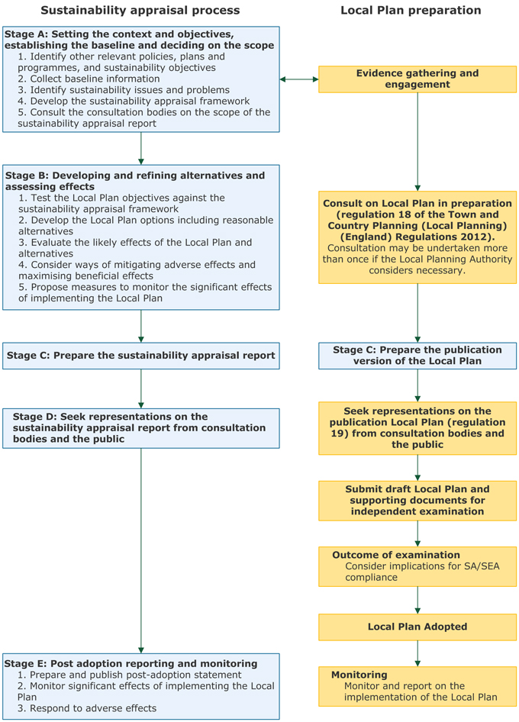

SA/SEA work completed ‘in house’ via the IIA Scoping Report. This was consulted upon at the Issues and Options stage. The winner of the tender will review this work for legal compliance

SA/SEA stages to be completed by winner of this tender via the outputs outlined in Section 6

including secondary, cumulative, synergistic, short, medium and long-term permanent and temporary, positive and negative effects

