**Framework Schedule 6 (Order Form Template and Call-Off Schedules)**

**Order Form**

CALL-OFF REFERENCE: 709474450.1

THE BUYER: Defence Infrastructure Organisation

BUYER ADDRESS Kentigern House

65 Brown Street

Glasgow

G2 8EX

THE SUPPLIER: Lambert Smith Hampton Group Limited

SUPPLIER ADDRESS: 55 Wells Street, London, W1T 3PT

REGISTRATION NUMBER: 2521225

DUNS NUMBER: 505733907

SID4GOV ID: N/A

APPLICABLE FRAMEWORK CONTRACT

This Order Form is for the provision of the Call-Off Deliverables and dated 19/12/23

It’s issued under the Framework Contract with the reference number RM6168 for the provision of Establishment Management Plans.

CALL-OFF LOT(S): Lot 4 Surveying and Strategic Advice

CALL-OFF INCORPORATED TERMS

The following documents are incorporated into this Call-Off Contract. Where numbers are missing we are not using those schedules. If the documents conflict, the following order of precedence applies:

1. This Order Form including the Call-Off Special Terms and Call-Off Special Schedules.
2. Joint Schedule 1(Definitions and Interpretation) **RM6168**
3. The following Schedules in equal order of precedence:

* Joint Schedules for RM6168
* Joint Schedule 2 (Variation Form)
* Joint Schedule 3 (Insurance Requirements)
* Joint Schedule 4 (Commercially Sensitive Information)
* Joint Schedule 6 (Key Subcontractors)
* Joint Schedule 7 (Financial Difficulties)
* Joint Schedule 9 (Minimum Standards of Reliability)
* Joint Schedule 10 (Rectification Plan)
* Joint Schedule 11 (Processing Data)
* Joint Schedule 12 (Supply Chain Visibility)
* Call-Off Schedules for RM6168
* Order Form- Template-Short-Form
* Call-Off Schedule 1 (Transparency Reports)
* Call-Off Schedule 2 (Staff Transfer)
* Call-Off Schedule 3 (Continuous Improvement)
* Call-Off Schedule 4 (Call Off tender (V3.1)
* Call-Off Schedule 5 (Pricing Details)
* Call-Off Schedule 6 (ICT Services)
* Call-Off Schedule 7 (Key Supplier Staff)
* Call-Off Schedule 8 (Business Continuity and Disaster Recovery)]
* Call-Off Schedule 9 (Security)
* Call-Off Schedule 10 (Exit Management)
* Call-Off Schedule 12 (Clustering)
* Call-Off Schedule 13 (Implementation Plan and Testing)
* Call-Off Schedule 14 (Service Levels)
* Call-Off Schedule 15 (Call-Off Contract Management)
* Call-Off Schedule 16 (Benchmarking
* Call-Off Schedule 17 (MOD Terms)
* Call-Off Schedule 20 (Call-Off Specification)

1. CCS Core Terms (version 3.0.10)
2. Joint Schedule 5 (Corporate Social Responsibility) **RM6168**
3. Call-Off Schedule 4 (Call-Off Tender) as long as any parts of the Call-Off Tender that offer a better commercial position for the Buyer (as decided by the Buyer) take precedence over the documents above.

No other Supplier terms are part of the Call-Off Contract. That includes any terms written on the back of, added to this Order Form, or presented at the time of delivery.

CALL-OFF SPECIAL TERMS

The following Special Terms are incorporated into this Call-Off Contract:

None

CALL-OFF START DATE: 15/01/24

CALL-OFF EXPIRY DATE: 31/12/25

CALL-OFF INITIAL PERIOD: 2 Years

CALL-OFF DELIVERABLES

Option A:

The milestones are detailed in ‘DIO EMP_A1 Service Delivery Mobilisation_Lot 1 (1)’ Dated November 2023 & ‘20230822_Attachment_3_EMP_SOR_V1.0_O (002)’ Dated 6th September 2023

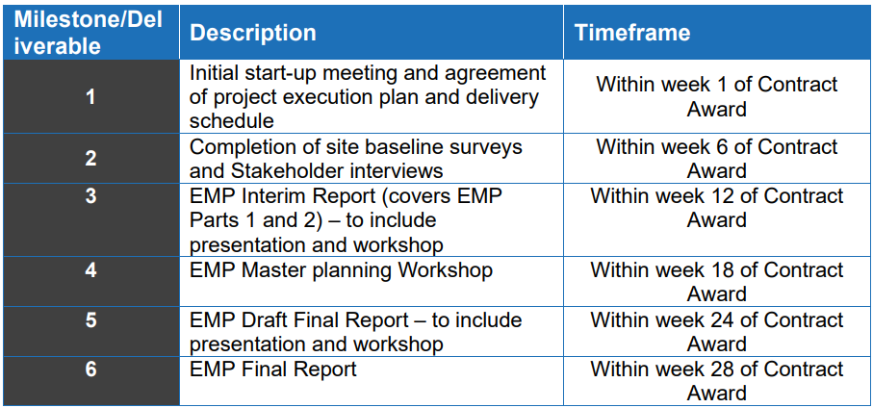

MAXIMUM LIABILITY

The limitation of liability for this Call-Off Contract is stated in Clause 11.2 of the Core Terms.

The Estimated Year 1 Charges used to calculate liability in the first Contract Year is

**£1,200,000.00 Ex VAT**

CALL-OFF CHARGES

Option A:

The call off charges for the contract are contained within ‘LSH_FINAL_Attachment_4_Pricing_Schedule_Lot 1_O V2 (1)’

***Redacted***

**TOTAL CALL OFF CONTRACT VALUE – £2,400,000.00 Ex VAT (Limit of Liability)**

The Charges will not be impacted by any change to the Framework Prices. The Charges can only be changed by agreement in writing between the Buyer and the Supplier because of:

* Indexation
* Specific Change in Law
* Benchmarking using Call-Off Schedule 16 (Benchmarking)

REIMBURSABLE EXPENSES

None (To be Agreed Outside of the Framework)

PAYMENT METHOD

CP&F via Exostar

BUYER’S INVOICE ADDRESS:

***Redacted***

***Redacted***

***Redacted***

BUYER’S AUTHORISED REPRESENTATIVE

***Redacted***

***Redacted***

***Redacted***

***Redacted***

BUYER’S ENVIRONMENTAL POLICY

[Management of environmental protection in defence (JSP 418) - GOV.UK (www.gov.uk)](https://www.gov.uk/government/publications/jsp-418-mod-corporate-environmental-protection-manual)

BUYER’S SECURITY POLICY

[Security policy framework: protecting government assets - GOV.UK (www.gov.uk)](https://www.gov.uk/government/publications/security-policy-framework)

SUPPLIER’S AUTHORISED REPRESENTATIVE

***Redacted***

***Redacted***

***Redacted***

Lambert Smith Hampton

Interchange Place

Edmund Street

Birmingham

B3 2TA

SUPPLIER’S CONTRACT MANAGER

As above

PROGRESS REPORT FREQUENCY

**Insert report frequency:** On the first Working Day of each calendar month

PROGRESS MEETING FREQUENCY

**Insert meeting frequency:** Quarterly on the first Working Day of each quarter

KEY STAFF

***Redacted***

***Redacted***

***Redacted***

Lambert Smith Hampton

55 Wells Street

London

W1T 3PT

KEY SUBCONTRACTOR(S)

Arup

IDEA

COMMERCIALLY SENSITIVE INFORMATION

Not applicable

SERVICE CREDITS

Not applicable

ADDITIONAL INSURANCES

Not applicable

GUARANTEE

Not applicable

SOCIAL VALUE COMMITMENT

The Supplier agrees, in providing the Deliverables and performing its obligations under the Call-Off Contract, that it will comply with the social value commitments in Call-Off Schedule 4 (Call-Off Tender)]

|  |  |  |  |
| --- | --- | --- | --- |
| **For and on behalf of the Supplier:** | | **For and on behalf of the Buyer:** | |
| Signature: | ***Redacted*** | Signature: | ***Redacted*** |
| Name: | ***Redacted*** | Name: | ***Redacted*** |
| Role: | ***Redacted*** | Role: | ***Redacted*** |
| Date: | 11.01.2024 | Date: | 12th January 2024 |