

www.gov.uk/naturalengland

Request for Quotation

Thermal Drone Surveys of landscape within Sussex Woods Protected Site Strategy Pilot Area. REF PSS.SW.C10.23

You are invited to submit a quotation for the requirement described in the specification, Section 2. Please confirm by email, receipt of these documents and whether you intend to submit a quote or not. Your response should be returned to the following email address by:

Email: Robert.hall@naturalengland.org.uk
Date: 24th July 2023
Time: 5pm

Ensure you include the name of the quotation and ‘Final Submission’ in the subject field to make it clear that it is your response

Contact Details and Timetable
Robert Hall will be your contact for any questions linked to the content of the quote or the process. Please submit any clarification questions via email and note that, unless commercially sensitive, both the question and the response will be circulated to all tenderers.

Action | Date
Date of issue of RFQ | 28-06-2023 at 17:00 GMT
Deadline for clarifications questions | 17-07-2023 at [17:00 GMT
Deadline for receipt of Quotation | 24-07-2023 at 17.00 hrs GMT
Intended date of Contract Award | 31-07-2023
Intended Contract Start Date | 01-08-2023
Intended Delivery Date / Contract Duration | 01-08-2023 to 31-07-2024

Section 1: General Information
Glossary
Unless the context otherwise requires, the following words and expressions used within this Request for Quotation shall have the following meanings (to be interpreted in the singular or plural as the context requires):
“Authority” | means Natural England who is the Contracting Authority.
“Contract” | means the contract to be entered into by the Authority and the successful supplier.
“Response” | means the information submitted by a supplier in response to the RFQ.
“RFQ” | means this Request for Quotation and all related documents published by the Authority and made available to suppliers.

Acceptance of Quotations
By issuing this RFQ the Authority does not bind itself to accept any quotation and reserves the right not to award a contract to any supplier who submits a quotation.

Costs
The Authority will not reimburse you for any costs and expenses which you incur preparing and submitting your quotation, even if the Authority amends or terminates the procurement process.

Self-Declaration and Mandatory Requirements
The RFQ includes a self-declaration response (Annex 1) which covers basic information about the supplier, as well as any grounds for exclusion. If you do not comply with them, your quotation will not be evaluated.
Any mandatory requirements will be set out in Section 2, Specification of Requirements and, if you do not comply with them, your quotation will not be evaluated

Clarifications
Any request for clarification regarding the RFQ and supporting documentation must be submitted via email no later than the deadline for clarifications set out in the Timetable. The Authority shall be under no obligation to respond to queries raised after the clarification deadline.

The Authority will respond to all reasonable clarifications as soon as possible but cannot guarantee a minimum response time. The Authority will publish all clarifications and its responses to all suppliers via email unless deemed commercially sensitive.
If a supplier believes that a request for clarification is commercially sensitive, it should clearly state this when submitting the clarification request. However, if the Authority considers either that:
- the clarification and response are not commercially sensitive; and
- all suppliers may benefit from its disclosure,

then the Authority will notify the supplier (via email), and the supplier will have an opportunity to withdraw the request for clarification by sending a further message requesting the withdrawal of the clarification request. If not withdrawn by the supplier within 2 working days of the Authority’s notification, the Authority may publish the clarification request and its response to all suppliers and the Authority shall not be liable to the supplier for any consequences of such publication.
The Authority reserves the right to seek clarification of any aspect of a quotation and/or provide additional information during the evaluation phase to carry out a fair evaluation. Where the Authority seeks clarification on any aspect of the quotation, the supplier must respond within the timeframe requested by the Authority.

Amendments
The Authority may amend the RFQ at any time prior to the deadline for receipt. If it amends the RFQ the Authority will notify you via email. Suppliers may modify their quotation prior to the deadline for Responses. No Responses may be modified after the deadline for Responses.
Suppliers may withdraw their quotations at any time by submitting a notice via the email to the named contact.

Conditions of Contract
The Authority’s standard Contractual terms and conditions provided as part of the RFQ will be included in any contract awarded as a result of this quotation process. The Authority will not accept any changes to these terms and conditions proposed by a supplier.
Suppliers should note that the quotation provided by the successful bidder will form part of the Contract.

Prices
Prices must be submitted in £ sterling, INCLUSIVE of VAT

Disclosure
All Central Government Departments, their Executive Agencies and Non Departmental Public Bodies are subject to control and reporting within Government. In particular, they report to the Cabinet Office and HM Treasury for all expenditure. Further the Cabinet Office has a cross-Government role delivering overall Government policy on public procurement, including ensuring value for money and related aspects of good procurement practice. For these purposes, the Authority may disclose within Government any details contained in your quotation. The information will not be disclosed outside Government during the procurement.
In addition, the Authority is subject to the Freedom of Information Act 2000 and the Environmental Information Regulations 2004, which provide a public right of access to information held by public bodies. In accordance with these two statutes, the Authority may be required to disclose information contained in your quotation to any person who submits a request for information pursuant to those statutes.
Further to the Government’s transparency agenda, all UK Government organisations must advertise on Contract Finder in accordance with the following publication thresholds:

- Central Contracting Authority’s: £12,000
- Sub Central Contracting Authority’s and NHS Trusts: £30,000
- For the purpose of this RFQ the Authority is classified as a 'Central Contracting Authority' with a publication threshold of '£12,000' inclusive of VAT.
- If this opportunity is advertised via Contracts Finder, we are obliged to publish details of the awarded contract including who has won the contract, the contract value, and indicate whether the winning supplier is a small and medium-sized enterprise (“SMEs”) or voluntary organisation or charity. A copy of the contract must also be published with confidential information redacted.
- By submitting a Response, you consent to these terms as part of the procurement.
Disclaimers
Whilst the information in this RFQ and any supporting information referred to herein or provided to you by the Authority have been prepared in good faith the Authority does not warrant that this information is comprehensive or that it has been independently verified.

The Authority does not:
- make any representation or warranty (express or implied) as to the accuracy, reasonableness or completeness of the RFQ;
- accept any liability for the information contained in the RFQ or for the fairness, accuracy or completeness of that information; or
- accept any liability for any loss or damage (other than in respect of fraudulent misrepresentation or any other liability which cannot lawfully be excluded) arising as a result of reliance on such information or any subsequent communication.
Any supplier considering entering into contractual relationships with the Authority following receipt of the RFQ should make its own investigations and independent assessment of the Authority and its requirements for the goods and/or services and should seek its own professional financial and legal advice.

Protection of Personal Data
In order to comply with the General Data Protection Regulations 2018 the supplier must agree to the following:

You must only process any personal data in strict accordance with instructions from the Authority.
- You must ensure that all the personal data that we disclose to you or you collect on our behalf under this agreement are kept confidential.
- You must take reasonable steps to ensure the reliability of employees who have access to personal data.
- Only employees who may be required to assist in meeting the obligations under this agreement may have access to the personal data.
- Any disclosure of personal data must be made in confidence and extend only so far as that which is specifically necessary for the purposes of this agreement.
- You must ensure that there are appropriate security measures in place to safeguard against any unauthorised access or unlawful processing or accidental loss, destruction or damage or disclosure of the personal data.
- On termination of this agreement, for whatever reason, the personal data must be returned to us promptly and safely, together with all copies in your possession or control.
- General Data Protection Regulations 2018
- For the purposes of the Regulations the Authority is the data processor.
- The personal information that we have asked you provide on individuals (data subjects) that will be working for you on this contract will be used in compiling the tender list and in assessing your offer. If you are unsuccessful the information will be held and destroyed within two years of the award of contracts. If you are awarded a contract it will be retained for the duration of the contract and destroyed within seven years of the contract’s expiry.
- We may monitor the performance of the individuals during the execution of the contract, and the results of our monitoring, together with the information that you have provided, will be used in determining what work is allocated under the contract, and in any renewal of the contract or in the award of future contracts of a similar nature. The information will not be disclosed to anyone outside the Authority without the consent of the data subject, unless the Authority is required by law to make such disclosures.

Equality, Diversity & Inclusion (EDI)

- The Client is striving to create a diverse and inclusive working environment where every individual has equality of opportunity to progress and to apply their unique insights to making the UK a great place for living. The Service Provider is expected to respect this commitment in all dealings with Natural England staff and service users.

Suppliers are expected to;

- support Defra group to achieve its Public Sector Equality Duty as defined by the Equality Act 2010, and to support delivery of Defra group’s Equality & Diversity Strategy
- meet the standards set out in the Government’s Supplier Code of Conduct
- work with Defra group to ensure equality, diversity and inclusion impacts are addressed (positive and negative) in the goods, services and works we procure, barriers are removed and opportunities realised.

Sustainable Procurement
Addressing global sustainability impacts and realising additional community benefits within commercial activity is core to Defra group’s approach, working with its supply chain is key to achieving sustainable outcomes. In addition to supporting Defra group to meet its outcomes we look to understand and reduce negative sustainability impacts associated with our commercial activity and realise benefits.The Client encourages its suppliers to share these values, work to address negative impacts and realise opportunities, measure performance and success.
Suppliers are expected to have an understanding of the Sustainable Development Goals, the interconnections between them and the relevance to the Goods, Services and works procured on the Client’s behalf

Conflicts of Interest
The concept of a conflict of interest includes but is not limited to any situation where an Involved Person or Relevant Body has directly or indirectly, a financial, economic or other personal interest which might be perceived to compromise their impartiality and independence in the context of the procurement procedure and/or affect the integrity of the contract award.
We expect suppliers to mitigate appropriately against any real or perceived conflict of interest through their work with government. A supplier with a position of influence gained through a contract should not use that position to unfairly disadvantage any other supplier or reduce the potential for future competition
Where the supplier is aware of any circumstances giving rise to a conflict of interest or has any indication that a conflict of interest exists or may arise you should inform the Authority of this as soon as possible (whether before or after they have submitted a quotation). Tenderers should remain alert to the possibility of conflicts of interest arising at all stages of the procurement and should update the Authority if any new circumstances or information arises, or there are any changes to information already provided to the Authority. Failure to do so, and/or to properly manage any conflicts of interest may result in a quotation being rejected.
Provided that it has been carried out in an open, fair and transparent manner, routine pre-market engagement carried out by the Authority should not represent a conflict of interest for the supplier.

Section 2: The Invitation
The aim of this contract is to undertake landscape thermal drone surveys of fallow deer within three adjoining Deer Management Areas (DMA) within the pilot area (west / central / east). These areas together comprise approximately 31,250 ha of woodland and farmland. Natural England recognise that full coverage of the pilot area is likely impractical or impossible, so the objective is to survey as much of the area as possible. This will require surveying over consecutive nights.

Refer to annex 2-4 for plans showing overall pilot area and individual DMAs. GIS Shapefiles for these boundaries can be provided on request.

The results will allow Natural England to monitor population trends within the local fallow deer population (of Western Downs) and review these alongside deer cull data and deer impact assessments

Payment
The Authority will raise purchase orders to cover the cost of the services and will issue to the awarded supplier following contract award.

The Authority’s preference is for all invoices to be sent electronically, quoting a valid Purchase Order number. Suppliers can invoice after key milestones (for example after completion of individual DMAs) or after all the work has been completed.

It is anticipated that this contract will be awarded for a period of 12 months to end no later than July 31st 2024. Prices will remain fixed for the duration of the contract award period. We may at our sole discretion extend this contract to include related or further work. Any extension shall be agreed in writing in advance of any work commencing and may be subject to further competition.

Evaluation Methodology
Since there is no established methodology for landscape scale drone surveys of fallow deer populations, please provide a detailed methodology of how you would propose to carry out the work. This must clearly demonstrate how your methodology will ensure maximum coverage of each DMA (target approx. 90 %) whilst adhering to Civil Aviation Authority guidelines. This may involve fixed point flights or transects or a combination of the two.
The contractor must carry out pre-survey reconnaissance of the pilot area to confirm suitable locations for drone launches / survey sampling areas. A map showing the proposed survey areas / routes must be provided to Natural England for comment prior to surveying. Indicative mapped routes can be provided as part of the tender process, but it is at the discretion of the contractor
Access to land & landowner permissions
Natural England will be responsible for obtaining landowner permission for each landholding to be included within the survey. Natural England will provide the contractor with an excel schedule identifying all landowners that have consented to be included within the survey, and for the contractor to contact them directly. This schedule will include a contact phone number & email for each landowner / agent. The contractor will then be responsible for contacting landowners to arrange site visits and to agree survey access routes and dates / times.
The contractor must adhere to the General Data Protection Regulations 2018 for handling of any personal data. (Refer to section on Protection of Personal Data)
The contractor must not access any ground without agreed landowner permission. Any refusals or other issues should be notified to the pilot co-ordinator since this may affect overall survey coverage. Please note that the proposed survey area / route may need to be modified where permission cannot be granted. The Western DMA also includes part of the Goodwood Airport no fly zone – the contractor will therefore need to apply for permission to fly over this area following the drone flight approvals process on their website.
Natural England will provide the contractor with the following information to enable them to carry out the surveys:
- Landscape scale plans for each Deer Management Area (DMA) identifying which landowners / landholdings that have consented to being included within the drone surveys.
- Excel spreadsheet with contact details for landowner consented to be in survey
- An anonymised ESRI shapefile showing Rural Land Registry (RLR) landholdings within each DMA. Please note this is a restricted dataset and will require the contractor to sign a separate license agreement before receipt of data.
- A separate ESRI shapefile identifying landowner / farm names (consented to be included with the survey) that can be cross referenced to RLR landholding shapefile

Additional requirements
- Surveys should aim to maximise coverage across each DMA to cover as large a representative sample as possible. A clear methodology demonstrating how this coverage will be achieved should be included within the tender – this includes adhering to CAA legal requirements around survey zones.
- Surveys should also include an estimate of sex ratio of deer for each DMA – this may require additional survey effort during the day.
- Surveys to be carried out on consecutive nights where weather allows to reduce the likelihood of double counting.
- Surveys to be carried out between January and March when fallow are most visible unless agreed otherwise with NE staff (for example East DMA is seasonally wet)
- Contractor should be aware of and sensitive to PROW users (where accessing shared tracks such as South Downs Way) and to livestock present within survey area.
- Record the date, start and finish times, and weather conditions for each survey visit.

Analysis and Reporting
The outputs, unless agreed otherwise in writing by the Pilot Co-ordinator, will be as detailed in this section
Reporting and presentation of data
- A report will be produced to include introduction, methods and results together with maps showing the locations of survey areas and individual deer records, and an estimate of sex ratio. Natural England intend to repeat the survey in early 2025 so the survey methodology must be repeatable so that multiple samples of the pilot area can be obtained

- Locations of deer records to be provided in a GIS file compatible with ArcMap.

- Deer totals and densities (km2) for flight / survey locations should be provided in an excel spreadsheet.

- Overall Deer population and density estimates should be recorded for the total pilot area. For example, if total pilot area is 20,000ha and 1500 no. deer are recorded on 50% of survey area, then the estimated average deer density would be:

- 10,000ha = 100km2
- 1500 deer / 100km2 = 15 deer / km2

And estimated population across pilot area would be:

- 1500 deer on 50% pilot
- 1500 x 2 = 3000 total estimate of deer

Maps
The following maps should be provided:

- Map demonstrating area of survey coverage within each DMA – this should identify proposed location of drone flights / survey transects
- Maps showing location / distribution of deer records for each flight / transect
- Maps showing location / distribution of deer records at landscape scale – pilot area can be broken into multiple tiles.
- Heat map showing location / distribution of deer records at landscape scale – this will be used as an anonymised / aggregated map for sharing with stakeholders.

A copy of maps should be provided in jpg or pdf format and as GIS layers, in or compatible with ESRI ArcGIS format. Information and guidance on requesting baseline digital geographical data from Natural England can be found on our website at Geographical Information for contractors and partners.
Health & Safety / Known Hazards
Risks associated with field-based work need to be considered especially since this work is likely to involve surveying during night hours. It is the contractor’s responsibility to check all survey routes, access, landing/take off points, op height and flying hazards, no-fly areas prior to surveying. Please provide a clear and structured proposal to demonstrate your intended approach to health and safety on this project and how you ensure the requirements of legislation are met. The Health and Safety at Work Act 1974 is to be fully complied with at all times.

The risk assessment must also include a section on Covid-19. If Covid-19 advice changes and affect the work as part of this contract, the successful contractor must inform the project manager within two working days and provide an updated risk assessment within five working days.

Your quotation for the work should be accompanied by the following Health and Safety documentation required by Natural England:

- Risk assessment: this must take any identified hazards into account.
- CAA-approved drone training certification (or similar)
- Employers Liability Compulsory Insurance
- Public Liability Insurance –provide description of level taken out
- Professional Indemnity Insurance –provide description of level taken out
Work shall not commence without Natural England being in possession of appropriate documentation and an agreed safe method of working.

Drone Operator Requirements
- Contractors must have Legally and CAA compliant drone with thermal camera and sufficient optical and digital zoom capability.
- Operator Qualifications and licences – A2 CofC and GVC certification, commercial insurance, experience flying in all weather conditions and at night is essential.
- Drone operators must adhere to Civil aviation regulations notably the requirement for the drone to be flown within the Visual Line of Sight (VLOS).
- Airspace restrictions and hazards should be identified, and Air Traffic Control notified of intention to fly (if required).

Pricing

The tenderer should demonstrate how they will cover the survey area and how the visits will be organised in terms of personnel and timescales.

Day rates and numbers of days for key staff should be provided. Costs should be broken down to show the time allocated to each part of the project.

Please itemise other costs including material / equipment costs.

Please detail any assumptions made when pricing for any aspects of this tender.
Please provide a separate rate for daytime flights for identifying the sex ratio of deer
It is anticipated that this contract will be repeated in June 2024 subject to funding. Prices will remain fixed for the duration of the contract award period. We may at our sole discretion extend this contract to include related or further work. Any extension shall be agreed in advance of any work commencing and may be subject to further competition

We will award this contract in line with the most economically advantageous tender (MEAT) as set out in the following award criteria:

Technical – 60%
Commercial – 40%

Evaluation criteria
Evaluation weightings are 60% technical and 40% commercial, the winning tenderer will be the highest scoring combined score
Award Criteria | Weighting (%) | Evaluation Topic & Weighting | Sub-Criteria | Weighted Question
Technical | 60% | Service / Product Proposal | Methodology | 2 Questions  Q1.1 Experience of carrying out comparable (landscape scale & multiple landowners) drone surveys outlined in this specification (25% of the technical score available)  Q1.2 Analysis, presentation and reporting of data generated from surveys (10% of the technical score available)
Technical | 60% | Service / Product Proposal | Key personnel | 1 Question  Q2 Qualifications, technical merit and experience of key staff engaged on the contract and any comparable projects, e.g. CVs and technical qualifications (10% of the technical score available)
Technical | 60% | Service / Product Proposal | Quality Assurance measures | 2 Questions  Q3.1 Include details of how the survey area will be covered and how the visits will be organised and how sufficient coverage of the area will be achieved (20% of the technical score available)  Q3.2 Include a proposed outline schedule or timetable of works explaining how you will achieve maximum accuracy for surveying over multiple days (20% of technical score available)
Technical | 60% | Service / Product Proposal | Management of sustainability and social value | 1 Question  Q4 (5% of technical score available)
Technical | 60% | Service / Product Proposal | Health & Safety | 1 Question  Q5 Provide detailed Risk Assessment for both day and night working and details of insurances (10% of the technical score available)
Commercial | 40% | Whole life cost of the proposed Contract | Commercial Model | 1 Question  Q4 (100% of commercial score available)

Technical (60%)
Technical evaluations will be based on responses to specific questions covering key criteria which are outlined below. Scores for questions will be based on the following:

Description | Score | Definition
Very good | 100 | Addresses all the Authority’s requirements with all the relevant supporting information set out in the RFQ. There are no weaknesses and therefore the tender response gives the Authority complete confidence that all the requirements will be met to a high standard.
Good | 70 | Addresses all the Authority’s requirements with all the relevant supporting information set out in the RFQ. The response contains minor weaknesses and therefore the tender response gives the Authority confidence that all the requirements will be met to a good standard.
Moderate | 50 | Addresses most of the requirements with most of the relevant supporting information set out in the RFQ. The response contains moderate weaknesses and therefore the tender response gives the Authority confidence that most of the requirements will be met to a suitable standard.
Weak | 20 | Substantially addresses the requirements but not all and provides supporting information that is of limited or no relevance or a methodology containing significant weaknesses and therefore raises concerns for the Authority that the requirements may not all be met.
Unacceptable | 0 | No response or provides a response that gives the Authority no confidence that the requirement will be met.

Technical evaluation is assessed using the evaluation topics and sub-criteria stated in the Evaluation Criteria section above.

Separate submissions for each technical question should be provided and will be evaluated in isolation. Tenderers should provide answers that meet the criteria of each technical question.

Methodology | Detailed Evaluation Criteria
Q1.1 | Experience of carrying out drone surveys outlined in this specification
Q1.2 | Analysis, presentation and reporting of data generated from surveys

Personnel | Detailed Evaluation Criteria
Q2.1 | Qualifications, technical merit and experience of key staff engaged on the contract, e.g. CVs and technical qualifications

Quality Assurance | Detailed Evaluation Criteria
Q3.1 | Include details of how the survey area will be covered and how the visits will be organised and how sufficient coverage of the area will be achieved
Q3.2 | Include a proposed outline schedule or timetable of works explaining how you will achieve maximum accuracy for surveying over multiple days

Health & Safety | Detailed Evaluation Criteria
Q5.1 | Provide detailed Risk Assessment for both day and night working and details of insurances

Commercial (40%)
The Contract is to be awarded as a 'fixed price' which will be paid according to the completion of the deliverables stated in the Specification of Requirements.
Suppliers are required to submit a total cost to provide the deliverables stated in the Specification of Requirements. In addition to this the Commercial Response template must be completed to provide a breakdown of the whole life costs against [Choose as appropriate 'each deliverable' / or 'objective/key personnel'] used in the delivery of this requirement.

Calculation Method

The method for calculating the weighted scores is as follows:
- Commercial
Score = (Lowest Quotation Price / Supplier’s Quotation Price ) x [40%] (Maximum available marks)
- Technical
Score = (Bidder’s Total Technical Score / Highest Technical Score) x [60%] (Maximum available marks)

The total score (weighted) (TWS) is then calculated by adding the total weighted commercial score (WC) to the total weighted technical score (WT): WC + WT = TWS.

Information to be returned
Please note, the following information requested must be provided. Incomplete tender submissions may be discounted.

Please complete and return the following information:
- completed Commercial Response template
- separate response submission for each technical question (in accordance with the response instructions)
- completed Mandatory Requirements (Annex 1)
- completed Acceptance of Terms and Conditions (Annex 2)
- Award
- Once the evaluation of the Response(s) is complete all suppliers will be notified of the outcome via email.
- 'The successful supplier will be issued the contract, incorporating their Response, for signature. The Authority will then counter sign'.
- Annex 1 Mandatory Requirements
- Part 1 Potential Supplier Information
- Please answer the following self-declaration questions in full and include this Annex in your quotation response.

Annexes

Annex 1: completed Mandatory Requirements
Annex 2: completed Acceptance of Terms and Conditions
Annex 3: Map showing Sussex Woods Pilot Area
Annex 4: Map showing Western DMA
Annex 5: Map showing Central & Eastern DMA
Annex 6: Acceptance of Terms and Conditions
Annex 1 Mandatory Requirements

Part 1.1 Potential Supplier Information:
Question no. | Question | Response
1.1(a) | Full name of the potential supplier submitting the information
1.1(b) | Registered office address (if applicable)
1.1(c) | Company registration number (if applicable)
1.1(d) | Charity registration number (if applicable)
1.1(e) | Head office DUNS number (if applicable)
1.1(f) | Registered VAT number
1.1(g) | Are you a Small, Medium or Micro Enterprise (SME)? | (Yes / No)

- Note: See EU definition of SME https://ec.europa.eu/growth/smes/business-friendly-environment/sme-definition_en

Part 1.2 Contact details and declaration

By submitting a quotation to this RFQ I declare that to the best of my knowledge the answers submitted and information contained in this document are correct and accurate.

I declare that, upon request and without delay you will provide the certificates or documentary evidence referred to in this document.

I understand that the information will be used in the selection process to assess my organisation’s suitability to be invited to participate further in this procurement.
I understand that the authority may reject this submission in its entirety if there is a failure to answer all the relevant questions fully, or if false/misleading information or content is provided in any section.

I am aware of the consequences of serious misrepresentation

Question no. | Question | Response
1.2(a) | Contact name
1.2(b) | Name of organisation
1.2(c) | Role in organisation
1.2(d) | Phone number
1.2(e) | E-mail address
1.2(f) | Postal address
1.2(g) | Signature (electronic is acceptable)
1.2(h) | Date

Part 2 Exclusion Grounds
Part 2.1 Grounds for mandatory exclusion

Question no. | Question | Response
2.1(a) | Please indicate if, within the past five years you, your organisation or any other person who has powers of representation, decision or control in the organisation been convicted anywhere in the world of any of the offences within the summary below.
 | Participation in a criminal organisation. | (Yes / No)  If yes please provide details at 2.1 (b)
 | Corruption. | ((Yes / No)  If yes please provide details at 2.1 (b)
 | Fraud. | (Yes / No)  If yes please provide details at 2.1 (b)
 | Terrorist offences or offences linked to terrorist activities | (Yes / No)  If yes please provide details at 2.1 (b)
 | Money laundering or terrorist financing | (Yes / No)  If yes please provide details at 2.1 (b)
 | Child labour and other forms of trafficking in human beings | (Yes / No)  If yes please provide details at 2.1 (b)
2.1(b) | If you have answered yes to question 2.1(a), please provide further details.  Date of conviction, specify which of the grounds listed the conviction was for, and the reasons for conviction.  Identity of who has been convicted  If the relevant documentation is available electronically please provide the web address, issuing authority, precise reference of the documents.
2.1 (c) | If you have answered Yes to any of the points above have measures been taken to demonstrate the reliability of the organisation despite the existence of a relevant ground for exclusion? (i.e. Self-Cleaning) | (Yes / No)
2.1(d) | Has it been established, for your organisation by a judicial or administrative decision having final and binding effect in accordance with the legal provisions of any part of the United Kingdom or the legal provisions of the country in which the organisation is established (if outside the UK), that the organisation is in breach of obligations related to the payment of tax or social security contributions? | (Yes / No)
2.1(e) | If you have answered yes to question 2.3(a), please provide further details. Please also confirm you have paid or have entered into a binding arrangement with a view to paying, the outstanding sum including where applicable any accrued interest and/or fines.

Part 2.2 Grounds for discretionary exclusion

Question no. | Question | Response
2.2(a) | The detailed grounds for discretionary exclusion of an organisation are set out on this webpage, which should be referred to before completing these questions.  Please indicate if, within the past three years, anywhere in the world any of the following situations have applied to you, your organisation or any other person who has powers of representation, decision or control in the organisation
2.2(b) | Breach of environmental obligations? | (Yes / No)  If yes please provide details at 2.2 (f)
2.2(c) | Breach of social obligations? | (Yes / No)  If yes please provide details at 2.2 (f)
2.2(d) | Breach of labour law obligations? | (Yes / No)  If yes please provide details at 2.2 (f)
2.2(e) | Shown significant or persistent deficiencies in the performance of a substantive requirement under a prior public contract, a prior contract with a contracting entity, or a prior concession contract, which led to early termination of that prior contract, damages or other comparable sanctions? | (Yes / No)  If yes please provide details at 2.2 (f)
2.2 (f) | If you have answered Yes to any of the above, explain what measures been taken to demonstrate the reliability of the organisation despite the existence of a relevant ground for exclusion? (Self Cleaning)

Annex 3. Sussex Woods PSS Pilot – Showing three DMAs within Drone Survey

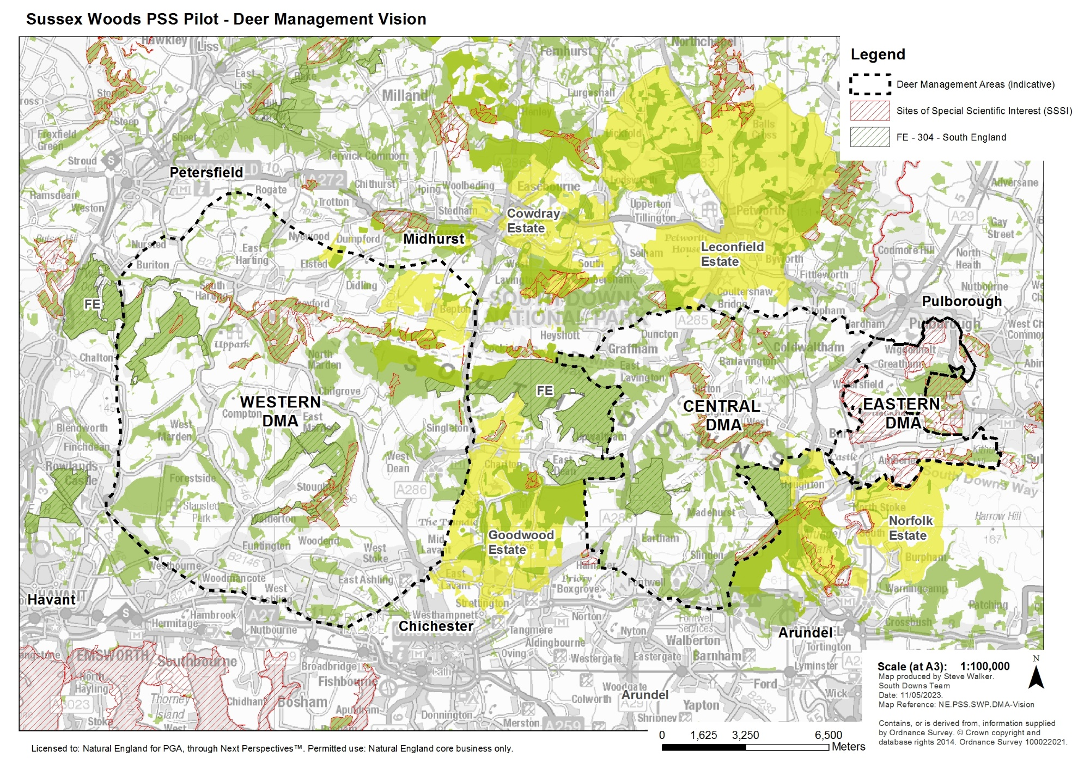

Annex 4. Sussex Woods PSS Pilot Area – Western DMA (approx. 18,000ha)

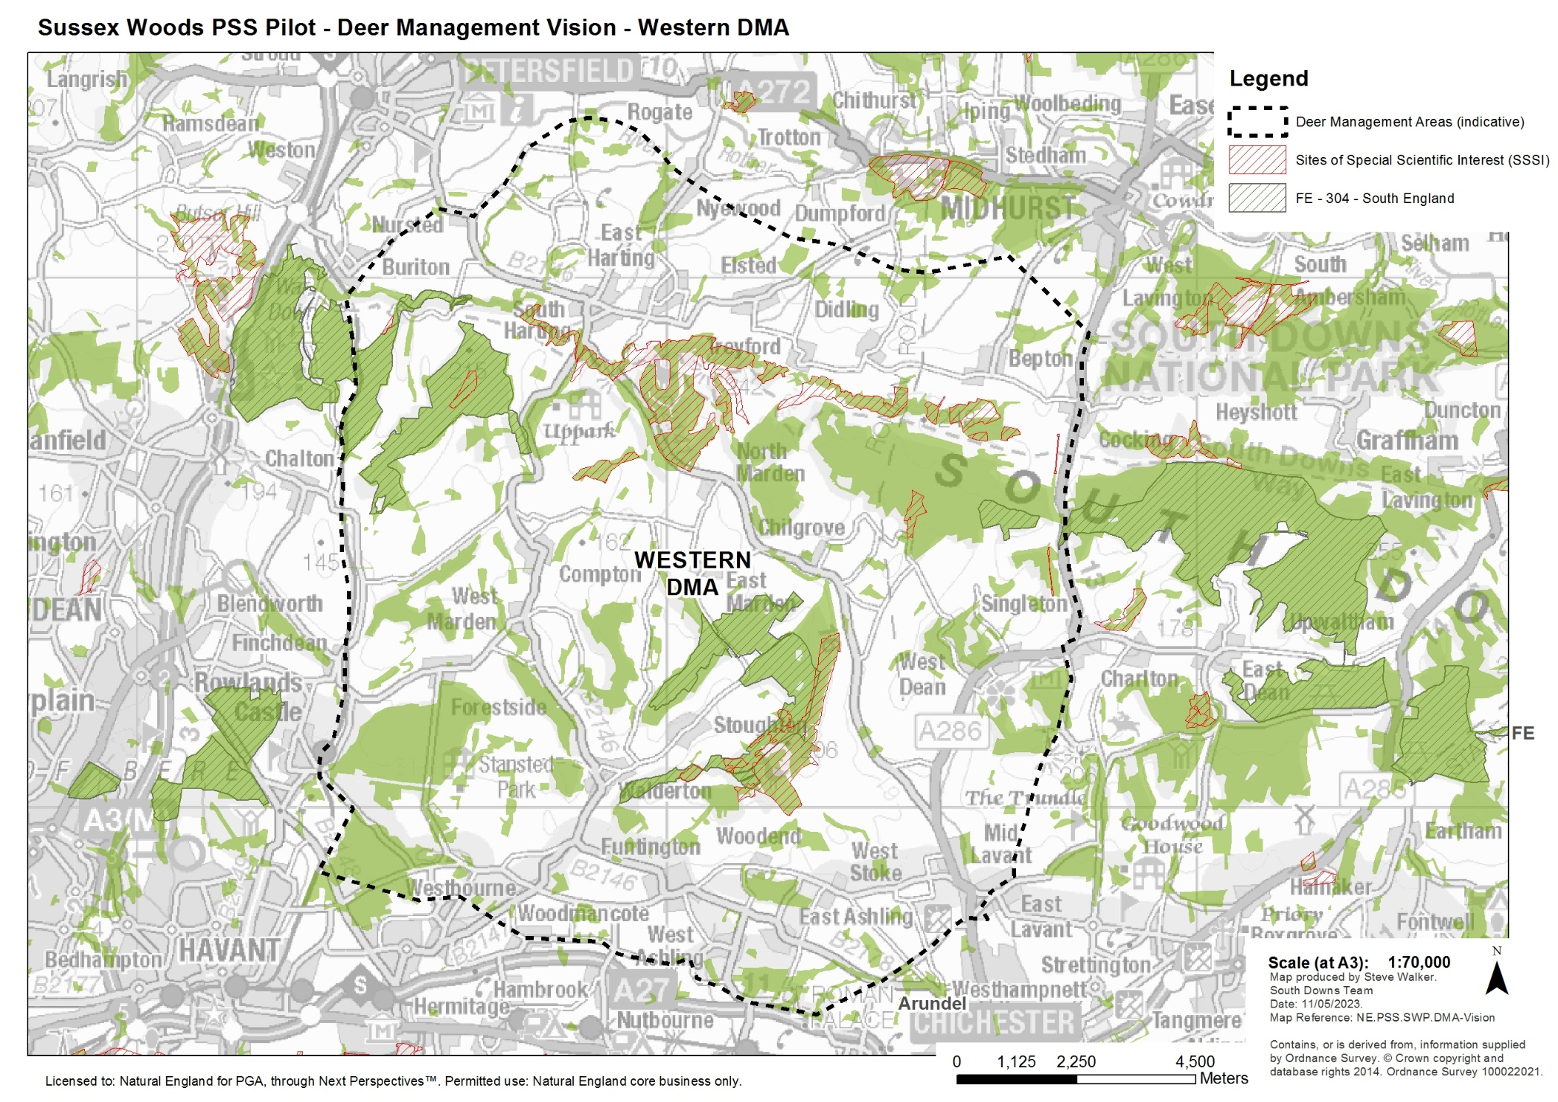

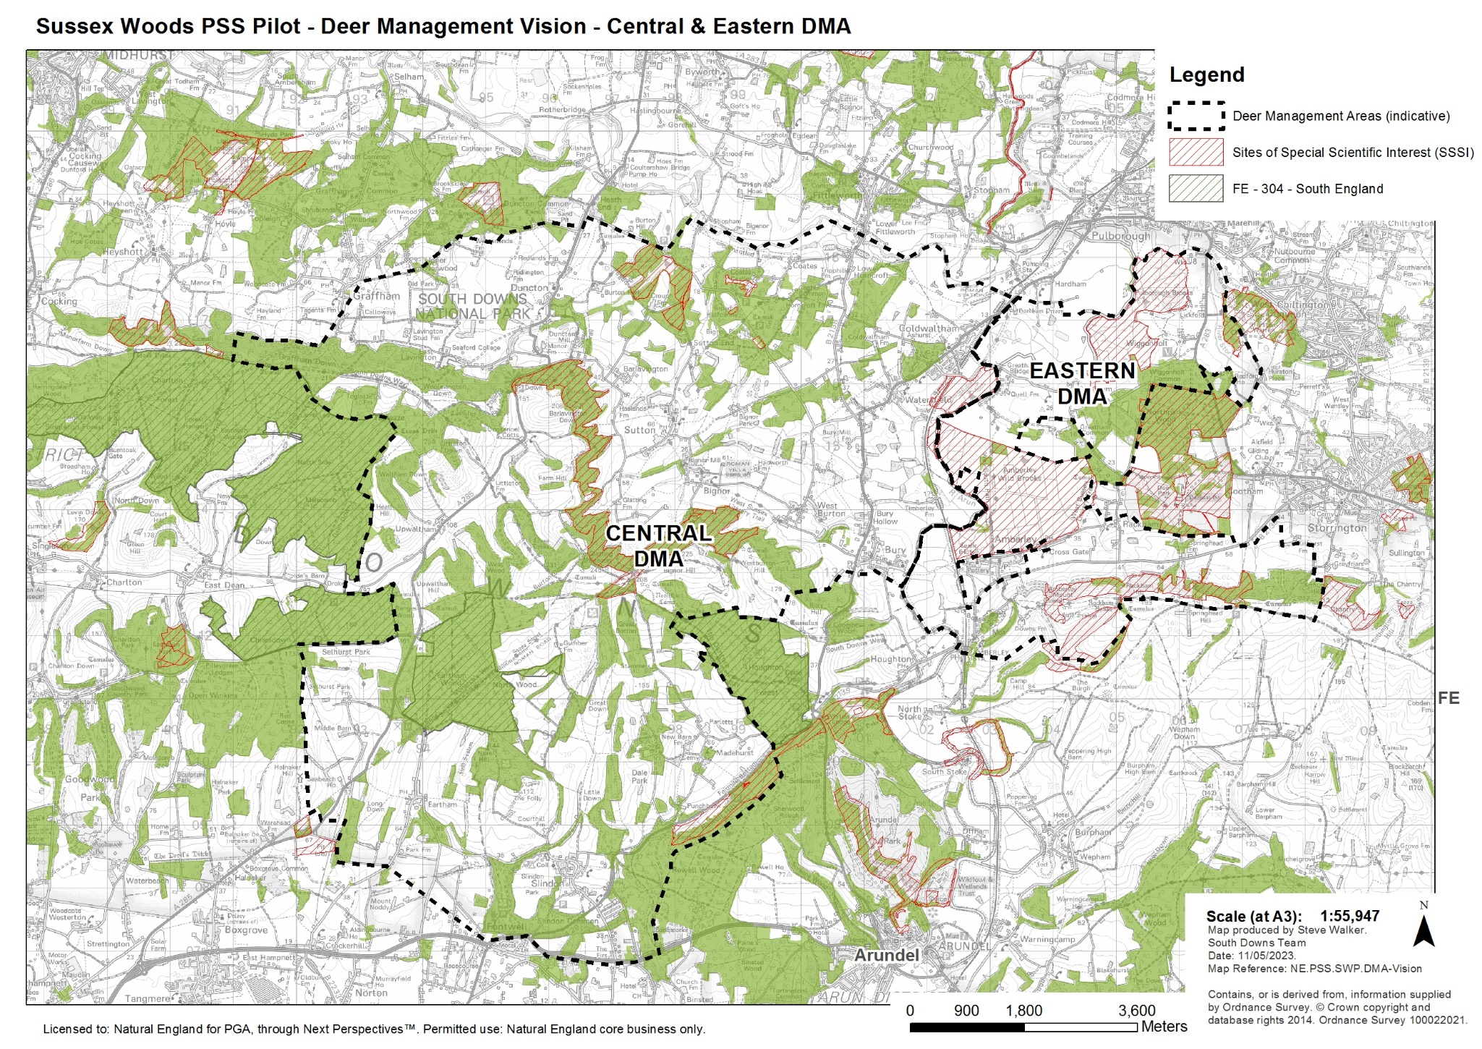
Annex 5. Sussex Woods PSS Pilot Area – Central DMA (approx. 11,000ha) & Eastern DMA (approx. 2,250ha)

Annex 2: Acceptance of Terms and Conditions
I/We accept in full the terms and conditions appended to this Request for Quote document.
Company ____________________________________________________
Signature ____________________________________________________
Print Name ____________________________________________________
Position ____________________________________________________
Date ____________________________________________________

