# LION GREEN GROUND MAINTENANCE SPECIFICATION Ref LG/1

**Note**

This specification must be read in conjunction with the Contract Procedure Rules.

**Contract requirements**

|  |  |
| --- | --- |
| **Grass cutting** | **No. of times per year** |
| Weekly grass cutting of Lion Green through the growing period (March-October) – except for the Wildflower Area (marked with green line and Lion Green Orchard (marked with a see map) | 28 |
| Strim areas along boundaries and around fixed obstacles through the growing period (March-October) | 22 |
| Edging of the footpaths and play area | 1 |
| Spiking the grass (Autumn/Winter) | 4 |

|  |  |
| --- | --- |
| **Grass cutting – WILDFLOWER AREA 2m strip from the stream** | **No. of times per year** |
| Grass cutting of wildflower area (adjacent to the stream and marked with a green line) and arisings to be collected and taken off the wildflower area (first cut in May, second cut mid/end August) [1] | 2 |

|  |  |
| --- | --- |
| **Grass cutting – LION GREEN ORCHARD** | **No. of times per year** |
| A mower’s width of weekly grass cutting and collection of arisings through the growing period (March-October) along it’s four perimeter edges and a vertical path through the middle (either to the right or left of the tree in the middle) | 28 |
| Grass cutting of entire orchard and arisings to be collected and taken off the orchard area (first cut in May, second cut end August) | 2 |

|  |  |
| --- | --- |
| **Tree management** | **No. of times per year** |
| Raising the crowns of all trees on Lion Green and removal of epicormic growth | As needed |

|  |  |
| --- | --- |
| **Leaf Clearance** | **No. of times per year** |
| Clearance of leaves from Lion Green during Autumn fall (to include the road from Lion Lane to the Apple Tree) | 16 |

|  |  |
| --- | --- |
| **Stream between Lion Green and Weysprings** | **No. of times per year** |
| Clearing of culvert | 4 |
| Clearance of entire stream | 1 |

|  |  |
| --- | --- |
| **Hedge cutting** | **No. of times per year** |
| To cut hedge line along path from Esso garage to Shottermill Primary school | 2 |

**General Conditions**

1. **Grass Cutting**
2. The contractor shall maintain the grass between 50 mm and 75 mm throughout the Contract period leaving no uncut grass between passes and no tufts or bents shall be left standing above the general sward area on completion of cut.
3. The Contractor should recognise that it may be necessary to employ more than one type of machinery on a site in order to achieve this standard.
4. Grass shall not be cut when ground conditions are so wet that damage to the surface occurs.
5. Certain areas are planted with naturalising bulbs and corms and these areas shall be left uncut until the plant leaves have died back.
6. Mowing shall be carried out as close to fixed structures as possible. Moveable obstructions shall be removed to facilitate cutting and replaced afterwards.
7. The Contractor shall be required to maintain the grass along boundaries and around fixed obstacles such as posts, furniture and rubbish bins to the same standard as the main grass areas. This shall be achieved by use of edging shears or strimmer. The Contractor shall ensure that adequate care and attention is paid so as to prevent damage to the fixed objects.
8. **Autumn Leaf Fall**
9. Following the end of the autumn leaf fall, the Contractor shall clear and dispose of all fallen leaves on Lion Green.

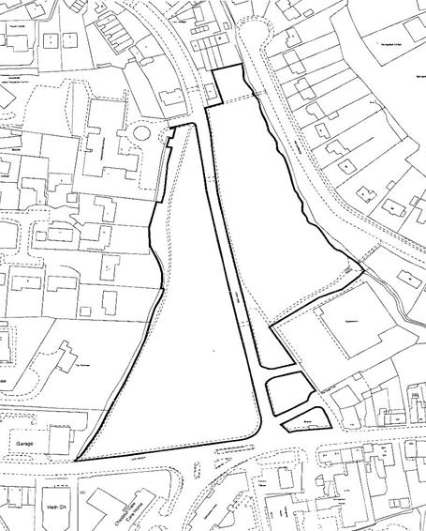



1. Council may decide to discontinue this wildflower area in November 2022 in which case it would be treated as a normal grass cutting area