

www.gov.uk/naturalengland
Request for Quotation

Request for Quotation: Breeding bird survey of woodland and scrub within Harting Down SSSI, West Sussex
You are invited, to submit a quotation for the requirement described in the specification below.

Please confirm, by email, receipt of these documents and whether you intend to submit a quote.

Your response should be returned to the following email address by:

Email: steve.walker@naturalengland.org.uk
Date: 20/01/2023

Ensure you state the reference number and ‘Final Submission’ in the subject field to make it clear that it is your response.

Contact Details and Timeline

Emma Bacchus will be your contact for any questions linked to the content of the quote pack or the process. Please submit any questions by email and note that, unless commercially sensitive, both the question and the response will be circulated to all tenderers.

Action | Date
Date of issue of RFQ | 13/12/2022
Deadline for receipt of Quotation | 20/01/2023
Intended date of Contract Award | 24/01/2023
Inception Meeting | w/c 28/02/2023
Intended Contract Start Date | w/c 14/03/2023
Draft report submitted to Project Officer | By 11/09/2023
Draft report to be returned to contractor with Natural England comments | By 18/09/2023
Intended Delivery Date / Contract Duration | 25/09/2023

Glossary

Unless the context otherwise requires the following words and expressions used within this Request for Quotation shall have the following meanings (to be interpreted in the singular or plural as the context requires):

“Authority” | Means the Department for Environment, Food and Rural Affairs acting as part of Natural England
“RFQ” | Means this Request for Quotation and all related documents published by the Authority and made available to suppliers
“Contract” | Means the contract to be entered into by the Authority and the successful supplier.

Conditions applying to the RFQ

You should examine your response to the RFQ and related documents ensuring it is complete prior to submitting your completed quotation.

Your quotation must contain sufficient information to enable the Authority to evaluate it fairly and effectively. You should ensure that you have prepared your quotation fully and accurately and that prices quoted are arithmetically correct for the units stated.

The supplier by submitting a quotation is deemed to accept the terms and conditions in the RFQ. Failure to comply with the instructions set out in the RTQ may result in the supplier’s exclusion from this procurement.

Acceptance of Quotations

By issuing this RFQ the Authority does not bind itself to accept any quotation and reserves the right not to award a contract to any supplier who submits a quotation.

Costs

The Authority will not reimburse you for any costs and expenses which you incur preparing and submitting your quotation, even if the Authority amends or terminates the procurement process.

Clarifications

The Authority reserves the right to discuss, confidentially, any aspect of your quotation with you prior to any award of Contract to clarify matters.

Amendments

The Authority may amend the RFQ at any time prior to the deadline for receipt. If it amends the RFQ the Authority will notify you in writing and may extend the deadline for receipt in order to give you a reasonable time in which to take the amendment into account.

Conditions of Contract

Natural England’s general Terms and Condition can be found here.

Specification

The Authority is Natural England. The Authority’s priorities are to secure a healthy natural environment; a sustainable, low-carbon economy; a thriving farming sector and a sustainable, healthy and secure food supply. Further information about the Authority can be found at: Natural England

- Background

Harting Down is a 336.3 hectare Site of Special Scientific Interest (SSSI) located along the South Downs, to the west of Midhurst in West Sussex. An area of 206.6 hectares is a Local Nature Reserve which is owned and managed by the National Trust
This site comprises areas of unimproved chalk grassland and ancient woodland on the scarp and dip slopes of the South Downs. The grassland supports a wide variety of flowering plants and grasses. Other areas are turning to scrub that includes the uncommon Juniper scrub. The woodland is dominated by Beech and Ash stands although there are also areas of Yew. A large number of the ash trees have been affected by Dieback disease.
The native Large-leaved lime tree has only relatively recently been discovered on the South Downs and is not common elsewhere in England. The woods also support a range of breeding birds, including nightingale, tree pipit, willow tit, and grasshopper warbler, as well as a rare moss and an uncommon snail.

- Aim

The aim of this contract is to undertake a breeding bird survey within the SSSI with the objectives as:
- Determining the breeding status of all bird species in the SSSI
- Determining the approximate locations of confirmed and probable breeding scoring assemblage species.
- Provide a habitat description and its condition, suggesting where current management is working and where it is not, why might that be.

The results will allow Natural England to undertake a Common Standards Monitoring (CSM) (JNCC, 2004) assessment of the condition of the woodland and scrub breeding bird assemblage at each site, and also help with advising on future management to conserve woodland and scrub birds.
- Methodology

The surveyor will need to survey the area shown on the maps at Annex 3; of which only revelant habitats must be surveyed. Please note a large proportion of the site is grassland species so the transects should be focused on the woodland and scrub areas.
A CSM assessment of the status of the breeding bird assemblage features require evidence of possible/probable/confirmed breeding for each species that score towards the assemblage using standard Bird Breeding Status Codes (Annex 1). The list with scoring species is provided in Annex 2. The list was taken from the 1983 guidance as that is the guidance closest to the year of the SSSI designation. Each species in that list will score towards the woodland and scrub habitat, the score is given by the rank number. The calculating of assemblage score is not required.

- Field Work

Using the methodology below the identity and activity of all target birds should be mapped using BTO species codes and behaviour codes respectively on a separate map for each visit.
- Detailed methodology

- A minimum of four diurnal visits in good weather should be undertaken to each SSSI transect.
- Two Dusk/nocturnal surveys should be included as relevant species are likely to be present (woodcock-Scolopax rusticola, owls, nightingale-Luscinia megarhynchos).
- Surveys are to be carried out from March to early July. Individual visits should be undertaken at least 10 days apart.
- A transect should be identified which allows good coverage of all relevant habitats. This does not need to achieve full coverage but should be sufficient to include the full range of habitat conditions present on the site. The intensity of coverage should be as even as possible although more time should be allowed for areas with higher bird density.
- The direction and, if possible, the starting point of the route should be varied between visits and a single visit should be completed in one morning.
- Survey visits for diurnal species should start 30 minutes before sunrise and finish by 10.00-11.00.
- Record as much information as possible including sex of adults and location of recently fledged juveniles.
- Record the date, start and finish times, observer name and weather conditions for each survey visit.
- No visits in windy conditions (Beaufort scale greater than 5), poor visibility or if the site is subject to unusually high levels of disturbance.
- General notes of habitat and management should also be made

- Indicative survey locations

If the area is not well known to the contractor pre-survey reconnaissance of the indicative survey locations should be carried out to determine the general nature and extent of the woodlands/terrain and to confirm suitable locations for survey transects. It is estimated that a preliminary walk-over assessment of all the proposed survey locations would take a maximum of two full days. Following the initial reconnaissance Natural England would welcome any advice or recommendations regarding the locations to be surveyed. For instance, the contractor may wish to recommend a variation of survey location(s) based on their experience. This can be discussed at the inception meeting.

- GPS data formats

It is important to be able to geo-locate the survey effort so that geospatial cross-referencing with other data sources can take place.
The location of the start and end points of all transect routes should be provided in six figure x:y co-ordinates format, entered in an Excel spreadsheet.
In addition, the location of registrations of the confirmed/probable breeding species from the woodland and scrub breeding bird assemblage (Appendix C, Selection Guidelines for Biological SSSIs, JNCC, 1989) should be provided using the same six figure x:y co-ordinates format, entered in an Excel spreadsheet.
At the discretion of the contractor, the locations of any additional ‘target notes’ of interest (e.g. registrations of ‘possible’ breeding species) can also be provided.
Once agreed with Natural England, a map showing the transect routes should be provided as part of the contract outputs (see below). Indicative mapped routes can be provided as part of the tender process at the discretion of the contractor.

- Access to Land

Due to the short time between the award of contract and expect field survey date, Natural England will initially obtain land owner/manager permission in advance of the surveys providing approximate timings of site visits.

Land manager contact details to be supplied to the contractor at the start of contract by Natural England. The contractor will then liaise directly with landowners and occupiers to arrange specific dates and times for access. Permissions must be obtained at least 48 hours prior to monitoring, with any refusals or other issues notified to the Natural England project officer within 3 working days.

- Analysis and Reporting

The outputs, unless agreed otherwise in writing by the Project Officer, will be as detailed in this section.
- Reporting and presentation of data

A report will be produced to include introduction, methods and results together with maps showing the locations of transect routes.
As described in the data format section above, an Excel spreadsheet should be included showing the six-figure x:y co-ordinates of the start and end points of the transect routes and the locations of registrations of confirmed/probable breeding bird species from the assemblage
A section describing the bird interest across the SSSI should be included, including a tabulated list of observed target species with the following information: ‘present’ (i.e. non-breeding birds, migrants); possible breeding; probable breeding; confirmed breeding; estimated number of territories/pairs/males; and comments, e.g. birds seen on site but likely to breeding outside the SSSI boundary. Possible, probable and confirmed breeding birds for the SSSI, defined according to the Bird Breeding Status codes (see Annex 1).
Provide information on survey visits (date, weather, etc.). Provide an indication of the reliability of survey and any limitations likely to reduce reliability of results.
Additional descriptive sections in the report relating to bird species of conservation interest and concern can be included at the discretion of the contractor.
A general description of the woodland and scrub habitat should be included, with clear and concise recommendations for management to benefit individual species or groups of woodland and scrub birds. Along with any negative impacts of current management or environment are having on the assessed species.

- Maps

Provide maps showing the location or each recorded probable or confirmed breeding record for each target species or provide separate x:y grid references and species codes in an excel spreadsheet. Precise locations of rare and sensitive species should not be included if the report is for wider circulation – such information should be provided separately, ideally in a confidential, password-protected annex.
Provide maps showing the location of any transects, point counts and survey routes in the report or in a GIS file compatible with ArcMap.
The following maps should be provided:
Maps showing areas surveyed and transect routes
Maps showing location of confirmed / probable breeding species
A copy of maps should be provided in jpg or pdf format and as GIS layers, in or compatible with ESRI ArcGIS format. Information and guidance on requesting baseline digital geographical data from Natural England can be found on our website at Geographical Information for contractors and partners.
- Health & Safety / Known hazards & risks

Risks associated with field-based work need to be considered. The Health and Safety at Work Act 1974 is to be fully complied with at all times.
Please provide a clear and structured proposal to demonstrate your intended approach to health and safety on this project and how you ensure the requirements of legislation are met.
The risk assessment must also include a section on Covid-19 which covers:
- Assurance that contractors will work within government guidance on working outdoors:https://www.gov.uk/guidance/working-safely-during-coronavirus-covid-19/construction-and-other-outdoor-work
- Assurance that coronavirus specific risk assessments have been carried out by the contractor.

If Covid-19 restriction changes affect the work as part of this contract, the successful contractor must inform the project manager within two working days and provide an updated risk assessment within five working days.
The risk assessment must also include a section on Avian influenza which covers assurance that contractors will work within the latest government guidance on Avian influenza.
Your quotation for the work should be accompanied by the following Health and Safety documentation required by Natural England:
- Risk assessment: this must take the hazards identified above into account.
- Valid certificates (if appropriate) to be made available on request:
- Employers Liability Compulsory Insurance
- Public Liability Insurance – provide description of level taken out
- Professional Indemnity Insurance – provide description of level taken out

Work shall not commence without Natural England being in possession of appropriate documentation and an agreed safe method of working.
The scoring quality criteria are listed in Annex 4.
- Outputs

An electronic copy of the draft report, in Word format, should be submitted to Natural England for consideration and comments. All reports should be submitted according to the timescale given on page 1/2. All reports should be sent to the Project Officer.

Prices

- Prices must be submitted in £ sterling, inclusive of VAT.
- Please price against the work described in this specification and annexes and complete the pricing template in Annex 5.
- The tenderer should demonstrate how they will cover the survey area and how the visits will be organised in terms of personnel and timescales.
- Day rates and numbers of days for key staff should be provided. Costs should be broken down to show the time allocated to each part of the project. Please itemise other costs including material / equipment costs. Please detail any assumptions made when pricing for any aspects of this tender.

It is anticipated that this contract will be awarded for a period of 8 months to end no later than 31/10/2023. Prices will remain fixed for the duration of the contract award period. We may at our sole discretion extend this contract to include related or further work. Any extension shall be agreed in advance of any work commencing and may be subject to further competition.

Suppliers should email invoices to APinvoices-NEG-U@gov.sscl.com or post them to:
Shared Services Connected Limited
Natural England
PO Box 793
Newport
NP10 8FZ
Please ensure that the Purchase Order number is included on the invoice

Quotation Submission

Your tender should include the following information

- Pricing Template (Annex 5)
- Your proposal outlining how you will meet Natural England’s Requirements.
- Methodology including a proposed outline schedule or timetable of works, including a rationale for the estimate of the number of days required for field survey work, how you will cover the survey area, and how the visits will be organised in terms of personnel and timescales.
- Please also provide a quotation for a four diurnal visit scenario
- Insurance certificates.
- Health and Safety Policy.
- Risk Assessment including that for Coronavirus.
- Acceptance of terms and conditions

Evaluation Criteria
The contract will be awarded to the tender which best fits the profile of requirements. This will be assessed by the Project Officer in consultation with relevant colleagues using the evaluation criteria detailed below.
As part of the evaluation process a quality threshold will be placed on each scoring criterion identified below. If your tender falls below the threshold then your bid will not be considered.
Your tender should include the following information and supporting evidence.
Evaluation Criteria | Weighting  (%) | Threshold score out of 10 | Tender Information
Technical expertise and experience –  Please provide details of your experience in undertaking:  - Breeding bird surveys using the methods detailed in this specification.  Please provide details of your experience in:  - Breeding bird surveys generally.  - Analysis, presentation and reporting of data generated from surveys. | 25 | 8 | Previous contracts for undertaking breeding bird surveys for site evaluations and Site Condition Monitoring on SSSI sites.  Qualifications, technical merit and experience of key staff engaged on the contract e.g. CVs, previous breeding bird survey / contracts, technical qualifications. Particular reference should be made to experience of breeding bird surveying of woodland and scrub habitats.
Fit with Specification and methodology –  Availability:  Please provide full details as requested under Tender Information.  Capability for full delivery of expectation:  Please provide full details as requested under Tender Information. | 15 | 7 | Include details of availability given the timescales page 1/2 and a proposed outline schedule or timetable of works.  Include details of capability for field survey work with a clear rationale for the estimated number of days for field work. Please include details of how the survey area will be covered and how the visits will be organised in terms of personnel and timescales.
Project and risk management, and resources allocated –  Please provide full details as requested under Tender Information | 10 | 7 | Details of personnel, support systems, organisational and management skills to deliver all aspects of the requirement in full. This must include an assessment of the risks to project delivery and mitigation (including contingency in the event of delays), evidence of quality control measures and project management procedures.
Financial (value for money) | 50 | No threshold | Include all costs and VAT clearly itemised.

The scoring quality criteria are listed in Annex 4

Contract Management

This contract shall be managed on behalf of the Authority by:

Steve Walker
Protected Site Strategy Sussex Woods Pilot co-ordinator
Tel: 07919 570703
Email: steve.walker@naturalengland.org.uk

Natural England will raise purchase orders to cover the cost of the services and will issue to the awarded supplier following contract award.

Suppliers will be required to invoice after each contract milestone. An invoice schedule will be agreed after the contract is awarded.

Fortnightly updates during the first month then monthly updates thereafter, an e-mail summary of work progress should be sent to the project officer monthly.

Disclosure

All Central Government Departments, their Executive Agencies and Non-Departmental Public Bodies are subject to control and reporting within Government. In particular, they report to the Cabinet Office and HM Treasury for all expenditure. Further the Cabinet Office has a cross-Government role delivering overall Government policy on public procurement, including ensuring value for money and related aspects of good procurement practice.

For these purposes, the Authority may disclose within Government any details contained in your quotation. The information will not be disclosed outside Government during the procurement.

In addition, the Authority is subject to the Freedom of Information Act 2000 and the Environmental Information Regulations 2004, which provide a public right of access to information held by public bodies. In accordance with these two statutes, the Authority may be required to disclose information contained in your quotation to any person who submits a request for information pursuant to those statutes.

By submitting a quotation you consent to these terms as part of the procurement.

Disclaimers

Whilst the information in this RFQ and any supporting information referred to herein or provided to you by the Authority have been prepared in good faith the Authority does not warrant that this information is comprehensive or that it has been independently verified.

The Authority does not:

- make any representation or warranty (express or implied) as to the accuracy, reasonableness or completeness of the RFQ;

- accept any liability for the information contained in the RFQ or for the fairness, accuracy or completeness of that information; or

- accept any liability for any loss or damage (other than in respect of fraudulent misrepresentation or any other liability which cannot lawfully be excluded) arising as a result of reliance on such information or any subsequent communication.

Any supplier considering entering into contractual relationships with the Authority following receipt of the RFQ should make its own investigations and independent assessment of the Authority and its requirements for the goods and/or services and should seek its own professional financial and legal advice.

Protection of Personal Data

In order to comply with the General Data Protection Regulations 2018 the contractor must agree to the following:

- You must only process any personal data in strict accordance with instructions from the Authority
- You must ensure that all the personal data that we disclose to you or you collect on our behalf under this agreement are kept confidential.
- You must take reasonable steps to ensure the reliability of employees who have access to personal data.
- Only employees who may be required to assist in meeting the obligations under this agreement may have access to the personal data.
- Any disclosure of personal data must be made in confidence and extend only so far as that which is specifically necessary for the purposes of this agreement.
- You must ensure that there are appropriate security measures in place to safeguard against any unauthorised access or unlawful processing or accidental loss, destruction or damage or disclosure of the personal data.
- On termination of this agreement, for whatever reason, the personal data must be returned to us promptly and safely, together with all copies in your possession or control.

General Data Protection Regulations 2018
For the purposes of the Regulations the Authority is the data processor.

The personal information that we have asked you provide on individuals (data subjects) that will be working for you on this contract will be used in compiling the tender list and in assessing your offer. If you are unsuccessful the information will be held and destroyed within two years of the award of contracts. If you are awarded a contract it will be retained for the duration of the contract and destroyed within seven years of the contract’s expiry.

We may monitor the performance of the individuals during the execution of the contract, and the results of our monitoring, together with the information that you have provided, will be used in determining what work is allocated under the contract, and in any renewal of the contract or in the award of future contracts of a similar nature. The information will not be disclosed to anyone outside the Authority without the consent of the data subject, unless the Authority is required by law to make such disclosures.

Annexes

Annex 1: Bird Breeding Status Codes
Annex 2: Bird Rank Scores
Annex 3: Map showing survey area
Annex 4: Scoring Criteria
Annex 5: Pricing Template

Annex 1: Bird Breeding Status codes
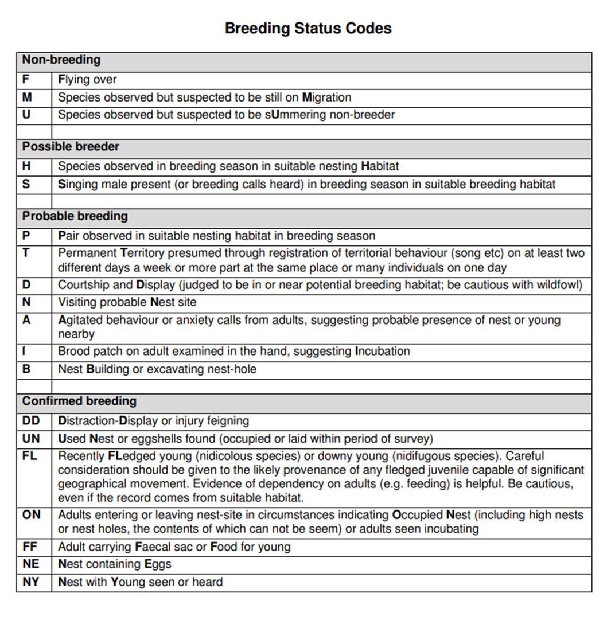

Annex 2: Bird species Rank scores
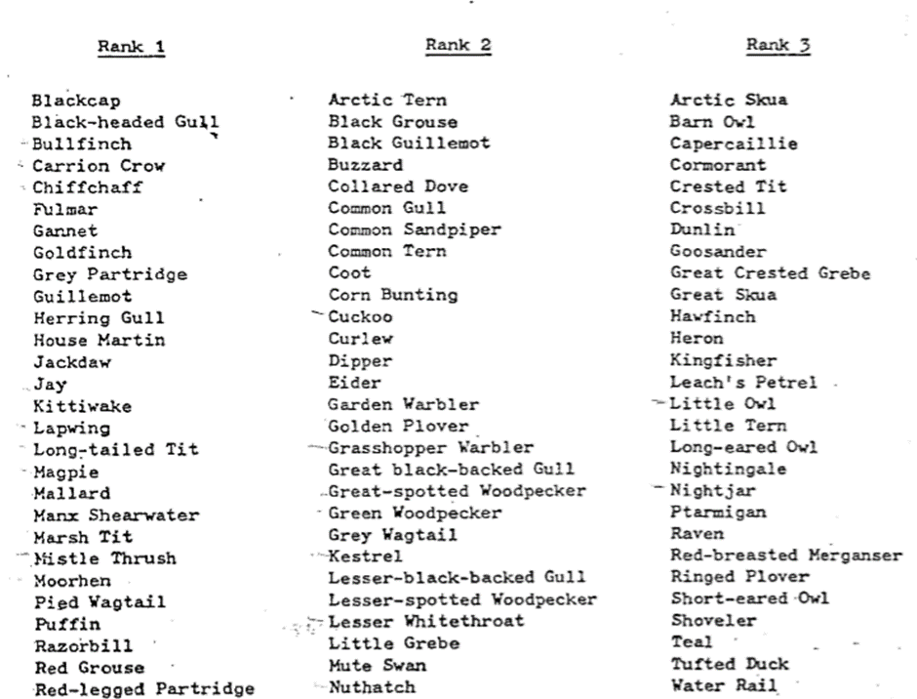
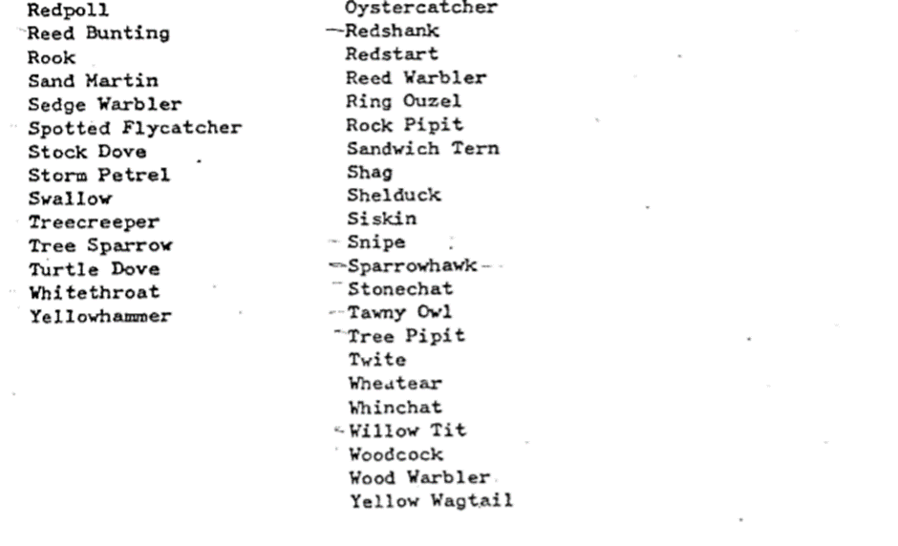

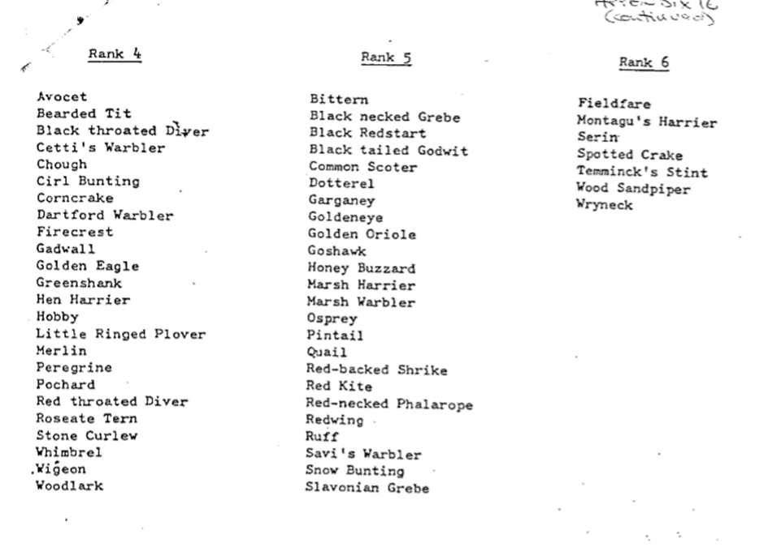
Annex 3: Maps showing approximate location and extent of survey areas
For more detailed information on site location please see Magic.gov.uk

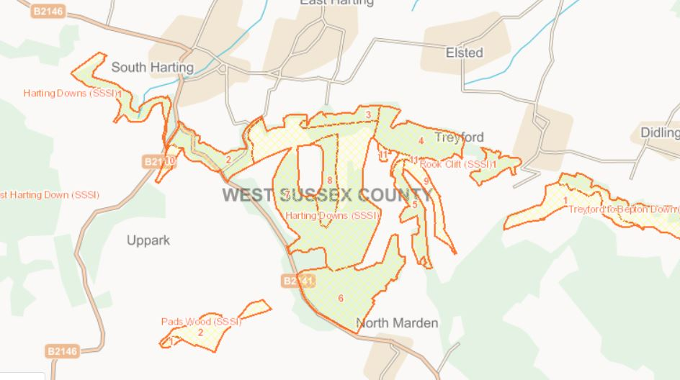

Annex 4: Scoring Criteria
Scoring - Quality Criteria
Rating of Response | Score
Very Good or Fully Compliant Submission:  meeting all requirements and is fully explained in comprehensive detail. | 9 - 10
Good or Fully Compliant Submission:  meeting all the requirements and is explained in reasonable detail. | 7 - 8
Satisfactory or Compliant Submission:  meeting the essential requirements and is explained in adequate detail. | 5 - 6
Weak or Partially Compliant (Minor issues) Submission:  falls short of requirements in some areas and is poorly explained. | 3 - 4
Unacceptable or Non-Compliant (Major issues) Submission:  fails to meet requirements and is not explained. | 1 - 2

Annex 5: Pricing specification
Item of work/task | Grade of Staff | Day Rate | Number of days | Total Cost
Project management meetings
Pre-survey reconnaissance
Field survey
Collation and analysis of results
Reporting
Other costs including materials / equipment
T&S
Total excl. VAT

(Note please submit separate Pricing specification for the four diurnal visit scenario)

