
Castle Edene Dean – Natural England Nature Reserve
Scoping Document - Lightning Protection – February 2025

Generally
The works: A Risk Assessment for the installation of Lightning Protection, as well as surge protection.
As Existing:
There is no lighting protection on site, and we are looking to cover the entire building, which is mainly single storey and with a two-storey office. Coverage should be for all buildings and distribution boards.
Office /House Single Phase: The incoming supply is on NW Elevation, outside of the courtyard. There is a dist board for the main office.
Workshop and Canteen: The incoming supply is within the Workshop, with a distribution board, and then a secondary one within the corridor.
Existing system details and photos:
Photo 1: Entrance to the Courtyard
Photo 2: SW elevation, before PVs installed.
Photo 3: SW Elevation
Photo 4: SE Elevation, two storey building
Photo 5: SE Elevation but outside of the courtyard area
Photo 6: NW Elevation outside
Photo 7: Workshop incoming supply
Photo 8: Office / House, incoming supply
- Scope of the works: Is to price and provide clarification / confirmation of all of the following within a quotation for the works:

  - The contractor is to provide a Risk Assessment: With the quotation, clearing stating the Lightning Protection calculated level of risk and the type of lighting protection system recommended.
  - Surge Protection: To clearly state the number of surge protection devices to be installed, with a narrative of their intended locations see suggested items to be covered.
- Main Switchboard 1No. 3 Phase Type I, 2 & 3 SPD – C/W Enclosure
- Sub-Distribution Board Feeding External Plant: 1No. 3 Phase Type I, 2 & 3 SPD – C/W Enclosure
- Fire Alarm Panel/Disabled Refuge: 2 No. Type 2 & 3 SPD
- Solar PV Inverter: 3 No. Solar PV Panel SPD up to 1000v – C/W Enclosure
- Telephone System: 1No. 10 pair Telecom line SPD for use with LSA framed terminal unit.
- Aerial/Satellite/DAB/CCTV: 5No. Coaxial SPD
  - Upon Contract Award: The contractor is to confirm within their quotation that they will attend site to verify intended locations of lighting protection pits.
  - Lightning Protection Design: To provide a schematic of the intended LP pits and with system layouts. Include for bonding to the PV panel rail supports.
  - As Built Layout: Provide a schedule of installation systems and a layout of ‘As installed equipment’.
  - Access Plant: Allow for all access plant for the full installation, and to clarify within the quotation the intended method of access.
  - Testing and Certificate of installation: Information / data for the installation of LP and surge protection devices.
  - Builders Works: Allow for all works that are non-electrical, associated with the installation. Ensure all pits installed include for the making good of areas around them.
  - Testing and Certification: Check and test all systems are working and provide an electrical certificate upon completion of the works.
2.0 Accreditation and Insurances: The contractor shall provide confirmation of registration of the NICEIC and any lightning protection accreditation or bodies registered with.
3.0 Welfare: The site will provide access to toilets and a kitchen.
4.0 Access, Location and Parking: The site is open from 8am until 4.30pm and is controlled via a CCTV system with card access. Parking is available adjacent to the building. All visits to be agreed with the Operational Manager, Joe Davies.
- The site is located: - Natural England, National Nature Reserve, Stanhope Chase, Peterlee SR8 1NJ.

5.0 Health and Safety: The contractor is expected to provide a set of RAMS prior to works commencing on site, and proof of qualifications for any installer, on the day. All ground works must utilise as a minimum a CAT scanner. Note all PV panels have an isolation switch which should be engaged and then returned to working order, should there be an electrical requirement to isolate the power supply.
6.0 Standards, Equipment and materials: All works should be carried out to British Standard for Lightning Protection BS EN 62305 and the IEE Regulations 18th Edition.
7.0 Site Inspection: The contractor has the opportunity to visit site or utilise the information provided, in order to provide a fixed priced for the supply and installation of the Scope of Works.
8.0 Tender Return: The contractor is to provide the following documents with the tender return, on the due date, as set out within ‘Contract Finder’.
- Priced Scope of Works items 1.1 to 1.9 + 2.0 inclusive.
- Quotation with Specification / Material list

9.0 Procurement: Natural England will set up the successful contractor on their supplier list, and then raise an order for the works, with payment upon completion. Payment is usually within 14 days.

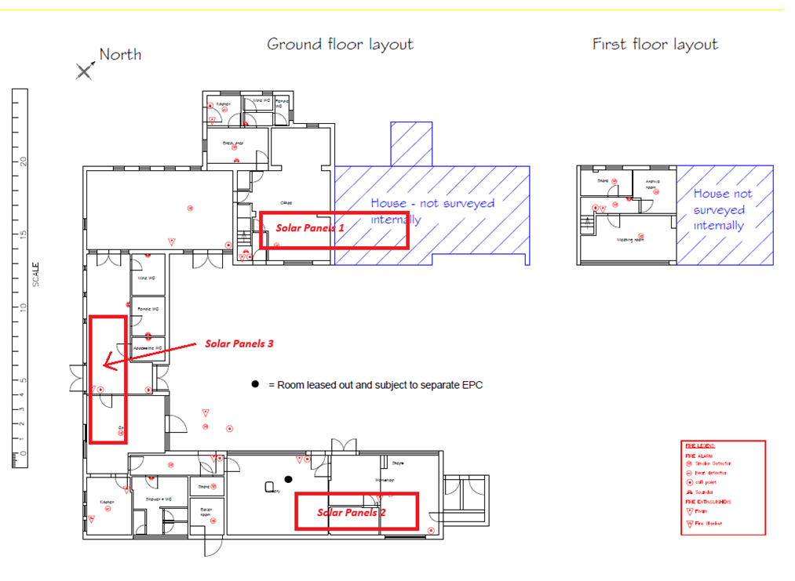
Site Layout Plan: Showing Office to the NW, the house to the NE and the Workshop to the SE corner.
In red are the new solar panel locations.
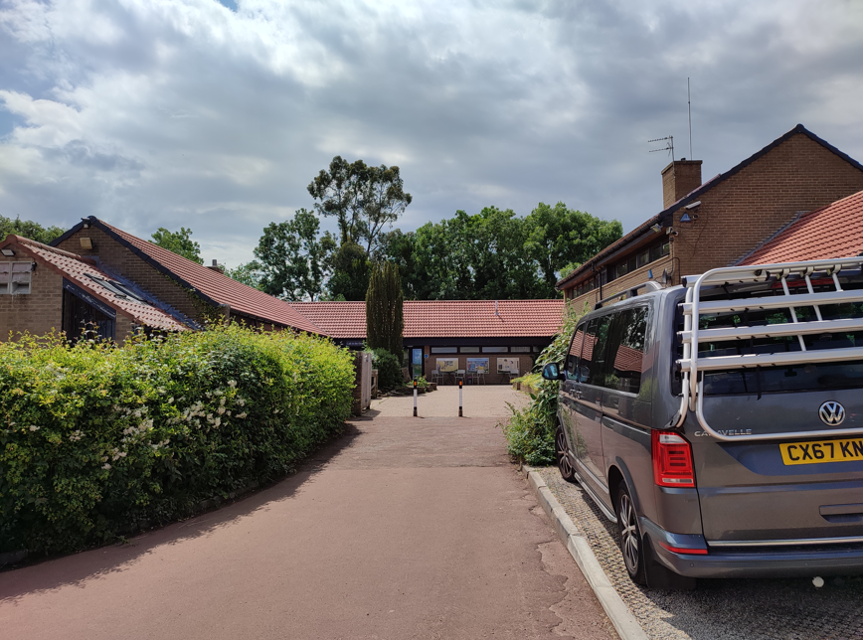
Photo 1: Entrance to the Courtyard
The entire building, with the two storeys to the right and the Workshop to the left

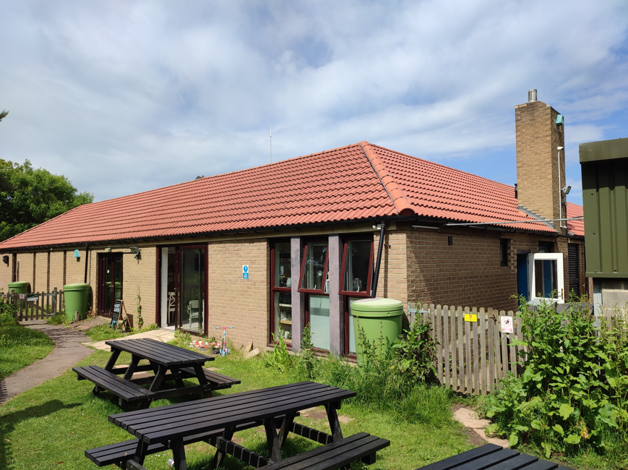
Photo 2: SW elevation, before the PV panels were installed, showing the chimney on the Workshop roof.
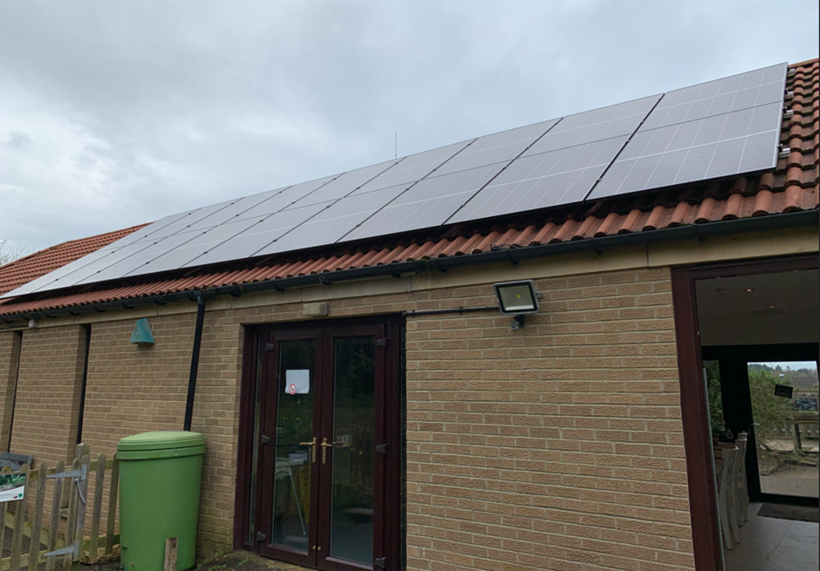
Photo 3: SW Elevation after PV panels fitted.

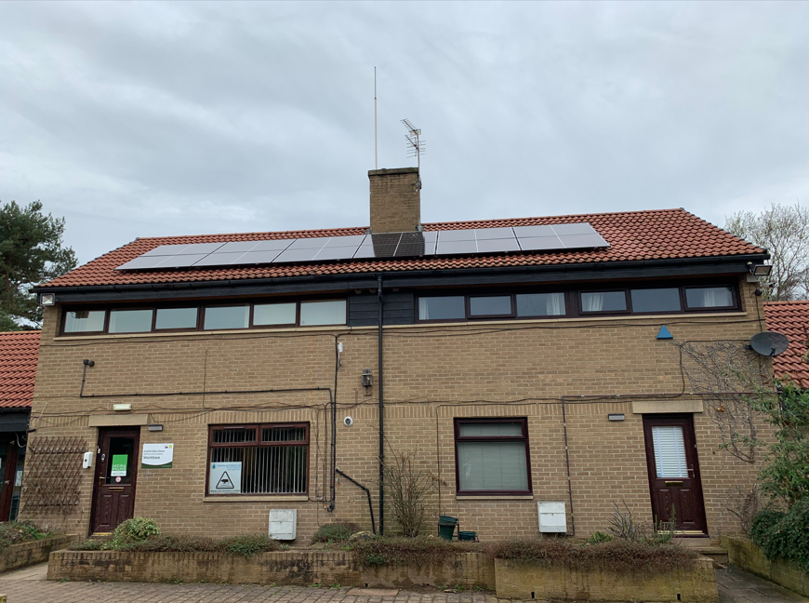
Photo 4: SE Elevation, two storey building within the courtyard. To the right is the house.

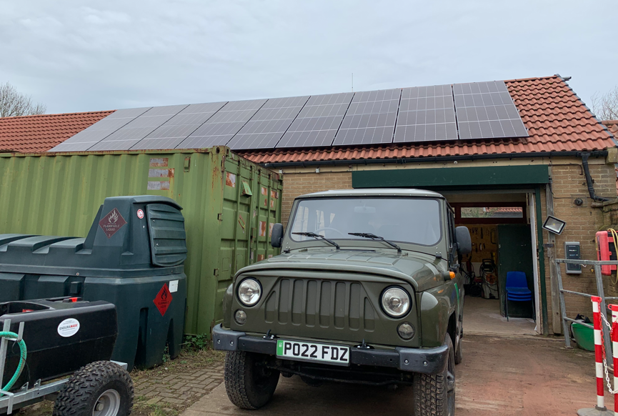
Photo 5: SE Elevation but outside of the courtyard area, with PV on roof
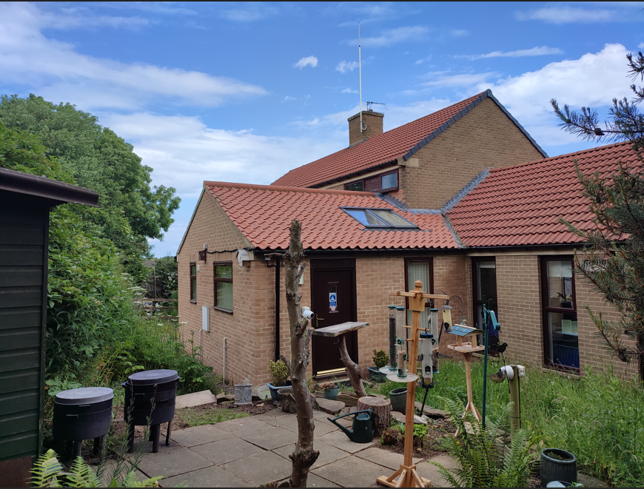
Photo 6: NW Elevation outside of the courtyard
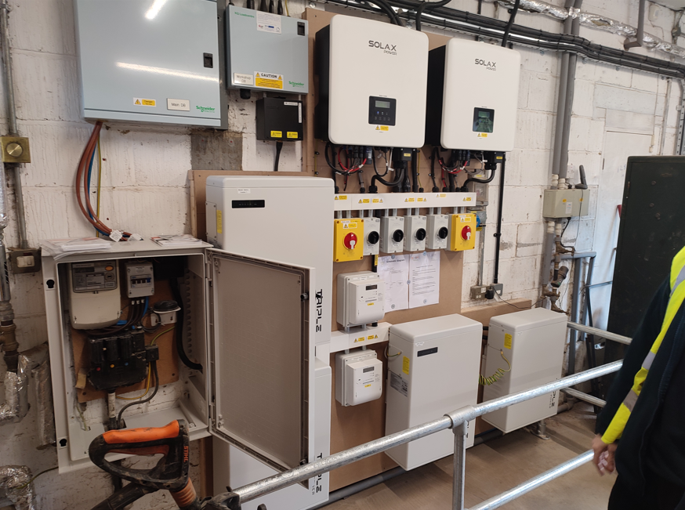
Photo 7: Workshop incoming supply and dist board at high level
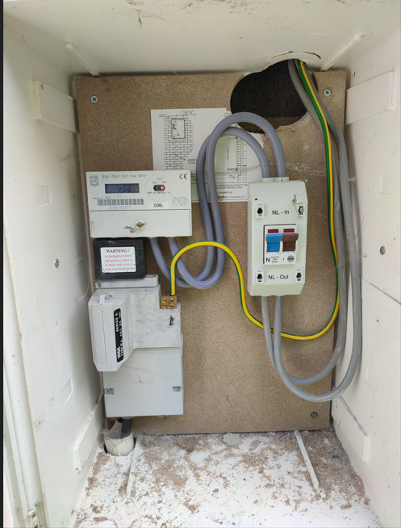
Photo 8: Office / House, incoming supply
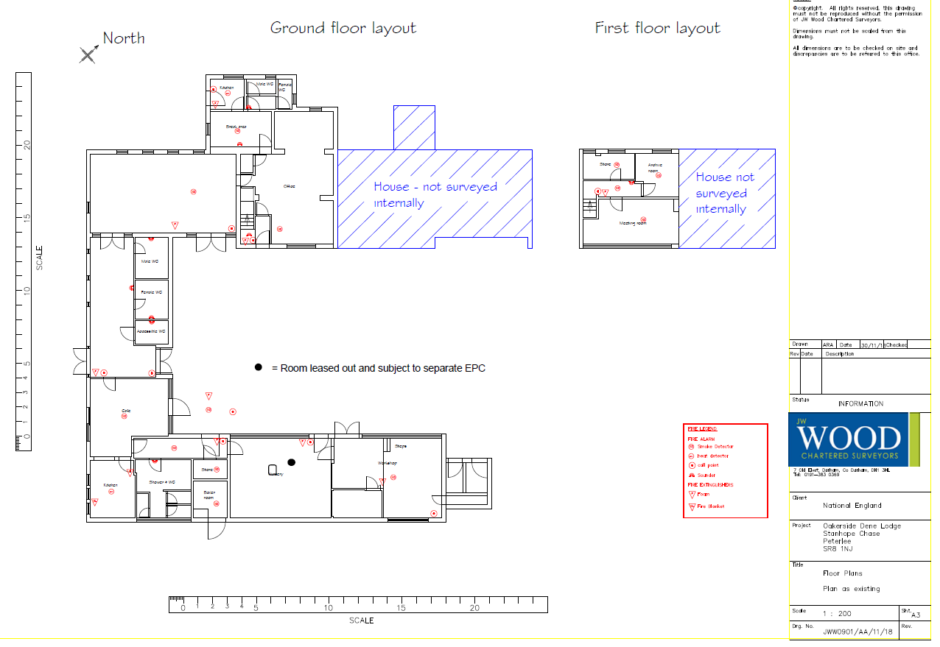
Existing Building Layout

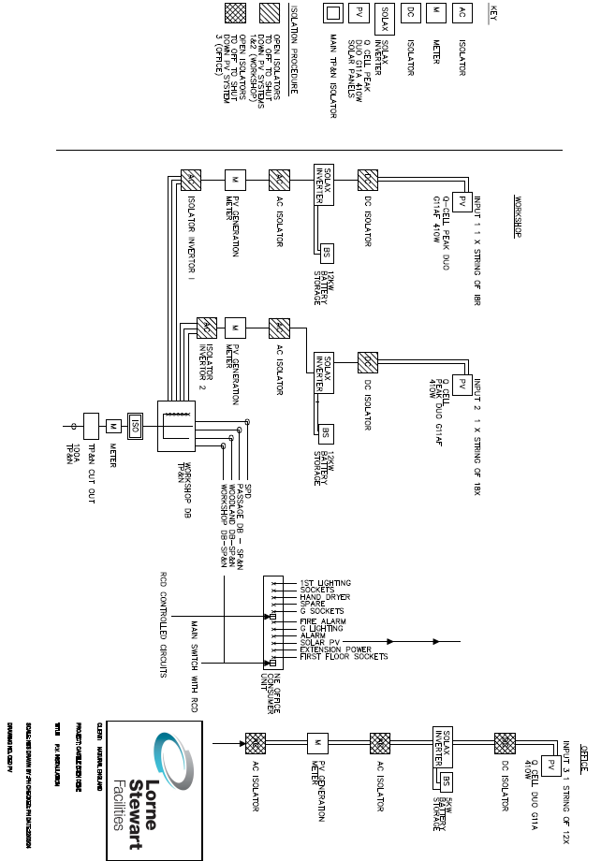
Electrical Schematic of PV systems

