
PROVISION OF ONLINE SURVEYS

Organisation Background

South West Yorkshire Partnership NHS Foundation Trust (SWYPFT) are a specialist NHS Foundation Trust that provides community, mental health and learning disability services to the people of Barnsley, Calderdale, Kirklees, and Wakefield.
Over 1 million people live in Barnsley, Calderdale, Kirklees, and Wakefield across urban and rural communities from a range of diverse backgrounds. We aim to match the community’s needs with locally sensitive and efficient services.
The geographical footprint of the areas that SWYPFT covers is represented pictorially below:

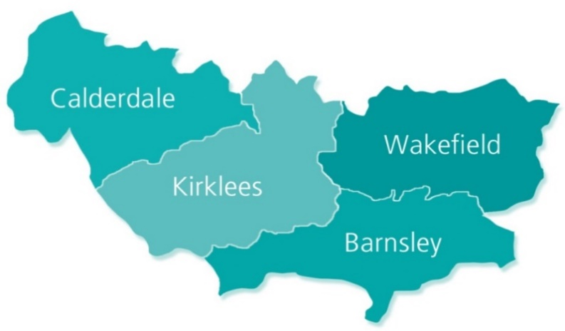

Introduction
South West Yorkshire Partnership NHS Foundation Trust would like to commission a provider to deliver an online survey tool to support the trust in canvassing its survey service users, families and carers, and diverse communities in its aims of improving and to be outstanding in the service we provide.
The service aims to use the data delivered through the surveys for analysis and feedback in a manner that is familiar to the general public.

Scope of Contract

The digital survey platform would need to directly support the work of the Quality Assurance and Improvement Team and the Equality and Involvement team, as well as Trust wide projects as appropriate, and therefore having multiple profiles able to access the platform at the same time is essential.

The range of the surveys are expected to offer a variety of formats, however, must have the flexibility to host surveys with a minimum of 20 questions or more. Where the minimum number of questions is less than 20, there should be the option of having an additional ‘about you’ section for equality monitoring questions available in templates.

Requirements

- There should be ability to have multiple super users able to access and edit at the same time

- The Trust should have access to administrative functions able to access all surveys created.

- There should be the ability to create template surveys

- There should be the ability to send a preview of the survey before going live

- There should be the option to have anonymous feedback

- The Trust requires the use of short links to access surveys

- The Trust requires the use of QR codes to access surveys

- There should be an answer validation function.

- There should be the ability to include images in the surveys

- There should be an ability for mobile phone compatibility

- There should be an option for results to be given in different formats

- There should be the ability to easily access a back up of surveys and a restore function should deletion by error occur

- There should be the functionality for preset timers/dates when surveys are open and closed

- There should be the ability to provide reports in various formats such as Word, Excel, Powerpoint.

- There should be the option to save reports in PDF format.

There should be the ability to have equality monitoring forms set up as a template
It is desirable that:
- There is a copy and paste functionality when creating the survey

- There is the ability to remove provider logos

- There is the ability to provide multi-lingual surveys, with the ability to translate surveys

- There is the option to have version control

- There is the ability to sort, categorise and nickname surveys

- The Trust is able to see who has created the survey

- The Trust is able to create and apply templates for various surveys to ensure Trust branding and a standard approach are applied

- There is the ability to transfer surveys to other users within the Trust

- There is the ability to apply analysis to both questions and responses

- There is integration of the surveys with MS Teams

- There are visual/customisable/innovative ways to present questions

- There is the option to customise viewing platforms such as filters to change screen colours to support dyslexia etc.

It is essential that:

- There are an unlimited number of questions allowed

- There are an unlimited number of responses allowed

- There are an unlimited number of surveys allowed

- The Trust is able to analyse, filter and edit results

- There are multiple question styles

- There is logic and routing of questions

- There is the ability to be able to edit a survey after publication

- There is the ability to be able to download results in an editable version and MS office formatting to allow data cleansing

- Data storage is compliant with GDPR

- There is simplicity of usage for respondents

- There is the ability to merge surveys

- There is the ability to add Trust logos

- There is the ability for the management of users – particularly being able to change access/users quickly.

Google Chrome is not supported by the Trust and the solution MUST be compliant with Microsoft Edge. We would want the supplier to comply with Cyber Essentials Plus and carry out annual assessments.

Policies

At contract award, a due diligence process will take place and the provider will be required to share all permitted policies and standing operating procedures. We anticipate the provider will have the following policies available:

Business Continuity
Risk Management
Data Protection

It is expected that the successful supplier will be able to demonstrate that it complies with all applicable legislation and regulation.

Customer Support

It is expected that there is customer support available Monday to Friday 8:00 – 17:00. An allocated phone number and/or email address would be desirable. Responses to queries would be expected to be within 48 hours of the issue being raised.

Data Security

The successful supplier must comply with UK GDPR regulations and the Trust Information Governance Policies.

Data must be stored within the EEA.

Bidding suppliers must successfully complete the Trust’s Application Take-on Questionnaire.

Budget

It is expected that the operational budget will be circa £10-15K per year.

Contract Term

The Trust is looking to award a contract term of three years with options to award a further 2 x 12 months extensions.

