Supplier meeting for research project:

T1154 PERFORM: Enabling better planning and resource management during disruption

The draft research specification which follows outlines RSSB’s proposed research project Enabling Better Planning and Resource Management During Disruption.
This pre-tender suppliers meeting has been scheduled for Friday 27 July 2018 at 2pm at the RSSB offices in Moorgate, London.
The purpose of this meeting is to:
- Provide an outline of the project proposal
- Provide interested suppliers an opportunity understand and discuss the draft research specification.
We ask that suppliers come to the meeting prepared to discuss the following elements that RSSB would like to firm up before publishing the ITT:
- What and how much support would be needed from industry to deliver this work (e.g. access to staff to interview, data, contingency plans, etc)?
- What enablers would support successful delivery of the project?
- What barriers are there to achieving the objectives?
- Are the described timescales achievable? How might the outputs change with a variation to the time?
- What is the suppliers estimate of effort required to deliver the project?

Suppliers wishing to attend in person or by dialing into the meeting should contact Shareditt@rssb.co.uk to confirm arrangements.

Draft Specification
- Background
Delivering against the timetable is an important commitment of the rail industry. Customers expect train services to be punctual, reliable and perform to the advertised timetable. Currently, service performance is determined by metrics including the Public Performance Measure (PPM) and Cancellation and Significant Lateness (CaSL). These metrics provide indicators of punctuality and reliability and are affected by service delay and disruption. Industry data shows a national decline in performance over the past five years, highlighting a concern regarding the current industry response to, and recovery from disruption.
Causes of disruption vary, with localised and contextual circumstances influencing the performance of each route. Generally, disruption to train services may include incidents arising from infrastructure failures, fleet reliability, traincrew, seasonality, and external factors (e.g. trespass). Such events will delay trains and can lead to service cancellations, hampering the measured performance against the timetable. For example, data from Network Rail’s top 10 incidents during 2017/18 Period 10, show that one track circuit failure incident caused 15,262 delay minutes and the cancellation of 115 trains.
Across GB, delays to passenger and freight services during 2017/18 totalled 14,800,000 minutes. This represents increase of 16% since 2010/11, of which 6% increase over the last financial year (2016/17). Meanwhile, rail demand has increased by 48.9% since 2006, with 1.7 billion passenger journeys reported in 2015. This has led to critical parts of the network running at almost 100% of their capacity during peak times, potentially exacerbating the risk of delay including reactionary and sub-threshold delay when key routes are affected.
Rail performance is a key industry challenge, which has a significant impact on the customer experience. Data from Transport Focus show that train punctuality/reliability has the largest contribution to the overall passenger satisfaction (37%), while TOC response to delays brings the largest influence on overall dissatisfaction (42%). Recent findings on the punctuality/reliability of the service show 74% passenger satisfaction, whilst how train companies deal with delays was 38% (Transport Focus, 2017). Moreover, punctuality/reliability is often the most common reason for passengers making a complaint, and comprised 26.4% of all complaints during 2016/17. Clearly, improving the response time, management of the event and recovery from disruption will significantly benefit the customer experience and industry performance.
To manage disruption, contingency plans provide pre-determined strategies for resolving an incident and restoring operations to the planned timetable. In the contingency plan, consideration is given to matching the available capacity in the timetable, maintaining safety, managing the customer experience and ensuring operational robustness. A contingency plan should aim to provide the best possible service based on the customer’s needs, taking into account considerations such as crowding management, alternative services, and bus replacement.
Current guidance and codes of practice for contingency plans provide high-level requirements or information relevant to disruption scenarios. However, limited information, resources and tools are available to support improving the effectiveness of contingency plans, including the detailed planning considerations for returning services to the timetable. There is no industry consensus about what a good contingency plan looks like (e.g. style, content, detail, examples, deliverability and ease of interpretation), the options available to recover the service, and in what situations these are perceived to work well. A methodology to measure and evaluate the effectiveness of a contingency plan, and test possible improvements to the plan, remains to be established.
Furthermore, delayed and redirected services may disrupt stock and crew across the network, displacing trains and staff away from their planned locations in the timetable. This can incur additional primary and reactionary delay, exacerbating disruption costs. Hence, operators need to know the location of stock and crew resources, their optimum resource utilisation and any operating constraints that apply. This requires complex resource management and appropriate allocation of crew to operate services, whilst adhering to crew terms and conditions.
The industry currently relies principally on manual processes to manage stock and crew during disruption. Although it is possible to track, manage and locate stock and crew through a range of technologies, there are currently no algorithms available to process stock, crew and infrastructure scheduling requirements in real-time during disruption. The development of a decision support tool / model to provide options for optimum resource utilisation may improve the recovery from disruption. However, in order to optimise existing resource management tools, technologies and methodologies, a clear understanding of the industry constraints, barriers and opportunities is needed.
The effective application of a contingency plan and management of stock and crew resources during disruption will be influenced by the level of staff competency and their ability to execute these plans correctly. Using contingency plans requires an adaptable skillset and the ability to manage multiple issues under pressure during disruption management compared to business as usual activity. The technical and non-technical skill requirements can also be influenced by situational challenges, resources develop staff competence, adapting to change including the introduction of new systems, rolling stock, train routes, and advances in technology. However, limited information and resources are currently available to support the development of control staff competence. Therefore, this work should also define the key control competences, skills, attitudes and capabilities required for business as usual and managing disruption, and identify the requirements for resources to support the continued development of staff training and competence.
This project is part of the RSSB Enabling Better Performance Research Challenge (PERFORM). The PERFORM research programme sets out to achieve performance improvements to run more trains on time today, while enabling better performance of tomorrow (see Appendix A for an overview). PERFORM, and T1154, are endorsed by the rail industry group the Better Operations Programme Board (BOPB).

- Work package objectives
T1154 should collate, review and critically assess the application of contingency plans, control staff competence, and stock and crew utilisation during disruption. This work will likely include a desk-based review, data analysis and industry consultation (workshops and interviews) to achieve the following work package objectives (WP):

WP1 Enabling better contingency plans
- Identify the constraints, barriers and opportunities to improving the effectiveness of contingency plans and feedback from users of the plans including current models and simulations that allow the testing of contingency plans.
- Define what good looks like in terms of an effective contingency plan (i.e. a ‘gold standard’), how to measure good practice effectively.
- Define and agree service recovery principles and strategies for aligning recovery priorities
- Develop a good practice toolkit or guidance to improve the effectiveness of contingency plans, including resources to overcome industry challenges and constraints, and resources to support the application of good practice. Toolkit resources should be agreed by industry members, and may include for example, good practice case examples, mitigation strategies for overcoming implementation challenges, or flow diagrams for common disruption scenarios.
- Define the options and parameters for a methodology to evaluate and improve the effectiveness of contingency plans. The specified requirements should enable the development of a methodology to quantify and test the key components that comprise the defined ‘gold standard’ contingency plan. It should enable users to evaluate the effectiveness of their contingency plans, and determine the possible current level of effectiveness compared to the optimum standard. Users should be able to simulate possible adjustments to their contingency plans, to allow the retesting and evaluation of alternative strategies that may improve the overall effectiveness of the plan. Data sources and requirements for the methodology should be specified. The methodology should be able to process complex, varying decision-making factors including the consequential impacts, to account for individual user needs and impact on other stakeholders.

WP2 Enabling better resource utilisation during disruption
- Process map the barriers and constraints to resource management (stock and crew) during disruption and identify potential opportunities for improving current practice.
- Identify what and how current tools, technologies and methods can be optimised to locate and utilise resources during disruption. This should consider varying operator needs, and how tools, technologies and methods may interface with current and planned future systems.
- Produce guidance on optimising existing tools, technologies and methods to improve resource utilisation during disruption. The guidance should identify the options available to optimise and improve decision making, resource locating and utilisation during disruption, share current good practice, workflows and possible strategies for improving resource utilisation during disruption.
- Define and design the options and parameters for a decision support tool / model to optimise resource utilisation during disruption. The tool / model should be able to process the key stock and crew scheduling requirements and availability in real-time to support decision making on what resources can be optimised to effectively respond and recover from disruption. This should include the consideration of (a) accurately locating stock and crew in real time, (b) crew rescheduling requirements including roles, incident workflows, competence, escalation processes, arrangements for cancellations, staff terms and conditions, (c) stock rescheduling requirements including infrastructure compatibility, fleet type, fuel, maintenance requirements, (d) timetable availability, and (e) the data requirements for identifying resources utilisation. Data sources and requirements should be specified, as should materials to help brief or train its use to staff, and the model should also be compatible with current and planned future technologies, including the contingency plan evaluation methodology (WP1).

WP3 Supporting the development of staff competence to manage disruption
- Task analysis to identify controller competencies required to effectively respond and recover train services from disruption, and to define what good looks like in terms of control staff competence. This should include the consideration of technical and non-technical skills, an adaptable skillset for working during disruption and business as usual conditions, and the psychometric testing requirements for recruiting competent control staff.
- Identify the resource constraints, barriers, gaps and opportunities to select, train and develop control staff competence. This should include identifying the resources available to develop and achieve control staff competence, and support staff progression through relevant stages of competence (e.g. from novice, not yet competent, competent, proficient and expert).
- Produce good practice guidance for developing control staff competence. The guidance should support the recruitment, development and retaining of expert control staff, including optimising current resources to develop competence. It should identify the skillset and competencies that exemplify good practice and offer strategies for improving competence, including a communication plan to engage the workforce. This should include during business as usual and disruption management, and where possible, the principles should be generalised to other roles involved in disruption management e.g. consideration of staff allocating stock and crew during disruption.
- Define the options and parameters for a control competency framework, including resource(s) to develop competence within the framework. This should define the scope, structure and format of a competency framework, including the key roles, knowledge, skills and attributes required for control tasks. The requirements to progress through stages of competence, and the learning approaches / resources to support this progression should be defined. The framework should provide a measure of control competence for each stage of progression, define a methodology for evaluating competency, including how quality assurance will be assessed. This should provide an industry benchmark for identifying and developing control staff competence.

WP4 Implementation support
- Disseminate outputs (e.g. a workshop) and obtain industry review and feedback of the good practice toolkit, guidance, and validate the defined options and parameters with industry members.
- Integrate feedback from industry members to refine / update the outputs where necessary.
- Develop an implementation strategy, including stakeholder map, to support of the wider industry use of the outputs, and the three projects planned to follow this work.

- Scope
In Scope | Out of scope
- Impact on the customer experience (passenger and freight), and measured performance (e.g. PPM)  - Review industry recovery / contingency plans for planned and unplanned incidents  - Desk based review and analysis of industry data, evidence, guidance, standards, codes or practice, reports, etc. for contingency plans, stock and crew management during disruption and control staff competence, including consideration of international best practice from other high performing rail networks and other industries.  - Rail operational models and phases of disruption management, including structure, roles and responsibilities within a control, workflows and communication for optimum recovery  - Consider knock-on safety risks arising from delays (e.g. overcrowding at stations, passengers self-evacuating), response to emergency situations, and interfacing with emergency services (ambulance, police, fire)  - Consideration of journey type (e.g. metro, inter-city, commuter, etc.), peak/off peak travel, areas prone to disruption, and impact on other routes, railway undertakings  - Alignment with current / planned future industry systems (e.g. traffic management systems, fleet systems, crew resourcing systems) and RDG stock and crew concept of operations  - Identify the opportunities for improvements, gaps, barriers and constraints to improving contingency plans, optimising resource utilisation during disruption and control staff competence  - Good practice toolkit and service recovery principles for effective contingency plans  - Guidance on optimising current methodologies, techniques, tools, resources, or technologies to overcome constraints associated with stock and crew scheduling, and infrastructure capacity  - Guidance on developing control staff competence, including consideration of key skills and capabilities, non-technical skills, skill retention, recruitment  - Define and validate the options and parameters for (a) methodology to evaluate and improve the effectiveness contingency plans, (b) model / toolkit to optimise resources management during disruption, (c) a control competency framework and resources to develop competence  - Implementation support | - Influence on schedule 8 and other contractual arrangements, and misaligned incentives  - Technologies not currently available  - Guidance, tools, resources for individual routes / operators  - Data modelling, simulation testing, algorithm development (P18 only, but likely to be included in P6 and P8 second phase work)  - Replace standards and codes of practice  - Testing changes to stock, crew, timetable scheduling  - Changes to staff terms and conditions

- Methodology
Suppliers will be expected to define the methodology that they are intending to use to meet the project objectives and cover the scope successfully.

- Deliverables
Deliverable Name | Type
Enabling better contingency plans (WP1) | Report
This report details all work undertaken in WP1, and includes a review of the relevant literature, methodology, findings, conclusions and recommended next steps. This should include detail on:
- The constraints barriers and opportunities to improving the effectiveness of contingency plans
- What a good contingency plan looks like (e.g. style, content, detail, examples, deliverability and ease of interpretation), and how to measure good practice
- The defined and agreed service recovery principles
- The options and parameters for a methodology to evaluate and improve the effectiveness contingency plans.
This deliverable should be accepted by the project steering group and the Better Operations Programme Board. The report will be produced in the RSSB template and will be made available on SPARK to RSSB members.

Deliverable Name | Type
Contingency plan good practice toolkit (WP1) | Resources
The good practice toolkit offers a range of resources to support industry in the planning, implementation and review of contingency plans, with guidance and recommendations on how to improve the effectiveness of contingency plans. This should include possible strategies to reduce delay minutes, achieve better train performance and improve the customer experience during disruption.
Resources within the toolkit should be agreed by industry members and may include, for instance, recommendations for aligning industry recovery priorities, good practice case examples, mitigation strategies for overcoming implementation challenges, or flow diagrams for common disruption scenarios.
This deliverable should be accepted by the project steering group and the Better Operations Programme Board. The resources will be produced in the RSSB template and will be made available on SPARK to RSSB members.

Deliverable Name | Type
Enabling better resource utilisation during disruption (WP2) | Report
This report details all work undertaken in WP2, and includes a review of the relevant literature, methodology, findings, conclusions and recommended next steps. This should include detail on:
- Process map(s) on the barriers and constraints to managing stock and crew during disruption, including identification of possible opportunities for improvement.
- Guidance on optimising existing tools, technologies and methodologies to improving locating and utilising stock and crew during disruption.
- The options and parameters for a decision support tool / model to optimise resource utilisation during disruption.
This deliverable should be accepted by the project steering group and the Better Operations Programme Board. The report will be produced in the RSSB template and will be made available on SPARK to RSSB members.

Deliverable Name | Type
Supporting the development of staff competence to manage disruption (WP3) | Report
This report details all work undertaken in WP3, and includes a review of the relevant literature, methodology, findings, conclusions and recommended next steps. This should include detail on:
- Task analysis of control staff competence, and defining what good looks like for working under business as usual conditions and responding to and recovering from disruption.
- The constraints, barriers, gaps and opportunities to recruit, train and develop control staff competence
- Good practice guidance for developing control staff competence, including how current resources can be optimised to develop competence, and consideration of how the guidance can be broadened to other roles managing disruption.
- The options and parameters for a control competency framework, including resource(s) to develop competence within the framework.
This deliverable should be accepted by the project steering group and the Better Operations Programme Board. The report will be produced in the RSSB template and will be made available on SPARK to RSSB members.

Deliverable Name | Type
Implementation support and case study application of resources (WP4) | Report
This report details all work undertaken in WP4, to present the findings from the implementation support tasks, including:
- Findings from industry feedback following a dissemination event (e.g. implementation support workshop), and recommendations on how industry members may implement the outputs.
- An implementation strategy and communication plan.
- Update the toolkit / guidance where necessary
This deliverable should be accepted by the project steering group and the Better Operations Programme Board. The report will be produced in the RSSB template and will be made available on SPARK to RSSB members.

Deliverable Name | Type
Executive Summary Presentation of Key Findings (WPs 1, 2, 3 and 4) | Presentation
The presentation will be provided by the supplier, to the project steering group and the Better Operations Programme Board. The executive summary presentation will be made available on SPARK to RSSB members. This deliverable is expected to be received by September 2019.

Deliverable Name | Type
Research in Brief (WPs 1, 2, 3 and 4) | Report
The research in brief should be created by the supplier, in partnership with RSSB, to summarise the findings of this work, in no more than 4 pages. The research in brief will summarise the aim, findings, impacts and benefits, background, and summary method of this work package. The document should also identify where to find out more information, identify recommendations and next steps for industry and further research and development.
The draft research in brief will be produced in a RSSB template, and an example can be provided. The research in brief will be made available on the SPARK and RSSB websites. This deliverable is expected to be received by September 2019.

- Stakeholders roles and responsibilities
 | General role in project | Specific role in acceptance of deliverables
Project Manager | The Project Manager is responsible for the detailed project management including project schedules, cost reporting and other relevant project management tasks.  The Project Manager leads the project in organising meetings, etc. and ensures timely and effective delivery towards project objectives. | Facilitates technical review and acceptance processes, identifies, and monitors corrective actions where needed, including facilitating decision making
Technical expert | Throughout the project, the technical expert ensures that the research accurately reflects technical aspects.  Technical aspects can refer to specific issues around Rail Operations, Performance, Recovery Planning, Stock and Crew Management, or any other specialist field. | Reviews emerging outputs from technical perspective
Industry and RSSB sponsor | The Industry and RSSB sponsors act as a figurehead for the research, championing its importance and its outputs.  Their key role is to provide steer to the research as it progresses and exert pressure on the industry to make use of its findings. | Formally accepts deliverables
Project supporters | The project supporters represent parts of industry complementary to the champion’s organisation. They offer expertise for effective project delivery and support the implementation of findings led by the champion through networking, advice and other support. | Formally accepts deliverables
Project steering group | The project steering group ensures the project delivers to industry needs.  As such, it helps formulate specifications, assesses tenders, reviews draft and final outputs and other relevant tasks. | Formally accepts deliverables

- Timescales and dependencies
This work is expected to start in September 2018 and should be completed by September 2019. Outputs from WP 1, 2 and 3 may support industry manage disruption during the May 2019 timetable changes. Suppliers are requested to consider in their bids what outputs could be delivered in time to support industry during the May 2019 timetable changes.
The defined options and parameters for WP 1, 2 and 3 shall directly enable the development and delivery of three further projects:
- A methodology to evaluate the effectiveness of recovery plans and test possible improvements to the plan
- A model / tool to optimise resource utilisation during disruption
- A control competency framework, including resource(s) to develop competence within the framework
These projects are expected to commence delivery by June 2019.
These are indicative dates and RSSB is prepared to consider bids that cannot meet these expectations if they have a robust and realistic project plan, and an explanation of why the expected start and end date cannot be met.

- Critical success factors and risk management
- Access industry contingency plans, industry data, and staff to attend workshops / interviews. This will be facilitated by the Project Steering Group and the Better Operations Programme Board.
- At least one duty holder to participate in the case study exercise. This will be facilitated by the Project Steering Group and the Better Operations Programme Board.
- Outputs from WP1, 2 and 3 should be aligned, and not show conflict across the outputs, or with current or planned future systems.
- Rail disruption, recovery planning and performance may have implications on schedule 8 payments and other industry contractual arrangements. To ensure robust, unbiased and independent findings, these considerations are out of scope and suppliers should demonstrate impartiality in their bids.

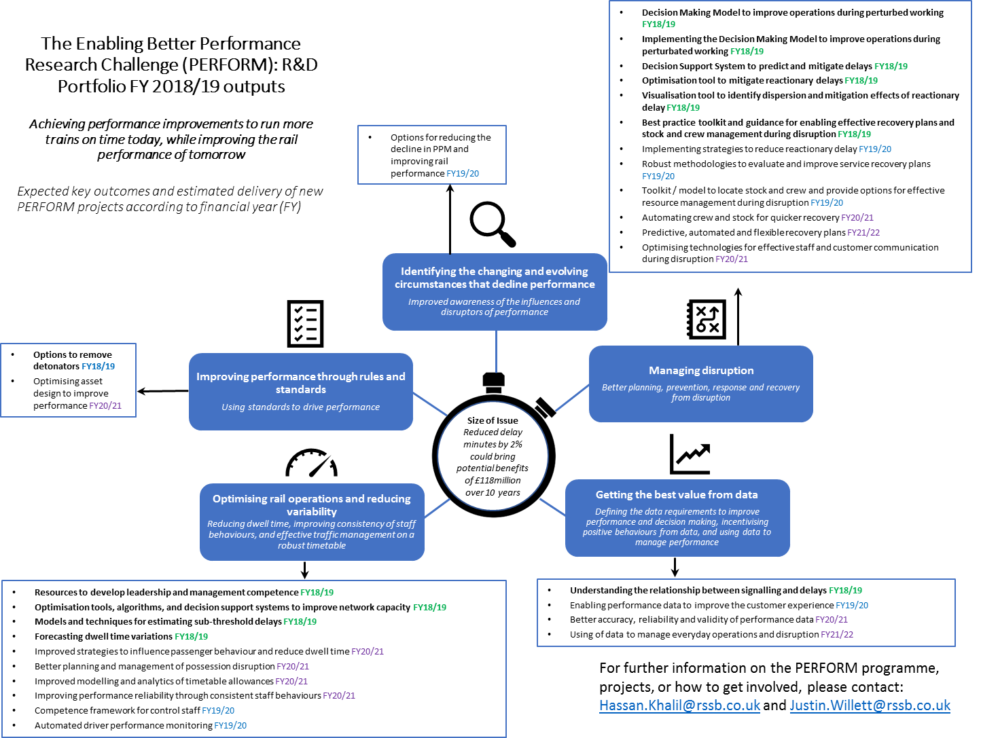
Appendix A

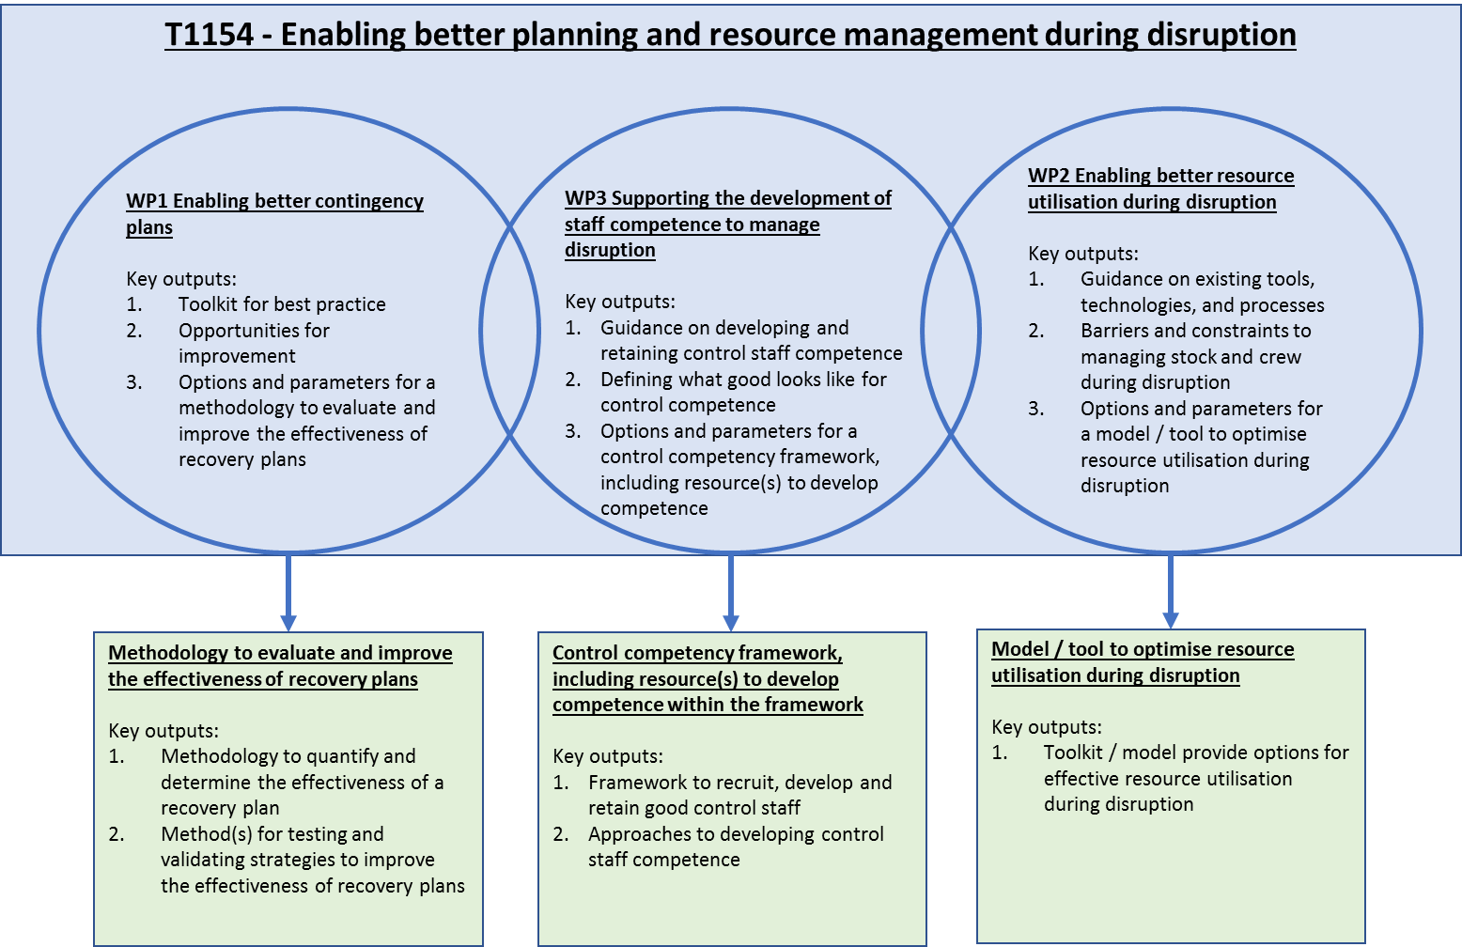
Appendix B

Selection and award criteria
Selection criteria
Heading | Specific question(s) | Evaluation Criteria
S1 Experience of the supplier in contingency planning, and resource utilisation and disruption management.  [Max 1 page] | Could you provide a short description of projects involving contingency planning, resource utilisation and disruption management, that you have delivered to clients over the last five years? Please provide one project for each and provide a short explanation of why they are relevant to our needs. | Pass: The tenderer provides RSSB with a strong degree of confidence in its experience involving contingency planning, resource utilisation and disruption management.  Fail: The tenderer either fails to provide evidence of example projects, or fails to provide RSSB with sufficient confidence in its experience of delivering projects involving contingency planning, and resource utilisation and disruption management.
S2 Experience of the supplier in work identifying and developing staff competencies.  [Max 1 page] | Could you provide a short description of projects involving identifying and developing staff competencies, that you have delivered to clients over the last five years? Please provide one project for each and provide a short explanation of why they are relevant to our needs. | Pass: The tenderer provides RSSB with a strong degree of confidence in its experience involving identifying and developing staff competencies.  Fail: The tenderer either fails to provide evidence of example projects, or fails to provide RSSB with sufficient confidence in its experience of delivering projects involving identifying and developing staff competencies.
S3 Experience of the supplier in Rail Operations and Performance.  [Max 1 page] | Could you provide a short description of at least two projects involving Rail Operations and Performance, that you have delivered to clients over the last five years? Please provide a short explanation of why they are relevant to our needs. | Pass: The tenderer provides RSSB with a strong degree of confidence in its experience shown in at least 2 projects involving Rail Operations and Performance.  Fail: The tenderer either fails to provide evidence of at least two example projects, or fails to provide RSSB with sufficient confidence in its experience of delivering projects involving Rail Operations and Performance.
S4 Strengths and key points of proposal  [Max 1 page] | Could you provide a short description a summary of the strengths and key points of the proposal | Pass: The tenderer provides RSSB with a 1-page summary of the strengths and key points of their proposal  Fail: The tenderer does not provide RSSB with a 1-page summary of the strengths and key points of their proposal
Award criteria
Heading | Specific question(s) | Evaluation Criteria | Weight
A1 Robust methodology and ability to apply it to client’s needs.  [Max 5 pages] | The tenderer provides a method statement of how it is intended to deliver against all aspects of the work package objectives of this work. This should include the good practice toolkit and defining the options and parameters to improving the effectiveness of contingency plans, control staff competence and utilising resources during disruption.  How will the defined options and parameters enable the delivery of the following projects:  - A methodology to evaluate the effectiveness of recovery plans and test possible improvements to the plan  - A decision support model for optimal resource management during disruption  - Resources that will develop staff competence and capability to manage disruption more effectively | The Tenderer’s response:  - Demonstrates their understanding of the objectives and provide a coherent and systematic approach to meeting all the objectives.  - Proposes a sound, impartial and credible methodology for undertaking the desk-based review, industry workshops / interviews, collation and synthesis of evidence and implementation support  - Has a clear approach to developing and implementing the good practice toolkit  - Explains how the approach taken to define the options and parameters will enable the development of further research expected from this project | 35%
A2 Independence, Knowledge and expertise in subject area  [Max 3 pages] | Detail the knowledge and expertise of the team who will be undertaking this work, relevant to the disruption contingency planning, resource utilisation, rail operations and performance.  How will the tenderer apply their knowledge, expertise and skills to meet the objectives of this work?  How will the team ensure fair, independent, and impartial outputs are delivered? | The Tenderer’s response includes:  - Evidence of their knowledge and expertise in the subject area.  - Evidence of their technical competence in disruption contingency planning, resource utilisation, rail operations and performance.  - Describes how they will apply their knowledge, expertise, and technical competence to deliver the objectives of this research.  - Evidence of team independence and impartiality. | 15%
A3 Competence in communication, and engaging and managing of stakeholders.  [Max 2 pages] | How will the tenderer manage and engage multiple stakeholders, including during the industry workshops / interviews, to ensure industry expertise is incorporated into the outputs of the work?  How will the tenderer manage and negotiate multiple stakeholder views to ensure the outputs provide a balanced, fair and unbiased representation of industry expertise in the outputs?  How will the tenderer engage and support stakeholders in the implementation support and good practice toolkit case study?  How will effective communication be achieved with key stakeholders? | The tenderer’s response demonstrates:  - Experience of effectively engaging and managing multiple stakeholders.  - Provides a well thought out and appropriate communication plan for communication between the tenderer and key stakeholders, to ensure the quality and content of the work is fit for purpose.  - The tenderer has detailed potential approaches for managing and negotiating multiple stakeholder views to ensure the outputs provides a balanced, fair and impartial evidence-base of industry expertise.  - The tenderer details how they will support stakeholders use the good practice toolkit during the implementation support workshops and case study exercise. | 10%
A4 Project Delivery and resources  [Max 2 pages] | Please identify the key roles and responsibilities that are essential to deliver the requirements of this work.  How will adequate allocation of appropriate resources be made against each deliverable?  How will the team ensure the quality and the content of the deliverables are fit for purpose?  What is the schedule that each task will be delivered against? | The tenderer’s response:  - Identifies relevant individuals to deliver the work and demonstrates that the mix of skills covered are appropriate to deliver the project.  - Provides a credible plan for delivering successful outcomes to time, quality and cost, including details of allocated effort to activities. | 10%
A5 Risks and opportunities  [Max 2 pages] | Tenderers should detail what risks and opportunities are foreseen in the delivery of the project. The tenderer should detail mitigating actions in relation to these risks, and how opportunities can be maximised.  What are the potential risks to this project? How will these risks be managed?  What are the potential opportunities that could be maximised during the delivery of this work? | The tenderer’s response:  - Identifies appropriate risks and opportunities through the use of a risk register.  - Identifies what mitigation actions will be taken with specific regard to each risk or challenge identified.  - Identifies approaches to maximising any opportunities through effective management. | 10%
A6 Cost of project | Provide a fixed cost for the project and the associated cost break down. Describe how and why this represents value for money. | - The tender with the lowest total cost will receive 100% of the available weighted score (20%).  Other Tenderer’s tenders will receive a pro-rated relative to the lowest cost according to the following formula:  Score of other tender = lowest tender total cost / other tender total cost x 100%. | 20%

PPM measures service punctuality as the total number of trains that arrive on time compared to the total number of trains planned. A train is currently considered ‘on time’ if it arrives at the end destination within five minutes for London, South East or regional services, and within ten minutes for long distance services. A train is considered CaSL should it arrive later than thirty minutes, or it is full/partly cancelled, or miss station stops. The MAA of PPM and CaSL provides an average score of performance measured from the previous thirteen periods.
In 2009/10, PPM and MAA was 91.2%, and performance above 90% was maintained for three subsequent years. In 2016/17, PPM MAA decreased to 87.7%, the lowest annual performance score since 2005/06. Meanwhile, the national CaSL for 2016/17 was 3.8%, the highest score reported since 2003/4. http://orr.gov.uk/__data/assets/pdf_file/0006/24756/passenger-freight-performance-2016-17-q4.pdf
Source Network Rail industry performance data
http://orr.gov.uk/__data/assets/pdf_file/0019/24832/passenger-rail-usage-2016-17-q4.pdf
https://www.networkrail.co.uk/running-the-railway/looking-after-the-railway/delays-explained/knock-on-delays/
Reactionary delay arises where trains that have been delayed by an incident delay other trains that were not directly involved. This leads to a ‘cascade effect’ which, in a worst-case, can lead to trains being delayed across an entire Network Rail route or even further afield as a result of a single incident.
The industry uses a computer system called TRUST (Train Running System – TOPS) which in turn is based on the Total Operations Processing System (TOPS). This is legacy computer system originally developed by the Southern Pacific Railroad in the 1960s, introduced by British Rail in the 1970s and still in use today despite being technologically obsolete. One of the limitations of TRUST is that only delays of 3 minutes or more between two timing points are identified. Delays of two or fewer minutes between timing points are not attributed to a cause and referred to as ‘sub-threshold’
http://d3cez36w5wymxj.cloudfront.net/wp-content/uploads/2018/01/29201549/National-Rail-Passenger-Survey-%E2%80%93-NRPS-%E2%80%93-Autumn-2017-%E2%80%93-Main-Report.pdf
http://orr.gov.uk/__data/assets/pdf_file/0006/24927/passenger-rail-service-complaints-2016-17-q4.pdf
For example, Information is currently available across various documents, including the Code of Practice for Contingency Planning for Train Service Recovery (RDG, 2013), Guidance on Incident Response Planning & Management (RSSB, 2008), Checklist for Major Incident Response (RDG, 2017) and Station Incident Response Planning (RDG, 2016).
For example, through the signalling system, TOPS, GPS, telematics, remote condition monitoring, TDs, High Performance Radio Frequency Identification, Wi-Fi.
S271 Crew Rescheduling for Disruption Management (RSSB, 2017)
The supplier will be supported by the project steering group and Better Operations Programme Board to access industry data, contingency plans, relevant reports / documents, and staff to participate in the workshops / interviews. The workshops will be led by the supplier, and where possible, RSSB may provide a venue at the RSSB Offices.
Planned future systems should align with the RDG stock and crew systems concept of operations, Traffic Management and Incident Management Systems.
S271 Crew Rescheduling for Disruption Management (RSSB, 2017) has done some work in this area that can be built upon.
Guidance for developing and maintaining staff competence can be found here: http://orr.gov.uk/rail/health-and-safety/health-and-safety-strategy/competence
The defined options and parameters for (a) the methodology to evaluate and improve the effectiveness contingency plans, (b) a decision support tool / model to optimise resource utilisation during disruption, and (c) a control competency framework, including resource(s) to develop competence within the framework.

