

|  |  |  |
| --- | --- | --- |
| Saffron Housing Trust | EPC Contract 2017-2019 | |
|  | | Property Team |

# Saffron Housing Trust EPC Contract 2017-2019

# Invitation to Tender

# Scope

# Saffron Housing Trust is currently reviewing its procurement of Energy Performance Certificates (EPC’s). We need to do this routinely to ensure that we are getting best value for money, as well as ensuring that we are keeping high standards of quality.

# Saffron is currently undertaking EPC’s where legislation requires us to do so. Therefore, properties that are subject to a change of tenancy, such as voids and mutual exchanges, require an EPC to be produced. We will also need EPC’s undertaken where it is required to access funding.

# Saffron Housing Trust has a dedicated budget for undertaking the production of EPC’s, and have an increase in budget to allow planned EPC’s to be carried out that will allow Saffron to undertake works directly targeting energy efficiency issues within our stock.

# The contract will be for 2 years, with a review after year 1 for the 2nd year of the contract. This will be based on the following points being met in year 1:

# Satisfactory adherence of Saffron KPI’s and Targets

# High levels of customer satisfaction

# Any changes to the benchmarked pricing for the potential 2nd year

# The success of any Cost Saving & Sharing Programme in year 1

# Continued company credit worthiness

# Compliance with Health & Safety Regulations

Expected available budget for year 1 will be up to £50,000 (including overheads & VAT) to capture a larger number of properties, with the second year being reduced to meeting legislation requirements only. The budget for year 2 will not be set and passed until March 2018.

# Completion of the Tender Document

It is important that the information requested is completed in line with the guidance given below. Failure to comply with this will be disadvantageous to your company as it may impact upon our final decision. Please break your responses into appendices matching the section that it is relating to.

## 3.0 Company Name and Contact Details

# Enter basic information about your company, providing full contact details.

## 4.0 Company Name and Contact Details

A working process, including completion information, and our required Key Performance Indicators will be supplied to the winning bidder. Once supplied changes to the KPI’s will only be acceptable with written consent from Saffron Housing Trust. You must confirm in your tender response that this is acceptable

## 5.0 Company Background

# This is your opportunity to sell your company to us. Please provide information on how long you have been in existence, your attitude to referrals, membership of trade organisations, Elmhurst, Stroma, PAS2030 and awards won etc. If you wish to include any letters of recommendation, these should be attached to the email or included as an appendix, in the hard copy.

## 6.0 Financial Viability

Saffron require a statement of the undertaking's overall turnover and, where appropriate, of turnover in the area covered by the contract for the last financial year. As with the scoring procedure listed below the credit worthiness of the contractor will be scored on a 1-100 rating. This score will form part of the tenders scoring along with the other sections requiring a response.

Saffron reserves the right to undertake its own investigation of the undertakings turnover and financial viability.

## 7.0 Number of Contractors Invited

Saffron will require a minimum number of 3 Contractors to be invited to complete this tender exercise, as per Saffron’s current finance & procurement policies. The contract will also be advertised via the Governments contracts finder web portal. This can be found at the following web address:

<https://www.gov.uk/contracts-finder>

## 8.0 Termination of Contract

If the contract is terminated we reserve the right to offer the work to the company who submitted the second most favourable tender, provided they maintain the rates and terms originally tendered.

## 9.0 Process & KPI’s

A working process, including completion information, and our required Key Performance Indicators will be supplied to the winning bidder. Once supplied changes to the KPI’s will only be acceptable with written consent from Saffron Housing Trust. You must confirm in your tender response that this is acceptable

## 10.0 Additional Information

# Saffron Housing Trust considers that this contract may be suitable for contractors that are small or medium enterprises (SME’s).

# Saffron ID badges will need to be supplied to any person(s) attending one of our properties and be displayed clearly whilst on site where the company does not provide its own identification system.

## 11.0 Contract & Due Diligence

# The form of contract will be a JCT Measured Term Agreement incorporating the contract price(s) extracted from the Tendering submission provided by the successful contractor.

## 12.0 Tender Scoring & Evaluation

The quotations received shall be evaluated on the basis of the most economically advantageous submission, with quality of services and work also being a significant consideration. Weightings for the evaluation shall be as follows:

* Price 60%
* Quality 40%

As part of this process we would like to get a feel for how your organisation operates, therefore can you comment on each section listed as needing a response, utilising the same section numbers as listed. We would also request that a representative from your organisation can be available to attend a meeting to discuss any matters further if required. Quality will form **40%** of the final scoring exercise.

Each heading, requiring a response, will be scored 1 to 10 with 10 being the best score. Any areas requiring a response that are not answered will be awarded an automatic score of 0.These scores will be based on the quality of your response, rather than the quantity of the written response.

The following table gives a brief overview on how the scoring and judgement will be assessed:

|  |  |
| --- | --- |
| **Score for**  **Assessed**  **Questions** | **Judgement** |
| 0-1 | Statement/Response is unsuitable and / or suggests unacceptable risk |
| 2-3 | Statement/Response fails to meet requirements in a significant way |
| 4-5 | Statement/Response fails to meet requirements in some way |
| 6-7 | Statement/Response meets all the requirements |
| 8-9 | Statement/Response exceeds requirements and adds some value |
| 10 | Statement/Response exceeds requirements and adds significant value |

The following sections will need a direct response, and each response will be worth a maximum score of 10 points each. A basic response that meets all requirements will be scored in the 6-7 points band. A truly exceptional response that adds extra value to the tender submission/contract can be awarded up to 10 points. The following sections require a direct response, with the remaining sections acknowledged and confirmed in your tender submission:

The financial, credit worthiness, of the contractor will be scored on a 1-100 rating based on the scoring mechanism supplied by Company Check.

The cost based scoring will be based on the lowest priced bidder being scored at 100%. Each subsequent bidder will then be scored, as a percentage, against the lowest bidder’s submitted pricing. Whilst pricing makes up 60% of the scoring, having a well thought out and detailed quality response will be very important in the overall scoring, and awarding, of the contract.

The following sections will need a direct response or, at the very least, an acknowledgement that you will comply with the relevant statements:

|  |  |  |
| --- | --- | --- |
| 3 | 4 | 5 |
| 6 | 7 | 9 |
| 10 | 11 | 12 |
| 13 | 13.1 | 14 |
| 15 | 16 | 17 |
| 18 | 19 | 20 |
| 28 | 29 |  |

Therefore, a maximum score 200 points available for the successful answering of each of the numbered sections.

# 13.0 Health & Safety

|  |  |
| --- | --- |
| Do you operate a Health & Safety Policy?  Is it being supplied as evidence  If **Yes**, please attach a copy for our records. | Yes / No  Yes / No |
| Have you reported any RIDDOR (Reporting of Injuries, Diseases and Dangerous Occurrences Regulations) incidents within the last 3 years:  If **Yes**, then please supply details in your tender response. Other points that will need to be responded to are as follows: | Yes / No |

# 13.1 Equal Opportunities

|  |  |
| --- | --- |
| Do you have an Equal Opportunities Policy?  If **Yes**, please attached a copy for our records: | Yes / No |
| If **No**, do you agree to adopt the Saffron Equal Opportunities Policy when working for Saffron? | Yes / No |

# 14.0 Customer Contacts & Procedure

# Explain here, in full detail, how customers are contacted when a referral is received. Include further attempts that are made to contact them, if the initial attempt is unsuccessful. If messages are left on answer phones or voice mail, and no response is received within a certain time, what further attempts are made to speak with the person within what timescales? When do you stop trying? Do you write to them? How will they know you’ve tried to contact them?

## 15.0 Installation Times and overall referral Capacity

# Please include detailed responses to the following points regarding installation times and overall capacity of your company:

**15.1** Average time to inspect a property after the receipt of a referral from Saffron Housing Trust

**15.2** Average time to produce an EPC after the receipt of a referral from Saffron Housing Trust

**15.3** Maximum number of referrals per month from Saffron Housing Trust which can be inspected and EPC’s produced

# The winning bidder will be issued with Saffron’s KPI’s and profile of inspections based on the responses to the installation times and overall capacity questions above.

## 16.0 Staffing

# It is Saffron’s preference that all companies employ their own staff on Saffron Housing Trust referrals and do not use sub-contractors. This is to ensure that in the event of any difficulty, Saffron Housing Trust knows exactly who to contact and to ensure that the invoicing for completed certification is as simple and transparent as possible. However, if a third party company is to work on Saffron referrals then prior agreement must be sought in writing.

# Please make it clear in this section whether or not you intend to use third party contractors from the beginning of the contract or whether there is potential to use them throughout. Also, please detail whether staff that will be visiting Saffron’s stock will have any company uniform, vans, identification etc. Saffron will provide saffron I.D badges to the winning bidder.

# 17.0 Professional & Technical Standards

# All applicants are expected to be members of an accredited body in order to produce EPC’s, and as such to abide by their Codes of Professional Practice. All applicants are also expected to work to industry technical standards (conventions), as recognised by their accreditation schemes. Should standards be superseded by new ones, then applicants are expected to abide by these revised standards. All applicants will be expected to confirm that they abide by relevant standards.

# As Saffron has a working relationship with NHER (now Elmhurst) Accreditation, the successful company will need to be able to lodge EPC’s through their scheme. We would also need to be supplied with the PRRN of the lodged EPC, the email address of the assessor lodging the EPC and a copy of the assessment form which shows the floor plan. We do not necessarily require a dedicated floor plan to be produced, but a scan of the assessment form, showing the floor plan, is beneficial.

# 18.0 Complaints Procedure

# Saffron Housing Trust understands the difficulties that can arise when delivering a contract and that the odd complaint may be received. Whilst we would all prefer that no complaints are lodged, the important thing is how they are handled when they arise.

# Detail here how your complaint system works and how you will liaise with both Saffron and its tenants to resolve any complaints.

# 19.0 Key Company Contacts

# Please enter your preferred point(s) of contact within your company to make Saffron Housing Trust aware who to contact if/when you are accepted as the winning contractor. Saffron would always prefer one point of contact for contracts, but we understand one person cannot always be available at all times.

# 20.0 Pricing

# Saffron will be looking to undertake up to 1000 EPC’s in the next two years. This could be increased if extra budget is available or may be reduced slightly if there is a sudden change in financial situation. Therefore, based around approximately 500 EPC’s each financial year, please place the prices as charged in the table below, including VAT. If you are VAT exempt, please make this clear in your return tender email/document. Saffron will expect that all fuel costs, VAT etc. are built into the price for the EPC’s.

|  |  |
| --- | --- |
| Per Energy Performance Certificate (exc. VAT) | £ |

Discretionary mileage costs can be discussed when a single property requires an EPC that is outside of Saffron’s core area of business.

# Please list in this section if you have any thoughts on cost saving and sharing and how you feel this could be implemented to work in the contract with Saffron Housing Trust. Should the need arise, Saffron reserves the right to request further clarification prior to awarding the contract.

# 21.0 Location

# As listed above, please ensure that all costs, including fuel, is rolled into the cost per certificate. Saffron’s stock covers a large section of Norfolk (as well some areas outside of Norfolk) so travelling will need to be taken into account. Properties can be grouped together as best as possible to try to minimise the amount of mileage covered.

As part of the contract it would be expected that properties outside of the core area would be treated to the same terms and conditions (with the exception of discretionary mileage costs) as the properties within the core area. See the map below for coverage information;

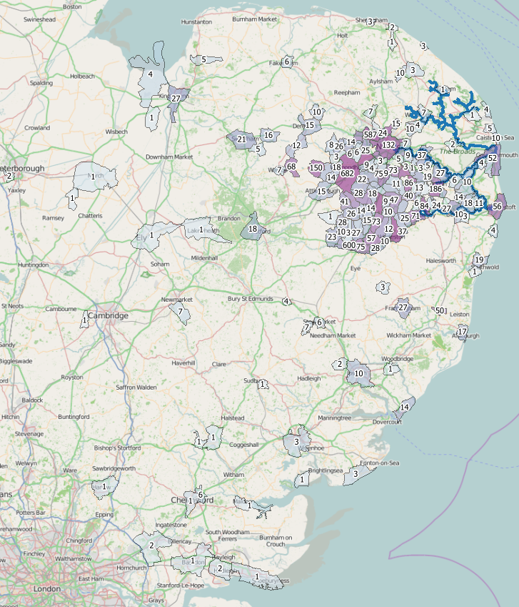

**22.0 Queries**

Any queries to this benchmarking submission should be raised via email to Saffron Housing Trusts Procurement officer at [tenderenquiries@saffronhousing.co.uk](mailto:tenderenquiries@saffronhousing.co.uk). To prevent distortion of competition, Saffron Housing Trust does not enter into negotiations prior to full submission and uses best endeavours to ensure that any queries raised and subsequent answers given during the tender process are shared with all participating parties.

# 23.0 Tender Returns

Tender submissions shall be returned fully completed to Saffron Housing Trust. The adjudication process is usually completed within three weeks of receipt and the award will be made within 5 working days from the end of the evaluation. The tender will be evaluated on a ratio of 60/40 with 60% being based on price.

*Returns that are not supplied in the prescribed format will be considered void*

The winning bidder will be expected to sign a Measured Term JCT agreement. Also, if not already a member of Saffron’s approved contractors list, the winning bidder will be expected to apply to join. The winning of the tender will not guarantee a place on the approved contractors list if the winning bidder cannot supply all the required information.

Benchmarking submissions should be returned by the 1st June 2017. These can be sent through via email as digital copies;

Procurement Officer

Saffron Housing Trust

Helen House

Chequers Road

Tharston

Norwich

NR15 2WZ

[tenders@saffronhousing.co.uk](mailto:tenders@saffronhousing.co.uk)

Or as hard copies in envelopes marked private & confidential to:

Financial Controller

Saffron Housing Trust

Helen House

Chequers Road

Tharston

Norwich

NR15 2WZ

**24.0 Award**

By issuing this invitation, Saffron is not bound in any way, and does not have to accept any tender. Saffron reserves the right to not award a contract, or to accept the whole, or any specified part of the tender.

**25.0 Contract Dispute Resolution**

This will follow the procedure set down in the winning bidders JCT agreement

**26.0 Contract Exit Clauses**

Exit clauses will be written into the JCT agreement for any serious breach of the law, health & Safety or continued contract performance failings.

**27.0 Insurances**

Saffron Housing Trust requires the successful Contractor to have the following insurances before being able to carry out any works on its behalf or its stock; the question on whether you have/willing to take out the required levels and types of insurance were built in the PQQ document. However, please confirm and submit evidence that these are currently in place, or confirmation that they will be before commencement of the contract.

|  |  |  |
| --- | --- | --- |
| **Please indicate which of the following current insurances you hold:** | **Yes/No** | **Indicate the level of indemnity:** |
| Public Liability:  (Minimum cover £5m) | Yes/No |  |
| Product Liability: | Yes/No |  |
| Professional Indemnity: | Yes/No |  |
| Employers Liability:  (Minimum cover £5m) | Yes/No |  |
| Contractors all Risk: | Yes/No |  |

**28.0 Data Protection Act**

Saffron endorses and adheres to the Data Protection Act 1998. Saffron regards the lawful and correct treatment of personal information as very important to successful operations and to maintaining confidence with our customers. It will ensure that any document retained in whatever format will be done so in accordance with this legislation.

Saffron will supply all data either by way of encrypted Microsoft office documents or by encrypted zip files that contain items such as work tickets that contain tenant’s details. Passwords will be supplied separately by a different form of communication, such as by a phone call to the person designated by the contractor to be responsible for that data.

Please confirm that your company adheres to the Data Protection Act 1998 and how you deal with data retention once the works are complete.

**29.0 Equality Act**

1. The Contractor and any Sub-Contractor employed by the Contractor shall adopt a policy to comply with employers’ statutory obligations under the Equalities Act 2010 and, accordingly, will not discriminate directly or indirectly against any person because of their colour, race, nationality or national or ethnic origin in relation to decisions to recruit, train, promote, discipline or dismiss employees.
2. The Contractor and any Sub-Contractor employed by the Contractor shall observe as far as possible the Commission for Racial Equality’s Code of Practice for Employment as approved by Parliament in 1983, which gives practical guidance to employers and others on the elimination of racial discriminations and the promotion of equality of opportunity in employment.
3. In the event of any finding of unlawful racial discrimination being made against the Contractor or any Sub-Contractor employed by the Contractor during the contract period by any court of industrial tribunal, or of any adverse finding in any formal investigation by the Commission for Racial Equality over the same period, the Contractor shall inform Saffron of this finding and of the steps taken to prevent repetition of the unlawful discrimination.