**National Army Museum Trading Limited**

Brief for the provision of Guidebook Design and Print Services

November 2016

**Contents Page**

**1. Introduction 3**

**2. Scope of works 4**

**3. Budget 6**

**4. Copyright 6**

**5. Schedule 7**

**6. Tender process 7**

**7. Appendices 12**

For information:

Appendix A: Background to the National Army Museum Appendix B: Our Audiences Appendix C: A New Brand

For action:

Appendix D: Form of Tender

Appendix E: Certificate of Bona-Fide Tender

Appendix F: Supplier Statement

Appendix G: Pricing Schedule

Appendix H: Confidentiality Agreement

**1. Introduction**

The National Army Museum (NAM) is transforming and currently completing a major redevelopment project called Building for the Future. The project sees the wholesale transformation of the Museum building, galleries, archive, learning, retail, cafe and visitor services as well as a radical change in every area of the Museum’s work which is underpinned by a new brand and ethos.

To compliment the Museum offer, extending the visitor experience and supporting National Army Museum Trading Limited (NAMTL) objectives the Museum is looking to appoint a suitably qualified and experienced company to provide an innovative official guidebook which will be on sale, online and at transactional spaces inside the Museum.

The guidebook is a key commercial product and whilst also delivering high volume sales and commercial return it must also be a reflection of the Museum’s brand and values. As such the company appointed must be able to translate the brand whilst ensuring the product is both commercially attractive and viable.

If you want to help us deliver this product, and are interested in tendering for this, this document provides the following information:

* Scope of works
* Schedule
* Tender Process

We would welcome your application to work with us.

**2. Scope of works**

NAMTL is ideally seeking to appoint a single company to design, edit, print and provide call off delivery services for the new official Museum guidebook. It must translate the brand and values to reflect the new Museum; it’s rich collection and new galleries.

The appointed company will be expected to deliver a creative and innovative solution on time and must meet the Museum’s aims as set out in the brief and in any subsequent briefings.

The museums transformation into a state of the art space must be reflected in the guidebook provision and therefore the Museum is seeking both printed and digital versions of the guide and the design should translate across media.

The contract will be to run for a 1-year period from Dec 2016 – November 2017, with the option to extend for up to an additional two further years at the end of Nov 2017.

**2.1 Design and editing services**

2.1.1 Design

* To develop the design treatment (print and online) for the guidebook utilising the guidelines, design brief and subsequent client feedback on the creative treatment submission.
* Prepare and provide sample pages for consideration and approval
* Prepare and provide full page layouts to include cover for consideration and approval
* Produce final artwork for approval by NAM and NAMTL including a mock up of the final design if required.

2.1.2 Copyedit service

* To provide copy editing services for the guidebook content using NAM’s house style and tone of voice guidelines.
* Provide revised copy for NAM and NAMTL to review and comment

**2.2 Print and delivery services**

**2.2.1 Specifications**

a) Size

* 235 x 170 mm
* 4pp cover
* 56pp text and images

b) Materials

* Cover sections 350gsm, matt coated, FSC certified product
* Text sections 150gsm, matt coated, FSC certified product

c) Finishing

* Fold, gather sections
* PUR bind
* Cover
* Trim flush
* Pack

**2.2.2 Print and delivery**

* Up to 30,000 initial print run
* Storage and call off stock delivery service

**2.3 Project management**

* Prepare a derailed programme for delivery of the project
* Liaise with NAM to ensure content deadlines are met
* Prepare a final budget for the project based on the agreed design solution(s)
* Ensure initial guidebook delivery date is met and set out procedures for call off stock service

**2.4 NAMTL’s requirements in fulfilling these services**

NAMTL is looking for a company with the ability to deliver this programme if works as a complete package. We are therefore looking for a company, which can take a holistic approach and facilitate all elements of this brief.

Ideally we are seeking one supplier to deliver this project, in order that the final product is consistent. However we would welcome quotations which include the use of subcontractors. All references must be provided as part of the tender submission and the main contractor must manage these sub contractors.

As a start you will have:

* Previous experience and success in creating and delivering engaging guidebooks
* Ability to translate a brand through visual communication
* Previous experience of producing guidebooks for a Museum or Visitor attraction
* Ability to maintain high-volume, high quality print whilst meeting tight deadlines

NAM and NAMTL will provide:

* Design briefing documentation including guidebook structure approach
* All text and image assets
* Brand and house style materials

In order to receive these documents, interested companies must sign and return a non-disclosure agreement. To request this information please contact [dwatkins@nam.ac.uk](mailto:dwatkins@nam.ac.uk)

**3. Budget**

NAMTL has a target RRP fir the Museum guide of £4.50 and is seeking to maximise the margin of the product.

In order to ensure the clear comparison of submissions a detailed price breakdown for submissions, at appendix, is provided.

All costs for individual elements detailed in the response must be fully disclosed along with all calculations.

Quoted fees must include all of the following:

1. Professional fees
2. Development, research and design costs
3. Print, delivery and storage costs
4. Travel and expenses
5. Accommodation
6. Disbursements
7. An estimate of any contingency
8. All third party fees
9. Report, printing and presentation costs
10. All other expenses and costs required in the delivery of the project.

The fees should indicate if they include or exclude VAT.

**4. Copyright**

It must be noted by the designer that all rights (including ownership and copyright) in any reports, documents, specifications, instructions, plans, drawings, patents, models or designs whether in writing or on other media:

1. Provided or made available to the designer by NAM shall remain vested in NAM.
2. Prepared by or for the designer (or any subcontractors employed or contracted by the designer) for use, or intended use, in relation to this project will be assigned to and shall vest in NAM absolutely.

The contractors should therefore allow for such vesting rights to be included within the fee bid.

**5. Schedule**

NAM would like to discuss the delivery schedule in detail with the appointed company as part of the discovery phase. However, the following list provides some indicative delivery milestones.

* **Dec 2016** – Project kick-off, commencement of design development, handover of text and delivery schedule sign off
* **Jan 2017** – Handover of final text and non gallery related assets and sign off of full page layouts
* **Feb 2017** – Handover of gallery related assets and final proof
* **March 2017** – First delivery drop completed guidebook

**5. Project team**

**Project sponsor team**

Ian Maine – Assistant Director (Collections)

Sophie James – Buyer and Merchandiser

Peter Johnston – Collections and Development Review Manager

Russell Clarke – Exhibitions and Interpretation Manager

**Project manager**

Dawn Watkins – Assistant Director (Commercial & Visitor Experience)

**6. Tender process**

**6.1 Tender requirements**

Proposals should comprise the following.

**6.1.1 Response to brief**

Response to the brief should demonstrate:

* An illustrative response to the brief with any thoughts about further development, limited to 2no. responses
* An clear methodology statement for the development and delivery of the works detailed in section 2
* An outline work plan identifying key milestones and sign off points informed by this brief
* Confirmation of team members, including sub-contractors if relevant.
* Cost plan detailing the tasks and staff responsibilities, daily and hourly rates and expenses.

**6.1.2 Tenderers project team, qualifications and experience**

Provide details of three relevant projects that demonstrate qualifications and experience. For each project, include a description of the project, you, your company’s and/or sub-contractors’ role, client, budget and project dates.

**6.1.3 Fee**

The Fee is to be a fixed sum for the provision of all Works as outlined in the Scope of Works.

The Fee is to include all expenses. This will include travel costs, accommodation, disbursements, reports and all other expenses and costs required in the provision of the Works. The fee should exclude VAT at the prevailing rate.

**6.1.4 Instalment payments**

Provide a suggested fee drawdown schedule in your response. NAM reserves the right to amend any suggested drawdown schedule.

**6.1.5 Insurance**

Please provide copies of up-to-date insurance - NAM requires Public

Liability with a minimum of £10 million, Employers Liability with a minimum £10 million and Professional Indemnity Insurance to the value of £2 million.

**6.1.6 References**

Provide reference details of three recent contracts that are relevant to this project. Include the name and contact details of the clients’ representatives who could be approached for references. References will be taken up before confirmation of appointment.

**6.1.7 Financial**

Please provide a copy of the company’s published accounts for the last three years.

**6.1.8 All company documentation as requested below:**

* The completed Form of Tender (Appendix E)
* The completed Certificate of Bona-Fide Tender (Appendix F)
* The completed Supplier Statement (Appendix G)
* The completed detailed price breakdown (Appendix H)
* All forms (Appendix E,F,G,H) should be signed by the Tenderer or, in the case of a Company by the Secretary or other authorised person
* Any other information that is required to clarify the tender.

**6.2 Tender submission**

Tenders should comprise 2x hard copies and 1 x electronic on DVD/memory stick of all tender content as outlined below:

* NAMTL Guidebook Design and Print Proposal
* The completed Form of Tender (Appendix A)
* The completed Certificate of Bona-Fide Tender (Appendix B)
* The completed Supplier Statement (Appendix C)
* Any other information that is required to clarify the tender.

**6.3 Tender return**

* Tenders must be submitted no later than 1200hrs on 5th December in a plain envelope labelled only with the address below and clearly marked “Tender – NAMTL Guidebook Design and Print Proposal”. No other marks or wording (including pre-paid franked stamps), which might indicate the identity of the sender, shall appear on the envelope containing the tender.

The tender shall be submitted to:

Mr John Foster

National Army Museum

Royal Hospital Road

Chelsea

London SW3 4HT

Tenders can also be returned via email at the above date and time to: jfoster@nam.ac.uk. The subject of the email should state “Tender –Visitor Experience and Front of House Proposal”. Any electronic tenders received before this date will be rejected.

Tenders are to remain open for acceptance for a period of 60 days.

**6.4 Tendering costs**

NAM will not be responsible for or pay for any costs or expenses that are incurred by any tendering consultant in preparing and submitting their tender.

**6.5 Contract award criteria**

The tender board may consist of the following NAM representatives:

* Assistant Director (Commercial & Visitor Experience)
* Assistant Director (Collections)
* Retail Buyer and Merchandiser
* Exhibitions and Interpretation Manager

Tenders will be assessed on the following criteria:

* Response to brief **30%**
* Qualifications and Experience **20%**
* Project Team and Resourcing **20%**
* Fee  **30%**

Each proposal will be given a score. A proposal considered to be unsuitable shall be rejected at this stage if it does not respond to important aspects of the brief. NAM shall notify unsuccessful tenderers of the rejection of their proposal after completing the selection process.

Tenders will be awarded on the absolute discretion of the Board of NAM, in accordance with internal policies and statutory regulations. NAM is not required to accept the lowest priced tender.

The decision will be final and binding, no correspondence will be entered into.

**6.6 Tender programme**

The key dates in relation to this tender exercise are detailed below.

|  |  |
| --- | --- |
| **Activity** | **Date** |
| Brief issued | 14 November 2016 |
| Tender submission deadline | 12:00hrs 5December 2016 |
| Notification shortlisted candidates | 5December 2016 |
| Interviews | 8 December 2016 |
| Appointment of chosen company | 9 December 2017 |
| Initial project start up meeting – agreement of timings going forward | w/c 12 December 2016 |

The above programme is indicative of NAM’s timescales. However, the project sits within the BftF Master Programme and may be subject to alteration.

The forward programme will be developed in discussion with the appointed company.

**6.7 Enquiries**

Any enquiries arising must be submitted in writing via email to:

Dawn Watkins, Assistant Director (Commercial and Visitor Experience), National Army Museum

Email: dwatkins@nam.ac.uk

Enquiries will be answered within three working days.

**Appendix A : Background to The National Army Museum**

**A new Museum**

In spring 2017, a new national Museum will open in London. The Museum’s vision is bold. To use its rich historical and developing contemporary collections to foster people’s awareness, understanding and knowledge of the British Army, its soldiers and legacy. And through this exploration, encourage debate about an institution that is little understood but is intrinsically part of our democratic society and enables us to live with the freedoms we enjoy everyday.

**Building for the Future**

This new Museum is being created through the auspices of the *Building for the Future* (BFTF) project. Set to cost £23.75million, the project has been funded by a Heritage Lottery Fund grant of £11.5m, with the remainder covered by fundraising carried out by the Museum.

The project is realising the wholesale transformation of the Museum’s offer onsite, offsite and online, across seven main work streams.

**1. A wholly new visitor experience.** A major restructure of the building has created: five new thematic galleries – Soldier, Army, Battle, Society, Discovery; a new 500m2 temporary exhibition gallery; a new three-room learning centre; a new early years learning facility – Play Base; a new research centre and archive; new café; new shop; new boardroom. All are being realised within a building designed to create a more welcoming and engaging physical experience and supported by a fresh approach to public programming (see below).

**2. New programmes for learning and outreach.** The closure of the Museum has provided unprecedented opportunities to pilot new approaches to delivering our learning purpose and to test how the Museum can extend its reach whilst also providing the depth and breadth of offer required of a national museum. On opening the Museum will offer relevant, thought provoking and challenging opportunities to engage with the Collection and our stories through community engagement and curation, new learning services aimed at early years, schools, families, adults and lifelong learners, and new a public programme that seeks to encourage active participation and debate in a wide range of topics from military history to present day conflicts and world geopolitics. It is a place that will spark conversations.

**3. New working models of service delivery and public engagement.**

The project has enabled the Museum to review its structure, the ways it fulfils its purpose, the services it offers and its enabling and supporting systems and processes. As the project moves into delivery phase, new teams, processes, services and training are being put in place to deliver an audience-focused, commercially sustainable and more goal driven organisation. This is being facilitated by new working models with a focus on process and cross-departmental and cross-divisional collaboration.

**4. A sharper focus on generating income.** The new visitor experience whilst creating a more welcoming and engaging physical experience has also sought to ensure a focus on facilities and activities to drive earned income. In order to achieve this commercial spaces and the overall offer within the Museum have been designed to be visible, enticing and reflect the growing expectation of Museum audiences.

**5. Better conservation of and access to the Collection.** The project has enabled the conservation of thousands of objects for the new displays. In addition, it has enabled a significant programme of digitisation that will provide easier and greater access to the Museum’s national archives online that through an accompanying cataloguing and external partnerships, will provide a modern, flexible and customer-centred online enquiry services, aimed at meeting the needs of a broad range of researchers from the school pupil to the family historian to the expert academic.

**6. A new brand and marque**

During 2014-15 the Museum worked to create a new brand model to help direct and inform the development of the new Museum. It has influenced every aspect of the new Museum, from permanent displays, to interior design to signage to the extent that the new building physically embodies the new brand, helping to transform the Museum from a dark and traditional place to a modern, bright, and relevant Museum fit for the 21st century.

**7.** **Going digital.** Digital transformation underpins much of the new Museum’s work. Whilst attention is necessarily focused on what needs to be done to deliver the modern services expected of a 21st century museum. The creation of the Museum’s new website is seen as the first step in a medium- to long-term digital journey that will see a wholesale review, modernisation and streamlining of the Museum’s systems as digital becomes central not only to realising efficiencies but to delivering a world-class national museum service, locally, nationally and internationally. Digital is central to the Museum achieving a greater sphere of influence and impact and in developing brand awareness.

**Appendix B : Our Audiences**

**The Museum’s audience segments**

As part of *Building for the Future*, the Museum has undertaken extensive audience research, working with market research company Morris Hargreaves McIntyre. This work identified the following seven market segments for the Museum *before its closure in 2014*. The Museum has used these segments to guide the development of the exhibitions and services within the project and to target and monitor audience development work to date within the delivery of the *Building for the Future* Activity Plan.

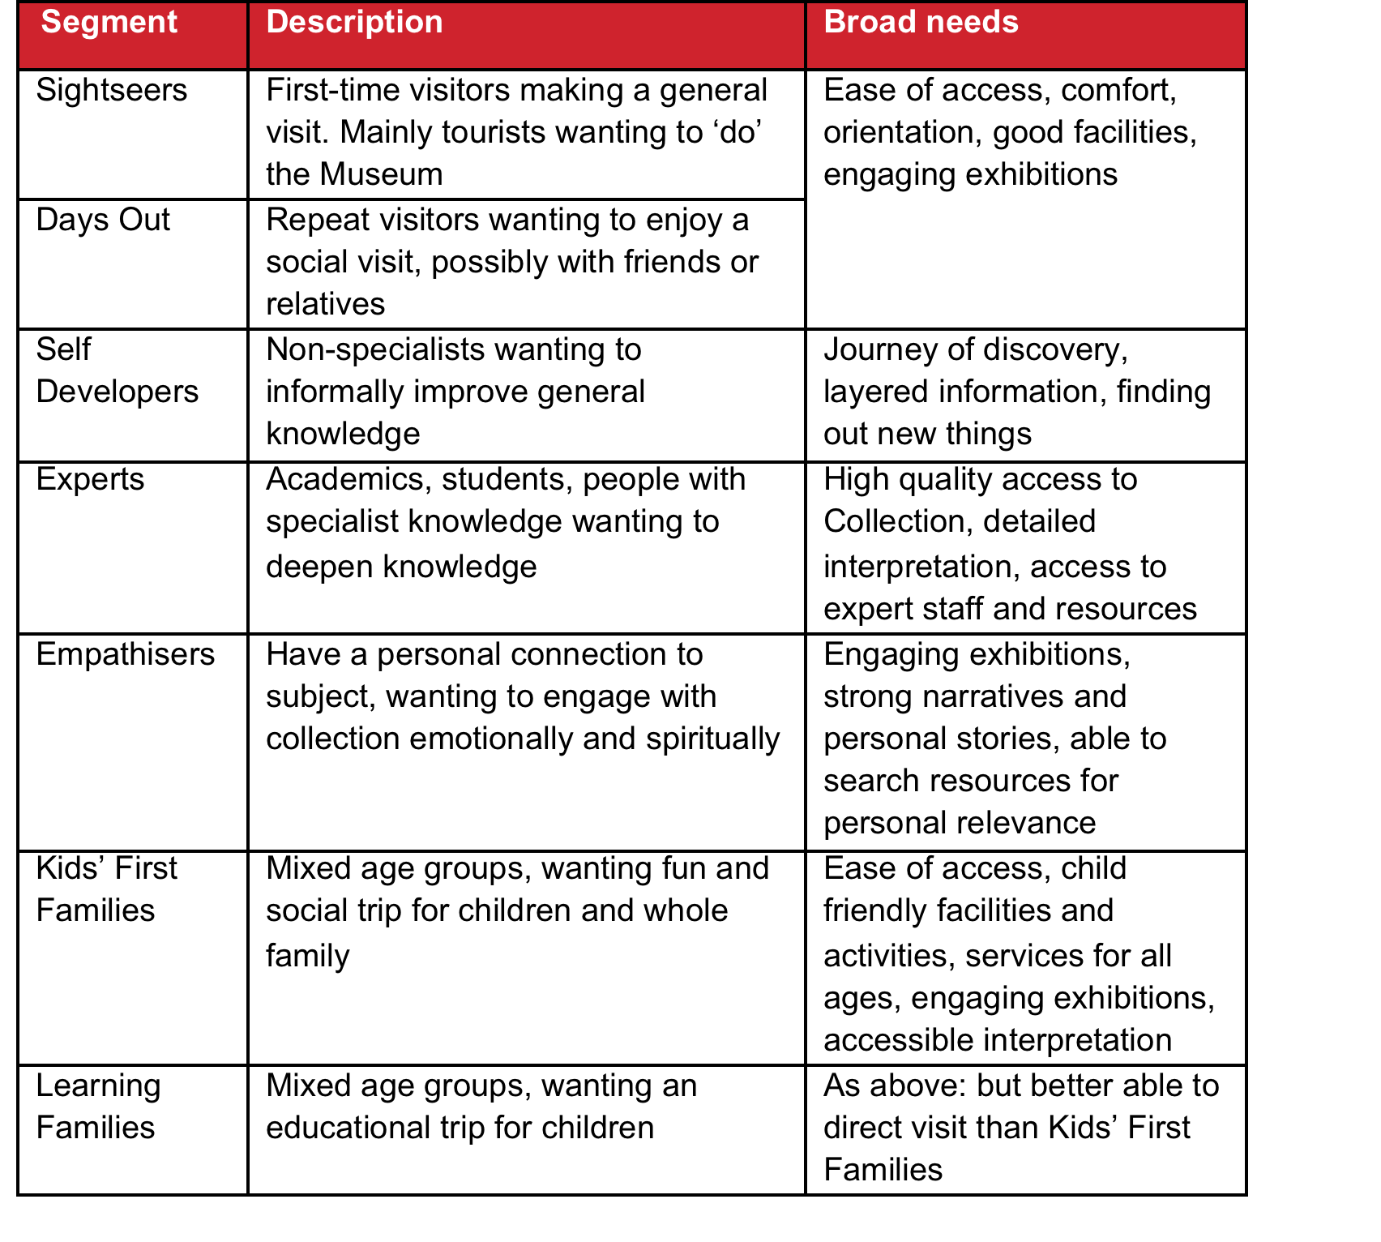

Figure 1: National Army Museum - Visitor segmentation

On opening, the Museum will continue to engage with eachthe above segments but there will be a particular focus on the following audience segments that have been identified as having the strongest potential for growth in visitor numbers:

* Learning Families
* Kids' First Families
* Empathisers
* Self Developers.

Of these, Learning Families and Kids' First Families will be further prioritised. Whilst project also expects to attract a greater number of curiosity-driven first time visits amongst Sightseers – either from the UK or overseas – these are not seen as a high priority in the short-term.

An important strategy in achieving this growth is to grow participation to reflect the population diversity of modern Britain particularly certain demographic groups who are under-represented in the Museum’s pre-closure audiences:

* Women
* Non-specialists
* Local residents from such culturally and socially diverse boroughs as Southwark, Wandsworth, Hammersmith and Fulham and Lambeth.

In addition, the Museum will continue to build relationships and deepening engagement with:

* Schools – particularly from local socially and culturally diverse boroughs in London
* Students and academics – in military history; social history; politics
* Members of the armed services – active and retired.

And as the Museum seeks greater participation and breadth in its audiences, it is looking to improve participation across Black, Asian and Minority Ethnic (BAME) groups, disability groups, young people, older people and N-Sec 5-8, continuing the work achieved through the Activity Plan.

**Appendix C : A new brand**

As part of *Building for the Future*, the Museum has developed a new brand and approach to visual communications.

The new brand model was developed in 2014-15, and has guided the development of the Museum – from the galleries themselves to the interior design of the Museum and its facilities – the new Museum is literally a physical manifestation of the new brand rather than it being applied after the design of the new Museum.

Whilst detailed information will be provided to the successful consultant, NAM’s new brand model is provided here to convey the nature of our new brand

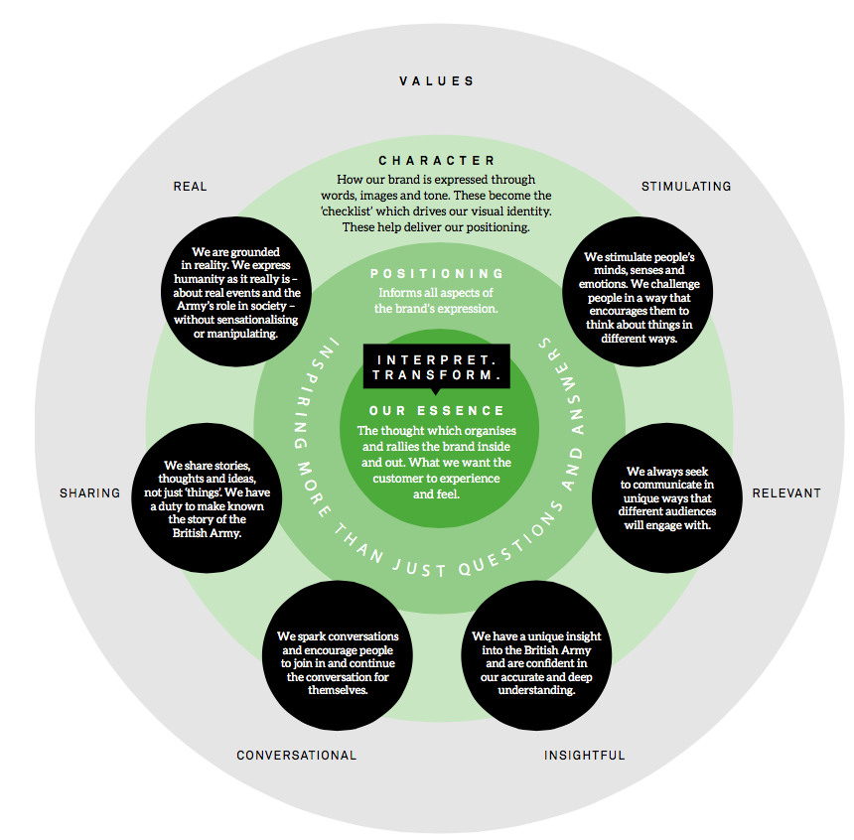

**Appendix E: Form of Tender**

Tender for: National Army Museum Trading Limited Guidebook Design and Print Project

To: The Council and Director of the National Army Museum

Sirs,

I/We the undersigned, having examined the enclosed tender documents and Appendices, do hereby offer to execute and complete in accordance with the said documents the works described therein:

For the sum as listed in the attached document:

Tenderer Reference:

I/We hereby affirm our agreement to enter into a contract with the Council of the National Army Museum for the due performance of the Works in the form described by the above said documents.

I/We have completed the Certificate of Bona-Fide Tender included in this document.

I/We understand that the Trustees are not bound to accept the lowest or any tender which may be received nor or responsible for any cost incurred in the preparation of any tender.

I/We declare that this offer is to remain open for acceptance for a period of 60 days from the date fixed for the receipt of tenders.

Signed: ____________________________________________________

In the capacity of

Duly authorised to sign the tender on behalf of:

Date:

**APPENDIX F: CERTIFICATE OF BONA-FIDE TENDER**

Tender for: Tender for: National Army Museum Trading Limited Guidebook Design and Print Project

I/We certify that this is a bona-fide tender and that I/we have not fixed or adjusted the amount thereof by or under in accordance with any agreement or arrangement with any other person.

I/We also certify that I/We have not done and I/We undertake that I/we will not do at any time any of the following acts:

1. Communicate to a person other than the person calling for these tenders the amount or approximate amount of the proposed tender except where the disclosure, in confidence, of such amount(s) was necessary to obtain insurance premium quotations required for the preparation of the tender.
2. Enter into any agreement or arrangement with any other person that he shall refrain from tendering or as to the amount of any tender to be submitted;
3. Offer or pay or give or agree to pay or give any sum of money or valuable consideration directly or indirectly to any person for doing or having done or causing or have caused to be done in relation to any other tender or proposed tender for the said work any act or thing of the sort described above.

In this certificate the word “person” includes any person and any body, association, corporate or un-incorporated; and “any agreement” includes such transaction, formal or informal, and whether legally binding or not.

Signed: ____________________________________________________

In the capacity of

Duly authorised to sign the tender on behalf of:

Date:

**APPENDIX G: SUPPLIER STATEMENT**

We certify that the information supplied is accurate to the best of our knowledge and that we accept the conditions and undertakings requested in the assessment. We understand that false information could result in our exclusion from the Tender process or the Approved Suppliers List at any time, even after initial inclusion. We also understand that it is a criminal offence to give or offer any gift or consideration whatsoever as an inducement or reward to any servant of a public body and that any such action will empower such body to cancel any contract currently in force and will result in exclusion from the Tender and / or the Approved Suppliers List.

Signed by: _____________________________________________________

Name: (in BLOCK LETTERS) ______________________________________

Title: _________________________________________________________

Date: _________________________________________________________

for and on behalf of: _____________________________________________

This form should be signed by a Director, Partner or other authorised signatory of the organization and returned as part of the Tender Response

**Appendix H – Price breakdown**

|  |  |  |
| --- | --- | --- |
| Design and Edit | Total Fee | Breakdown of Costs (where applicable) |
| Design Services Print |  |  |
| Design Services - Digital |  |  |
| Copy Edit Services |  |  |
| Provision of Proof Documents |  |  |
| Provision of Mock Up |  |  |

|  |  |  |
| --- | --- | --- |
| Print | Total Fee | Breakdown of Costs (where applicable) |
| Provision of ISBN |  |  |
| Digital Asset Provision |  |  |
| Print and Package 10,000 copies |  |  |
| Print and Package 20,000 copies |  |  |
| Print and Package 30,000 copies |  |  |

|  |  |  |
| --- | --- | --- |
| Delivery | QTY Delivered | Total Cost |
| Initial Delivery Fee |  |  |
| Call off deliveries |  |  |

|  |  |  |
| --- | --- | --- |
| Reprint | Total Fee | Breakdown of Costs (where applicable) |
| Print and Package 10,000 copies |  |  |
| Print and Package 20,000 copies |  |  |
| Print and Package 30,000 copies |  |  |

|  |  |  |
| --- | --- | --- |
| Reprint Deliveries | QTY Delivered | Total Cost |
| Initial Delivery Fee |  |  |
| Call off deliveries |  |  |