WWF NATURE PAYS HUB:
Terms of Reference for Communications Support
Housed within WWF's Markets Practice team, the Nature Pays Hub aims to foster a community, share best practices, and spur innovation to enable market access for community enterprises in support of biodiversity conservation and sustainable livelihoods, in the world’s most critical land/seascapes. For conservation to be effective, local communities must benefit from conservation efforts. This is the understanding at the heart of WWF’s Nature Pays, which helps communities set up and run enterprises that support conservation. There is a significant opportunity to leverage WWF conservation outcomes by supporting community enterprises and cooperatives to fulfil their potential. WWF is already working with a variety of communities and has built trustful relationships over the years and almost all WWF offices support small scale enterprises as a conservation strategy, with 200+ projects identified in 50+ offices. This work has also become even more critical in light of the global pandemic, its drastic impact on the tourism sector and urgent need to create and diversify livelihoods for the communities WWF supports.
Nature Pays Objectives:  - Improve access to formal markets and enable demand  - Reduce the pressure on environmental resources  - Ensure conservation benefits are equitably distributed, resulting in positive social impact | Our Three-pronged approach:  Community of Excellence: Capture knowledge, capacity build, and share best practices  Advisory Services: Internal advisory capability for WWF enterprises, programs, and proposals  Design Innovation: Shift the paradigm through business model and tech innovation
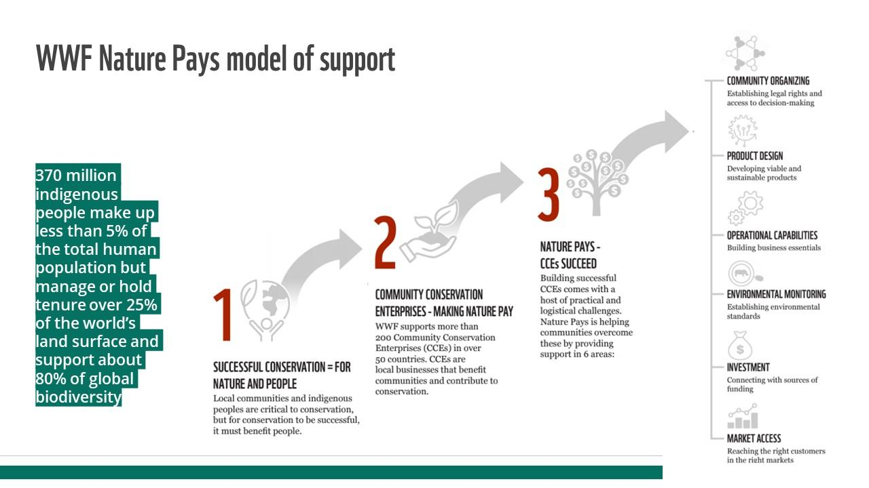
Nature Pays Hub was created in 2018, and excellent progress has been made in the start-up phase of this critical work - a few of our recent highlights:
- After successfully rolling out Nature Pays global capacity building programme across WWF Network, reaching more than 40% of offices, with over 180+ participants, the training was adapted for an external audience for the very first time in 2021. We are now working around scaling this highly popular capacity building program, co-created with Impact Hub, and strengthening our vibrant global community;
- We are facilitating in collaboration with WWF-US, a global partnership with TechnoServe - the #1 non-profit organisation for poverty alleviation to support community conservation enterprises and improve livelihoods and protect water and biodiversity;
- On a cross-Practice collaboration with WWF's Oceans Practice, we are supporting the Accelerating Coastal Community-led Conservation Initiative on creating enabling environments for coastal community enterprise development;
- We are also researching options for developing a Socio-Economic Impact Assessment Framework, to support WWF practitioners with a universal tool & KPIs to measure, monitor, and evaluate the socio-economic impacts alongside the ecological impacts of their work with communities.
We are now seeking specialist consultancy support on Communications to help us continue to raise WWF’s profile in this space to be seen as the go-to environmental NGO for community-led conservation enterprise programming. This consultant will also be the main Nature Pays global communications lead for one of our flagship programs in Mexico.

COMMUNICATIONS ACTIVITIES:
The current areas of focus for communications support are likely to be as outlined below but may vary slightly depending on emerging needs. Likely communication deliverables are as follows:
- Act as Nature Pays communications liaison with WWF Mexico, WWF Sweden and Ikea Social Entrepreneurship managing the communications needs of the project “Nature Pays: Community Conservation Enterprises (CCE) to improve livelihoods and protect water and biodiversity in the Oaxacan Watershed Copalita-Zimatán-Huatulco (CZH) Mexico”.
- Creating an engaging data-driven impact report showcasing the Nature Pays theory in action
- Identification of relevant thought leadership opportunities & surrounding communications opportunities maximised e.g. creation of OpEd/blog post content, speaking points/key messages for public speaking/media opportunities
- Assessment, review and update of current communications content relating to Nature Pays, including the update of Nature Pays page/subsite connected to the Markets Hub Google Site (internal) and external profile of Nature Pays on WWF website (panda.org/markets)

- Develop communications strategies and assets (outreach packages and landing page) for the micro learning capacity building programmes
TIMEFRAME: 1-2 days per week for 6 months
BUDGET: £5,000-£8,000
Please supply a one-page explanation of how you would approach the outlined consultancy role, along with a CV and examples of relevant portfolio work by 29th April to ideally start by mid-May 2022.
CONTACTS: Hina West, Nature Pays Director – hwest@wwwf.org.uk
Giana Andonini, Capacity Development Coordinator - gandonini@wwfint.org

