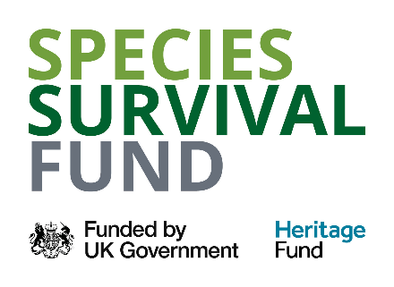

**Invitation to Tender as part of the New Forest Species Survival Fund Project**

**Lowland Heathland Restoration, Stanswood Valley on the Cadland Estate**

**(NFSSF – 01 ARC)**

Date: 16 December 2024

**New Forest National Park Authority**

Lymington Town Hall, Avenue Road, Lymington, Hampshire SO41 9ZG

**Telephone** 01590 646600 **Fax** 01590 646666   **Email** tender@newforestnpa.gov.uk

[**www.newforestnpa.gov.uk**](http://www.newforestnpa.gov.uk/)

VAT Reg No. 871 9343 00

**CHAIRMAN** David Bence   **CHIEF EXECUTIVE** ALISON BARNES

**Contents PagE**

1. SUMMARY 3

2. SPECIES SURVIVAL FUND LEAD PARTNER OVERVIEW 3

5. WORKING ARRANGEMENTS 4

6. TENDER SPECIFICATION 4

7. EVALUATION OF TENDERS 9

8. INSTRUCTIONS TO TENDERERS 11

9. CONDITIONS OF TENDER 13

## SUMMARY

The Species Survival Fund is a short-term programme to create, restore, expand, and connect habitats that help reverse the decline of species across England. The fund is delivered by the National Lottery Heritage Fund on behalf of DEFRA, as part of the Species Survival Fund scheme.

To deliver the Species Survival Fund project in the New Forest, a collaboration of organisations has come together, including Amphibian and Reptile Conservation, Freshwater Habitats Trust, Hampshire & Isle of Wight Wildlife Trust, New Forest Commoners Defence Association, and Wild New Forest, with the New Forest National Park Authority as the lead entity pursuant to the Memorandum. Our aim is to improve 250-300 hectares of habitat across multiple sites around the New Forest National Park and surrounding area.

The project will run from April 2024 to February 2026, with capital works to be completed by 31December 2025.

## SPECIES SURVIVAL FUND LEAD PARTNER OVERVIEW

The **New Forest National Park Authority** is the organisation responsible for promoting the two statutory purposes of the National Park as set out in the Environment Act 1995 which are:

■ To conserve and enhance the natural beauty, wildlife and cultural heritage of the area

■ To promote opportunities for the understanding and enjoyment of the special qualities of the Park by the public.

The Authority also has a duty to seek to foster the economic and social well-being of the local communities within the National Park.

1. **DELIVERY PARTNER OVERVIEW**

**Amphibian and Reptile Conservation Trust (ARC)** is a UK-based wildlife charity dedicated to the conservation of frogs, toads, newts, snakes and lizards, and the disappearing habitats on which they depend. We do this by managing over 80 nature reserves covering a variety of different habitats, and carrying out a wide range of national and regional projects and campaigns through our staff and our volunteers, by working with partners and by influencing others through advocacy, education and increasing awareness.

1. **RELATIONSHIP BETWEEN LEAD PARTNER AND DELIVERY PARTNER**

The New Forest National Park Authority is the Accountable Body for the funding, manages the relationship with the funding body, and provides project governance including project management and co-ordination support as well as the use and access to supporting systems such as for procurement of goods and services.

This contract, whilst utilising systems provided by the New Forest National Park Authority, is between the Delivery Partner named above and the awarded supplier.

## WORKING ARRANGEMENTS

Any queries may be submitted through our [In-tend supplier portal](https://in-tendhost.co.uk/newforestnpa/aspx/Home) or via the contact details below:

For tender process / procurement queries:

Tom Knott, Finance & Sustainable Procurement Officer - 01590 646678 [tender@newforestnpa.gov.uk](mailto:tender@newforestnpa.gov.uk)

For technical queries:

Paul Edgar, Principal Ecologist

[paul.edgar@arc-trust.org](mailto:paul.edgar@arc-trust.org)

## TENDER SPECIFICATION

**Overview of requirements (if applicable, supplementary documents are placed in the Appendices section)**

**Background to the project:**

Funding has been allocated for habitat restoration work at Stanswood Valley which is owned by the Cadland Estate. The site is part of the North Solent SSSI and North Solent National Nature Reserve. The area this contract covers is included within Unit 71 which supports lowland heathland.

SSSI Unit 71 have recently in 2023 been downgraded from ‘favourable’ SSSI’ status to ‘unfavourable no change’ status due to scrub and tree encroachment which has developed over parts of the site over recent decades

**Work objective:**

To restore lowland heathland Priority Habitat within Unit 71 of the North Solent SSSI and NNR on Cadland Estate. Achieved through removal of European gorse and scrub in specific locations and litter removal to manage the regrowth of European gorse. The work is targeted towards improving the conservation status of smooth snakes and adders on the site, although many other species associated with lowland heathland will also benefit.

**Description of site:**

The site is owned and managed by the Cadland Estate with support from Natural England. Unit 71, where the works will be undertaken, is a part of the North Solent SSSI and the North Solent National Nature Reserve (NNR). The main habitat within this unit is lowland Heathland (a notified feature of the SSSI; Natural England 2023) with abundant scrub and European gorse, with some secondary woodland present.

The site used to have an agri-environment scheme that ran until about 10 years ago but does not have one at present. Scrub management was undertaken through this agreement to restore and manage the site. Stock grazing (cattle) was reintroduced to Stanswood Valley along with the surrounding heathland during the most recent agri-environment scheme.

The most recent condition assessment of Unit 71, carried out in September 2023, found the unit to be in ‘unfavourable condition’. The recent condition assessment identified increasing cover of trees and scrub in open heathland areas as acting pressures on the site. It is important that Unit 71 is managed appropriately to reverse the unfavourable condition status of the SSSI as lowland heathland is recognised as a Priority Habitat that supports rich assemblages of species including specialist plants, invertebrates, reptiles, and birds. This site has known adder populations and adder hibernaculum, and the potential to be occupied by reptile European Protected Species.

The SSSI has a network of Public Rights of Way crossing the sites and is also Open Access Land. Public Safety is therefore a consideration when working on this site. Vehicular access is possible from the gate at the north end of Walker’s Lane South at SU 44864 01749 – a map will be provided at the start of contract showing vehicle accessible areas on the SSSI.

**Work required:**

The work is divided into 4 areas:

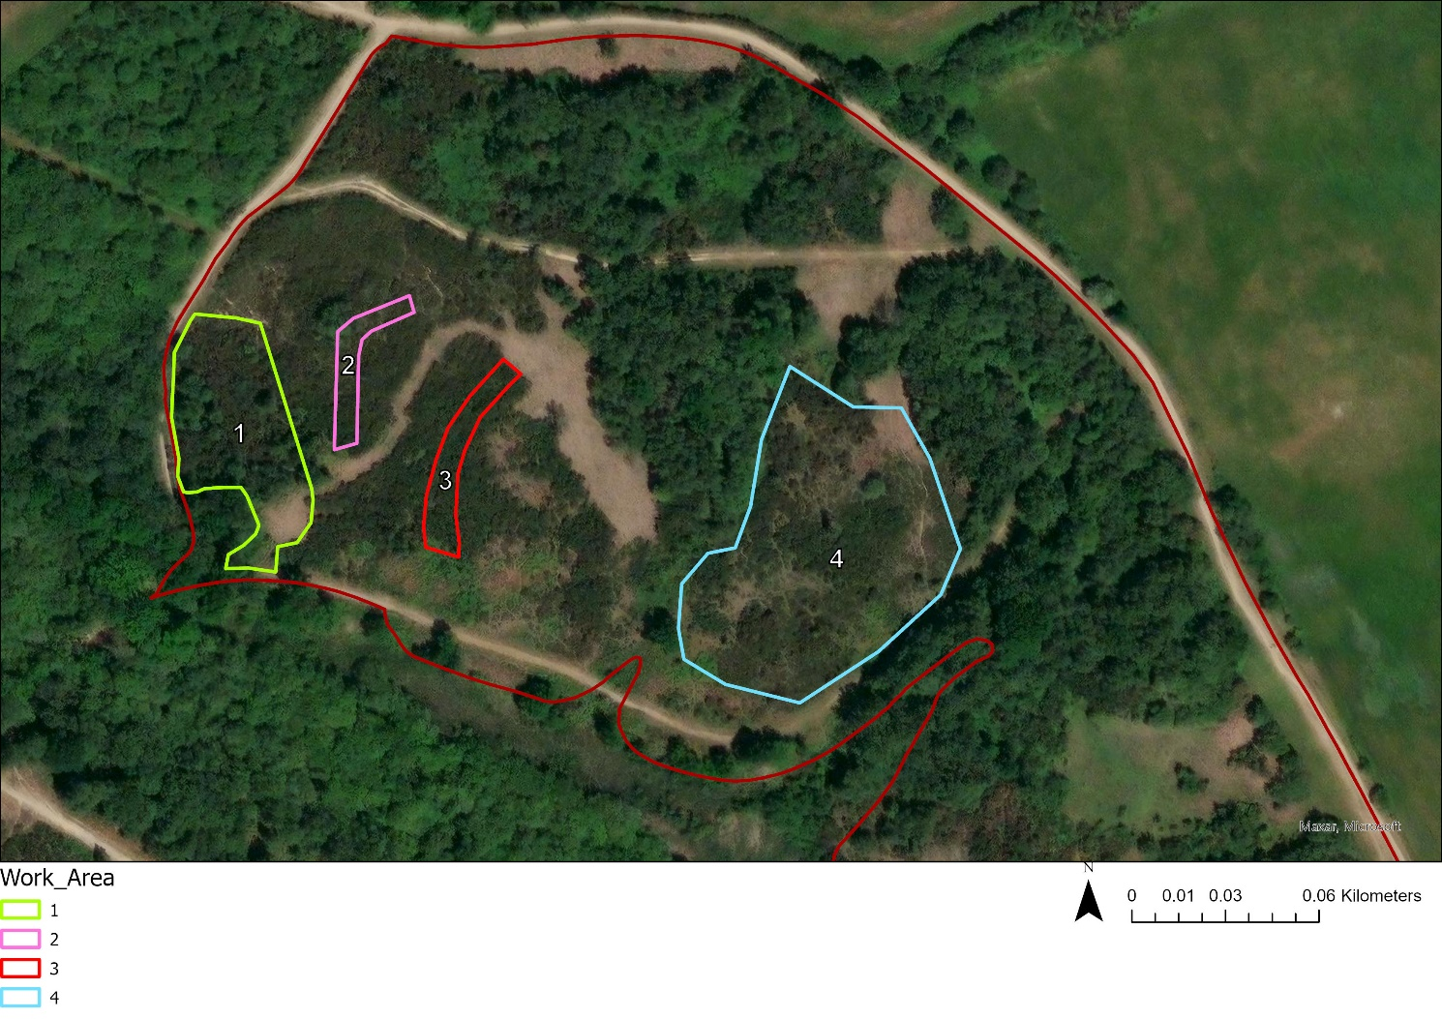

Figure 1: Overview of Cadland Estate Reptile Works (boundary = North Solent SSSI Unit 71).

**Area 1 (approximately 0.3 ha)**

This area has recently been cleared of gorse and scrub by the landowner. This area retains the top level of leaf litter that is likely to result in the regrowth of European gorse if not removed.

Work items:

* Remove leaf litter and humus layer down to a consistent layer of bare substrate
* Move arisings to create a boundary bank along the adjacent path as directed by staff

**Area 2 (approximately 60 m x 8 m)**

This area consists of a large, tall, dense section of European gorse.

Work items:

* Creation of an 8 meter wide fire break through tall European gorse, leaving blind ends on either side where possible
* Gorse is to be removed by chainsaw and collected by hand. Any small scrub present should also be removed.
* Arisings are to be burnt on site in areas away from sensitive habitats as agreed with Natural England. The fires are to be attended at all times.
* Any stumps of 2 inches or larger in diameter are to be stump treated with appropriate herbicide, taking great care to avoid spillage into surrounding vegetation

**Area 3 (approximately 60 m x 8 m)**

This area consists of a large, tall, dense section of European gorse.

Work items:

* Creation of an 8 meter wide fire break through tall European gorse, leaving blind ends on either side where possible
* Gorse is to be removed by chainsaw and collected by hand. Any small scrub present should also be removed.
* Arisings are to be burnt on site in areas away from sensitive habitats as agreed with Natural England. The fires are to be attended at all times.
* Any stumps of 2 inches or larger in diameter are to be stump treated with appropriate herbicide, taking great care to avoid spillage into surrounding vegetation

**Area 4 (approximately 0.6 ha)**

This area consists of a mixture of European gorse, dwarf gorse, heather, and grasses.

Work items:

* Selective thinning of European gorse and scrub as directed by staff
* Any stumps of 2 inches or larger in diameter are to be stump treated with appropriate herbicide, taking great care to avoid spillage into surrounding vegetation
* Arisings are to be burnt on site in areas away from sensitive habitats as agreed with Natural England. The fires are to be attended at all times.

**Constraints and considerations:**

Close liaison with Paul Edgar (ARC project officer), Ian Elcock (the Cadland Estate site manager), Adam Wells and Heidi Staines (Natural England site managers) is essential.

* Due to the site having public access, signage and notification to any users when entering and leaving the site will be required
* The site is SSSI and a protected site, therefore care must be taken at all times to avoid damage to wildlife, soils and water. All work must adhere to conditions set out in the SSSI consent. Prior to the work, the site will be walked with the contractor to ensure any sensitive wildlife areas are avoided. If any protected wildlife is found during the works (e.g. bats or dormice), the works must cease, and the project officers are to be informed.
* Timings of the works will be arranged with the staff mentioned above. Areas 2, 3, and 4 must be completed before the end of February 2025 to avoid disturbing ground nesting birds. Area 1 is to be completed by the end of March 2025.
* There are resident populations of adders on site. Some of the areas of work are adjacent to known adder hibernacula which will require extra consideration when planning works.

**Expected delivery timetable**

Areas 2, 3, and 4 must be completed before the end of February 2025. Area 1 is to be completed by the end of March 2025.

**Methodology requirements**

* Contractors must comply with all applicable regulations and adhere to best practice at all times
* Appropriate site safety signage must be present and visible throughout the work period
* Any interactions with the general public are to be carried out in a professional manner
* No fires are to be left unattended
* All fire activity should be logged with Fire Control on a daily basis
* Site sensitivity maps (adder hibernacula, other key reptile/bird habitats) are to be available/used through the task and the areas retained are to be marked in advance
* Contractors are to supply a nominated central point of contact
* Examples of site safety signage to be used during the work
* Membership to the Forestry Industry Safety Accord (FISA)

**Skills, expertise, qualifications or statutory requirements**

* Experience of working on reptile habitats, especially for European Protected Species
* Experience of carrying out conservation work on sites used by the general public, with demonstratable measures taken to minimise disturbance
* Experience of working on SSSI lowland heathland sites
* Chainsaw- Certificate of Competence
* Herbicides- certificate of use for PA1 and PA6
* Public liability insurance (up to £5,000,000)

**Health and Safety**

Provide a ‘Safe Systems of Work’ package which should include;

* Site Specific (Activity) Risk Assessment
* Method Statement – how you intend to carry out the work including how safety on site is managed.
* Emergency procedures for (if applicable): COSHH/fuel spills/fire/medical emergency/electricity/lone working etc.

**Anticipated budget**

For work areas 1, 2, and 3, estimate your overall costings for the work. For work area 4, the total price should be no more that £3,000 inclusive of VAT for the work being commissioned.

## EVALUATION OF TENDERS

Suppliers must complete, in full, the Assessment Document which is attached below. This outlines the minimum information required from suppliers and will form the basis upon which your submission will be evaluated. It is envisaged that this scoring and evaluation exercise will take no longer than 3 working days after the ITT response deadline, which is **9th January 2025**. It is envisaged that a decision will then be made on or around **14th January 2025**.

No information contained in this ITT, or in any communication made between **ARC** and you in connection with this ITT shall be relied upon as constituting a contract, agreement or representation that any contract shall be offered in accordance with this ITT. **ARC** reserves the right, subject to the appropriate procurement regulations, to change without notice the basis of, or the procedures for, the competitive tendering process or to terminate the process at any time. Under no circumstances shall **ARC** incur any liability in respect of this ITT or any supporting documentation.

Please answer all questions as accurately and concisely as possible in the same order as the questions are presented. Where a question is not relevant to your organisation, this should be indicated, with an explanation.

***Completeness and Further Information***

The information supplied will be checked for completeness and compliance with the instructions before responses are evaluated.

Failure to provide the required information, make a satisfactory response to any question, or supply documentation referred to in responses, within the specified timescale, may mean that you are not invited to participate further. In the event that none of the responses are deemed satisfactory, **ARC** reserves the right to terminate the procurement and where appropriate re-advertise the procurement.

You should be explicit and comprehensive in your responses to this ITT as this will be the single source of information on which responses will be scored and ranked. You are advised neither to make any assumptions about any past or current supplier relationships with **ARC** nor to assume that such prior business relationships will be taken into account in the evaluation procedure.

The ITT is provided on the same basis to all tenderers. Please note that to ensure fair and open competition, the responses to any questions raised by interested contractors will be made available to all other contractors, where appropriate. Any such clarifications will be posted on our In-tend portal and you will receive email notification to make you aware of this. If you wish to be updated with any tender clarifications but do not wish to register on our In-tend portal, then you must formally request to receive such clarifications via email, to the contact listed in Section 3 of this ITT. The deadline for receipt of clarifications relating to the specification or any other part of this ITT is **7th January 2025**.

Please note that the spaces provided in the Assessment Document should not be viewed as an indication of the length and depth of responses we require for a particular section. Suppliers are encouraged to generate as much space as required to answer each section in full, ensuring that any additional pages used are clearly cross-referenced to the relevant section being addressed, where applicable.

It should be noted that whilst some sections of the Assessment Document are not directly scored (e.g. financial information), **ARC** reserves the right to take into account supplier responses to these elements when evaluating and awarding the contract.

Supplier responses in the Assessment Document shall form part of the contract, where appropriate, thus the supplier will be legally obliged to comply with the responses provided therein. Should your company be successful and be awarded the contract, any variations to the proposals in the Assessment Document must receive prior written approval from **ARC**.

**ARC** expressly reserves the right to request you to provide additional information supplementing or clarifying any of the information provided in response to the requests set out in this ITT. **ARC** may seek independent financial and market advice to validate information declared, or to assist in the evaluation.

***Disqualification and selection***

**ARC** may disqualify you if you fail to:

1. Provide a satisfactory response to any questions in the ITT or inadequately or incorrectly complete any question or have not provided the required information; and/or
2. Submit the completed ITT before the stated deadline.

The potential providers who are not disqualified in accordance with the above grounds shall be evaluated on the qualification criteria which take into account the economic and financial standing and the technical or professional ability of each.

**The Assessment Document is attached here:**

[SSF LA&D Assessment Document](https://newforestnpa-my.sharepoint.com/personal/john_stride_newforestnpa_gov_uk/Documents/Desktop/SSF%20LA&D%20Assessment%20Document.docx?web=1)

The Contract will be awarded on the basis of the most economically advantageous tender to **ARC**, based on the evaluation criteria of 30% price and 70% quality. Tenders will be evaluated and assessed using the scoring matrix below, by at least three Species Survival Fund Partner staff.

|  |  |
| --- | --- |
| **Criteria** | **Weighting** |
| Price | 20% |
| Evidence of suitability | 80% |

Sub-weightings for the Quality Criteria are provided below:

|  |  |  |
| --- | --- | --- |
| **Section** | **Quality Heading** | **Sub-Weighting** |
| A | Company Information | 0% |
| B | Your Approach | 45% |
| C | Scope of Services | 10% |
| D | Your Experience / References | 45% |

The following scoring mechanism will be used to allocate points available.

|  |  |
| --- | --- |
| **Scoring** | **Points** |
| Response meets the required standard in all material respects and adds value in some or all of the major requirements | 9 – 10 |
| Response meets the required standard in all material respects | 7 – 8 |
| Response meets the required standard in most material respects, but is lacking or inconsistent in others | 5 – 6 |
| Proposal falls short of achieving expected standard in a number of identifiable respects | 3 - 4 |
| Response significantly fails to meet the required standard, contains significant shortcomings or is inconsistent with other responses | 1 - 2 |
| Completely fails to meet required standard or does not provide a response | 0 |

**Price** –with regards to the price evaluation, the lowest accepted (i.e. reasonable) submitted price will be awarded the maximum price score of **20%**. Thereafter, each tender will be ranked and scored in accordance with how much more expensive their respective price is compared to the lowest price (e.g. – if it is 50% more expensive than the lowest price, it will be awarded 50% less price points in comparison to the lowest price tender).

**Quality** - weighted scores will be calculated by multiplying the score for each quality criteria by its weighting. The weighted scores will be totalled for each tender. The totals will be normalised so that the normalised highest total will attract the highest Quality score of **80%**.

There is an overall quality threshold of **6 points**. If the summation of the weighted scores under each quality heading is below this figure, then the tender will no longer be considered, regardless of price.

**ARC** reserves the right to withdraw this contract opportunity at any point, without notice, and will not be liable for any costs incurred by suppliers during any stage of the process. Suppliers should also note that, in the event a tender is considered to be fundamentally unacceptable on a key issue, regardless of its other merits, that tender may be rejected.

## INSTRUCTIONS TO TENDERERS

The proposed Tender timescales are as follows, however these are subject to change. In such an event, all Tenderers will be informed immediately via our In-tend supplier portal:

|  |  |
| --- | --- |
| **Tender Process** | **Deadline** |
| Invitation to Tender (ITT) placed on Contracts Finder | **Monday 16th December 2024** |
| Deadline for ITT clarifications / questions | **Tuesday 7th January 2025** |
| ITT response deadline | **Thursday 9th January 2025 – (Midday 12pm)** |
| Evaluation of ITT submissions | **Tuesday 14th January 2025** |
| Contract Award | **Tuesday 14th January 2025** |
| Standstill period (5 days) | **15th January 2025 – 19th January 2025** |
| Contract Commencement date | **Monday 20th January 2025** |
| Pre-commencement meeting | **Monday 20th January 2025** |

Tenders submitted after the stipulated time and date advised will be rejected, unless exceptional circumstances are proven, such as clear evidence of postal guarantee or record of successful submission through In-tend.

Tenderers must ensure that their completed Assessment Document has been returned, by **9th January 2025** in order for their bids to be evaluated:

1. If your submission is via our [In-tend supplier portal](https://in-tendhost.co.uk/newforestnpa/aspx/Home), then it must be completed **9th January 2025**. Please note that you will have to register on this portal before you can view the Invitation to Tender document and submit a tender
2. If your submission is via email, please return it to: [tender@newforestnpa.gov.uk](mailto:tender@newforestnpa.gov.uk) - to arrive no later than **9th January 2025**
3. If you wish to post a hard copy reply, it must be marked for the attention of Tom Knott, to arrive no later than **9th January 2025** and sent to:

FAO: Tom Knott, Finance and Sustainable Procurement Officer – [NFSSF - 01]

New Forest National Park Authority

Lymington Town Hall

Avenue Road

Lymington

Hampshire

SO41 9ZG.

Please note that you must ensure that the envelope used must bear **no mark to identify the sender**. Failure to comply with this may result in your tender being excluded from the evaluation process.

Please note that you may use either [In-tend](https://in-tendhost.co.uk/newforestnpa/aspx/Home) or post in submitting your responses, or both should you wish. Posted entries are sent at the risk of the supplier and confirmation of receipt will not be provided by the Authority, unless specifically requested by the supplier; the Authority will not be liable in any way for entries not received or delayed in the post. Furthermore, the Authority is unable to return any documentation provided, whether the supplier is successful or not.

The Authority shall keep all tenders received unopened until after the ITT submission deadline of **9th January 2025**. Any tenders received after this time shall not be considered for evaluation and shall be returned promptly to the tenderer.

## CONDITIONS OF TENDER

The Terms and Conditions of Contract will be based on **ARC’s** General Standard Conditions of Contract, a copy of which can be found below:



**ARC** **or NFNPA** reserves the right to withdraw this contract opportunity without notice and will not be liable for any costs incurred by suppliers during any stage of the process. Suppliers should also note that, in the event a tender is considered to be fundamentally unacceptable on a key issue, regardless of its other merits, that tender may be rejected.

### Representations

A supplier may contact **ARC** to obtain any further information about the requirements of the contract or the tendering procedures if these are not evident or clear from the documents supplied to suppliers.

No questions will be answered that provide a competitive advantage to any party interested in tendering.

Should questions arise during the tendering period, which in our judgment are of material significance, we will inform all suppliers to explain the nature of the question, and our formal reply. All suppliers should then take that reply into consideration when preparing their own bids and we will evaluate bids on the assumption that they have done so.

### Specification

For the avoidance of doubt, the contract specification shall include all requirements explicit or implied within this Invitation to Tender.

**ARC or NFNPA** reserves the right to withdraw this tender document and all funding contained within it without notice.

### Conflicts of Interest

Tenderers must disclose in their Tender any circumstances, including personal, financial and business activities that will, or might, give rise to a conflict of interest by taking part in this competition, or if awarded any contract as a result of this opportunity. This also applies to any sub-contractors that the Tenderer wishes to employ as part of any contract.

Where Tenderers identify such potential conflicts, they should immediately state these to **NFNPA** and confirm how they intend to avoid such conflicts. **NFNPA** reserves the right to reject any Tender which, in the opinion of **NFNPA** gives rise, or could potentially give rise to, any conflict of interest.

### Tenders Excluded

No tender will be considered for acceptance if the supplier has indulged or attempted to indulge in any corrupt practice or canvassed the tender with an employee of **ARC or NFNPA**. If a supplier has indulged or attempted to indulge in such practices and the tender is accepted, then grounds shall exist for the termination of the contract and the claiming of damages from the successful suppliers.

It is unlikely that any tender will be accepted which (a) is incomplete or inaccurately or inadequately completed or which purports to impose conditions other than those provided in the contract documents and (b) is delivered out of time or in a manner other than specified in the specification.

### Collusive Tendering

In submitting a tender against this contract, the supplier confirms that they have not fixed or adjusted the amount of the tender by or under or in accordance with any agreement or arrangement with any other person.

The supplier also certifies that at no time, before or following the submission of the tender, has the Supplier carried out any of the following acts:

i) communicating to a person other than the person calling for the tenders the amount or approximate amount of the proposed tender, except where such disclosure is required for the purpose of obtaining insurance

ii) entering into any agreement or arrangement with any person that he shall refrain from tendering or as to the amount of any tender to be submitted

iii) offering or paying or giving or agreeing to give any sum of money or valuable consideration directly or indirectly to any person for doing or having done or causing or having caused to be done in relation to any other tender or proposed tender for the said work any act or thing of the sort described above. In the context of this clause the word ‘person’ includes any persons and any body or association, corporate or unincorporated; and ‘any agreement or arrangement’ includes any such transaction, formal or informal, and whether legally binding or not.

### Freedom of Information

The National Park Authority is subject to the Freedom of Information Act 2000 and the Environmental Information Regulations 2004 and therefore information in relation to this tender may be requested by third parties. Requests for information will be considered on a case-by-case basis and consideration will be given as to whether or not the information is exempt from disclosure under the legislation.

Suppliers should identify if any of the information supplied by them is confidential or commercially sensitive and provide details of why they feel release of the information would prejudice their interests.  This will not guarantee that the information will not be disclosed but your views will be taken into account when considering a request.

It is important to note that information may be commercially sensitive for a time (e.g. during a tender process) but afterwards it may not be.  The timing of any request for information will be taken into account when determining whether or not the information is exempt, however suppliers should note that no information is likely to be regarded as exempt forever.

**Confidentiality**

The Tenderer (whether this Tender is accepted or not) and all other recipients of the Specification and documents (whether they submit a tender or not) shall treat the details of the Specification and the documents attached hereto as private and confidential and shall not disclose the details to any party.