Expression of Interest

Project Details
Project Name | PS24207 – PIN
Notice Title | GPEx Delivery Model
Closing date | Monday, 14th October 2024 at 12:00pm

Description of the Project
Summary
UKRI is seeking a supplier to develop and test a model for delivering a Research Culture Good Practice Exchange (GPEx). This model must be tested and iterated with the wide breadth of stakeholders the GPEx is designed to serve.

Background
Context
UKRI’s vision is for an outstanding research and innovation system in the UK that gives everyone the opportunity to contribute and to benefit, enriching lives locally, nationally and internationally. The success of the research system depends on the people working within it. To answer complex research questions requires a diverse community of people in a wide range of roles, along with a culture that welcomes difference and supports constructive debate and challenge.

UKRI commissioned a Research Culture Initiatives in the UK Report, to map current and past research culture activity across the R&I sector. A research culture framework was developed through this work to provide a holistic view of the many aspects of research culture. This is underpinned by the Royal Society’s definition of research culture and is expressed in terms of appropriate values and behaviours – see Figure 1.
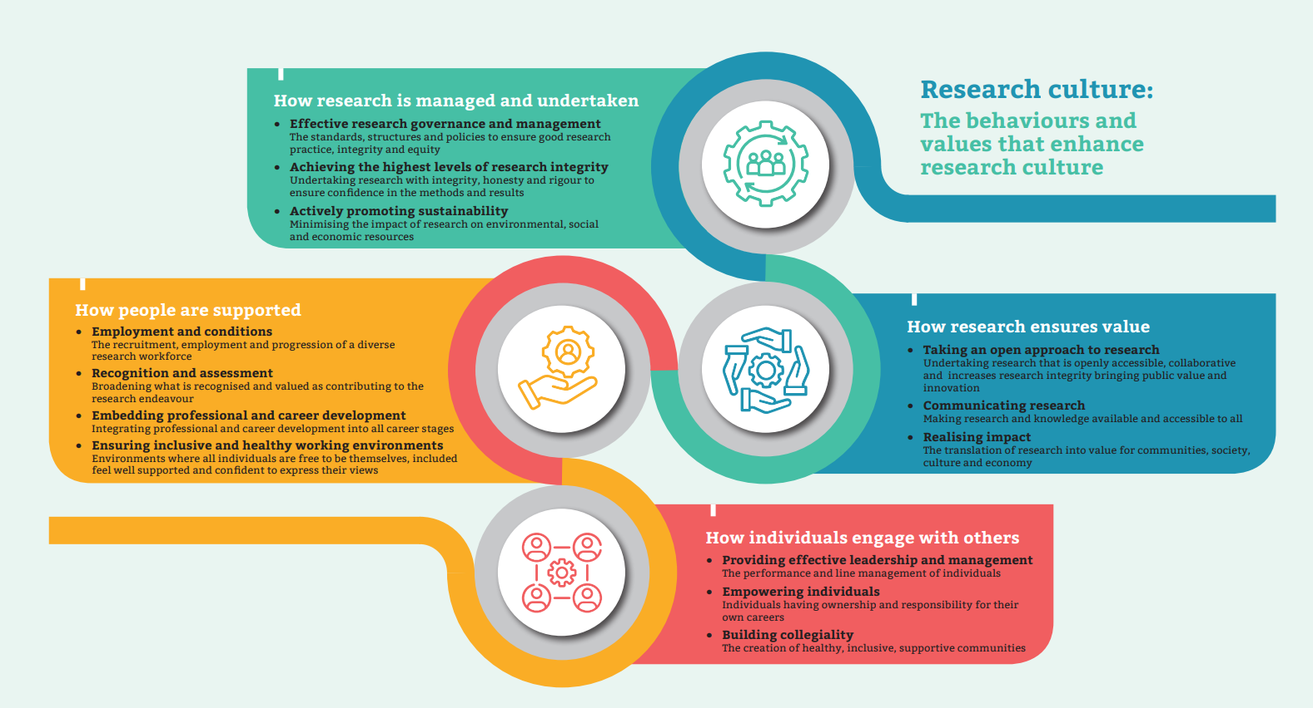
Figure 1. The Research Culture Framework

Key findings from the report include:
- Most research culture initiatives had a focus on higher education contexts.
- Initiatives often had broad coverage of research culture elements and behaviour.
- Evaluation of initiatives was often weak or uncertain
- There was a diversity of approaches and activity types
- Most initiatives had a UK or region-wide focus
- Many initiatives reported some level of collaboration
- While a majority of initiatives had been shared, this sharing tended to be fairly ‘passive’
- Early career researchers (ECRs) were commonly targeted
- Initiative coverage of EDI matters was broad rather than specific
- EDI was seen both as being ‘well served’ and a ‘gap’
- There is a call for more decisive action to improve research culture
Although the primary beneficiary is intended to be UK research and innovation, the GPEx is expected to draw on international practice.

Cross-sector partnership working on research culture is needed, to build on current momentum in the sector and catalyse further activity to improve culture. A Good Practice Exchange would develop, test, evaluate and highlight ideas to improve culture sourced from the community, bringing together people from across the sector to work creatively.

Using recommendations from the Research Culture Initiatives report and wide stakeholder engagement, objectives for the Exchange have been established as follows.

GPEx Objectives
The goal of the Good Practice Exchange is to harness and consolidate existing activities relevant to research culture for the benefit of researchers, research itself, and society.

The Exchange is for the full breadth of UK research and innovation disciplines and sectors. Sectors include, but are not limited to:
- Academic (universities, research institutes, funders, networks);
- Industry / the private sector (research institutes, research & development (R&D) departments, networks, human resources (HR)).
- Public sector, including Government, NHS, public sector research establishments (PSREs) and public engagement organisations.
- Third sector, including research-oriented charities and volunteering organisations.
- Other organisations involved in facilitating and connecting research activities.
- The wider public

The GPEx will have the following three core objectives:
- Building networks, sharing and collaboration: The GPEx will provide a route for people and organisations across the sector to come together, leveraging existing initiatives and communities. It will build connections between networks and research culture activities, facilitating collective effort, building on existing interest and action. In particular with the purpose of: a) sharing good practice and b) encouraging collaboration. It would not fund a new network, but build connections between existing networks – a “network of networks”.

- Supporting more and better evaluation: There is a need for more research culture initiatives to be tested and evaluated, and for this activity (where proportionate) to be more robust and longer-term, so as to build understanding of what works to enhance research culture. This includes - where possible and proportionate - considering testing and evaluation at the conception of an activity, so that the activity can be designed with this in mind. Quality evidence is crucial for demonstrating the effectiveness of interventions. More evaluation is needed of smaller, focussed interventions, as well as methods to evaluate research culture change in ways that are appropriate and relevant to different contexts. Evaluation should also be conducted across sectors and with different communities to determine effectiveness in different contexts. There is a need for evaluation tools, and for these to be made available to practitioners to conduct their interventions as experiments. The GPEx will promote and support these evaluation needs. The focus of the GPEx is on supporting the sector to deliver the best evaluation possible, rather than the GPEx delivering evaluation (or meta-evaluation) itself.

- Strengthening strategic leadership: The GPEx will take a strategic leadership role and have a compelling vision, both for its own activities and for research culture. The GPEx will create opportunities for strategic leadership on research culture across R&I that can set a shared vision and guide action. The GPEx must be conscious to take an inclusive approach, and cover the full breadth of UK research and innovation disciplines and sectors.

The need for a GPEx delivery model
Whilst the three objectives of the GPEx are set, the manner of delivery is currently open. Internal consultation work has established that there is scope for a supplier to take a wide range of approaches to delivery of the GPEx, with various deliverables, timelines and costings attached. A clear model for delivery therefore needs to be established, with foundations in a theory of change and logic model that has been developed and tested with the community the GPEx would service. UKRI would then use this model as the basis for its tender of the GPEx.

Aims and Objectives
UKRI is seeking a supplier to develop and test a model for delivering a Research Culture Good Practice Exchange (GPEx). This model must be tested and iterated with the wide breadth of stakeholders the GPEx is designed to serve.

Core objectives are:
- Provide a comprehensive GPEx model, which covers each of the key components listed below.
- This model will be informed by and tested with the full spectrum of stakeholders, which represent the GPEx community. The model will be iterated and retested with stakeholders, to ensure it best serves their needs.

Objective 1: GPEx Delivery Model
The GPEx delivery model must identify how each of the established objectives of the GPEx will be delivered in practice. This model will then be used as the basis for commissioning a supplier. The model must address each of the following components:

- Theory of Change, and proposed Logic Model
A GPEx Theory of Change and proposed logic model should be developed, which includes a clear set of activities for the GPEx to deliver. Both the causal mechanisms behind why activities are expected to achieve outcomes and the logical sequence to achieving outcomes should be identified. A clear causal path to the ultimate objectives of the GPEx should be identified. It is essential that the theory and model is built in partnership with the full breadth of GPEx stakeholders.

Success indicators should be identified which can be used to chart the progress of the GPEx, and inform an evaluation of the GPEx.

The model should paint a clear picture of what good looks like.

Prioritisation of activities should be provided.

- Partnerships and Wide Inclusion:
A core component of the GPEx is that it serves the needs of the full breadth of UK research and innovation disciplines and sectors, including devolved administrations. The GPEx delivery model must explicitly address how this will be achieved, recognising that needs may vary between groups (persona profiles may be of use). The model must take account of the varying resourcing constraints of those the GPEx seeks to engage and be sure to include engagement with smaller institutions in a resource-appropriate manner.

The model should suggest what fora and spaces the GPEx would look to operate in, particularly with regards to the leadership objective, and consider how to best position itself in relation to other organisations operating in the area.

The model should consider UKRI’s work on “Place”, particularly around connecting and facilitating research at local, regional and national levels.

The proposed model should build on learning from similar past investments that have aimed to support good practice exchange (e.g. What Works Centres) and existing activity to build evidence banks supporting rapid syntheses.

- Deliverables
The model should identify specific deliverables that UKRI would require of a supplier to deliver their GPEx role. These deliverables would be a fundamental basis of the contract between the supplier and UKRI. Satisfactory delivery would release staged payments. Therefore it is crucial deliverables comprehensively cover the expectations of the GPEx.

- Timeline with Key Milestones.
Suppliers should identify a specific timeline for the GPEx, with key milestones set against this. The supplier is free to propose whichever timeline they consider best for the GPEx to achieve its objectives. This may include multiple stages of the GPEx, to allow for it to develop.

Progress on the objectives of the GPEx will build iteratively over time. A balance will need to be sought between proposing a model which can deliver meaningful progress and ensuring that funds are not spread so thinly over years as to risk delivery. The setting of short, medium and long term milestones for the GPEx may be of use.

The proposed model should consider the sustainability of GPEx activities over the longer-term, and outline possible options for GPEx objectives once funding ends. For example, some activities may be initiated by the GPEX then be outsourced. However other activities such as sustaining connectivity between networks, or hosting a web platform, require longevity to be most effective.

- Costings Model and Value for Money
The budget for the GPEx is not yet established, and the evidence provided by this model will likely be used to make a case for funding. The model must clearly delineate required investments to achieve distinct outputs, outcomes and impacts of the GPEx, as it may not be possible to secure funding for all components of the model. Interdependencies within the model therefore must be clearly identified.
The supplier is required to develop model(s) on the basis of three potential total GPEx budgets: £500,000; £2,500,000; and £5,000,000.

This budget can be profiled over a period of years as needed for the model. There is no requirement for the budget to be spread evenly between years.

The supplier should offer an evidence-informed view as to the value for money of the distinct elements of the proposed GPEx model.

A general guiding principle of the GPEx is that it looks to reuse and recycle existing activity, to make the most out of existing investments. As opposed to channelling its own funds into new pockets of activity.

The model should consider opportunities for strategic level collaboration by effective collaborative use of resources.

- Necessary Infrastructure
The model should identify necessary infrastructure for the GPEx, mindful of its long-term future and ensuring value for money.

- Required consortium of staffing skills.
Given the breadth of objectives of the GPEx, and the wide community it is required to serve, it is expected that a consortium of suppliers will be needed to cover all necessary skills, expertise and engagement needs. The model should clearly identify the essential staffing requirements of the model.

The GPEx will need to be a trusted part of the community, that the sector has confidence in. The supplier should consider that the GPEx may be best based within the community, with community ownership.

It is intended that the GPEx is sourced through a procurement route, rather than awarding as a grant. The model should consider if the required consortium can be sourced through this route, or if an alternative grant-based route should be preferred.

- Governance Model, including monitoring and evaluation requirements
The supplier should propose a governance model for the GPEx which will best ensure it delivers on its objectives.
The model should take account of the following:
- The GPEx will be accountable to UKRI for delivery against its contract. UKRI would expect a regular reporting schedule and to be involved in key decisions.
- The GPEx will have a wide range of stakeholders (see above). The proposed governance model should ensure this spectrum of stakeholders is most appropriately incorporated into these structures.

The model should demonstrate alignment with UKRI’s approach to and ambitions for good research culture. It should embody the good principles of the area in which it is working.

The supplier should propose proportionate monitoring and evaluation requirements of the GPEx, which will demonstrate regular progress updates and ultimate delivery of the GPEx objectives. At a minimum, we anticipate this would include data points before and at the end of activities. The GPEx is a relatively novel approach, therefore it will be important to capture and share learning of its own endeavours. Case studies will be one important technique of showing delivery. The supplier should draw on models which have worked well in other contexts. Plans for quality assurance of materials generated by the GPEx should be included as part of the model. We anticipate this monitoring and evaluation would primarily be delivered by the GPEx i.e. they would evaluate their own progress against their plans. However in addition, it is possible an independent evaluation of the GPEx may be commissioned, therefore planning should also consider this prospect and the need for the GPEx to hand over data to a separate evaluation supplier.

- Risk and risk mitigation
The GPEx will be a complex and potentially high value investment. The supplier should identify potential risks to delivery and propose mitigations to these risks which can be required in the GPEx specification. Likely mitigations may cover the management structure of the GPEx and the relationship between the GPEx and UKRI e.g. making best use of Advisory Boards/ Steering Groups.

Objective 2: Stakeholder engagement
The supplier should work with stakeholders to test and iterate the model, ensuring it best serves the needs identified by the sector. The supplier will therefore develop multiple iterations of the delivery model, which are tested, and retested with stakeholders.

It is crucial that the stakeholders engaged in this process capture the wide span of people and activities the GPEx is expected to serve, covering the full breadth of UK research and innovation disciplines and sectors (see above for further detail of sectors). This should be sure to include, though not be limited to, devolved administrations, Independent Research Organisations, business, and disciplines of social science, arts and humanities. Proposals should identify the supplier’s routes to engagement of all groups, and particularly identify their intended approaches to engaging harder to reach groups (e.g. those that are not already part of existing networks). The supplier’s approach to stakeholder engagement should embody the principles of the GPEx.

A core deliverable will be the provision of stakeholder evidence and case studies of how the particular model of delivery proposed by the supplier will best address stakeholder needs. Please note, this is distinct from, and a development of, the stakeholder evidence provided in the Research Culture Initiatives Report and annexes.

This stakeholder engagement objective also serves the purpose of ensuring the GPEX delivery model has been well socialised with the community it will serve, paving the way for the future implementation of the GPEx. The supplier should be mindful of this additional purpose in their interactions with stakeholders.

Deliverables
The indicative timeline for the contract is 6 months.

The supplier will be expected to deliver:
- Document detailing finalised approach to delivery, including stakeholders to be covered and route to engagement. Within one month of contract start. Milestone payment 1 will be made at this point.

- Interim Findings: Identifying early /emerging findings. Within 3 months of contract start. Milestone payment 2 will be made at this point.

- Final Report: A written report which presents:
- A model for GPEx delivery addressing each of the above numbered components.
- Evidence from a broad, representation of stakeholders that the proposed model of delivery will address the issues and needs identified in the Research Culture Initiatives report.
The core report should be maximum 30 pages, plus an additional Executive Summary (maximum 3 pages). Additional material can be provided in annexes. First draft to be submitted within 5 months of contract start and a final draft to be submitted within 6 months of contract start.

- Slide set, with speaking notes, capturing the core information of the final report. Slides will be taken forwards and used by UKRI staff.

- Presentation with Q&A: A presentation of near final findings to UKRI staff, with Q&A. In the final month of the contract.

All deliverables should be accessible, meeting recognised practice in accessible and inclusive documents. UKRI would hold the copyright and reuse rights for the report and accompanying outputs.

Methodology
Suppliers are invited to propose a methodology they consider will best achieve the objectives and deliverables for this activity. Proposals should clearly identify how this methodology will provide the GPEx model required, and how they will ensure a full and comprehensive stakeholder engagement approach.

UKRI expect the methodology to primarily comprise a number of workshops and interviews which capture the widest possible stakeholder engagement, as well as some desk-based research.

Suppliers are required to work closely with UKRI throughout the length of the contract, ensuring UKRI is kept well informed of progress (minimum of monthly check-ins) and working with us on all core decisions for the project.

Procurement Plan / Dates and Budget

Project budget – The maximum budget available for completion of this project is £115k

Indicative advertising timescales for a further competition – We are intending on launching this procurement in October with a 4 week procurement live period for bid responses

Indicative Contract start date – late November/early December 2024

Validation Questions

- Supplier Capability and Supplier Capacity –
- Please can you confirm that you would have the relevant skills, capability and capacity to undertake the services detailed.
- Please can you confirm if this Contract would be something that you would be able to deliver internally or, if interested, would you look to submit as a consortium bid.

- Procurement Timescales – Based on the timescales for the procurement and services, please can you advise if your organisation would have capacity to provide a bid response and undertake the services within the timescales detailed.

- Project Budget and Scope –
- Based on the budget provided, please can you advise if you feel this is appropriate based on the scope of services required.
- Please can you advise if there is any additional information that you would require to ensure you have all the information required to submit a tender response.

Response from Supplier:

Based on the project detail provided, is it your intention to respond to the Further Competition documentation once issued?

Yes / No

Response to Validation Questions

- Supplier Capability and Supplier Capacity –

- Procurement Timescales –
- Project Budget and Scope –

Any further comments

Name:
Role:
Organisation:
Email:

Please return completed feedback questions to professionalservices@UKSBS.co.uk

Shift Insight, UK Reproducibility Network & Vitae. Research Culture Initiatives in the UK, 2024.
UKRI Strategy 2022-2027
The research resource hub brings together policies, standards and guidance to support researchers, innovators and organisations, nurturing an inclusive research and innovation environment. https://www.ukri.org/manage-your-award/good-research-resource-hub/”

