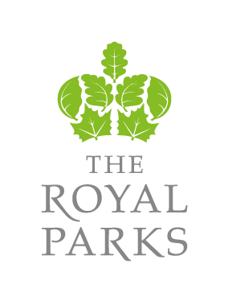

FOL16/670: DRILL, CONSTRUCT, DEVELOP & TEST PUMP A NEW BOREHOLE WITHIN
THE REGENT’S PARK TOGETHER
WITH PERMANENT INSTALLATION
WORKS, CONTROLS
AND PIPE WORK

APPENDIX 2

Appendix 2

Statutory Instrument 1997 No 1639 - The Royal Parks and Other Open Spaces Regulations 1997

