Invitation to Quote for Stand Build
AHDB Exports Stand
SIAL Canada 2023
Toronto

Contact Name: Claire Sayers-Smith Email: Claire.Sayers-Smith@ahdb.org.uk

Company Name: AHDB Exports Website: www.ahdb.org.uk

Address: Stoneleigh Park Tel: +44 (0) 7854 093908
Kenilworth
Warwickshire
CV8 2TL Contract Period: 9 Jan 2023 to 12 May 2023
United Kingdom

Show Name: SIAL Canada 2023 Show Dates: 9 – 11 May 2023

Hall: Fresh Product Stand Number: 2143

Stand Size: 400 sq.ft (37 sqm) Open Sides: 3

Budget: approx. £55,000 (inc VAT)

Show Venue: Enercare Centre Deadline for submissions: Friday 10 February 2023
Toronto, Canada

- Introduction

This document outlines the requirements for the AHDB Exports stand at SIAL Canada 2023.

AHDB Exports are part of AHDB (the Agriculture, Horticulture Development Board) and based in Warwickshire, England.

We are a non-departmental Government public body working to promote British Pork and English Beef, Lamb and Cheese both at home and abroad.

2. Objective of attending the show

To provide a platform for our levy paying meat producers to create new business relationships with international meat buyers.

3. The Stand

We have booked a prime location for our stand. The floor plan can be viewed under point 8 showing our exact location.

Our stand measures 200 x 200 sqft, a total floor-space of 400 sq.ft.

The stand will be shared equally between AHDB meat (Beef, Pork & Lamb) and AHDB dairy.

The look and feel of our stand are important and must portray the quality to enhance our Quality British meat and dairy. The stand will need to be seen from a distance and be visually appealing.

The design should encompass a high-level fascia board/lampshade to enable us to brand this as GREAT following our brand hierarchy (see point 4) This will enable us to clearly distinguish we are British; ensure we can be seen from a distance and draw people to our stand.

Further details on stand build times and services available from the venue/organiser are here - Home - SIAL Canada

4. Stand Build Requirements

To include all electrics, hot and cold-water supplies, wastewater disposal.

Requirements include a shared networking space, shared lockable storage room and clear designated areas for both meat and dairy branding.

All lighting should be low heat creating.

The stand needs to have the following elements and provisions.

- All electrics, (including 24 hrs electric for refrigeration units)
- Hot and cold water supplies
- Waste-water disposal
- Cleaning of the stand each evening
- Access to the internet, so provision of Wi-Fi
- Security
- TV

Refrigeration units need to be in place and must be operational by the morning of Monday 8th May, ready to receive all edible consumables.

Kitchen/Storeroom
This is a shared space and needs to include:

- Lockable door
- One small hand basin with hot and cold water for hand washing
- Countertop work services for food preparation, shelving
- 1 x H3A fridge underneath the counter (Lowe refrigeration or equivalent) for drinks – 24 hour power
- Wall shelving for literature storage
- Additional double electrical socket
- Coat hooks / rack
- Coffee machine – to provide coffee and tea services
- Space for storing luggage/valuables/laptops etc.
- Power for recharging mobile/cell phones (UK adaptors)
- Water dispenser with hot and cold water.
- Disposable cutlery, plates and napkins (approx.100 each per day)
- Red resin cutting board approx. 600x450 mm – raw products
- Yellow resin cutting board 300x450mm – cooked product
- Hot plate scrapper
- J cloths
- Cleaning fluids
- Anti-bacterial spray
- Anti-slip matt for chopping boards
- Disposable latex gloves
- Hand sanitiser for each table
- Box of disposable masks
- Waste bins and bags
- Soap for handwashing

Dairy Networking Area:

- 3 x A1 Lowe (or equivalent) display chillers with display grass with 24 hour power
- Chiller and graphic wrap
- Welcome/ reception desk with lockage storage underneath and graphic to the front
- 2x2m space for a VR device equipment with poseur table
- Bin
- Literature rack
- Electrical sockets for charging items

Meat Networking Area:

- 1 x A1 Lowe (or equivalent) display chiller with display grass with 24-hour power
- Chiller and graphic wrap
1x Double Induction hob (with frying pans) for cooking meat - There should be a protective partition at the front of the cooking area to protect spectators whilst they watch products being cooked
- Welcome/ reception desk with lockage storage underneath and graphic to the front
- Bin
- Literature rack
- Electrical sockets for charging items

Other

- Shared networking area of multiples of low tables with 4 chairs each to provide meeting points. Please note the number of tables and chairs is dependent on visitors being able to walk around the stand freely and without obstruction.
- Down lighting above graphic walls
- Flooring to be wood effect padded vinyl
- TV screen mounted on stand wall

Maintenance of Stand

Maintenance, up-keep and cleaning of the stand shall be carried out daily by the successful supplier during the duration as well as prior to the start of the Exhibition. This is to include, but not limited to the below requirements:

- The cleaning of floors throughout the stand
- The cleaning of furniture including tables, chairs and work surfaces
- Emptying of bins

Hospitality package

Please provide a price for supplying the following hospitality package for the entire show:-

- Pods for coffee machine
- UHT milk
- Tea bags
- Sugar sachets
- Stirring sticks
- Water for cooler
- Cups for water, tea, coffee
- Soft drinks e.g coke, sprite
- Refuge sacks – for bins

5. Stand Management

A member of the successful supplier’s team shall be nominated and must be available during the duration of the Exhibition covering construction and dismantling of the stand, and capable of dealing with any eventuality. A nominated deputy must be available during any absence of such person. AHDB would require names of who will be in attendance.

AHDB will nominate a “Stand Manager” who will be the key contact for the successful supplier for the full duration of this project.

6. Graphics

AHDB will provide full and print ready artwork for all graphics. Please include print deadline in your response

Top level branding (lampshade / banner) needs to be seen from a distance in all directions and draw people to our stand – see below.

There will need to be dedicated walls/panels for AHDB Meat and Dairy and ideally these will be either lightboxes or if walls have surrounding lights.

AHDB graphic panels

The theme will be based on Great British beef, lamb, pork and dairy using landscape images with live animals and food images.

Our key message “Quality Meat from Britain” and “Quality Dairy” – will need to be shown in a prominent position.

Our USP is based around a quality product and so graphics design needs to reinforce this message.

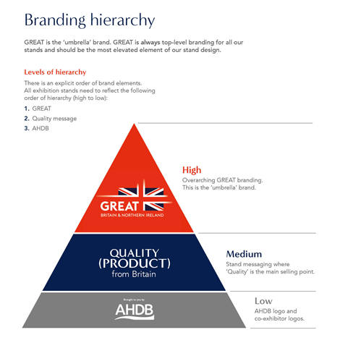

7. Stand Layout & Design

The visuals below illustrate previous stands of a similar size effectively combining multiple elements i.e. info counter, cookery/sampling area, store/kitchen. Note that GREAT branding and graphic panel styles shown have been updated, ensuring you refer to Section 7 and the appendix when considering your design.

We would also be open to lightboxes on the stand to help draw people into the stand – whether these have rolling images to help engage visitors or static images – this is open to interpretation.

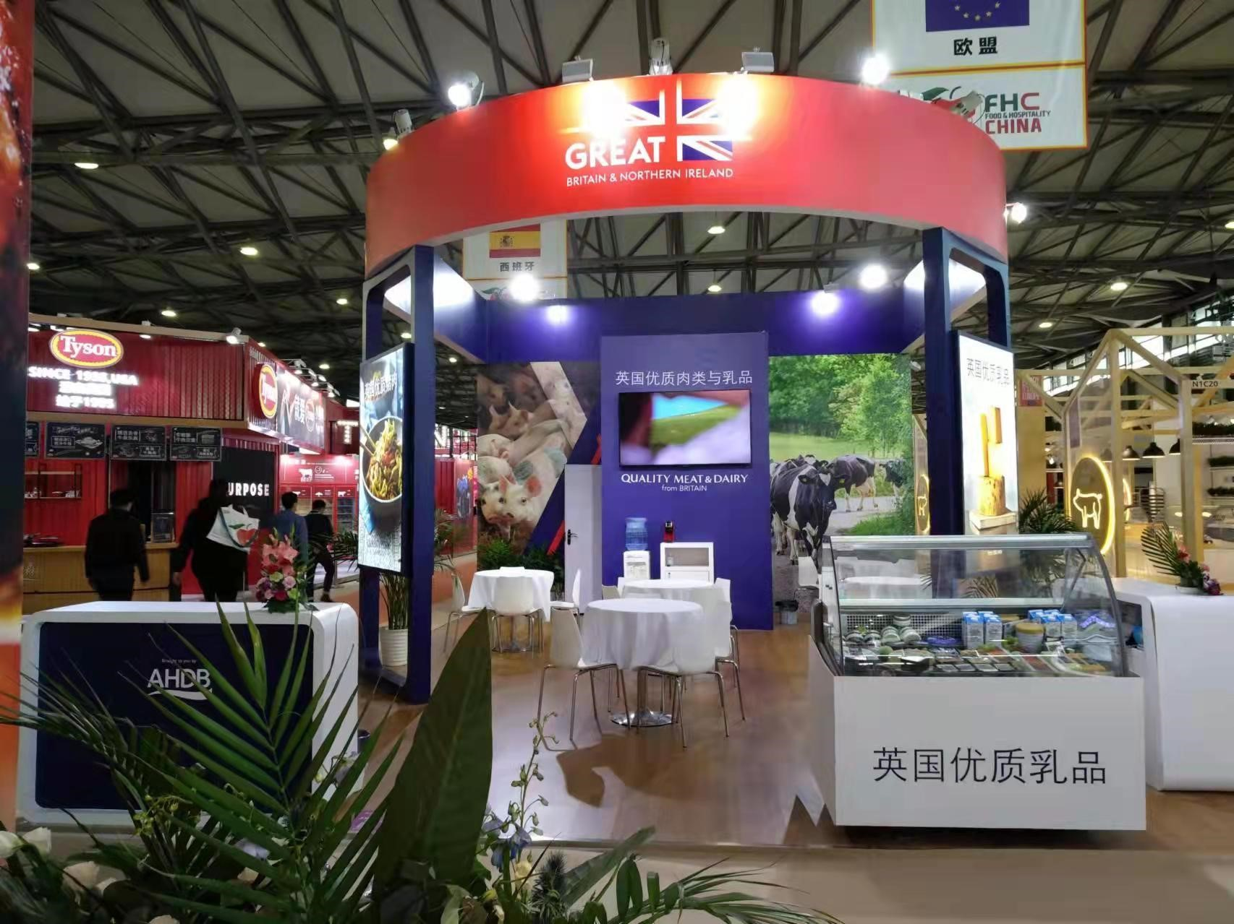

8. Hall Plan

Below is the layout of the hall showing the location of our stand.

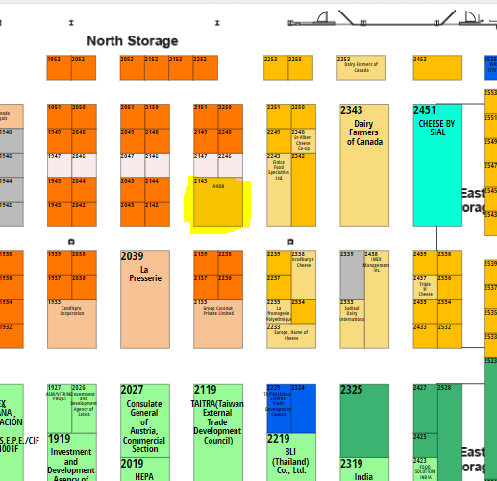

9. Useful information

Structural Height Restriction
4.5.0m (14.7 ft) will be the absolute maximum height allowed and approved.

All stands, irrespective of height must have at least half of any frontage facing an aisle left open or fitted with transparent (clear see-through) material to be underside of the fascia. This area must be left visibly free of obstruction. Each side of the exhibition stand should not be obstructed for more than 3 meters continuously.

Booth design with hanging banner or hanging structure will have to pay advertising fee per sqm of surface area.

Stand build dates
The contractor will be responsible for completion and submission of organisers forms relating to the design and construction of the stand, including organiser design approval. A login for the exhibitor portal will be provided after the contract is awarded, and a copy of the exhibitor manual sent electronically.

10. Tender submissions

The contractor shall deliver the whole of the services, complete in all parts and furnished with every necessary detail, notwithstanding any omission or inconsistency in the specification.

Your quote should include
- “To-scale” visuals of your stand design, including dimensions
- 3D drawings of the stand design from each angle
- A clearly itemised breakdown of all costs covering all products and services outlined in the brief (noting anything that isn’t included)
- Details of the build materials
- A graphic plan detailing
  - all graphic dimensions (to allow for a quick process once appointed)
  - Artwork timelines (when final print ready artwork is to be supplied)
- Details of if sub-contractors are to be used

Except as otherwise stipulated in the specific conditions of service required, the contract shall remain at the fixed price and rates shall not be revised.

The Stand Manager can order reasonable additions to or reduce from the service specified. These amendments shall be requested in writing and agreed by both parties.

11. Evaluation of Quotes

Our award criteria:

- Price (40%)
- Design, creative impression, and equipment (50%)
- Ability to meet event timelines, artwork, build-up and break-down (10%)

Please email your design proposals to Claire.Sayers-Smith@ahdb.org.uk by Friday 10 February 2023

Tender submissions will then be reviewed, and the winning contractor advised on Friday 17 February.

Any interested parties with queries relating to the tender please email Claire.Sayers-Smith @ahdb.org.uk who will respond to queries to all interested parties.

