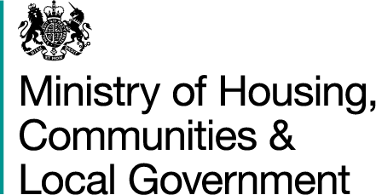

Bravo Solution Registration

The Ministry of Housing, Communities and Local Government (MHCLG) has issued a Request for Information (RFI) and would like to invite you to take part.

The RFI process will be run via the Bravo e-Tendering system (located at https://dclg.bravosolution.co.uk), so in order to respond and to receive further documentation, including Q&As, you will need to be registered.

If you are not already registered please follow the instructions below to do so:

Register your company on the Bravo eSourcing portal (this is only required once)

- Browse to the eSourcing Portal
- Click the “Click here to register” link
- Accept the terms and conditions and click “continue”
- Enter your correct business and user details
- Note the username you chose and click “Save” when complete
- You will shortly receive an email with your unique password (please keep this secure).

Registration is free and you will then be able to access full details of the RFI and download all further documentation.

Once registered on Bravo please e-mail the MHCLG contact detailed within the Contracts Finder notice and you will be added to the eSourcing event.

