This is the Quotation Return Label and should be attached to your quotation envelope. Quotations returned without this Label will be returned unopened. Do Not reduce the size of the label when printing your hard copy. Please Note that the quotation should be returned by 02/07/2018 and 12 noon.


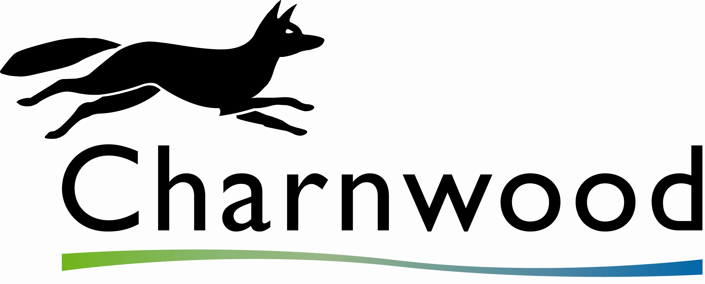
Quotation for: Meeting room – Presentation Facilities

Reference No.: AK/CSICSMR
Return Date: 02/07/2018
Return Time: 12 Noon

Received by:

Received Date:
Received Time:

Q
To:
Contract Compliance Officer
Charnwood Borough Council
Southfield Road
Loughborough
Leicestershire
LE11 2TN

