**FOR SALE:**

**2007 Volvo B7RLE Single Decker Bus**

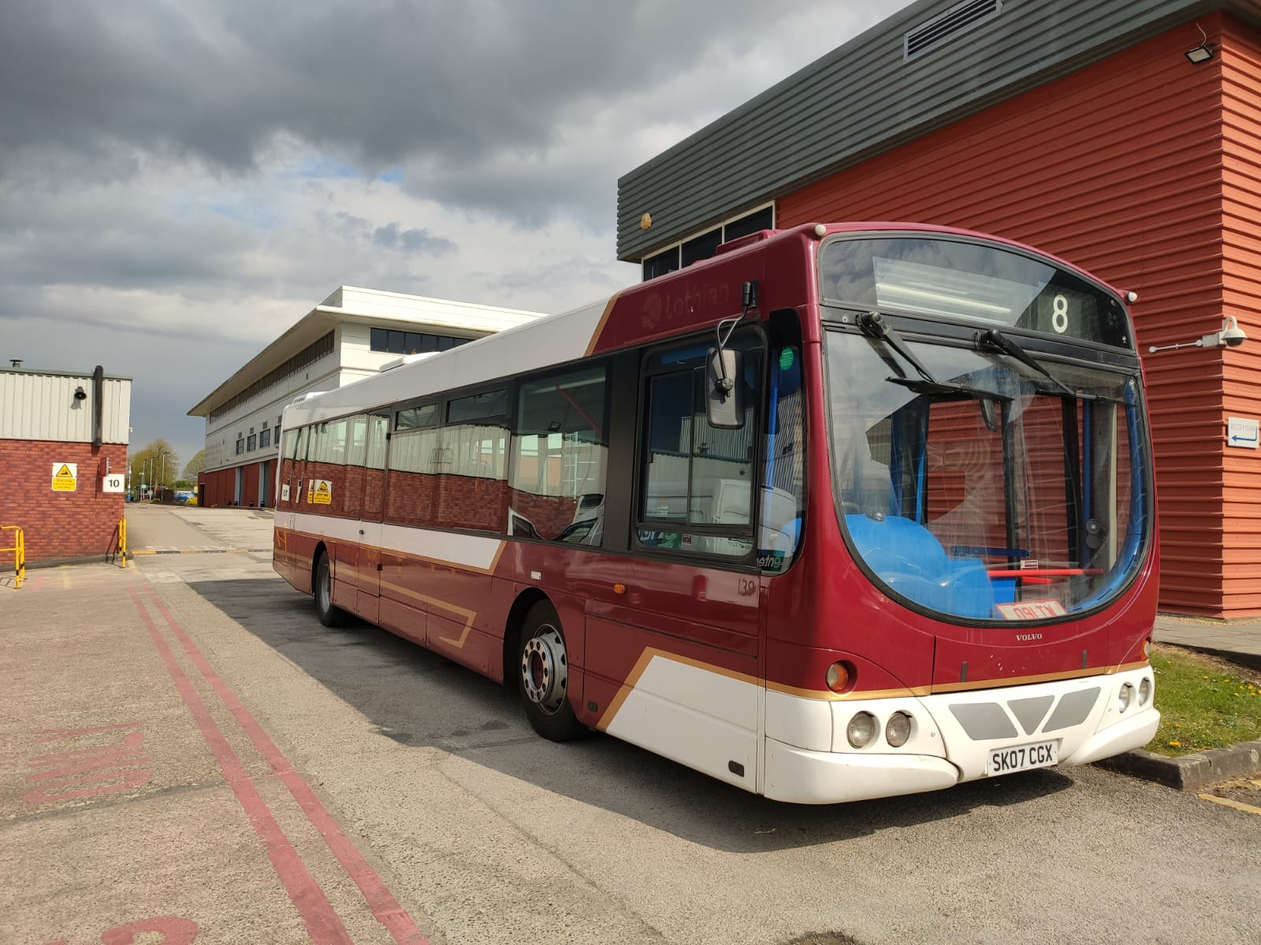

**Details**

Can be viewed and collected from: Ricardo Midlands Technical Centre, Southam Road, Radford Semele, Leamington Spa, Warwickshire, CV31 1FQ.

Please contact *Clint Gulliver* ([Clint.Gulliver@ricardo.com](mailto:Clint.Gulliver@ricardo.com))for viewing details on 01926 319462.

All sealed bids must be emailed to Jon Collyns at [jon.collyns@cambridgeshire.gov.uk](mailto:jon.collyns@cambridgeshire.gov.uk) before 10th July and submitted in pounds and pence.

Please Note that the vehicle is SOLD AS SEEN and that the seller shall accept no liability after the sale has been made.

|  |  |  |  |
| --- | --- | --- | --- |
| Make | Volvo | Model | B7RLE |
| Colour | Red and White | **Year** | 2007 |
| Engine Size | Volvo D7C | **Length/Width** | 12 x 2.55m |
| Number of Seats | 38 | **Drive Side** | Right |
| Fuel | Diesel | **MOT and Road tax** | Expired 25/04/22 |