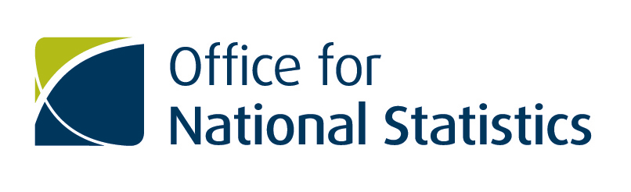

Notice of market engagement activity
Better Data for Britain: Securing commercial data partnerships to deliver better statistics for better decisions.

About ONS
ONS is the UK’s largest independent producer of official statistics and is the recognised national statistical institute for the UK. Formally, it is the executive office of the UK Statistics Authority, a non-Ministerial Department established by the Statistics and Registration Service Act 2007. It is responsible for collecting and publishing statistics related to the economy, population and society at national, regional and local levels. It also conducts the Census in England and Wales every ten years. ONS plays a leading role in national and international good practice in the production of official statistics.
Introduction
The Office for National Statistics (ONS) is looking to identify and engage with industry partners to help bring third party data and or expertise to directly support a ‘shift’ to accessing better more relevant data sources and to improve the aggregate official statistics about our population, society and economy that decision makers, businesses and citizens so urgently need.

For decades ONS evidence base has primarily been underpinned by large scale social and economic surveys of people and businesses. Notable examples include the 200 year old Census and the statutory Annual Business Survey. Such surveys whilst rich in unique data are also costly to taxpayers and businesses alike, take considerable time to deliver and are typically slow to adapt. Whilst qualitative data collection methods remain core to ONS’ approach, the organisation is making a step change in its focus to identify and access alternative data sources, tools and capabilities to embrace the opportunities to improve official statistics made possible by our increasingly data driven digital world. Developments such as the ONS Enhanced Financial Accounts and Data Science Campus Market Engagements, see supporting documentation for links, demonstrate the ONS appetite to directly tackle transforming economics statistics and resource the researching of new indicators.

The Statistics and Registration Service Act ensures that the ONS only collects and analyses confidential data for statistical and research purposes, never for operational reasons. That will not change but the 2016 Digital Economy Bill will offer ONS a new legal gateway to facilitate access to data for the purposes of producing statistics for the public good. Better Data for Britain will serve as a platform from which ONS can transition to a more collaborative model of commercial data access and a world in which the very best decisions are made based on trusted official statistics whether or not these are entirely self generated by ONS or co-created with partners. This market engagement is the the first step to accelerating a step change in the sharing of data.

ONS welcomes any approaches that support its drive to provide improved data for Britain so we can all make better decisions for our society and our economy using official national statistics underpinned by the very best evidence base.

Additional Information
ONS is looking to identify and access all levels of data that can help enhance and augment existing official national statistics and identify new outputs across but not limited to the following categories and sub categories:
Economic
- Gross Domestic Product
- Balance of Accounts
- Labour Market and Household
- Balance of Payments and trade
- Price Data
Population and Society
- Population
- Wellbeing
- Life events
- Census
Research led data source to support The Data Science Campus and our work on the World Resources Institute Sustainable Development Goals (SDG’s) underlined in our People, Planet and Prosperity programmes:
- Urban future
- Society
- Sustainability
- Evolving economy
- UK in a global context
For any data we have access to we will require a clear explanation of both the source of the data and any methodology used in the production of the data.
Engagement Details
The invitation to engage with this opportunity is extended to any organisations that may be interested working with ONS to develop this strategy. ONS is eager to hear from a diverse range of providers, including small and medium sized enterprises.
Supporting documents
- Delivering better statistics for better decisions https://www.statisticsauthority.gov.uk/publication/delivering-better-statistics-for-better-decisions-data-access-legislation-march-2016/

- Better Statistics Better Decisions https://www.statisticsauthority.gov.uk/archive/news/uk-statistics-authority-statement-of-strategy-2015-2020-better-statistics-better-decisions.pdf

- Bean review
https://www.gov.uk/government/publications/independent-review-of-uk-economic-statistics-final-report

- Linked PIN’s
  - ONS Data Science Campus: https://www.contractsfinder.service.gov.uk/Notice/4dd18f63-33aa-4565-9451-0bdb1fff873f

  - ONS Enhanced Financial Accounts: https://www.contractsfinder.service.gov.uk/Notice/f3bc98ff-0873-41fe-ad34-b6ed0a830247

- Digital Economy Bill
http://services.parliament.uk/bills/2016-17/digitaleconomy.html

How to register
If you would like to express an interest in being part of this engagement process, register on the ONS e-tendering portal https://in-tendhost.co.uk/ons and use the "express an interest" function against the Commercial Data Partnerships Project.
You will need to complete the spreadsheet, which requires you to select the data you are able to provide and also provide a brief outline of the nature of your business.
Additional Information
This Exercise is NOT a pre-qualification or selection exercise and is NOT part of any pre-qualification or selection process that may apply to any future potential procurement. The Exercise is intended to act as an awareness and information gathering exercise offering an opportunity for suppliers to advise the extent to which they potentially are able to provide some or all of the services that ONS may require, in order to help ONS with its future commissioning intentions.

