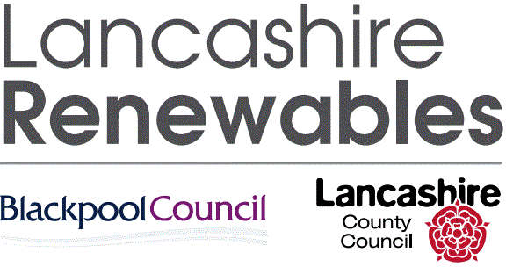

**Preliminary Market Consultation Exercise**

**for**

Provision of Agency Workers / Staff @ Lancashire Renewables Limited (Leyland & Thornton Sites)

Issue – 17/07/2023

**Introduction:**

This process is being undertaken to provide Lancashire Renewables Ltd (LRL) and Lancashire County Council with a current view of the market options for an agency staffing solution.

**This is not an ITT (invitation to tender) exercise.** This is a preliminary market consultation or ‘soft market testing’ exercise that will help inform the content of a future ITT exercise; from which a supplier will be awarded a contract for the service.

This market consultation is a two-stage process:

Stage 1

To declare your interest in this project, please respond to the questionnaire below and return your completed questionnaire to James Mynott / Procurement Manager @ LRL / [james.mynott@lancashirerenewables.co.uk](mailto:james.mynott@lancashirerenewables.co.uk) no later than 1st September 2023.

Stage 2

LRL then intend to invite a nominal number of suppliers to the Head Office (Leyland) to engage in open discussion and present their capabilities and ideas. These meetings will be scheduled for September 2023. Depending upon the number of responses that this consultation receives, LRL may not be able to accommodate meeting dates for all the interested parties.

Note: exclusion from Stage 2 does not preclude any supplier from engaging in the formal tender process for this service, at the appropriate release date in 2023.

**Please refer to the scoping document for a more-detailed overview. The below is a summary.**

**Requirement:** for a recruitment agency to provide agency workers to LRL. The agency workers will cover a variety of roles primarily across operational, administrative, professional, and supervisory categories.

**Background**

Lancashire Renewables Limited (formally Global Renewables) was established in 2010 and operates two flagship waste treatment facilities in Leyland and Thornton; handling household and residual waste (circa 400,000 tonnes p.a.). LRL currently employs circa 180 people. The headcount will increase up to a total of 272 people as the company prepares to undertake additional processing activity in 2025.

To support LRL’s operation and commencing from April 2024, LRL wishes to have a contract in place with a recruitment agency to provide and support the ongoing requirement for agency workers. LRL currently spends approximately £400-450k per annum on agency staff (based on company payroll information). Currently, LRL typically has 10-15 agency employees on the ground.

As part of the soft market testing exercise, we are hoping to review and clarify certain criteria that will help us to create a final tender specification. Typical criteria may include, but not be restricted to, the following topics:

* Presenting the industrial nature of LRL’s sites and clarity of the working environment
* Whether the recruitment agency can provide a physical presence at LRL’s sites to support the service, any agency staff on the ground, and moreover a close relationship between the agency and LRL
* Typical roles and responsibilities of both the agency and LRL under a contract
* Creation of a pool of staff assigned to LRL covering multiple roles
* Ability to service each of LRL’s two sites or any envisaged difficulties servicing either location
* Feasibility and criteria around permanent employment from either an agency worker on the agency’s books or a new employee
* Contract terms (including duration) and performance metrics.

**Questions & Topics – requiring your response:**

1. Introductory details: please provide a brief overview of your company (preferably in PowerPoint format); details to include:-
   1. Company structure, ownership and history.
   2. Annual turnover & business strategy.
   3. Typical client base; including any references.
   4. Familiarity and experience of supporting the waste industry.
2. Describe your potential to meet our scope of requirements and your willingness to proffer advice when required by the LRL project team.
3. Please state whether a physical presence at LRL’s sites (Leyland and Thornton) via a hot-desking arrangement is something that you would be willing to provide, for example, line manager / HR meetings, inductions support, onboarding process, etc.
4. Do you feel that your company is able to support both LRL sites, or is there any restriction that prevents this (e.g. geographical location covered by your company).
5. Would you be committed to identifying and evaluating any opportunities to improve the service offering, around the headline criteria of Quality, Service, Cost, and Innovation.
6. Are there any specific issues that would either encourage or discourage you from bidding for a contract to deliver the agency service to LRL, taking into account any improvements that may be identified as part of our market consultation.

**Contact:**

Lancashire Renewables Ltd:

All technical and procurement questions should be directed to:

James Mynott (Procurement Manager)

[James.mynott@lancashirerenewables.co.uk](mailto:James.mynott@lancashirerenewables.co.uk)

Joanne West (HR Advisor)

Joanne.West@lancashirerenewables.co.uk