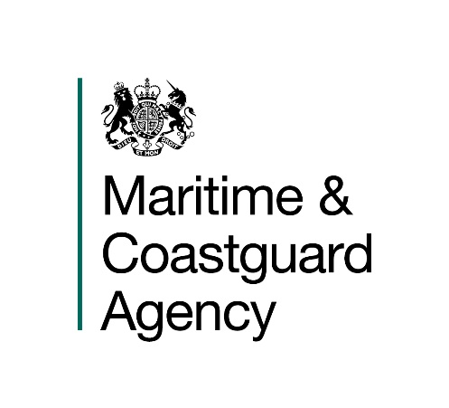

Introduction

The Maritime and Coastguard Agency (MCA) is an Executive Agency of the Department for Transport. The MCA is responsible throughout the UK for implementing and developing the UK Government's maritime safety and environmental protection policy. That includes co-ordinating Search and Rescue (SAR) at sea through Her Majesty’s Coastguard 24 hours a day, and checking that ships meet UK and international safety rules. The MCA work to prevent the loss of lives at the coast and at sea, to ensure that ships are safe, and to prevent coastal pollution: Safer Lives, Safer Ships, Cleaner Seas.

The MCA provide a full range of search and rescue, counter pollution, survey, inspection and enforcement activities and has 12 major business activities:

- Survey | - Seafarers Services
- Inspection | - Search & Rescue
- Enforcement | - Pollution Response & Salvage
- Ship Registration | - Stakeholder Communication
- Navigation Services | - Ministerial Services
- Strategic Prevention Design/Development | - Regulatory Process

These activities are supported by support services responsible for providing a range of administrative functions including; infrastructure, MCA people, financial management & administration and corporate management.

You are invited to submit a tender to the following Specification:

CONTRACT REFERENCE: TCA 3/7/1133
RAPID DEPLOYMENT FENCE BOOM SYSTEM

- General Requirement
  - The MCA wishes to purchase 200m of fence boom that is designed for quick and easy deployment.
  - The Boom will form part of the MCA’s stockpile of Counter Pollution Equipment and will be used, in the event of a major marine oil spill, for the recovery of oil spilled into the seas around the UK. The System will also be used on a regular basis for training exercises.
  - The winning tender must be able to provide evidence that the system has been reliably tested in marine conditions and operated in oil emulsions with varying viscosities and in varying current speeds and sea energy.
- Technical Specification
  - A full specification for the fence boom system, including all major critical parts and assemblies, and a complete comprehensive method statement describing how the boom operates should be included in the tender submission.

  - The draught of the flotation boom will need to be a maximum of 350cm.
  - The boom should be heavy duty with high visibility markings and tenderers should provide full details of the material used to manufacture the fence boom. Please provide a sample no larger than an A4 sheet of paper, to enable effective evaluation of strength and durability.
  - If the fence boom is comprised of multiple boom sections / segments; please explain how each section of boom is connected. This should be a full description of the joining method & mechanism of each adjacent section of boom to enable MCA to effectively evaluate suitability & durability.
  - Although Tenderers may have the information requested on the internet or in printed literature, in order to assist the MCA with the evaluation process it is essential that the responses to the bullets are provided in the order below:

- Draught
- Freeboard
- Ballast
- Type of vertical stiffener to be utilised between each chamber
- Material type – including sample (no larger than A4 size)
- Strength and durability of boom material
- The tensile strength of the system
- Boom connectors
- Dimensions of the boom (length & diameter)
- Overall weight of the boom
- Storage method
- The wave height and speed limitations within which the boom will function successfully
- The type of connectors on the towing bridles (the MCA’s preference is for ASTM connectors).
- Deployment
  - In an emergency it is vital that as part of the counter pollution equipment the boom is capable of being deployed rapidly.
  - The fence boom must be deployable from a dockside or from a vessel at sea. Tenderers need to specify the timescales for deployment and the number of operational staff required for deployment.
  - Whether deployed from a dockside or from a vessel, the boom should be towable at a range of speeds up to a maximum of 15 knots. Please state details of effectiveness of the boom at different towed speeds and confirm that the boom can be towed up to 15 knots.
- Storage & Distribution
  - The boom system should be palletised and tenderers must confirm that this will be the proposed method of storage in their submissions.

  - The Tenderer shall detail how the proposed equipment is to be stored, including suitable environmental conditions. Information on a full range of ideal storage temperatures needs to be identified in the tender submission.

- Warranty

  - We regard warranties as an important component of achieving overall best value for money. Full details of your warranty on the tendered equipment is required, including the period of cover. Please explain if in-house maintenance by the MCA’s equipment storage contractors affects your warranty terms.

- Technical Support
  - The Tenderers shall detail what technical support and back up they are able to provide. This is to include as a minimum:

- Customer Support Contact numbers and email addresses, Standard support service availability times for this offer – e.g. 0900 to 1800 Monday to Friday, Monday to Sunday, full 24/7, etc.
- Maximum standard and emergency response times, to attend site if required &
Maximum standard and emergency times to fix a fault.
- Spares/Repair Packages required to be held by MCA’s equipment storage contractors.

- Maintenance
  - The maintenance of the boom will be carried out in-house. Tenderers are to provide an operating manual in MS Word or PDF electronic format including maintenance requirements and schedules.
  - Tenders should include the expected life of all components and consumables, when stored ready for deployment, and if applicable, details of how the expected life of all components and consumables are affected by one or more deployments. This should include recommendations of what should be held in our stock, and the associated cost should be detailed in the Pricing Schedule under Ancillaries and Spare Parts.
- Delivery
  - The delivery price should be included in the overall cost as per the Pricing Schedule.
  - Suppliers must state in their tender the lead time for delivery to Barnsley, UK. Delivery on or before 31st March 2020 is a critical factor and is a mandatory requirement for any Tender to be considered at the evaluation stage.

- Proposed Procurement Timetable

Description | Date
Tender published on Contracts Finder | 18th December 2019
Final date for Queries / Questions | 30th December 2019
Bid Submission date and time | 11am 6th January 2020
Proposed Contract Award | 9th January 2020
Delivery date | Before 31st March 2020

