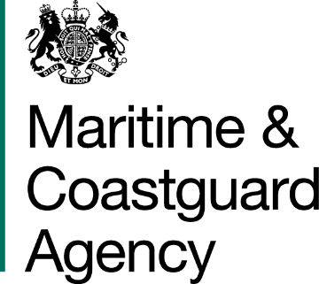
3/17
Spring Place
105 Commercial Road
Southampton
SO15 1EG

Gavin Rae Tel: +44 (0)203 81 72538
BT Openreach Fax: +44 (0)23 8032 9388
E-mail: contacts@mcga.gov.uk
81 Newgate Street
London

EC1A 7AJ
8th March 2018

Dear Mr Rae,

Openreach survey proposition for: -154 sites being migrated from current Kilostream connectivity

- On behalf of the Secretary of State for Transport, I accept your tender dated 22nd February 2018 for the above-mentioned Contract. This letter and the documents listed below form a binding contract between you and this Department.

  - MCA Survey Quotation
  - Appendix A – Integrity letter
  - Appendix B – ECC’s
  - Appendix C – Response Guidance

- The Firm Price for the Contract is £545,120 exclusive of Value Added Tax comprising of the following milestone payments.

    - £150,000 payable in March 2018.
    - £395,120 to be paid in June 2018 on completion of surveys.

All Prices are Subject to Contract and exclusive of VAT.

- Invoices should be submitted to the DfT Shared Service Centre in accordance with the directions provided in the Contract documents.

- Please acknowledge receipt of this letter by signing in the box below and returning a hard copy to me within 14 days of receipt. Failure to do this could result in a delay of payment of appropriate invoices.

Yours sincerely

Bill Dunham
Director of Strategy and Corporate Services

Please acknowledge receipt of this letter by signing and returning a copy of this letter to me as soon as possible:

Signed…………………………………………… Name…………………………………….^{Gavin Rae}

Print name………………………………………. Position…………………………………Gavin Rae Senior Business Development Manager

