ProofID Limited

8 Exchange Quay

Salford

Manchester

M5 3EJ

22/05/2024

Dear Andy,

**Contract Title:** UKRI Identity and Access Management Solution

**Contract Reference:** DDaT21551

**Contract Variation Reference:** 002

Please find the attached contract variation reference; DDaT21551 with effect from 20/06/2024

This Variation is for the removal of the On-going support for the remainder of the contract and extending the contract for year 3.The contract value for the additional year extension is £78,000 (Excl VAT).

The cumulative contract value remains unchanged, providing room for contingencies.

Please ensure that you review and satisfy yourselves with its content and the contractual implications of this variation before signing and returning to Mobolaji Dawodu and [DDaTProcurement@uksbs.co.uk](mailto:DDaTProcurement@uksbs.co.uk) for our records.

|  |
| --- |
| Yours Sincerely,  [REDACTED](mailto:REDACTED)  Procurement Manager – Digital, Data and Technology  **UK Shared Business Services Ltd**  [REDACTED](mailto:REDACTED)    For and on behalf of UK Research and Innovation |

Contract DDaT21551 is varied as follows and shall take effect on 20/06/2024 between:

|  |
| --- |
| 1. **UK Research and Innovation** Polaris House, North Star Avenue, Swindon SN2 1FF (The Contracting Authority).   and |
| 1. **ProofID Limited**, 8 Exchange Key, Salford, Manchester, M5 3EJ (the Contractor). |

Collectively known as the “**Parties**”

The Parties agree to the following changes to contract DDaT21551 – UKRI Identity and Access Management Solution

This Variation is for the removal of the On-going support for the remainder of the contract and extending the contract for year 3.The contract value for the additional year extension is £78,000 (Excl VAT).

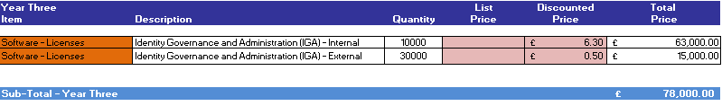

|  |  |
| --- | --- |
| For and on behalf of ProofID Limited **(The Supplier)**  Signed  Name  Position  Date | [REDACTED](mailto:REDACTED)  ……………………………………………  [REDACTED](mailto:REDACTED)  ………………………………………………  [REDACTED](mailto:REDACTED)  ……………………………………………  ……………………………………………… |
| For and on behalf of UK Research and Innovation**(The Contracting Authority)**  Signed  Name  Position  Date | [REDACTED](mailto:REDACTED)  ……………………………………………  [REDACTED](mailto:REDACTED)  ………………………………………………  [REDACTED](mailto:REDACTED)  ………………………………………………  [REDACTED](mailto:REDACTED)  ……………………………………………… |

Words and expressions in this variation shall have the meanings given to them in Contract DDaT21551. Contract DDaT21551, including any previous variations, shall remain effective and unaltered except as amended by this variation.