OVESCO REQUEST FOR TENDER:

The Purchase and Installation of a Photovoltaic System And Air Source Heat Pump at
Pine Grove Enterprise Park
Pine Grove,
Crowborough
TN6 1DH

The Purchase and Installation of a Photovoltaic System At Wolfe Tractor Shed
Blackness Rd,
Crowborough
TN6 2NA

Request for tender. Document release date: Friday 1st April 2025
Return date: Wednesday 1st March 2025

Tenders must be submitted by hard copy by hand or post only to OVESCO.

All correspondence to be with Frank Donghi OVESCO’s Technical Manager frank@OVESCO.co.uk

Contents

Section 1. Background and conditions of the project 3
1.1 About the project 3
1.2 Contract requirements 4
1.3 Scope of supply 4
1.4 Project location 6
1.5 Tender process and project timetable 11
1.6 Tender assessment criteria 11
1.7 Tender conditions 14
Section 2. Information required 15
2.1 Tender information requirements 15
2.2 Added Value 17
2.3 Local knowledge and impact 17
2.4 Guarantees 18
2.5 Site meeting 19
2.6 Company Information 20
2.7 Check list of documents to include in the tender 22

Background and conditions of the project

About the project
Pine Grove Enterprise Park and Wolfe Tractor shed are Crowborough Town council owned sites located on the town of Crowborough in East Sussex, England. The project is being project managed by OVESCO a community organisation based in Lewes. Pine Grove Enterprise Park and Wolfe Tractor Shed project is one of a series of installations being developed by Ouse Valley Community Energy Company (OVESCO) in the Lewes District/East Sussex region.
OVESCO is a community interest company created for the benefit of the community. It aims to develop renewable energy schemes in East Sussex to lower the area’s carbon footprint, and generate income to support the community in other carbon-reduction activities, creating a double impact on carbon emissions.
Further detail about all OVESCO’s activities can be found at www.ovesco.co.uk
All works at Pine Grove Enterprise Park and Wolfe Tractor Shed is fully funded by Crowborough Town council.

The Framework Agreement is divided into three separate Lots:-
Lot 1 – Pine Grove Enterprise Park Design, Supply and Installation of Solar PV System, connection and commissioning with associated equipment. Operations and Maintenance of Solar PV system. 5 years and 10 years.
Lot 2 - Pine Grove Enterprise Park Design, Supply and Installation of Air source heat pump (ASHP). Operations and Maintenance of Air Source Heat Pump (ASHP) and associated equipment for 5 years and 10 years.

Lot 3 – Wolfe Tractor Shed Design, Supply and Installation of Solar PV System, connection and commissioning with associated equipment. Operations and Solar PV system and associated equipment for 5 years and 10 years.

Contract requirements
Lot 1:
The intention is to enter a fixed price contract for the design, supply, installation, connection and commissioning of a solar photovoltaic system on the roof of Pine Grove Enterprise Park in the Wealden District.
The intention is to contract for an installation size of an estimated 98 kWp.

The roof mounted system is to be placed on or in line with modern tiled roof see appendix 1 for structural engineer report on roof construction.

The invitation is to provide a battery option with cost benefit analysis and ROI.

The invitation is to provide Maintenance of the solar PV system post commission in line with MCS recommendations for a period of 5 and 10 years.

Lot 2:
Pine Grove Enterprise Park. The invitation is to Design and Install ASHP heating system. Ensure integration with existing heating system, by bi-valve design. Provide certificate of compliance, O&M manuals and method to demonstrate energy savings upon completion. Decommissioning of existing gas-powered boilers. The expected heat demand design is 100kW for the building.
The invitation is to provide Maintenance of the ASHP system post commission for a period 5 and 10 years.

Lot3:
Wolfe Tractor Shed. The intention is to enter a fixed price contract for the design, supply, installation, connection and commissioning of a solar photovoltaic system on the roof of Wolfe Tractor Shed.
The intention is to contract for an installation size of an estimated 18 kWp.

The roof mounted system is to be placed on modern sheet metal seemed roof.

The invitation is to provide a battery option with cost benefit analysis and ROI.

The invitation is to provide Maintenance of the solar PV system post commission for a period of 5 and 10 years.

Scope of supply
Lot 1:
The fixed price contract will include: Pine Grove Enterprise Park
- design, supply and installation of the solar panels and all associated equipment necessary for the optimal supply of electricity from the solar panels to the connection point(s) (the connection point(s) will be determined by the contractor following the site visit).
- design and supply of battery option(s) calculations and method to demonstrate energy savings.
- connection and commissioning of the installation including liaising with UKPN.
- supply of scaffold and hording where required.
- structural calculation.
- roof condition report in advance of installation.
- ORSIS type total generation and import/export meter with sim cards for remote metering.
- 25-year guarantees for key elements of the system.
- Operations and Maintenance quotes for PV system and all parts for a period 5 years and 10 years.

Lot 2:
The fixe price contract will include: Pine Grove Enterprise Park
- design, supply and installation of the air source heat pump (ASHP) demand 100kW and all associated equipment necessary for the optimal heating and hot water of the site. Bi-valve design is preferred.
- connection and commissioning of the installation including liaising with UKPN.
- supply of hording where required.
- ORSIS type meter with sim cards for remote monitoring.
- guarantees for key elements of the system ASHP, hot water tank and buffer tanks.

Lot 3:
The fixe price contract will include: Wolfe Tractor shed
- design, supply and installation of the solar panels and all associated equipment necessary for the optimal supply of electricity from the solar panels to the connection point(s) (the connection point(s) will be determined by the contractor following the site visit).
- Design and supply of battery option(s) calculations and method to demonstrate energy savings.
- connection and commissioning of the installation including liaising with UKPN.
- supply of scaffold and hording where required.
- structural calculation.
- roof condition report in advance of installation.
- ORSIS type total generation and import/export meter with sim cards for remote metering.
- 25-year guarantees for key elements of the system.
- Maintenance quotes for PV system and all parts for a period 5 years and 10 years.

Project location

Lots 1 and 2:
Pine Grove Enterprise Park
Pine Grove,
Crowborough
TN6 1DH

The panels will be installed on the South facing roof, East and West facing roof of the mains roof at Pine Grove Enterprise Park. The orientation of potentially suitable roofs is identified in the images below.

The arrow marks the location of the ideal roof for PV panels.

The ASHP connection is at the point of plant room. Site survey will confirm heat pump siting.

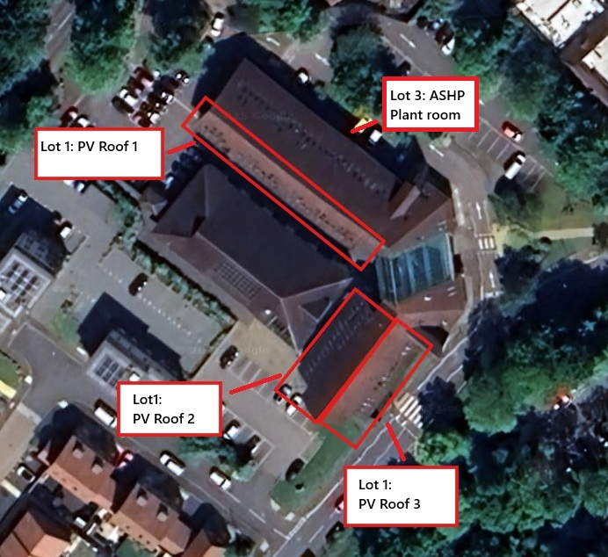
Lot 2: ASHP plant room
Lot 2: ASHP
Plant room
- Photo PV roof and Plant room location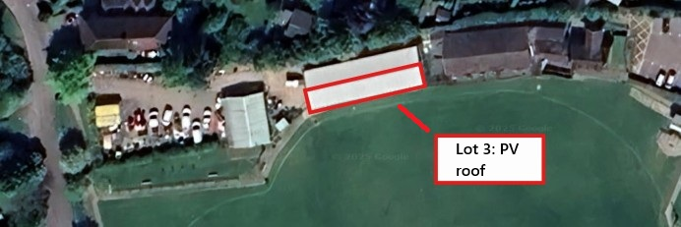

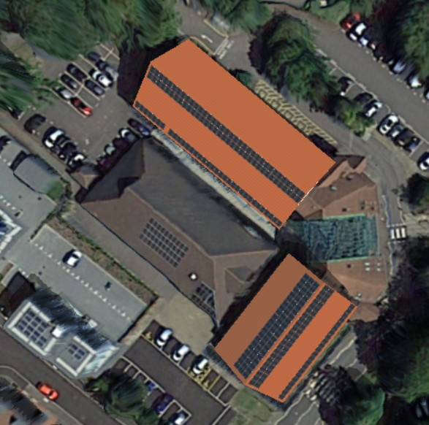
- Lot 1: PV Sol Solar PV model

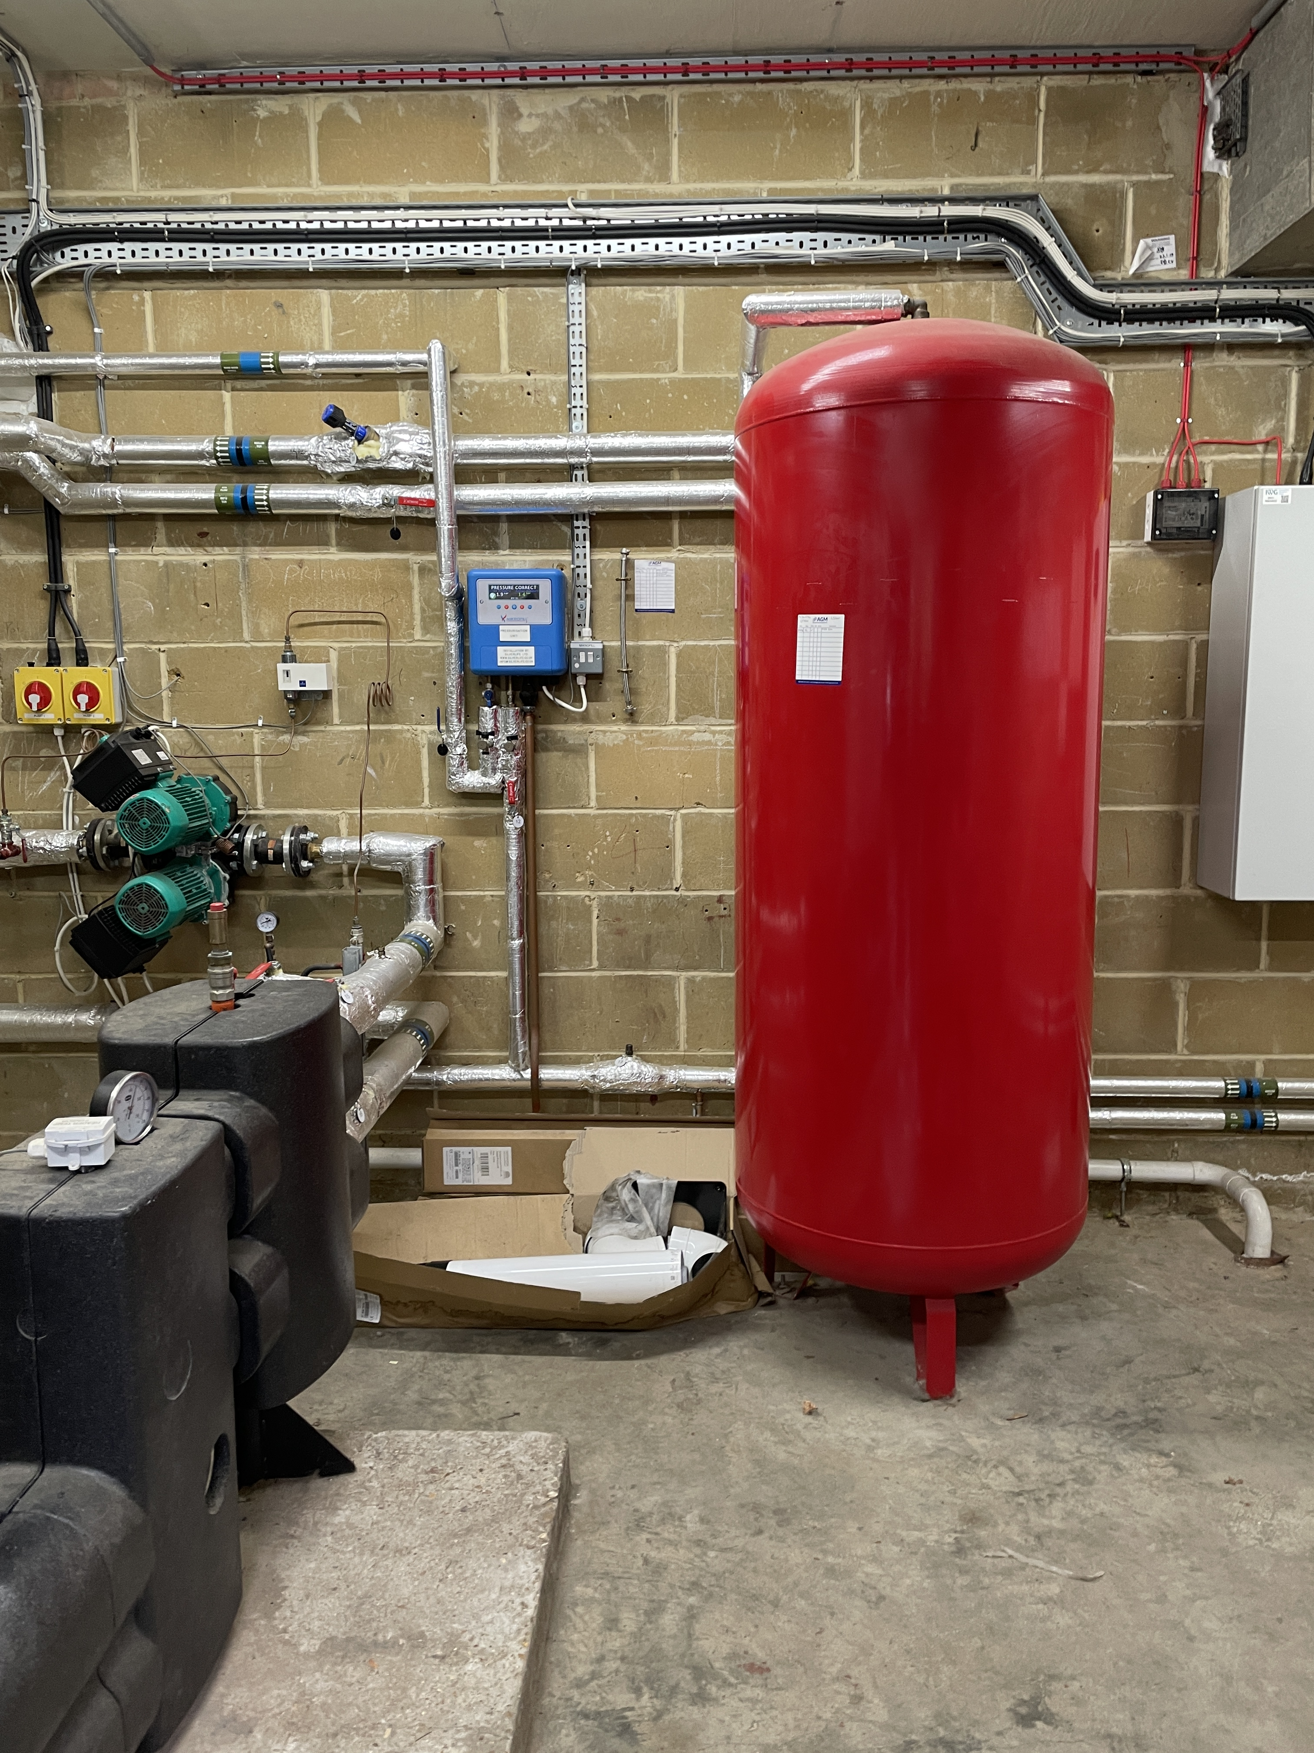
- Lot 3 Plant room
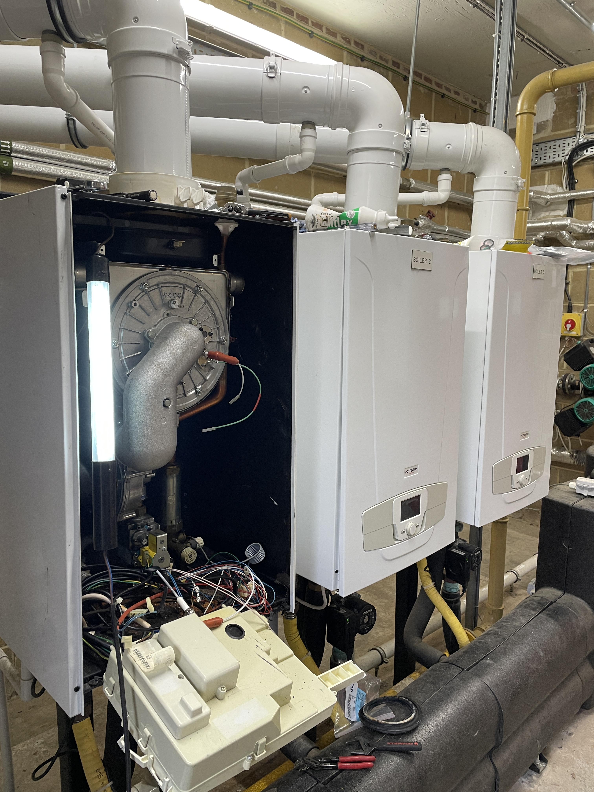
- Lot 3 Existing Gas boiler heating system 3 x 40kW

Lot 3:
Wolfe Tractor Shed
Blackness Rd,
Crowborough
TN6 2NA

The panels will be installed on the South facing roof, of the main roof at Wolfe tractor Shed. The orientation of potentially suitable roof is identified in the images below.
- Wolfe Shed PV roof location

The tenderer will be asked for a quotation based the information given in this request for tender document only. No contact is to be made with Crowborough Town Council. The tenderer will be asked to quote a fixed price for the whole of the specified supply, including the cost of connection and running cabling from the panels to the connection point(s).
Tenderers will been selected on the basis of the information provided in their tenders and Crowborough Town Council will then select one installer for interview by OVESCO and a site visit.

Tender process and project timetable
The tendering process will be as follows:

1. | Request for tender documents issued | 01.04.2025
2. | Tenders returned to OVESCO – the tenderer will supply a compliant tender including a fixed price for the entire scope of supply including cabling and connection. | 01.05.2025
3. | Preferred tenderer will be selected on the basis of the tender assessment criteria noted in section 1.6 below Decision by Crowborough Town Council. | 24.06.2025
4. | Notification of successful tenderer (subject to viable quotation) | 25.06.2025
5. | Visit to site (TBA) | W/C 01.07.2025
6. | Contracting process | 15.07.2025
7. | Contract start date | 01.08.2025

If OVESCO determines (in its sole discretion) that the finalisation of the contract is taking too long then it may switch to the best runner-up tender, and so on.
OVESCO’s aim is for the solar panels to be installed during July 2025.

Tender assessment criteria
For a tender to be assessed, the tenderer must:
- complete all of the information requested in the format provided (supplementary material may also be submitted); and
- have successfully installed a PV scheme of 50kWp or larger to date for Lot 1
- Have successfully installed ASHP commercially and have case studies for evidence. Lot 2
- have successfully installed a PV scheme of 15kWp or larger to date for Lot 3

Compliant tenders will be assessed on the basis of the information provided by the tenderer, placing emphasis on the following criteria:
- Price
- Guaranteed output level
- Added value
- Ability to provide local service
- Ability to complete and commission in September 2025

Tender conditions
The tenderer agrees to comply with the following tender conditions:
- The tenderer and all equipment installed must be certificated by the Microgeneration Certification Scheme (MCS) to ensure compliance with the Feed-in Tariff legislation.
- The tenderer must notify in writing if any of the submitted tender information changes or if the tenderer becomes aware that information provided to OVESCO is inaccurate, incomplete or misleading.
- The installation will comply in all respects with the specifications and performance information set out in the tender.
- The tenderer must not hold itself out as an agent of OVESCO or Crowborough Town council or make any representations that would lead people to believe that OVESCO guarantees the products and/or services offered by the tenderer.
- If any claim is brought by Crowborough Town Council or other third party against OVESCO and the claim is caused by any act or activities of the tenderer (or its subcontractors) under or in connection with the installation or any other act, omission, misrepresentation or negligence on the part of the tenderer (or its subcontractors), then the tenderer must indemnify OVESCO from and against all costs, expenses (including, but not limited to, legal and other professional fees and expenses) losses, damages and other liabilities (of whatever nature, whether contractual, delictual or otherwise) suffered or incurred by OVESCO,
- The tenderer must gain OVESCO's prior written agreement to any publicity in connection with this contract.
By signing below the tenderer agrees to be bound by the Tender and confirms that the information set out in its submitted tender documentation document is true and accurate in all respects:

for and on behalf of [insert tenderer name]
Name:
Position:
Date:

Information required

Tender information requirements

Scenario for Solar PV |  |  | One
PV size required (kWp) |  |  | kWp
A. Brief Design Description
A.1 Overall description
Lot 1,2,3 (delete as required)

A.2 Panel brand, model, quantity and description (including country of manufacture, number and dimensions of panels)
A.3 Inverter brand, model, quantity and description (including country of manufacture)
A.4 Racking system brand, model and description (including country of manufacture)
A.5 Cabling brand and description (including country of manufacture)
B. System Performance
B.1 The closest system size you can provide (kWp)
B.2 The required roof area for the PV panel (m²)
B.3 Forecast annual electricity generation (metered kWh)
B.4 Basis of the forecast annual electricity generation
B.5 Please describe the design process to ensure that the maximum power generated by the panels reaches the distribution board
C. Price
C.1 Fixed price for the entire scope of supply including the cabling from the panels to the connection point(s) and the connection
C.2 Estimated cost of cabling and connection
C.3 Basis upon which the cabling and connection costs will be estimated
D. Inverter replacement
Please say when the inverters will need replacing and the expected cost of this including equipment supply and fitting.
D. Maintenance and ongoing support
Please outline operations and maintenance and support services, the level of service you would provide and the price for a 5 year and 10 year contract. e.g MCS maintenance schedule.

Added Value
Part of the scope of supply is the provision of a suitable information feed and electronic display to provide educational information about the performance of the panels and possibly also about the real-time energy consumption of the building. Please give your ideas about this and what you think may be possible.
Please detail how remote monitoring of the panels may be possible and what are the costs associated with this.

Local knowledge and impact
a) | Has your company worked in or around East Sussex before? If so, please give details.
b) | Is the installation team local?
c) | Please advise your estimated time on site and how you intend to minimise environmental impact in delivering this work.

Guarantees
a) | OVESCO’s preference is for a single guarantee for the total performance of the system, i.e. for the electricity delivered to the connection point rather than for the panels and inverters separately. Please state if this is possible and the basis of such a guarantee. Please provide the guaranteed output levels throughout the 25-year life of the installation, e.g. at 5, 12, 18 and 25 years.

b) | If it is not possible to guarantee the whole system as one, please provide details of the individual guarantees provided for:  i) The collector  ii) Other parts of the system as appropriate, and  iii) The installation.  Please provide the guaranteed output levels throughout the 25-year life of the installation, e.g. at 5, 12, 18 and 25 years.
c) | Please advise any arrangements you may propose to directly monitor actual performance for one year compared with an insolation meter and any associated guarantee terms and/or retentions you would propose in association with this.

Site meeting
TBC once preliminary quotes are submitted
Date TBC
Morning
Noon
Afternoon

Company Information
Organisations can also partner to compete for a bid. In this case, please provide below the details of the lead bidder and how this organisation will ensure a high standard of installation is achieved with its tenderer partners/subcontractors.

Address Details:
Company name:
Address:
Town: |  | Postcode:
Registered Office (if different from above):
Phone: |  | Fax:
Easy-access contact (i.e. local office, 24/7 hotline) |  | Website:
Person to contact regarding this tender:
Position:
Direct line: |  | Mobile:
E-mail:

Company Details:
Legal status (e. g. Sole Trader, Partnership, Private Limited Company, Public Limited Company or other):
Details of any outstanding claims or litigation against the Company:
VAT registration number: |  |  | Date established or registered:
Name of Parent Company or details of Group Structure
Include details of other organisations when bid is on behalf of a group of organisations:
Number of staff:

Accreditation and quality assurance
MCS (or equivalent) certification number(s):
Renewal audit date for MCS certification:
Do you intend on renewing your MCS (or equivalent) certification for another year beyond your current certification period? |  | YES  NO
Please indicate how you make sure that all aspects of the building regulations are followed during an installation including structure, fire, hygiene, conservation of energy, electrical safety and any others that might apply and how you make sure that completion certificates are accepted by the appropriate local authority.
List any additional quality assurance standards that you will strictly follow within the installation process:
State the names of any associations or guarantee schemes of which the company is a member of and any company awards:
Declaration of how many complaints raised under Clearskies, MCS and/or REAL against the company, partners or subcontractors used by the company for the installation of any type of renewables systems:
Declaration of any corrective action requests (CARs) raised under Clearskies, MCS or REAL against the company, partners or subcontractors:
Declaration of how many complaints resolved and how many are outstanding:

Give details on how quality is achieved/checked through using subcontractors

Technical scope
How long has your organisation been installing solar PV systems of equivalent size and what is its total installed capacity?
What is your specialist area and what are the other services you provide?
Can you provide one or more case studies and a reference site of 45kW as a demonstration of your previous experience? | YES, documents enclosed  NO

Check list of documents to include in the tender
Please provide the following documents in addition to your quote/completed questionnaire and the signed declaration on page 6:

Contractual terms and conditions including payment terms and details of warranties
Full details of warranties
MCS certification (or equivalent) document
Case Study
Copy of standard quote

PLEASE REMEMBER TO COMPLETE AND SIGN THE DECLARATION ON PAGE 6 AND INCLUDE THIS WITH YOUR RETURNED TENDER DOCUMENTATION. SUBMITTED SIGNATURES MUST BE ORIGINALS IN HARD COPY.

