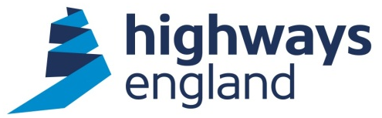  Our ref: CCS RM3786 TO08/19  FAO: Redacted  Gowling WLG  Via Bravo | Redacted  1st Floor  Woodlands  Manton Lane  Bedford MK41 7LW  Direct Line: Redacted  28 August 2019

OFFICAL – SENSITIVE

CCS RM3786 – THE PROVISION OF LEGAL SERVICES TO SUPPORT HIGHWAYS ENGLANDS DBFO SCHEMES

AWARD LETTER
Dear Redacted,

On behalf of Highways England, I am writing to accept your recent offer to carry out the above-mentioned Package Contract within the terms of the Crown Commercial Services RM3786 framework contract. You have been awarded this contract, as detailed in the notification letter dated 15 August 2019.

The commencement date will be 2 September 2019 (or later dependant on when the Panel Agreement is signed), as detailed in the attached Panel Agreement Schedule 4, Order Form.

The Project Managers for this contract are Redacted and Redacted, their contact details are below:
Email – Redacted and Redacted
- Telephone work Redacted – Redacted
- Telephone work Redacted – Redacted
- Mobile Redacted – Redacted

This is an option E – Cost Reimbursable contract and will be paid in accordance with the rates submitted in your tender, please see Annex B, rate Card included with the Panel Agreement, Order Form.

The end date specified in the Order form is 1 September 2022, with the option to extend this by a further 12 months to 1 September 2023.

You should note that we will not pay for any work unless it has been specifically authorised in writing within the terms of the Agreement.

Please also find attached the DBFO Legal Services Scope of Work, which details the work to be undertaken through the lifetime of this contract.
This award is subject to the following:
- Completion and return of the Panel Agreement Schedule 4, order form included with this award letter – this needs to be signed and returned via email as soon as possible to Redacted
- confirmation by return that the Key People you have offered in your tender will be available to start the project.
- Confirmation by return of the lead partners contact details.

The CPF toolkit has now been tailored to suit individual types of task orders/contracts and is attached.

Invoices should be sent by email to:
invoices@highwaysengland.co.uk
quoting the Project Manager’s name, Agreement number and release number, all of which will be provided by the Project Manager.

Please note you must not make any public announcements and all media enquiries should be directed to the Highways England Press Office.

Please acknowledge receipt of this letter via email to:
Redacted.

Yours faithfully,

Redacted
Head of Corporate Services - Commercial & Procurement Directorate

