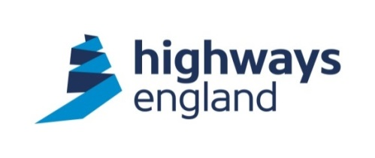

Traffic Officer Vehicle
Alternative Signs Trial

Request for Proposal
Contents
1 Background 3
2 Current Specification 3
3 Procurement Route 4
4 Potential Supplier Information 6
5 Trial Entry Criteria (Mandatory) 7
6 Off-road Trial Criteria: 7
7 On-road Trial 10
8 Accessing Highways England’s e-tendering system 11
9 Current Storage Provisions 12

Background
Following feedback from Highways England Traffic Officer’s and recommendations following a recent review of Traffic Officer Emergency Traffic Management (ETM) by Transport Research Laboratory (TRL), a project is being developed to investigate alternatives to the current signs carried in Traffic Officer Vehicles (TOVs).
The recent review identified that existing signs can be unstable in adverse weather and often require additional support by ballast (Figure 1) or spare signs to remain in position. Given the size and weight of ballast, additional support is usually provided in the form of unused signs or cones.
Figure 1
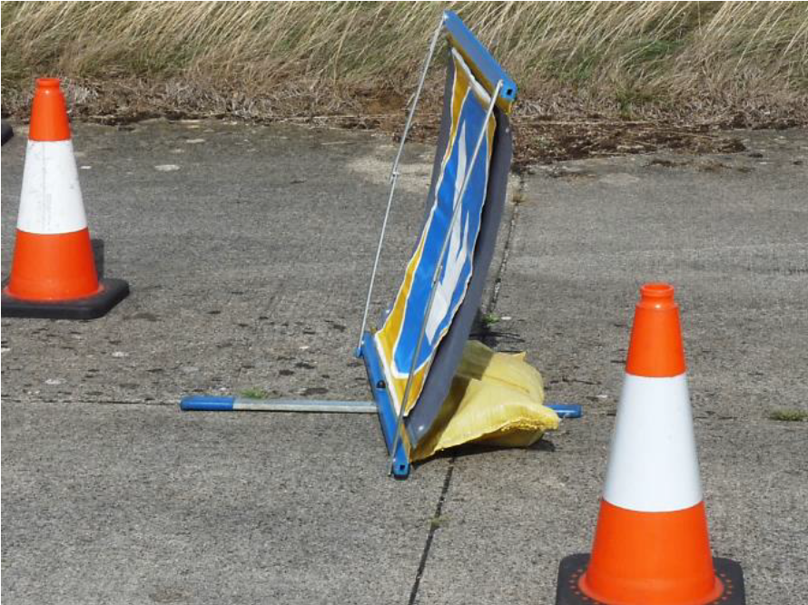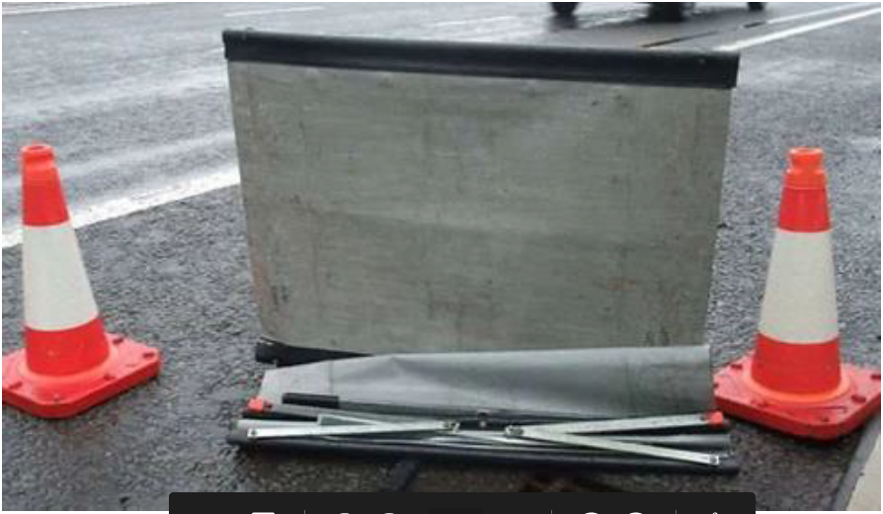
Up to 5 cones (stacked) or 3 rolled-up signs could potentially be used as ballast and although this can prove effective, a typical view from Traffic Officers is that sometimes the extra ballast helps, but if it’s too windy, they are ineffective, and the signs become a hazard to colleagues and customers.
There are also clearly safety considerations that if the current signs and methods for weighing the signs down prove insufficient and the signs collapse, the equipment could potentially end up being blown into a live lane. The use of additional equipment also means that it takes longer to deploy and clear.
The report noted that there are potential alternatives on the market that have interchangeable faces, are substantially lighter, and which are more stable due to their design features, offering greater wind resistance in an on-road environment.

Current Specification
A Highways England Traffic Officer Vehicle currently carries the following signs:
Description | Quantity
Diagram 610: ‘Keep Left or ‘Keep Right’ 600mm diameter | 6
Diagram 616: ‘No Entry’ 600mm diameter | 1
Diagram S2: ‘Incident Slow’ | 2
Sign Extension Bar | 4

Highways England requires potential suppliers to provide the same set of signs as per Chapter 8 requirements for ETM deployment.
The potential benefits of moving to new signs include:
- Weight and space savings: Space within a TOV is at a premium and the current TOVs are operating at or near to their operational capacity
- Usability: More stable signs will require no additional ballast to be added to maintain stability, thereby minimising the time taken to deploy and clear
- Safety: More stable signs are less likely to be blown into a live lane. Additionally, Traffic Officers are more likely to deploy signs, knowing that they will remain in place and can withstand the conditions on the network particularly in adverse, windy conditions

Procurement Route
Highways England intends to fulfil the requirements utilising the live Traffic Officer Service Consumables contract with Pro-Tect Signs following the 7 stages outlined below.

If you are not registered on our Bravo tendering system, please follow the instructions outlined in Section 8 Accessing Highways England’s e-tendering system.
Highways England reserves the right to cancel, amend or vary the Request for Proposal process (in whole or in part) at any point.
Highways England reserves the right not to accept the lowest priced proposal for any reason.
Potential Suppliers to note that all information provided as part of their proposal must be true and accurate. Highways England reserves the right to reject any proposal if the potential supplier provides misleading or false information.
Tenderers who wish to be considered for the trial must complete Section 4 and Section 5 below and return via Highways England’s e-tendering system, Bravo by Tuesday 18th February 2020.

Potential Supplier Information
Please answer the following questions in full.
Question Number | Question | Response
 | Full name of the potential supplier submitting the information
 | Registered office address (if applicable)
 | Registered website address (if applicable)
Trading status
- public limited company
- limited company
- limited liability partnership
- other partnership
- sole trader
- third sector
- other (please specify your trading status)
 | Date of registration in country of origin
 | Company registration number (if applicable)
 | Charity registration number (if applicable)
 | Head office DUNS number (if applicable)
 | Registered VAT number
 | Are you a Small, Medium or Micro Enterprise (SME)1? | Yes ☐ No ☐
 | Annual Turnover2
 | Gross Profit
Details of immediate parent company:
- Full name of the immediate parent company
- Registered office address (if applicable)
- Registration number (if applicable)
- Head office DUNS number (if applicable)
- Head office VAT number (if applicable)

(Please enter N/A if not applicable)

Question Number | Question | Response
Details of ultimate parent company:

- Full name of the ultimate parent company
- Registered office address (if applicable)
- Registration number (if applicable)
- Head office DUNS number (if applicable)
- Head office VAT number (if applicable)

(Please enter N/A if not applicable)
1 See EU definition of SME https://ec.europa.eu/growth/smes/business-friendly-environment/sme-definition_en
2 Annual turnover is requested to ensure that the potential suppliers annual turnover does not exceed more than 50% of the potential contract value. If the potential supplier has failed the financial evaluation solely because of the calculation and if the Supplier is a subsidiary, a parent company guarantee (PCG) or some appropriate for of guarantee other will be requested. The total contract value will be dependent on the potential suppliers’ commercial submission.

Trial Entry Criteria (Mandatory)
In order to proceed to the off-road trial all criteria listed below must be met, therefore potential suppliers who answer ‘Yes’ to all questions will be invited to the off-road trial.
Question | Criteria | Yes | No
 | Product is BS 8442:2015 compliant | ☐ | ☐
 | Product complies with Chapter 8 requirements | ☐ | ☐
Outcome (Pass/Fail)
Highways England use only

Off-road Trial Criteria:
Each product deemed to have met the minimum entry criteria will be tested by invitation only at a Highways England off-road simulation facility on Tuesday 25th February 2020 and assessed according to the requirements outlined in 6.1 Alternative Signs Criteria Table below.
Potential Suppliers will be granted an individual time slot for this test where your product will be viewed and trialled by Highways England only.

Alternative Signs Criteria Table
ID | Requirements
Physical Characteristics
1 | The product weighs less than 6kg
2 | When stored the product must measure no more than 145mm x 900mm to comply with current Traffic Officer vehicle specification
3 | Product accommodates interchangeable sign faces
4 | If product has any moving parts they are maintenance free
5 | If product has any fixings they are non-ferrous
Safety Characteristics
6 | Product can be deployed wearing gloves issued as standard as part of Traffic Officer PPE
7 | Product can be collapsed and cleared away wearing gloves issues as standard as part of traffic officer PPE
8 | Product can be deployed and cleared away in the dark without the requirement for any external lighting?
9 | Product is CE marked and compliant with EU safety, health and environmental requirements
Usability Characteristics
10 | Product can be set out with no requirement to return to vehicle more than four times
11 | Product can be deployed/cleared away in less than an average of 3 minutes per sign
12 | If stored in a protective sleeve, Product can identify the sign inside, without having to remove it from the sleeve

Scoring Criteria
The product presented by potential suppliers at the off-road trial will be assessed against 6.1 Alternative Signs Criteria Table and given a score using the mechanism outlined in 6.3 Off-road Trial Scoring Mechanism below.
The product(s) with the highest score will proceed to an on-road trial within a designated Highways England region for a period of at least six weeks for which 10 sets of signs will be required.

Off-road Trial Scoring Mechanism
Theme | Mark | To what extent does the proposal meet the criteria?
Physical  Characteristics | 1 | The product presented at the Off-road Trial meets 2 or fewer of the requirements outlined in Alternative Signs Criteria.
Physical  Characteristics | 3 | The product presented at the Off-road Trial meets 3 of the requirements outlined in Alternative Signs Criteria.
Physical  Characteristics | 5 | The product presented at the Off-road Trial meets 4 of the requirements outlined in Alternative Signs Criteria.
Physical  Characteristics | 7 | The product presented at the Off-road Trial meets all 5 requirements outlined in Alternative Signs Criteria.
Safety  Characteristics | 1 | The product presented at the Off-road Trial meets 1 or fewer of the requirements outlined in Alternative Signs Criteria.
Safety  Characteristics | 3 | The product presented at the Off-road Trial meets 2 of the requirements outlined in Alternative Signs Criteria.
Safety  Characteristics | 5 | The product presented at the Off-road Trial meets 3 of the requirements outlined in Alternative Signs Criteria.
Safety  Characteristics | 7 | The product presented at the Off-road Trial meets all 4 requirements outlined in Alternative Signs Criteria.
Usability  Characteristics | 1 | The product presented at the Off-road Trial meets 1 or fewer of the requirements outlined in Alternative Signs Criteria.
Usability  Characteristics | 3 | The product presented at the Off-road Trial meets 2 of the requirements outlined in Alternative Signs Criteria.
Usability  Characteristics | 5 | The product presented at the Off-road Trial meets 3 of the requirements outlined in Alternative Signs Criteria.

On-road Trial

On-road Trial Criteria Table
ID | Criteria | Score
ID | Criteria | 1 | 3 | 5 | 7
1 | How long did it take to deploy the signs? | Less than 2 minutes☐ | Less than 3 minutes☐ | 3 - 6 minutes☐ | More than 6 minutes☐
2 | The number of near miss reports for incidents where the signs were deployed during incident management | None  ☐ | One  ☐ | Two  ☐ | More than 3  ☐
3 | How many times did you have to return to/access the rear of the TOV to collect/replace signs during deployment/clearance | One  ☐ | Two  ☐ | Three  ☐ | More than 4  ☐

ID | Criteria | Score
4 | Traffic Officer reported issue(s) in relation to deployment and clearance of the signs
5 | Traffic Officer noted issue(s) in relation to the signs once deployed
6 | Traffic Officer noted issue(s) in relation to storage of the signs in the Traffic Officer vehicle
7 | Traffic Officer noted performance issue(s) in adverse weather conditions
8 | Traffic Officer noted observations on sign usage/performance which were recorded in incident debriefs

Scoring Criteria
The product presented by potential suppliers at the off-road trial will be assessed against 7.1 On-road Trial Criteria Table and given a score using the mechanism outlined in 7.3 On-road Trial Scoring Mechanism below.

On-road Trial Scoring Mechanism
Mark | To what extent does the proposal meet the criteria?
1 | The product could not be deployed due to total product failure
3 | The product was deployed with one or more issues which were a result of the product (i.e the frame failed to lock into place, the interchangeable sign face failed to adhere)
5 | The product was deployed with one or more issues which where circumstantial to the incident and not caused by the product (i.e uneven ground, adverse weather conditions)
7 | The product was deployed with no issues

Accessing Highways England’s e-tendering system
If you have a Bravo account;
Please reply with your company Bravo username and the contact name/email address associated with this account.
If you do not have a Bravo account;
Suppliers Instructions How to Express Interest in this opportunity:
1. Register your company on the e-Sourcing portal BRAVO (this is only required once)
a) Browse to the e-Sourcing Portal: https://highways.bravosolution.co.uk and click the link to register.
b) Accept the terms and conditions and click 'continue'
c) Enter your correct business and user details - Note the username you chose and click 'Save' when complete - You will shortly receive an email with your unique password (please keep this secure)
If you encounter any problems with the above please contact the Bravo helpdesk who can assist you:
Phone: 0800 368 4850
E-mail: help@bravosolution.co.uk
Note – if your company details change or have a change of email/mailbox then you can update this yourselves via Bravo. Highways England does not have control over your Bravo accounts.

Current Storage Provisions
The 2 images below are examples of where the ETM signs are currently stored in the Traffic Officer Vehicles. Highways England is not considering alternative storage provisions at this time.
