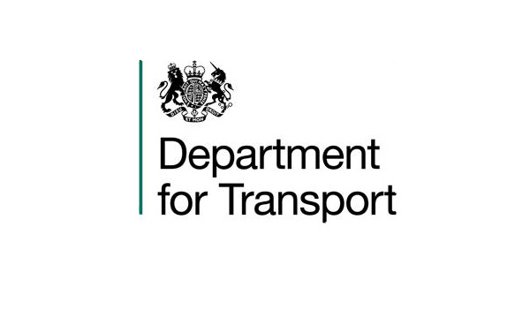

VARIATION TO CONTRACT FORM

Contract Name: The Provision of Legal Advice Regarding the Railways Pension Scheme

CONTRACT REF: CCLL17A32-01

Current CCS ref: CCLL17A32

Variation Number: 1

Effective from: 24th February 2018

Between:

The Department for Transport (hereinafter called “the Client”) and Eversheds-Sutherland (hereinafter called “the Contractor”)

The Contract is extended as follows:

- This is an extension to the contract between the Client and the Contractor.

The original contract term was for four months 24th October 2017 – 23rd February 2018.The contract shall be extended for two months (which is within the scope of the award letter / call off agreement) from 24th February 2018 to 23rd April 2018.

This is a time only extension, the original contract value of £50,000 (ex VAT) shall not be exceeded.

The Terms and Conditions of Contract as previously agreed and amended between the Client and the Contractor will still apply.

2. Words and expressions in this Variation shall have the meanings given to them in the Contract.

3. The Contract shall remain effective and unaltered except as amended by this Variation.

SIGNED

For the Client: For the Contractor:

Full Name: REDACTED Full Name: REDACTED

Title: REDACTED Title: REDACTED
Date: 31/01/2018 Date: 01/02/2018

