Maritime & Coastguard Agency

Drone Demonstration and Development Project

invitation to tender (itt)

Senior Responsible Owner: Damien Oliver

Document Author: Neil Grant

Document Version: V3

Document Date: 26th July 2019
Contents
Glossary of Terms 4
Specification of Requirement 4
The Requirement 5
The Contract 6
The Tender Process 6
Conflicts of Interest 9
Evaluation Criteria 10
Annex 1 – User Requirements, Bidder Proposed Solution and Required Evidence 11
Annex 2 - Evaluation Criteria & Weighting 19
Annex 3 - Price Evaluation 21
Annex 4 – MCA Use Cases 23
Annex 5 – Form of Contract 26

Drone Demonstration and Development Project Invitation to Tender (ITT)

Glossary of Terms
BVLOS | Beyond Line of Visual Sight
CAA | Civil Aviation Authority
MCA | Maritime And Coastguard Agency
OJEU | Official Journal of the European Union
SAR | Search and Rescue
UAV | Unmanned Aerial Vehicle

Specification of Requirement

Background
- The Maritime and Coastguard Agency (MCA) provides a national 24-hour maritime and coastal search and rescue emergency response service throughout the United Kingdom (UK). It also has a requirement to undertake periodic and reactive aerial surveillance flights throughout the UK’s Exclusive Economic Zone. The purpose of these flights is to determine the presence, size and type of pollution on the water.

- The aerial surveillance capability is also required by other government departments involved in activities including fisheries management, aerial mapping, law enforcement and protection of the environment, where the ability to conduct routine surveillance and data gathering from the air is an essential part of their business. The aerial surveillance service further supports long range search and rescue missions through the provision of top cover for its helicopters that operate at an extended range. Our capabilities can also be used to assist in the recovery of people lost or endangered at sea, as well as coastal and overland operations, through performing searches and providing greater situation awareness.

- These core functions could potentially be enhanced by the deployment of drone capabilities, which could improve the speed of response, reduce costs and perform automated functions which would add to search coverage.

The Requirement
- The MCA is responsible for the safety of life at sea, the provision of an emergency response helicopter service on behalf of all the blue light services, and the protection of the marine environment. The procurement of a drone demonstration and development contract will enable the MCA to assess the potential use of UAV to augment current and future aerial surveillance capability by reducing, enhancing or replacing existing delivery methods. It will seek to improve the efficiency and effectiveness of MCA operations whilst reducing the risk to MCA personnel.

- The Government is keen that the UK aerospace sector leads the way in the development and use of drone technology. The MCA’s aviation needs, together with that of other Government departments and their agencies, can at least in part be fulfilled using drone technology. Other Government departments and their agencies that might also benefit from drone technology include the other emergency services, Border Force, the Marine Management Organisation (together with the marine enforcement organisations in the devolved administrations), the Environment Agency, and the Ordnance Survey.

- The key deliverable the MCA aims to achieve from a drone demonstration and development contract is to address and remove the regulatory issues and barriers to allow Beyond Visual Line of Sight (BVLOS) flight in unsegregated and uncontrolled UK airspace.

- The resulting evidence will support any recommendation for the employment of drones and provide evidence for the value for money argument of an operational capability.

- The UK’s nascent civilian drone operating industry stands to benefit from the removal of the regulatory barriers currently preventing drone operations BVLOS in unsegregated and uncontrolled airspace from being a commonplace occurrence.

- In recognition of this significant potential gain, the Authority anticipates that bidders may wish to submit a tender which is enhanced by the bidder allocating resources (such as drones, equipment, systems, logistics and man hours) to this exciting project without fully charging the Authority for such resources. This might be reflected in bidders submitting a lower price and/or an enhanced technical solution than they might otherwise offer. The Authority actively encourages such approaches and all tenders will be evaluated in accordance with the methodology set.

- A full breakdown of the user requirements and a template in which the bidder should propose their solution is provided in Annex 1.

The Contract
Upon contract award, the Contract will comprise of:

- This Invitation to Tender, inclusive of the Specification of Requirement, Annex 1: User Requirements, Bidder Proposed Solution and Required Evidence, Annex 3: Price Evaluation and Annex 4: MCA Use Cases;
- The Form of Contract as set out in Annex 5.

The Tender Process
- This tender has been published in the Official Journal of the European Union (OJEU) under contract reference TCA 3/7/1111 and, in compliance with OJEU rules, the tender process and supplier selection will be conducted as an open and fair process. Consequently, this contract has been advertised on the Contracts Finder portal (https://www.gov.uk/contracts-finder) and all information related to the tender will be published here.

- Queries on the tender process or the requirement are welcome and should be submitted to AviationPMO@mcga.gov.uk showing the above reference number. However, in the interest of fairness, the questions themselves and the Authority’s responses will be published on the Contracts Finder portal and will not be emailed to individual bidders. All bidders, whether they have posed a question or not, should therefore monitor the Contracts Finder portal for any additional documents or information until after the closing date. The closing date for the receipt of queries is 14 August 2019 at 12:00 pm (local UK time), five days prior to the closing date for the submission of tenders on 19 August 2019 at 12:00 pm (local UK time) (“Tender Deadline”).

- The documentation submitted by the bidder as their response to this invitation, in accordance with the required detail and supporting evidence specified in Annex 1 and Annex 3, will constitute the entirety of their bid. No amendments will be accepted, and no further communication or documentation will be considered after the deadline specified for submission; prospective bidders should therefore make good use of the opportunity to ask questions prior to the submission deadline.

- Table 1 outlines the procurement timeline. Prospective bidders will have 30 days from the publication of the invitation to tender to construct a response, including as in their bid:

- The Form of Contract (see Annex 5) signed and dated by an authorised representative of the bidder (included on the contracts finder advert);
- A full description of the bidder’s proposed solution using the template provided in Annex 1 and any additional supporting documentation and required evidence, which must be clearly referenced in Annex 1.
- A completed Pricing Schedule showing full costs for the bidder’s proposed solution using the template contained in Annex 2.

- You must not alter any of the Authority’s tender documents.

- Bids shall be submitted by email to the following address:

AviationPMO@mcga.gov.uk

- Where multiple attachments or multiple emails (in the event that data limits prevent single email submissions) constitute a bid, bidders should submit a master list of documents listing everything that should be included in their bid. It is the bidder’s responsibility to ensure that they have received confirmation from the Authority that it has received all bid documentation.

- The Authority will confirm in writing its receipt of all bid documentation according to the master list of documents.

- No bids or additional bid documentation received after the deadline for submission will be considered, so email submissions should be sent in good time prior this to allow for any technical issues.

- The Authority will evaluate submitted bids only after the deadline for submission. It is expected that the evaluation phase will take three weeks. While evaluating the Authority may pose clarification questions to the bidder, who should nominate in their submitted documentation a point of contact to resolve these. Please note, these questions are only intended to seek clarification on specific points identified in the submitted tender and are not an opportunity for the bid to be materially changed in any way.

- When the Authority has identified the highest scoring bidder, it will notify all other bidders individually in writing that they have been unsuccessful, and the successful bidder of its intention to award the contract to them. A mandatory ten-day standstill period, required under EU procurement rules, will then be in effect prior to the actual awarding of the contract.

Table 1 – timescale for procurement and delivery
Task Name | Date for completion
Drone Demonstrations ITT Publication | 5th July 2019
Return of ITT Responses | 19 August 2019 at 12:00 pm (local UK time)
Evaluation of ITT Responses | 3 weeks
Contract Award | 10 days after the standstill period
Development of Drone Demonstrations Report | By October 2020 (this above date represents the current plan and is subject to change).

- You must not tell anyone else, even approximately, what your tender price is or will be, before the date of contract award. The only exception is if you need an insurance quotation to calculate your tender price - in which case you may give your insurance company or brokers any essential information they ask for, provided that you do so in strict confidence.

- You must not try to obtain any information about anyone else’s tender or proposed tender before the date of contract award.

- You must not make any arrangements with anyone else about whether or not they should tender, or about their or your tender price. The only exception is where bidders are considering joint or team bids, which will be allowed providing all participants to the discussions surrounding the bid are clearly stated in the tender response. (See also ‘Group Bids’ below).

Group Bids
- The Authority welcomes tenders from groups/consortia of suppliers, each providing part of the specified requirement. In the event of a group of suppliers submitting an acceptable offer, the group will be required to nominate a lead partner with whom the Authority can contract. Alternatively, the group will need to form themselves into a single legal entity before the contract is awarded. An undertaking that the group will so form themselves, if required by the Authority, must be provided when the tender is submitted.

Tender Validity
- Each bidders’ tender shall remain open for acceptance by the Authority for a minimum of 90 calendar days from the Tender Deadline.

- You should note that: -

- The Authority reserves the right not to accept the lowest, or any, tender;

- The Authority reserves the right to accept any part of the tender without accepting the remainder;

- Acceptance of a tender/award of contract will be by written communication from the Authority;

- Where the tender process has been subject to the full EU Procurement Process, a mandatory 10-day standstill period must be applied between communicating the award decision to bidders and awarding the contract; and

- Complaints arising from the tender process should be directed in the first instance to the Procurement Team (contracts@mcga.gov.uk).

Tender Costs
- You should note that any expenditure, work or effort undertaken by you prior to the award of a contract is a matter solely for your own commercial judgement. The Authority reserves the right to withdraw this tender invitation at any time or to re-invite tenders on the same or any alternative basis. In such circumstances, and in any event, the Authority and/or its advisers shall not be liable for any costs or loss of expenses whatsoever incurred by the bidder or any company, agent, subsidiary or organisation who may have contributed to the proposals submitted by the bidder in response to this tender invitation.

Trading Names
- If your tender is submitted in the name of one organisation but you intend submitting invoices in the name of another, or require payments to be made to another, please give full details. Otherwise there may be delay in payment.

Invoicing and Payment
- Payment terms are outlined in the Form of Contract.

Conflicts of interest
- Bidders written proposals must disclose any potential conflicts of interest.

- Bidders should make an assessment of any potential conflicts of interest before submitting their bid and should include a clear statement in their bid which:

    - explicitly sets out that there is no conflict of interest, or sets out any existing conflicts of interest, either real or perceived, for their firm in relation to this Statement of Requirement;
    - provides full details of proposed risk management arrangements (e.g. segregation of staff and security of information); and
    - provides a clear description of how any subsequently arising conflicts would be dealt with.

Conflicts of interest are assessed on a pass/fail basis.
- The Authority will discuss any conflict of interest issues that have been disclosed by each bidder.

- The Authority will decide whether any internal management processes and controls that bidders have in place are satisfactory.

- Bidders will be ruled out of the competition if, in the Authority’s view, there is a conflict of interest which could compromise the delivery and integrity of the contract, or if the arrangements to deal with a future conflict of interest arising offer insufficient protection for the Authority.

Evaluation Criteria
- Bids will be evaluated based on the Criteria and weightings set out in Annex 2 - Evaluation Criteria & Weighting.

Annex 1 – User Requirements, Bidder Proposed Solution and Required Evidence

Tender Requirement
- The user requirements, which are a breakdown of the specific outputs required under this contract, are detailed in Table 2. The supplier must detail in this table their proposed solution, providing clear reference to external documentation where required, alongside supporting evidence as per the minimum requirements for evidence detailed in the second column of the table. Bidder’s will be evaluated against the strength of their solution for each user requirement.

Table 2: User requirements, bidder proposed evidence and required evidence
User Requirement | Evidence or rational required for the bid against the supplier’s solution | Supplier’s solution and evidence (explanation or reference to external evidential material)
UR1 - The contractor shall be required to articulate a Mission Profile to demonstrate how MCA drone Use Cases in annex 4 will be achieved.  The mission profile created will be:  - aligned with the use cases articulated in Annex 4  - performed in unsegregated and uncontrolled airspace; and  - performed beyond visual line of sight (BVLOS). | In this section the bidder shall provide details of their experience in creating Mission Profiles or equivalent documents to demonstrate the use cases can be delivered.  To demonstrate an understanding of the MCA’s operating environment for drones, the bidder shall submit outline Mission Profiles as part of the Tender. These will be finalized and agreed with the Authority in the first phase of the project.  The bidder shall detail the project risks and assumptions pertinent to this UR in the response, together with the method(s) of monitoring, managing and reporting these.  An outline overarching project plan shall be provided as evidence for the tender evaluation. This will include, as a minimum:  - A project timeline which provides a breakdown of the overall project into specific work packages, each of which shall be clearly linked to each user requirement;  - The resource plan shall detail the resources allocated to the delivery of this user requirement and their nominal days of use.
UR2 - The contractor shall engage with the regulator (CAA) and airspace managers (CAA and NATS) to agree a plan to achieve UR1. | The bidder can demonstrate experience of negotiating permissions for drone operations with the regulator – this could be demonstrated, for example, as case studies or profiles on the experience of individual members of the proposed project teams.  Previous experience of working within aviation regulatory frameworks shall be stated. These must clearly illustrate a good understanding of the challenges and regulatory issues pertaining to the implementation of drones.  The bidder shall detail the project risks and assumptions pertinent to this UR in the response, together with the method(s) of monitoring, managing and reporting these.  An outline overarching project plan shall be provided as evidence for the tender evaluation. This will include, as a minimum:  - A project timeline which provides a breakdown of the overall project into specific work packages, each of which shall be clearly linked to each user requirement;  - The resource plan shall detail the resources allocated to the delivery of this user requirement and their nominal days of use.
UR3 – The contractor shall select an appropriate location(s) in which to conduct the trials and a suitable airfield from which to base operations, negotiating with airfield owner and operator as required.  The selected location shall be a civil facility which is representative of the operating environment to support the Mission Profiles. | The tenderer shall provide a shortlist of their proposed location(s) on this form, giving a clear rationale for their choice.  The proposed locations must also be detailed in the project plan and in the relevant methodology, with reference to their place in these documents to be given here.  If successful in their bid, bidders proposed locations shall be agreed with the Authority in the first phase of the project.  The bidder shall detail the project risks and assumptions pertinent to this UR in the response, together with the method(s) of monitoring, managing and reporting these.  An outline overarching project plan pertinent to this UR shall be provided as evidence. This will include, as a minimum:  - A project timeline which provides a breakdown of the overall project into specific work packages, each of which shall be clearly linked to each user requirement; and  - The resource plan shall detail the resources allocated to the delivery of this user requirement and their nominal days of use.
UR4 – The contractor shall develop the necessary approvals and support paperwork to allow BVLOS flying trials to take place. A concept of operations and draft standard operating procedures shall be developed during this phase. | The MCA will need to be assured of safe operation, reviewing the safety cases and operating procedures.  Evidence of previous experience of writing safety cases and operational procedures and experience of current or previous CAA approvals would be an advantage.  The bidder shall detail the project risks and assumptions pertinent to this UR in the response, together with the method(s) of monitoring, managing and reporting these.  An outline overarching project plan pertinent to this UR shall be provided as evidence. This will include, as a minimum:  - A project timeline which provides a breakdown of the overall project into specific work packages, each of which shall be clearly linked to each user requirement; and  - The resource plan shall detail the resources allocated to the delivery of this user requirement and their nominal days of use.
UR5 – The contractor shall conduct a flying programme to deliver the agreed Mission Profiles.  Continued development of a concept of operations and draft standard operating procedures (SOP) shall be performed during this phase.  The flying programme shall:  - be agreed by the Authority  - demonstrate that beyond visual line of sight (BVLOS) drone flights are achievable, regularly, routinely and without the need for special permission in unsegregated and uncontrolled airspace.  - demonstrate persistent operations and cover a wide area at distance from the operating base.  - The proposed system that shall be used in the demonstration of BVLOS must, as a minimum, be above the 7kg criteria. The system shall have an endurance of greater than 3 hours at operational weights. | The proposed flying programme shall be detailed in the project plan, which shall be clearly referenced in this document.  An overview of the proposed flying programme shall be given here.  The bidder shall detail the project risks and assumptions pertinent to this UR in the response, together with the method(s) of monitoring, managing and reporting these.  An outline overarching project plan pertinent to this UR shall be provided as evidence. This will include, as a minimum:  - A project timeline which provides a breakdown of the overall project into specific work packages, each of which shall be clearly linked to each user requirement;  - The resource plan shall detail the resources allocated to the delivery of this user requirement and their nominal days of use.
UR6 – Post delivery of the flying programme the contractor shall produce a report detailing the findings, together with recommendations and lessons learnt at each stage for:  - regulatory change,  - data dissemination and handling.  A concept of operations and a draft SOP shall also be delivered.  The bidder will be required to provide sufficiently experienced personnel to create a report detailing the findings, lessons learnt at each stage and recommendations for the development of the drone regulatory environment.  The final report shall be provided in an electronic format. | Previously completed reports (redacted as required) or case studies demonstrating that the project team have previously compiled similar reports, shall be given as evidence of experience.  The bidder shall detail the project risks and assumptions pertinent to this UR in the response, together with the method(s) of monitoring, managing and reporting these.  An outline overarching project plan pertinent to this UR shall be provided as evidence. This will include, as a minimum:  - A project timeline which provides a breakdown of the overall project into specific work packages, each of which shall be clearly linked to each user requirement;  - The resource plan shall detail the resources allocated to the delivery of this user requirement and their nominal days of use.
UR7 – The contractor shall articulate how the proposed system will conduct the example scenarios in table 2.  Please note: The Authority wish to understand details of the flight characteristics and flight profiles of the proposed system rather than sensor performance. | Examples of previous scenarios developed shall be provided as evidence.

Table 3 – Example Scenarios
Scenario | Response
- Maritime Search/Surveillance – search for objects of interest in a 5NM x 5NM box with a last known position in the centre of the box. This shall be conducted in BVLOS conditions and in non-segregated airspace.
P Please note: The Authority wish to understand details of the flight characteristics and flight profiles of the proposed system rather than sensor performance.
- Littoral Search – perfunctory search for objects of interest in a 10NM x 1NM box with a last known position at one end of the box. This shall be conducted in BVLOS conditions and in non-segregated airspace.
Pl Please note: The Authority wish to understand details of the flight characteristics and flight profiles of the proposed system rather than sensor performance.

Annex 2 - Evaluation Criteria & Weighting
A2.1. The Authority will safeguard all tenders received and open them once the tender deadline has expired.

A1.2. The scoring criteria for the contract will be as follows:

Award Criteria

A2.3. Tenders will be evaluated to determine which is the most economically advantageous using the following criteria and weightings and will be assessed entirely on the response submitted:

Criteria | Weighting
Supplier’s Solution | 72%
Price | 28%
Total | 100%

Sub-criteria and weightings
A2.4. The Supplier’s Solution (which has a weighting of 72%) will be assessed according to the strength of each response to and, where applicable, the evidence provided against, each user requirement (the sub-criteria) using the following weightings:

Section of Supplier’s Solution | Weightings
UR1 | 14%
UR2 | 14%
UR3. | 14%
UR4 | 15%
UR5 | 14%
UR6 | 15%
UR7 | 14%
Total | 100%

A2.5. Each response to the above criteria (with the exception of Price) will be awarded a mark out of 10 in accordance with the following marking scheme: -

Technical Scoring Criteria

Points | Interpretation
10 | Good – The response fully meets the requirement providing additional usable capability, together with robust supporting evidence, that promotes a high degree of confidence with the Authority that the bidder will fulfil the requirement.
6 | Acceptable –The response states that it fully meets requirement, with an acceptable level of evidence provided to give confidence that the bidder can meet the requirement.
3 | Partially Acceptable – The response states full or partial compliance with the requirement, but critical areas of evidence requested have not been provided or provided with insufficient detail, to give the Authority confidence that the bidder can meet the requirement.
0 | Unacceptable – The response provided does not meet the requirement or, no response has been provided.

A2.6. The marks awarded in accordance with the above table will then be adjusted in accordance with the weightings.

A2.7. Bidders shall not make any comments on or amendments to the Form of Contract. A tender which comments on or suggests amendments to the Form of Contract will fail and will not be considered further.

Annex 3 - Price Evaluation

A3.1. The total project price will be paid in accordance with the Form of Contract. For the purpose of their supporting bid, bidders are required to specify their total project price and populate the Pricing Schedule below with the expected dates that each milestone will be achieved and the price payable by the Authority at each milestone, based upon the percentages specified by the Authority. Costs should be shown in pounds sterling, inclusive of any expenses but exclusive of VAT.

A3.2. The total budget approved for the work specified in this ITT is £990,000. A tender

whose total project price exceeds the total budget will fail and will not be considered further.

Table 4 - Pricing Schedule
No. | Name | Percentage of total project price | Milestone Payment | Milestone Achievement Date
 |  |  | to be completed by the bidder
M1 | Mission Profiles agreed by MCA (UR1) | 5% | £
M2 | Plan agreed with the regulator (UR2) | 20% | £
M3 | Location agreed by MCA (UR3) | 10% | £
M4 | Draft SOPs and CONOPS produced (UR4) | 10% | £
M5 | Completion of the flying programme (UR5) | 25% | £
M6 | Report of findings and presentation to MCA (UR6) | 30% | £
 | Total project price | 100% | £

A3.3. The Percentage Scoring Methodology will be used to evaluate the total project price proposed for this requirement. The total project price will be evaluated as follows:

- the lowest tendered total project price will be scored 100 (weighted score = 28.0%);

- each other tendered total project price will be baselined to this score.

Example

- a tender which is 20% more expensive on total project price than the lowest tendered total project price will be allocated a score of 80 (weighted score = 22.4%);

- a tender that is double or greater than double the lowest tendered total project price will score nil.

Annex 4 – MCA Use Cases
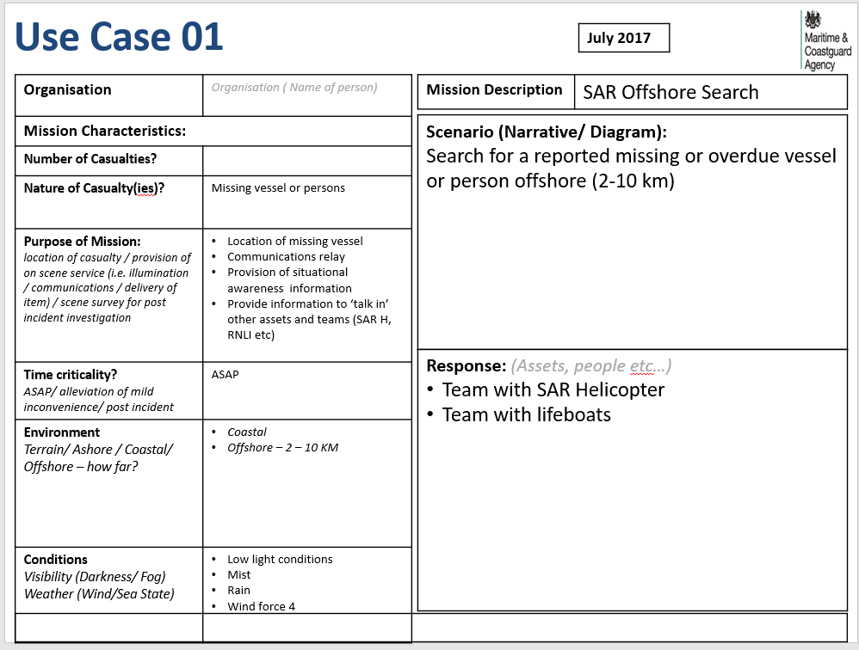
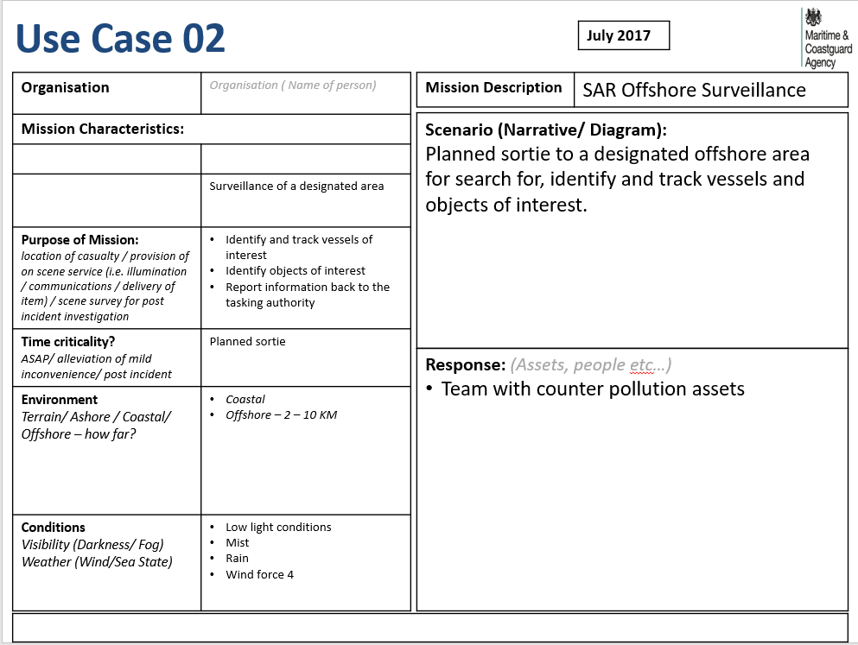
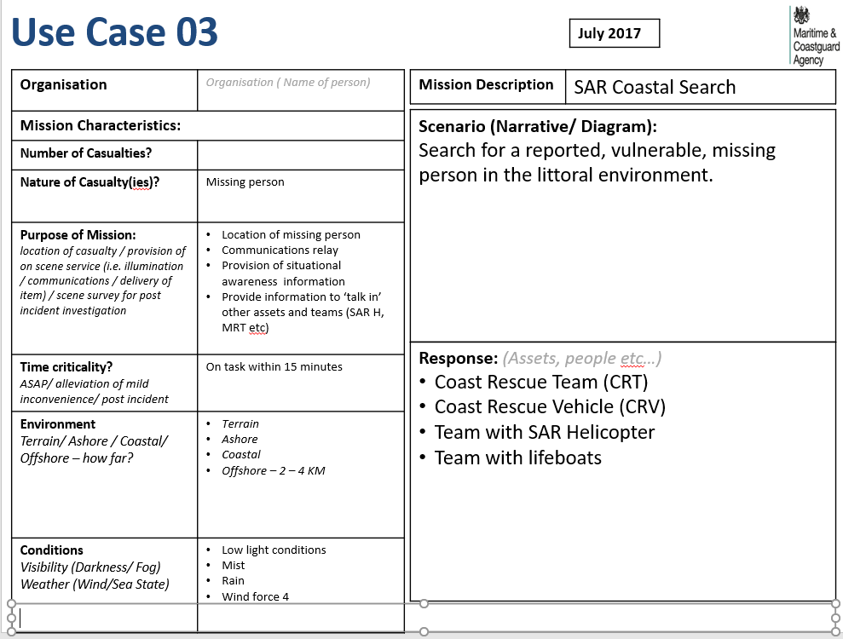

Annex 5 – Form of Contract

 | DATED | 2019
 | MARITIME & COASTGUARD AGENCY ACTING ON BEHALF OF THE SECRETARY OF STATE FOR TRANSPORT  and  [CONTRACTOR] |  | (1)  (2)
AGREEMENT

relating to the DRONE DEMONSTRATION AND DEVELOPMENT PROJECT

DATE 2019
- (1) MARITIME & COASTGUARD AGENCY of 105 Commercial Road Southampton SO15 1EG acting on behalf of the Secretary of State for Transport; and

- (2) [NAME OF THE CONTRACTOR] a company registered in [England and Wales] under company number [ ] whose registered office is at [ ]

- Interpretation

  - Unless otherwise defined in this Contract, capitalised expressions shall have the meanings set out in the Department for Transport General Conditions of Contract for Services version dated 24 January 2019 for contracts with a value of under five million pounds (£5,000,000) (the “DfT General Conditions”): https://assets.publishing.service.gov.uk/government/uploads/system/uploads/attachment_data/file/773857/general-conditions-of-contract-for-services-under-5.pdf

- Terms of Contract and Schedules

  - This Contract shall incorporate all of the terms of the DfT General Conditions other than Clause C2.1 (Payment and VAT) which shall be replaced by:

“Clause C2.1: Upon satisfaction of each milestone set out in the Pricing Schedule, the Contractor shall invoice the Authority for the proportion of the Contract Price for that milestone as set out in the Pricing Schedule and the Authority shall pay such sum within 30 days of receipt of a valid and undisputed invoice from the Contractor.”

  - The Pricing Schedule shall be the completed form of Pricing Schedule included in the Tender.

  - Tables Two Specification Schedule shall be the completed Table 2, Table 3 and Table 4 as set out in the Tender in response to Annex 1 and Annex 3 of the Authority’s invitation to suppliers for formal offers to supply it with the Services.

- The Contract

3.1 Upon contract award, the Contract will comprise of:

- The Invitation to Tender, inclusive of the Specification of Requirement, Annex 1: User Requirements, Bidder Proposed Solution and Required Evidence, Annex 3: Price Evaluation and Annex 4: MCA Use Cases;
- This Form of Contract; and
- The Form of Tender.

- Management of work and Contract administration

4.1 The MCA Aviation Technical Assurance Manager (or his delegated deputy) will act as Contract Manager.

4.2 The Contractor shall be responsible for the planning and development of demonstration processes, all demonstration logistics, resource allocation to support the delivery and execution of drone exercises and day to day coordination of demonstration delivery, under the supervision of the Contract Manager.

4.3 The Contractor must gain approval from the Contract Manager before carrying out any additional work.

4.4 The Contractor shall submit demonstration plans (timings, costs, locations, deviation breakdowns, resource allocation and demonstration methodologies, including anticipated outcomes) to the Contract Manager prior to demonstration activities commencing.

4.5 The Contractor shall report on progress against the milestones at least monthly and shall provide rectification plans in the event that a milestone is at risk of not being achieved.

4.6 Throughout the delivery and completion of demonstration tasks:

4.6.1 activities will be monitored by the Contract Manager or delegated members of his Technical Assurance Team;

4.6.2 the Contractor shall attend a contract/demonstration management call at regular intervals (to be specified by the Contract Manager but no less than once a week) to assess progress, to discuss tasks to be completed, any/all task deviation, general resource based activities and provide updates on the preparation/delivery of demonstration exercises;

4.6.3 the Contractor shall prepare and circulate a management call briefing note prior to the call to aid the discussion about progress.

4.6.4 if any resources allocated to the Contract or nominated individuals change after contract award, the Contractor shall notify Authority in writing of the proposed change.

This document has been executed as a deed on the date and was delivered and takes effect on the date stated at the beginning of it
Executed as a deed by [INSERT NAME OF contractor] acting by a director in the presence of: | )  )  )  )
 |  | Director’s signature
 |  | Director’s name
Witness’ signature:
Witness’ name (BLOCK CAPITALS):
Witness’ address:
Witness’ occupation:
Signed by [INSERT NAME] for and on behalf of MARITIME & COASTGUARD AGENCY acting on behalf of the Secretary of State for Transport | )  )  )
 |  |  | Signature
 |  |  | Name

